**NAME: ……………………………………………… ADM NO: ………… CLASS: ……….**

**PHYSICS**

**FORM TWO**

2 hours

##### SET 4

**FORM TWO**

**Instructions**

*Write your name, admission number and class in the spaces provided above.*

*This paper consists of* **TWO** *sections:* **A** *and* **B**.

*Answer* **ALL** *the questions in sections* **A** *and* **B** *in the spaces provided.*

***ALL*** *working***MUTS** *be clearly shown.*

***ALL*** *numerical answers***MUST** *be expressed in decimal form.*

*KNEC mathematical tables and non-programmable silent electronic calculators* ***may be used****.*

**For Examiners Use Only**

|  |  |  |  |
| --- | --- | --- | --- |
| **Section** | **Question** | **Maximum**  **Score** | **Candidate’s**  **Score** |
| **A** | 1 – 12 | 25 |  |
| **B** | 13 | 10 |  |
| 14 | 10 |  |
| 15 | 9 |  |
| 16 | 10 |  |
| 17 | 6 |  |
| 18 | 7 |  |
| **Total Score** | | **80** |  |

*This paper consists of 8 printed pages. Candidates should check the question paper to ascertain that all the pages are printed as indicated and no questions are missing*

**SECTION A (25marks)**

***Answer all question this section in the spaces provided***

**1.** Distinguish between mass and weight of a body stating the S.I units for each. (2mks)

……………………………………………………………………………………………………..

……………………………………………………………………………………………………..

**2**. The figure below shows part of scale of vernier calipers.

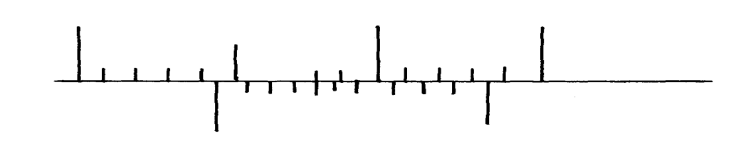

7cm

8cm

0

10

What is the reading indicated on the scale ………………………………………….. (1mk)

**3.** 180cm3 of fresh water of density 100kg/m3 is mixed with 2200cm3 of sea water of density 1025kg/m3. Calculate the density of the mixture (4mks)

…..………………………………………………………………………………………………….……………………………………………………………………………………………….……………………………………………………………………………………………………..………………………………………………………………………………………………….………………………………………………………………………………………………..……………………………………

**4.** Explain why fish can survive under water when the surface is already frozen (2mks)

……………………………………………………………………………………………………..

……………………………………………………………………………………………………..

……………………………………………………………………………………………………..

……………………………………………………………………………………………………..

**5.** Two inflated balloons are at the same level while suspended from threads a short distance apart as shown below;

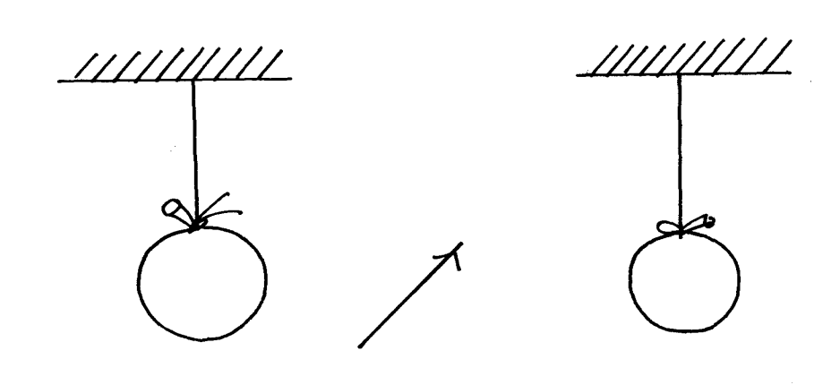

Air blown

Some air is blown gently in the space between the balloonin horizontal direction. Explain

what happens to the balloons. (2mks)

……………………………………………………………………………………………………..

……………………………………………………………………………………………………..

……………………………………………………………………………………………………..

**6.** State **one** advantage of an alkaline battery over a lead acid battery. (1mk)

……………………………………………………………………………………………………..

**7.** The diagram below shows a permanent magnet suspended by aspring. State with reason the behaviourof the magnet when the switch is closed. (2mks)

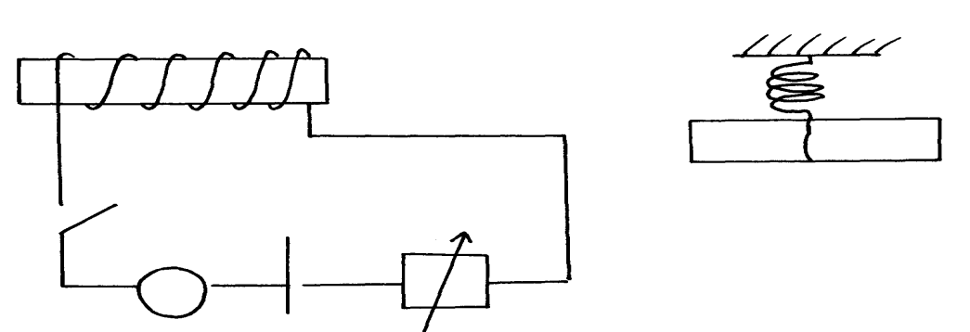

Spring

S

A

Y

N S

X

+ -

……………………………………………………………………………………………………..

……………………………………………………………………………………………………..

**8.** Convection and diffusion both involve motion of fluids. Distinguish between the two. (2mks)

……………………………………………………………………………………………………..

……………………………………………………………………………………………………..

……………………………………………………………………………………………………..

……………………………………………………………………………………………………..

**9.** A negatively, charged rod is brought close to (but not touching) an uncharged sphere. If the

sphere is momentarily earthed and then the rod is removed, briefly explain what happens.(2mks)

……………………………………………………………………………………………………..

……………………………………………………………………………………………………..

**10.** Indicate on the diagram below, the level of mercury in the tubes **X**and **Y**  (2mks)

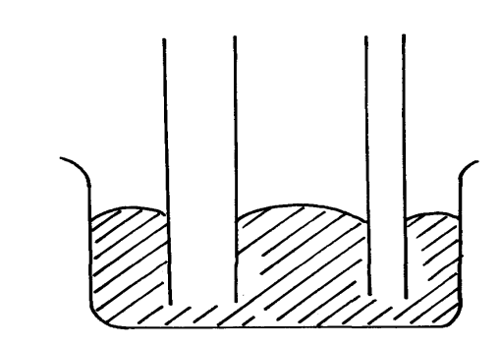

Mercury

X

Y

**11.** An object weighs 1200N on a certain planet. What is the gravitational field strength of this

planetif the object is 60kg? (3mks)

**12.** State **two** properties of a thermometric liquid. (2mks)

……………………………………………………………………………………………………..

……………………………………………………………………………………………………..

**SECTION B (55MARKS)**

***Answer all question this section***

**13.** (a) How does amplitude affect the loudness of musical note? (1mk)

……………………………………………………………………………………………………..

(b) What can be done to reduce echo in theatre halls? (1mk)

……………………………………………………………………………………………………..

(c) A girl stands some distance from a high wall and claps her hands;

(i) What **two** measurements would need to be made in order to determine the speed

of sound? (2mks)

……………………………………………………………………………………………………..

……………………………………………………………………………………………………..

(d) Describe how you would make use of these measurements. (3mks)

……………………………………………………………………………………………………..……………………………………………………………………………………………………..……………………………………………………………………………………………………..……………………………………………………………………………………………………..……………………………………………………………………………………………………..……………………………………………………………………………………………………..

(e) A girl is standing between two cliffs A and B but nearer to cliff B than A. She stands

140m from wall **B** and shouts once.She hears two echoes and discovers that the time

between the two echoes is 0.6seconds. Determine how far the girls if standing from the

cliff given that the speed of sound in air is 340m/s. (3mks)

……………………………………………………………………………………………………..……………………………………………………………………………………………………..……………………………………………………………………………………………………..……………………………………………………………………………………………………..……………………………………………………………………………………………………..……………………………………………………………………………………………………..

**14.** (a) State **Hooke’s law** . (1mk)

……………………………………………………………………………………………………..……………………………………………………………………………………………………..……………………………………………………………………………………………………..

(b) The following readings were obtained when a spring was loaded gradually;

|  |  |  |  |  |  |  |  |  |  |
| --- | --- | --- | --- | --- | --- | --- | --- | --- | --- |
| Load (N) | 0 | 10 | 20 | 30 | 40 | 50 | 60 | 70 | 80 |
| Extension(cm) | 0 | 12 | 25 | 37 | 48 | 60 | 70 | 78 | 85 |

(i) Plot a graph of load (N) against extension(cm) (5mks)

(ii) Mark on your graph the elastic limit **P**. (1mk)

…..……………………………………………………………………………………………………..…………………………………………………………………………………………………….…………………………………………………………………………………………

(iii) Determine from the graph the elasticity constant of the material of the wire. (3mks)

…………………………………………………………………………………………………

…..……………………………………………………………………………………………………..…………………………………………………………………………………………………….…………………………………………………………………………………………

**15.** (a) Distinguish between streamline and turbulent flow. (2mks)

…..……………………………………………………………………………………………………..…………………………………………………………………………………………………….…………………………………………………………………………………………………

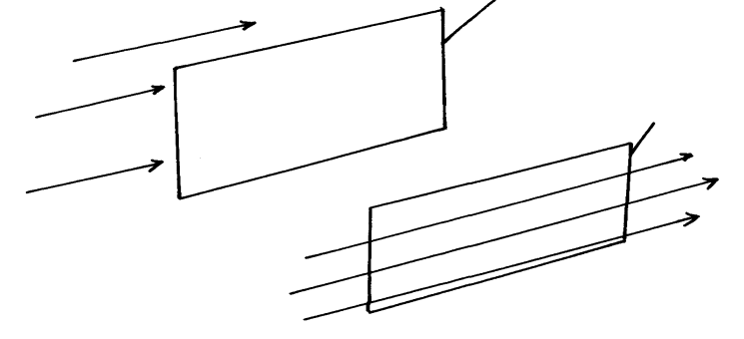

Paper

Paper

B

A

(b) The figure below shows two light sheets of paper arranged as shown;

Explain the observation made when air is blown at the same speed and at the same time

at point **A** and **B**. (2mks)

……………………………………………………………………………………………………..…………………………………………………………………………………………………..…………………………………………………………………………………………………..

(c) The diagram below shows an incompressible fluid moving through a tube of varied

cross-sectional area. If the area of the mouth region is 0.055m2, calculate the diameter

of the lower region. (3mks)



…..……………………………………………………………………………………………………..…………………………………………………………………………………………………….…………………………………………………………………………………………………

(d) Explain why a high speed jet has a sharp–nose shape (2mks)

…..……………………………………………………………………………………………………..…………………………………………………………………………………………………….…………………………………………………………………………………………………

**16.** (a) Define **pressure** and give its S.I nits. (2mks)

……………………………………………………………………………………………………..

……………………………………………………………………………………………………..

(b) The diagram below represents a motor car hydraulic braking system;

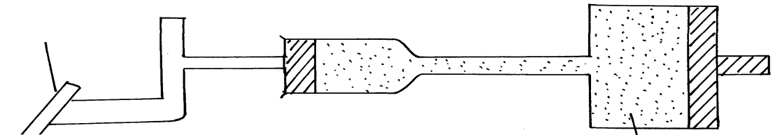

Brake pedal

Master piston

Slave piston brake fluid

**B**

**A**

1. State **two** properties of the liquid used as a brake fluid (2mks)

……………………………………………………………………………………………………..……………………………………………………………………………………………………..

1. Given that in the diagram **(b)** above the master piston has an area of 15cm2 and the slave piston has an area of 50cm2 a force of 100N is applied on the master piston. Find the force used to stop the car. (3mks)

…..……………………………………………………………………………………………………..…………………………………………………………………………………………………….……………………………………………………………………………………………………..……………………………………………………………………………………………………..…………………………………………………………………………………………………

(c)Compare the values of pressure in the two pistons above and give a reason for your

answer. (2mks)

…………………………………………………………………………………………………..……………………………………………………………………………………………………..

(d) Give a reason why gas is not suitable for use in place of the brake fluid. (1mk)

……………………………………………………………………………………………………

**17.** (a) Define **centre of gravity**. (1mk)

……………………………………………………………………………………………………..

……………………………………………………………………………………………………..

(b) State **two** factors affecting stability of a book. (2mks)

……………………………………………………………………………………………………..

……………………………………………………………………………………………………..

(c) Use simple sketches to show the three states of equilibrium. Name the states. (3mks)

**18.** (a) Distinguish between a **longitudinal wave** and a **transverse wave**. (1mk)

……………………………………………………………………………………………………..

……………………………………………………………………………………………………..

(b) The figure below shows a displacement time graph of a wave. The velocity of the wave is 0.4m/s

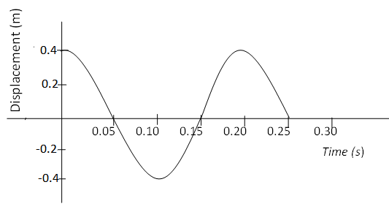

Determine;

1. The amplitude (1mk)

……………………………………………………………………………………………………..………………………………………………………………………………………………….………………………………………………………………………………………………..………………………………………………………………………………………………….

1. The period (1mk)

…..………………………………………………………………………………………………….………………………………………………………………………………………………..…………………………………………………………………………………………………

1. The wavelength (2mks)

.………………………………………………………………………………………………….………………………………………………………………………………………………..……………………………………………………………………………………………………..…..………………………………………………………………………………………………….……………………………………………………………………………………………….

(c) State **one**disadvantage of a convex mirror when used as a car driving mirror (1mk)

……………………………………………………………………………………………………..

(d) What property of light is suggested by the formation of shadows? (1mk)

……………………………………………………………………………………………………..