**SET 4**

**PHYSICS MARKING SCHEME**

**FORM TWO**

**1.** Mass is the quantity of matter in a body while weight is the measure of the pull of gravity on the body.

weight S.I unit Newtons (N ) (½mk)

mass S.I unit Kilogram(kg) (½mk)

**2.** Main scale reading = 7.4cm

Vernier scale reading = 4x0.01 = 0.04cm

Total reading = 7.4 + 0.04 = 7.44 cm (1mk)

**3.** Density of mixture = mass of mixture

Volume of mixture

Mass of fresh water = 1800 x 1 =1800g

Mass of sea water = 2200 x 1.025 = 2255g

Density of mixture = 2255 + 1800

1800 + 2200

= 1.01375g/cm3

**4**. Ice being less dense than water, floats on water. Water at 4oC being the most dense, remains at the bottom of the lake and aquatic life survives.

**5.** The two balloons move towards each other. On blowing air between the balloons, the speed of air increases and pressure reduces. The high atmospheric pressure on the sides pushes the balloons towards each other.

**6.** Large currents can be drawn fromthem

They can be kept in a discharged condition for a very long time before the cells are ruined

They require very little attention to maintain

They are lighter (portable) than lead-acid accumulators

**7.** The magnet towards on passing the current on the coil, the core XY is magnetized with the South Pole on Y thus **attracting the North Pole of the permanent magnet.**

**8.** Convection is the transferof heat through fluids

Diffusion – is the process by which particles spread from regions of high concentration to those of low concentration.

**9.** The sphere acquires a positive charge by induction method.

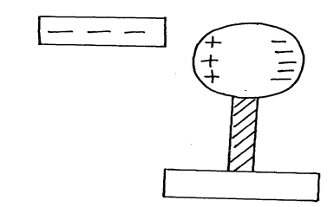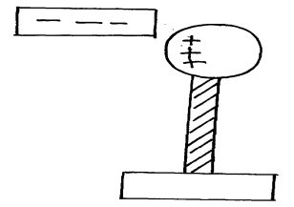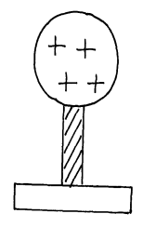

Negative charge to the ground

Earthing

**10.**

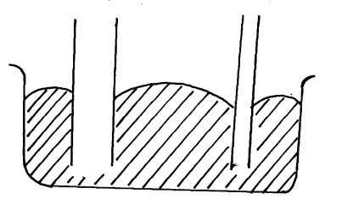

X Y

Y – is lower than x

**11**. w-Mg

1200 = 60xg

g = 1200 = 20N/Kg

60

1**2.** -Easily visible

-Expand or contract uniformly

-Have a wide range of temperature

-Not stick to the walls of the glass

**Section B**

**13.** (a) the higher the amplitude the louder the sound

(b) Use of sound absorbent materials on walls

(c) (i) Time taken for n number of claps . the distance between the girl and the walls.

(d) Sound has to travel to the walls and reflected back to the girl

Distance traveled is 2d;

For **n** claps there will be **n** echoes

Total distance traveled = n x 2d = 2nd

Speed = 2nd;

t

140m

140 - x

x

**(e)**

t1 – t2 = 0.6

2x – 2(140-x) = 0.6

340 340

2x – 280 + 2x= 0.6

340

4x = 444

*x = 11m*

**14.** (a) (i) The extension of a spring is directly proportional to the force applied provided the elastic limit is

not exceeded.

(ii) elasticity constant , k = f/e = gradient

= 50 – θ

60- 0

= 50/60

(b)

= 0.833N/cm

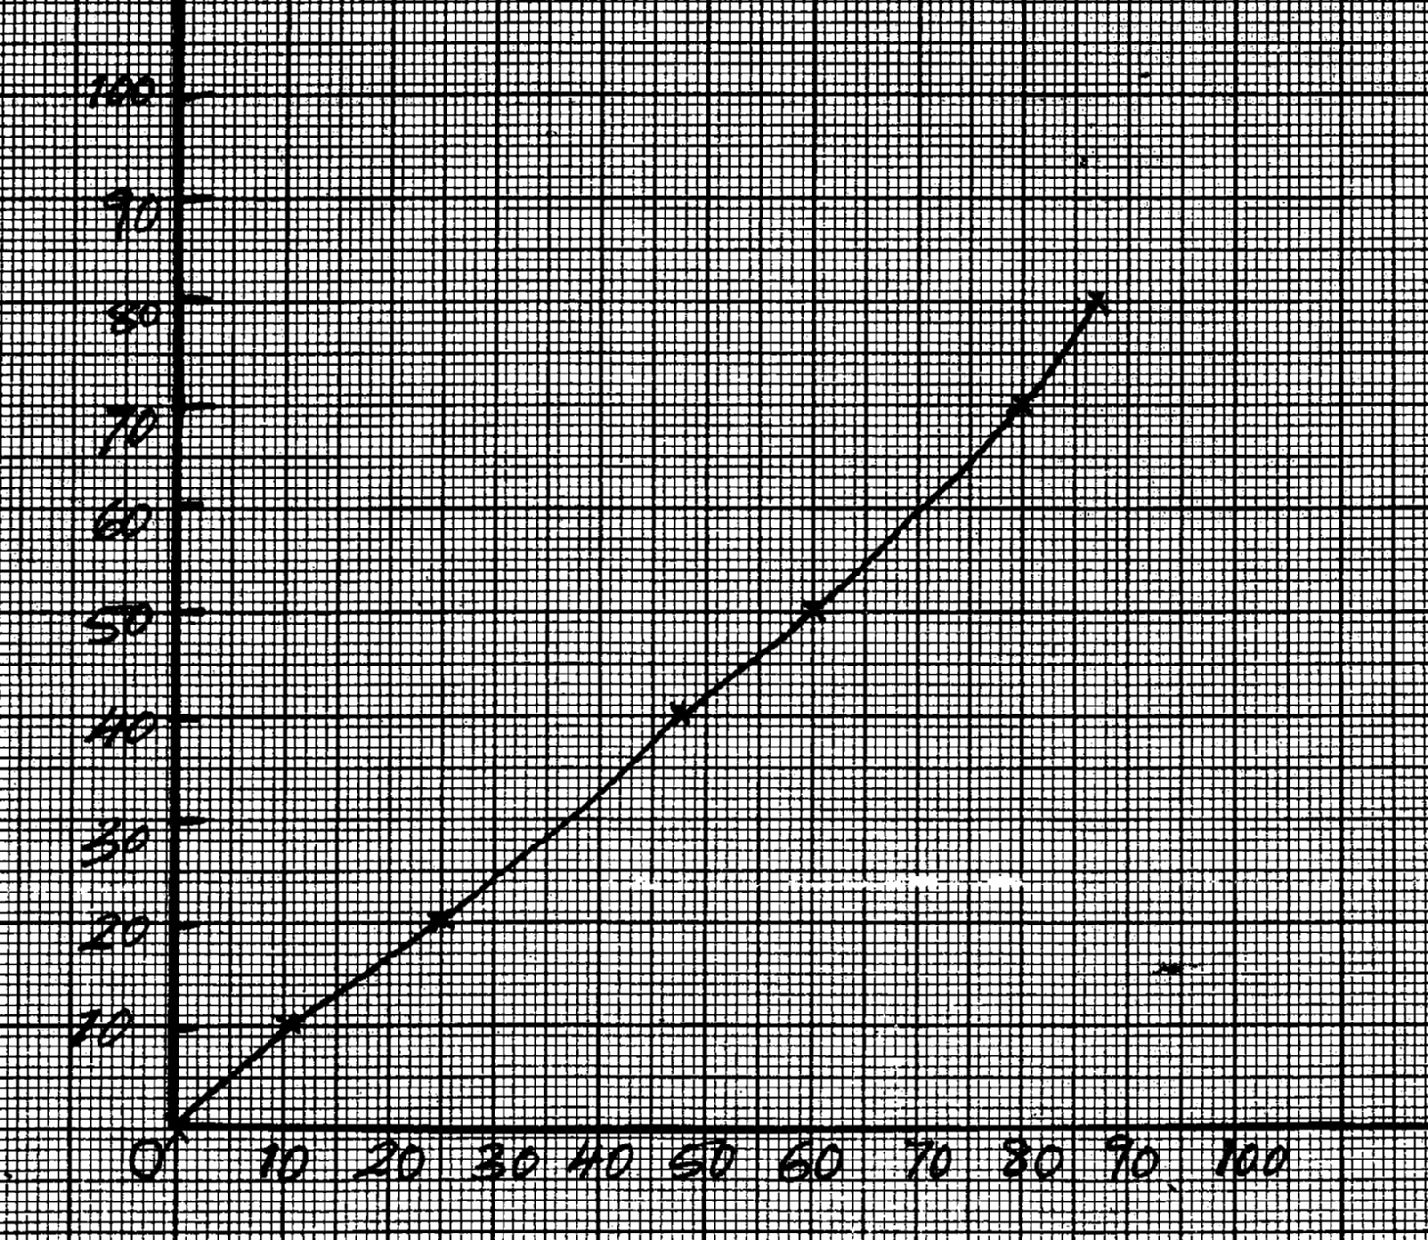

Axes – 1mk

Scale – 1mk

Plotting – 9pts – 2mks

6-8 pts = 1mk

Less than 6pts -0

Line/curve - 1

***Load (N)***

***Extension (cm)***

**15.** (a) Streamline flow- spread and direction of fluid particles passing anypoint do not vary with time.

turbulent flow – sped and direction of flow particles passing any point vary with time.

(b) The sheets more outwards from each other. Pressure at A and B reduces because air velocities atthese points are high

(c) A1V1 = A2V2

A1 x 0.1 = 0.055 x 2.2

A1 = 1.21m2

A = πr2

r2 = A/π

=

= 0.6205

D = 1.241m

(d) It enables the jet cut through the fluid with least resistance thus facilitating streamline flow.

**16.** (a) Pressure is force per unit area S.I unit is N/m2 or Pascals.

(b) (i) -incompressible

-Low freezing point

-High boiling point

-Should not corrode the parts of the brake system

(ii) PA = PB

F1 = F2

A1A2

100 = F2

15 50

F2 = 333.3 N

(c) PA = PB

Pressure in liquids is transmitted equally in all directions.

(d) Gas is compressible in liquid is incompressible.

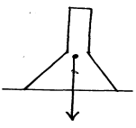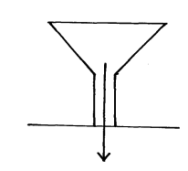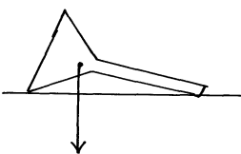

C.O. G

C.O. G

C.O. G

1. (c) (i) Stable equilibrium

(ii) unstable equilibrium

(iii) neutral equilibrium

(a) It is the point of application of the resultant force due to the earth’s attraction n the body.

(b) Base area

Position of C.O.G

Vertical line drawn from C.O.G

**18.** (a) Longitudinal wave- particles of the medium vibrate parallel to the direction of travel of he wave.

Traverse wave - Particles of the medium vibrate at right angles to the direction of the crave.

(b)(i) amplitude = 0.4m

(ii) T = 0.20seconds

(iii) V = 0.4m/s

λ= ?

F= 1/T

= 1/0.2

= 5Hz

V =fλ

0.4 = 5x λ

λ= 0.4/5

= 0.08m

(c) It makes it difficult for a driver to judge the distance when reversing the car since the distances

involved are distorted.