**NAME:…………………………………………………………… ADM. NO…………………………..…..…..**

**SCHOOL:……………………………………………………SIGNATURE………………………………DATE…………….……………………………….**

**233**

**CHEMISTRY**

**(Theory)**

**TIME: 2HOURS**

**FORM TWO**

**INSTRUCTIONS TO CANDIDATES**

* Write your name and Adm. number in the spaces provided.
* Answer ALL the questions in the spaces provided,

**FOR EXAMINERS USE ONLY**

|  |  |  |
| --- | --- | --- |
| Question | Maximum score | Candidates score |
| 1-17 | 70 |  |

***This paper consists of 8 printed pages.Candidates should check the question paper to ensure that all the pages are printed as indicated and no questions are missing.***

1. Chebet, Mutua and Waweru are international athletes. Paper chromatography was used to test for the presence of illegal drugs in their blood which enhance the performance. The diagram below shows the chromatogram with the illegal drug labeled N.

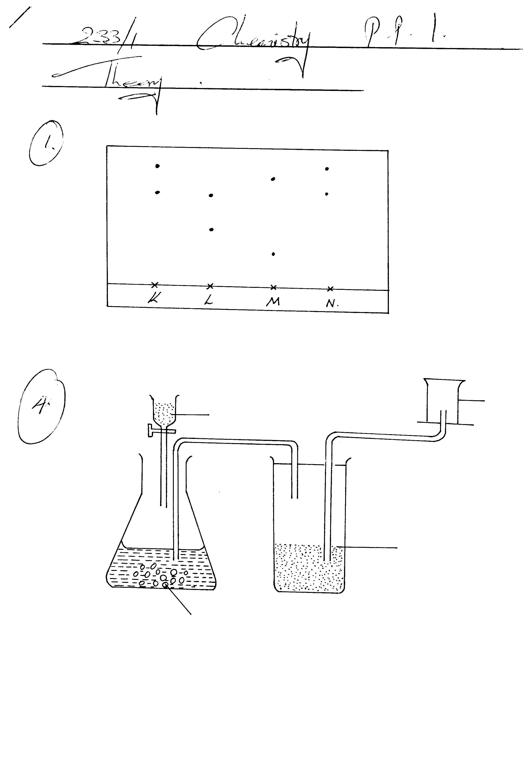

**(a)** Who among them tested positive for the illegal drug? Explain. **(2marks)**

………………………………………………………………………………………………………………………………………………………………………………………………………………………………

**(b)** Explain what is meant by ‘solvent front’ **(1mark)**

………………………………………………………………………………………………………………

**2. a)** describe how oxygen gas can be tested in the laboratory **(2marks)**

………………………………………………………………………………………………………………………………………………………………………………………………………………………………………………………………………………………………………………………………………………

**b)** State two uses of oxygen gas. **(2marks)**

………………………………………………………………………………………………………………………………………………………………………………………………………………………………

3. The diagram below represents the apparatus used to react steam with magnesium.

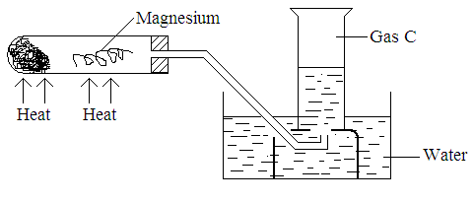

Wet cotton

1. State the observation made in the boiling tube. **(1 mark)**

………………………………………………………………………………………………………………

1. Write an equation for the reaction that takes place in the tube. **(1 mark)**

…………………………………………………………………………………………………………….

**c)** State and explain one precaution required before the heating is stopped **(2marks)**

……………………………………………………………………………………………………………………………………………………………………………………………………………………………..

**d)** Identify gas C **(1mark)**

4. Both chloride and iodine are halogens

**(a)** What are halogens **(1mark)**

**…………………………………………………………………………………………………………………………………………………………………………………………………………………………………………………………………………………………………………………………………………………………………**

5. Oxygen exists naturally as isotopes of mass number 16, 17 and 18 in the ratio 96:2:2 respectively. Calculate its R.A.M**. (3 marks)**

…………………………………………………………………………………………………………….

…………………………………………………………………………………………………………….

**6.** Elements **X** and **Y** have the atomic masses of 39 and 23 respectively.

**(a)** Complete the table below by filling the blank spaces **(2marks)**

|  |  |  |
| --- | --- | --- |
| **Elements** | **X** | **Y** |
| Atomic mass | 39 | 23 |
| Number of neutrons | 20 | 12 |
| Electronic configuration |  |  |

**(b)** Which element has a higher ionization energy? **(1mark)**

**(c)** Explain your answer in (b) above. **(2marks)**

**………………………………………………………………………………………………………………………………………………………………………………………………………………………………………………………………………………………………………………………………………….**

7. The following two tests were carried out on chlorine water contained in two test tubes:

a) A piece of blue flower was dropped into the first test tube. Explain why the flower was bleached. **(2marks)**

………………………………………………………………………………………………………………………………………………………………………………………………………………………………

1. The second test-tube was corked and exposed to sunlight. After a few days, it was found to contain a gas that rekindles a glowing splint. Write an equation for the reaction which produced the gas. **(1 mark)**

**…………………………………………………………………………………………………………**

**8.** State and explain the changes in mass that occurs when the following substances are separately heated in open crucibles. **(4marks)**

**a)** Copper metal.

……………………………………………………………………………………………………………………………………………………………………………………………………………………………..

**b)** Copper (II) nitrate

……………………………………………………………………………………………………………………………………………………………………………………………………………………………..

**9.** Air was passed through several reagents as shown in the flow chart below.

Air

Concentrated potassium hydroxide solution

Excess hot copper turnings

Excess heated magnesium powder

Escaping gases

1. Write an equation for the reaction that took place in the chamber with the magnesium powder. **(1mark) ……………………………………………………………………………………………………………………………………………………………………………………………………………………………………**………………………………………………………………………………..
2. Name **one** gas that escapes from the chamber containing magnesium powder. Give a reason for your answer. **(2marks)**

**………………………………………………………………………………………………………………………………………………………………………………………………………………………………………………………………………………………………………………………………………..**

**10.** Give **two** reasons why helium is used in weather balloons. **(2marks)**

………………………………………………………………………………………………………………………………………………………………………………………………………………………………

11. Name another gas which is used together with oxygen in welding. **(1 mark)**

………………………………………………………………………………………………………………

12. When extinguishing a fire caused by burning kerosene, carbon dioxide is used in preference to water. Explain **(2marks)**

………………………………………………………………………………………………………………………………………………………………………………………………………………………………

14. The grid given below represents part of the periodic table. Study it and answer the questions that follow. The letters are not the actual symbols of the elements.

|  |  |  |  |  |  |  |  |  |
| --- | --- | --- | --- | --- | --- | --- | --- | --- |
|  |  |  |  | | | | | **A** |
| **B** |  |  | **G** |  | **H** | **E** |  |
|  | **J** | **I** | **L** |  |  |  | **C** |
| **D** |  |  |  |  |  | **M** |  |
| **Y** |  |  |  |  |  |  |  |
|  |  |  |  |  |  |  |  |

(i) What name is given to the family of elements to which A and C belong? **(1 mark)**

……………………………………………………………………………………………………………………

(ii) Write the chemical formula of the sulphate of element D. **(1 mark)**

(iii ) Which letter represents the most reactive **(2 marks)**

(a) Metal ……………………………………………………………………………………

(b) Non-metal ………………………………………………………………………………

(iv) Select one element that belongs to period 4. **(1mark)**

………………………………………………………………………………………………………………

(v) Explain why the Ionic radius of element E is bigger than the atomic radius. **(2marks)**

………………………………………………………………………………………………………………………………………………………………………………………………………………………………………………………………………………………………………………………………………………

(vi) The electron configuration of a divalent anion of element N is 2.8.8. Indicate the position of element N on the periodic table drawn above. **(1mark)**

(vii) How do the atomic radii of I and C compare. Explain. **(2 marks)**

………………………………………………………………………………………………………………………………………………………………………………………………………………………………

(vii) Explain the trend in the 1st ionization energies of the elements J, I and L. **(1 mark)**

………………………………………………………………………………………………………………………………………………………………………………………………………………………………

**15.** For each of the following experiments, give the observations and the type of change that Occurs (Physical or chemical) **(3 marks)**

|  |  |  |
| --- | --- | --- |
| Experiment | Observation | Type of change |
| A few drops of water are added  to small amount of anhydrous Copper (II) Sulphate |  |  |
| A few crystals of Iodine are heated gently in a test tube |  |  |
| A few crystals of copper (II) Nitrate are heated strongly in a test tube. |  |  |

1. A form one teacher cut small pieces of sodium and performed different experiments. In each of the

experiments below, state the observations and write an equation of the reaction.

I. A piece of sodium metal is burnt in excess air.

Observation **(1 mark)**

……………………………………………………………………………………………………………………………………………………………………………………………………………………………………………………………………………………………………………………………………………..

Equation **(1 mark)**

………………………………………………………………………………………………………………

II. Product in (I)above is added to water.

Observation  **(1 mark)**

……………………………………………………………………………………………………………………………………………………………………………………………………………………………………………………………………………………………………………………………………………..

Equation  **(1 mark)**

……………………………………………………………………………………………………………………………………………………………………………………………………………………………

III. Heated sodium is lowered into a gas jar of chlorine.

Observation **(1 mark)**

………………………………………………………………………………………………………………………………………………………………………………………………………………………………

Equation **(1 mark)**

………………………………………………………………………………………………………………

IV. A small piece of sodium is put in cold water in a beaker and resulting solution is tested with litmus paper.

**Observation**  **(1 mark)**

…………………………………………………………………………………………………………………..

……………………………………………………………………………………………………………………

**Equation**  **(1 mark)**

……………………………………………………………………………………………………………………

……………………………………………………………………………………………………………………

**b)** Define the term ionization energy.  **(1 mark)**

……………………………………………………………………………………………………………………

17.Study the diagram below and answer the questions that follow. The diagram shows the method used to separate components of mixture Q.

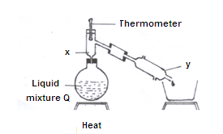

**a)** Name X and Y. **(2 marks)**

X……………………………………………………………………………………………….

Y……………………………………………………………………………………………………

b) What is the purpose of apparatus X?  **(1mark)**

……………………………………………………………………………………………………………………

…………………………………………………………………………………………………………………….

c) What name is given to the above method of separating mixtures? **(1mark)**

……………………………………………………………………………………………………………………

…………………………………………………………………………………………………………………….