

**VIRAJ INTERNATIONAL ACADEMY**

# HUMANITIES AND CTV DEPARTMENT

## FORM 4 GEOGRAPHY TERM 2

## 312/1

**KNC END-TERM EXAMINATION**

### ACADEMIC YEAR 2021/2022

**DURATION: 2HOURS 45MINUTES**

***Additional Materials:***

*NONE.*

##### READ AND FOLLOW THESE INSTRUCTIONS:

1. Write your name, class, subject tutor’s name and date in the spaces provided below.
2. Write in **black** or **dark blue** ink. You may use a soft pencil for any diagrams, graphs or rough work.
3. Do not use staples, paper clips, highlighters, and glue or correction fluid.
4. Answer ALL questions in section A and number 6 and any other two.
5. The number of marks is given in brackets **[ ]** at the end of each question or part question.
6. This paper consists of **15 printed** pages and the total number of marks is **100.**

**NAME:**

**CLASS:**

#### SUBJECT TUTOR:

**DATE:**

*READ, LEAD, SUCCEED*

**SECTION A 25MARKS**

1. a) Name two branches of geography. (2marks)

……………………………………………………………………………………………………………………………………………………………………………………………………………………………………………………………………………………………………………….

b) Give three reasons why it is importance to study geography. (3marks)

………………………………………………………………………………………………………………………………………………………………………………………………………………………………………………………………………………………………………………………………………………………………………………………………………………………………………………………………………………………………………………………………………………………………………………………………………………………………

2. a) What is solar insolation? (2marks)

………………………………………………………………………………………………………………………………………………………………………………………………………………………………………………………………………………………………………………

b) Outline three importance of moisture in the atmosphere. (3marks)

…………………………………………………………………………………………………………………………………………………………………………………………………………………………………………………………………………………………………………………………………………………………………………………………………………………………………………………………………………………………………………………………

3. a) State two effects of the rotation of the earth on its axis. (2marks)

……………………………………………………………………………………………………………………………………………………………………………………………………………………………………………………………………………………………………………………………………………………………………………………………………………………

b) The local time at manual 600W is 11.30 am. What is the time in Nairobi?

370E? (3mks)

……………………………………………………………………………………………………………………………………………………………………………………………………………………………………………………………………………………………………………………………………………………………………………………………………………………

4. a) What is an ice sheet? (2marks)

………………………………………………………………………………………………………………………………………………………………………………………………………………………………………………………………………………………………………………

b) State three positive effects of glaciations in lowland areas. (3marks)

………………………………………………………………………………………………………………………………………………………………………………………………………………………………………………………………………………………………………………………………………………………………………………………………………………………………………………………………………………………………………………………….

5. a) Name the two types of waves experienced in the coastal area. (2marks)

……………………………………………………………………………………………………………………………………………………………………………………………………………………………………………………………………………………………………………....

b) List three coastal features which result from wave deposition. (3marks)

………………………………………………………………………………………………………………………………………………………………………………………………………………………………………………………………………………………………………………………………………………………………………………………………………………………………………………………………………………………………………………………………………………………………………………………………………………………………

***SECTION B:***

***Answer question 6 and any other two questions.***

6. Study the map of Kijabe I :5(0,000 (sheet 1 34/3) provided and answer the following questions.

(a) (i) Convert the scale of the map extract into a statement scale, (2 marks)

………………………………………………………………………………………………………………………………………………………………………………………………………………………………………………………………………………………………………………………………………………………………………………………………………………………………………………………………………………………………………………………………………………………………………………………………………………………………

* 1. is the bearing of the pump house at grid square 3893 from the trigonometrical station at Mweri? (2 marks)

...............................................................................................................................................................................................................................................................................................................................................................................................................................................................................................................................................................................................................................................................................................................................................................

iii) Calculate the area of the part of the forest to the east of easting 40 and south of northing 97. Give your answer in square kilometres. (2marks)

………………………………………………………………………………………………………………………………………………………………………………………………………………………………………………………………………………………………………………………………………………………………………………………………………………………………………………………………………………………………

(i) Apart from forest, give three types of natural vegetation found in the area covered by the map. (3 marks)

……………………………………………………………………………………………………………………………………………………………………………………………………………………………………………………………………………………………………………………………………………………………………………………………….

iv). Identify the three river drainage patterns found in the area covered by the map. (3 marks)

……………………………………………………………………………………………………………………………………………………………………………………………………………………………………………………………………………………………………………………………………………………………………………………………………………………

1. (i) Using a vertical scale of 1 cm to represent 100 metres, draw a cross section from the water tank on grid square 2592 to the peak of Kijabe hill on grid square 2699. (4 marks)



On it, mark and label the following:

1. All weather road-bound surface (1 mark)

11. Railway line (1 mark)

111. Steep slope. (I mark)

* 1. Calculate the vertical exaggeration of the cross section. (2 marks)

………………………………………………………………………………………………………………………………………………………………………………………………………………………………………………………………………………………………………………………………………………………………………………………………………………………………………………………………………………………………

1. Citing evidence from the map, identify two economic activities in the area covered by the map (4marks) ……………………………………………………………………………………………………………..……………………………………………………………………………………………………………………………………………………………………………………………………………………………………………………………………………………………..………………………………………......................7.a) State two factors which influence the occurrence of underground water (2marks) ……………………………………………………………………………………………………………………………………………………………………………………………………………………………………………………………………………………………………………………………………………………………………………………………………………………………………………………………………

b) Differentiate between a well and spring. (2marks) ……………………………………………………………………………………………………………………………………………………………………………………………………………………………………………………………………………………………………………..............................................................................................................................................................................................................................................................c) The diagram below represents an artesian basin. Use it to answer question C (i) and (ii) . 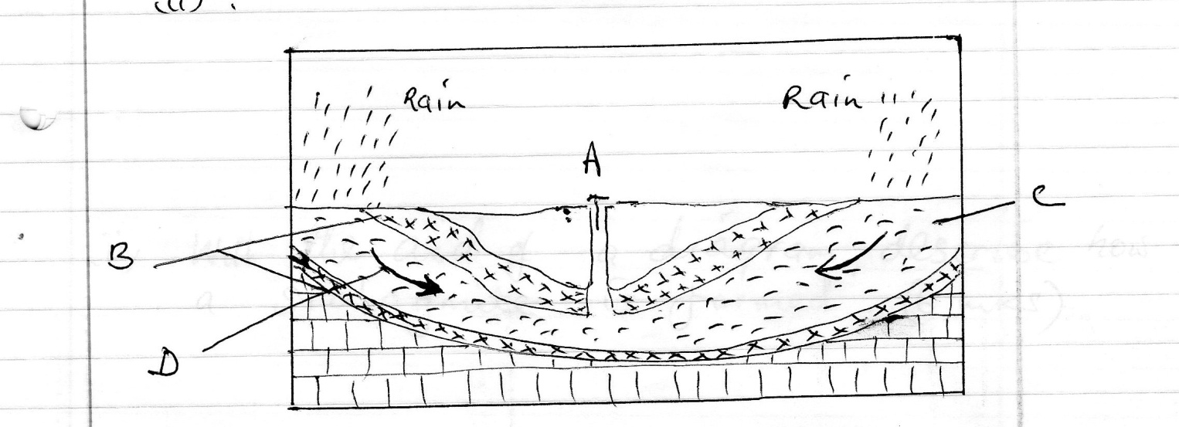. i). Name the parts marked A, B, C (3marks) …………………………………………………………………………………………………………………………………………………………………………………………………………………………………………………………………………………………………………………………………………………………………………………… ii) Identify the process marked D (1mark) ……………………………………………………………………………………............... iii) State three factors which favors the location of an artesian well (3marks) …………………………………………………………………………………………………………………………………………………………………………………………………………………………………………………………………………………………………………………………………………………………………………………………………………………………………………………………………………………………………………………………………………………………………………………………………………………………………………………………………………….

d) i) Apart from stalagmites name three other underground features formed in limestone areas. (3marks) .………………………………………………………………………………………………………………………………………………………………………………………………………………………………………………………………………………………………………………………………………………………………………………………………………………………………………………………………………………… ii)With the aid of a diagram describe how a stalagmite is formed (6marks) ……………………………………………………………………………………………………………………………………………………………………………………………………………………………………………………………………………………………………………………………………………………………………………………………………………………………………………………………………………………………………………………………………………………………………………………………………………………………………………………………………………………………………………………………………………………………………………………………………………………………………………………………………………………………………………………………………………………………………………………………………………………………………………………………………………………………………………………………………………………………… e i). State three reasons why there are few settlements in Karst Landscapes (3marks) ……………………………………………………………………………………………………………………………………………………………………………………………………………………………………………………………………………………………………………………………………………………………………………………………………………………………………………………………………………………………………………………………………………………………………………………………………………………………………………………………………………………………………………………………………………………………………………………………………………………………………………………………………….

ii) Name two surface features found in limestone areas. (2marks)

………………………………………………………………………………………………………………………………………………………………………………………………………………………………………………………………………………………………………………

8. a) i) What is secondary vegetation? (2marks)

……………………………………………………………………………………………………………………………………………………………………………………………………………………………………………………………………………………………………………………………………………………………………………………………………………………

ii) State five ways in which vegetation is of important to the physical and human environments. (5marks)

…………………………………………………………………………………………………………………………………………………………………………………………………………………………………………………………………………………………………………………………………………………………………………………………………………………………………………………………………………………………………………………………………………………………………………………………………………………………………………………………………………………………………………………………………………………………………………………………………………………………………………

b) Describe three characteristics of the Mediterranean type of vegetation. (6marks)

……………………………………………………………………………………………………………………………………………………………………………………………………………………………………………………………………………………………………………………………………………………………………………………………………………………………………………………………………………………………………………………………………………………………………………………………………………………………………………………………………………………………………………………………………………………………………………………………………………………………………………………………………………………………………………………………………………….

c) Explain three factors which influence the distribution of vegetation in Kenya. (6marks)

…………………………………………………………………………………………………………………………………………………………………………………………………………………………………………………………………………………………………………………………………………………………………………………………………………………………………………………………………………………………………………………………………………………………………………………………………………………………………………………………………………………………………………………………………………………………………………………………………………………………………………

d) The students of Kaburia secondary are to carry out a field study of vegetation across a slope.

i)Formulate two hypotheses they could have made for the study. (2marks)

……………………………………………………………………………………………………………………………………………………………………………………………………………………………………………………………………………………………………………………………………………………………………………………………………………………

ii)Give four characteristics of vegetation which they would study. (4marks)

………………………………………………………………………………………………………………………………………………………………………………………………………………………………………………………………………………………………………………………………………………………………………………………………………………………………………………………………………………………………………………………….

9. a) Describe podzolization as a process of leaching. (4marks)

…………………………………………………………………………………………………………………………………………………………………………………………………………………………………………………………………………………………………………………………………………………………………………………………………………………….

b) State three ways in which mulching helps in soil conservation. (3marks)

…………………………………………………………………………………………………………………………………………………………………………………………………………………………………………………………………………………………………………………………………………………………………………………………………………………………………………………………………………………………………………………………

c) Explain how the following factors influences the formation of soils.

i) Climate (4marks)

………………………………………………………………………………………………………………………………………………………………………………………………………………………………………………………………………………………………………………………………………………………………………………………………………………………………………………………………………………………………………………………….

ii) Topography (4marks)

…………………………………………………………………………………………………………………………………………………………………………………………………………………………………………………………………………………………………………………………………………………………………………………………………………………………………………………………………………………………………………………………

d) i) What is soil catena? (2marks)

……………………………………………………………………………………………………………………………………………………………………………………………………………………………………………………………………………………………………………………………………………………………………………………………………………………

ii) Draw a well labelled diagram to show a well – developed soil profile. (3marks)

………………………………………………………………………………………………………………………………………………………………………………………………………………………………………………………………………………………………………………………………………………………………………………………………………………………………………………………………………………………………………………………………………………………………………………………………………………………………………………………………………………………………………………………………………………………………………………………………………………………………………………………………………………………………………………………………………………

e) Explain five causes of soil degeneration. (5marks)

……………………………………………………………………………………………………………………………………………………………………………………………………………………………………………………………………………………………………………………………………………………………………………………………………………………………………………………………………………………………………………………………………………………………………………………………………………………………….

10. i) Define the term faulting. (2marks)

……………………………………………………………………………………………………………………………………………………………………………………………………………………………………………………………………………………………………………….

ii) Name 2 types of faults. (2marks)

…………………………………………………………………………………………………………………………………………………………………………………………………………………………………………………………………………………………………………………………………………………………………………………………………………………….

iii) Use the diagram below to answer the question that follows: -

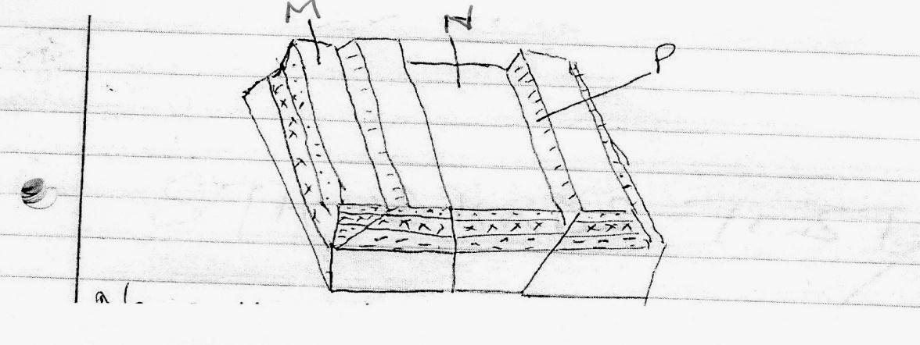

a) Name the features marked M, N and P (3marks)

…………………………………………………………………………………………………………………………………………………………………………………………………………………………………………………………………………………………………………………………………………………………………………………………………………………….

b) With well labelled diagrams explain the formation of the Rift valley through tensional forces. (8marks)

……………………………………………………………………………………………………………………………………………………………………………………………………………………………………………………………………………………………………………………………………………………………………………………………………………………………………………………………………………………………………………………………………………………………………………………………………………………………………………………………………………………………………………………………………………………………………………………………………………………………………………………………………………………………………………………………………………………………………………………………………………………………………………………………………………………………………………………………………………………………………………………………………………………………………………………………….

c) Explain five positive effects of faulting. (10marks)

……………………………………………………………………………………………………………………………………………………………………………………………………………………………………………………………………………………………………………………………………………………………………………………………………………………………………………………………………………………………………………………………………………………………………………………………………………………………………………………………………………………………………………………………………………………………………………………………………………………………………………………………………………………………………………………………………………………………………………………………………………………………………………………………………………………………………………………………………………………………………………………………………………………………………………………………………………………………………………………………………………………………………………………………………………………………………………………………………………………………………………………………………………………………………………………………………………………………………………………………………………………