1. Look at the diagram. It shows part of the alimentary canal.

**A**

**B**

**C**

**D**

**E**

* 1. Where is acid added to the alimentary canal?

Circle the correct answer.

|  |  |  |
| --- | --- | --- |
| **A B C D E**      **(b)** Where is digested food absorbed from the alimentary canal into the blood?    Circle the correct answer. |  | [1] |
| **A B C D E** |  | [1] |

**(c)** Look at the part labelled **A** on the diagram.

Write down the names of the **two** parts of the alimentary canal that part **A** connects.

and [1]



1. The diagram shows the shells of five molluscs labelled **A**, **B**, **C**, **D** and **E**.

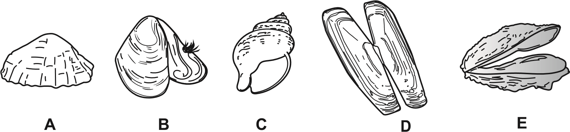

NOT TO SCALE

Use the key to identify the scientific names of the five molluscs.

shell consists of one single part go to **2**

**1**

shell consists of two parts go to **3**

shell is spiral-shaped mollusc is *Buccinum*

**2**

shell is **not** spiral-shaped mollusc is *Patella*

shell is long and thin mollusc is *Ensis*

**3**

shell is **not** long and thin go to **4**

shell has a small tuft of hairs mollusc is *Mytilus*

**4**

shell does **not** have a small tuft of hairs mollusc is *Ostrea*

Write your answers in the table.

|  |  |
| --- | --- |
| **scientific name** | **letter** |
| *Buccinum* |  |
| *Ensis* |  |
| *Mytilus* |  |
| *Ostrea* |  |
| *Patella* |  |

[2]

1. Look at the diagram of four different varieties of the same species of chicken.

**A**

**B**

**C D**

A farmer uses selective breeding to produce a new variety of chicken.

This new variety of chicken must be black with white spots and have a large tail.

Describe **two** stages in the production of this new variety of chicken.

1





2



[2]

1. Look at the picture of an elephant.

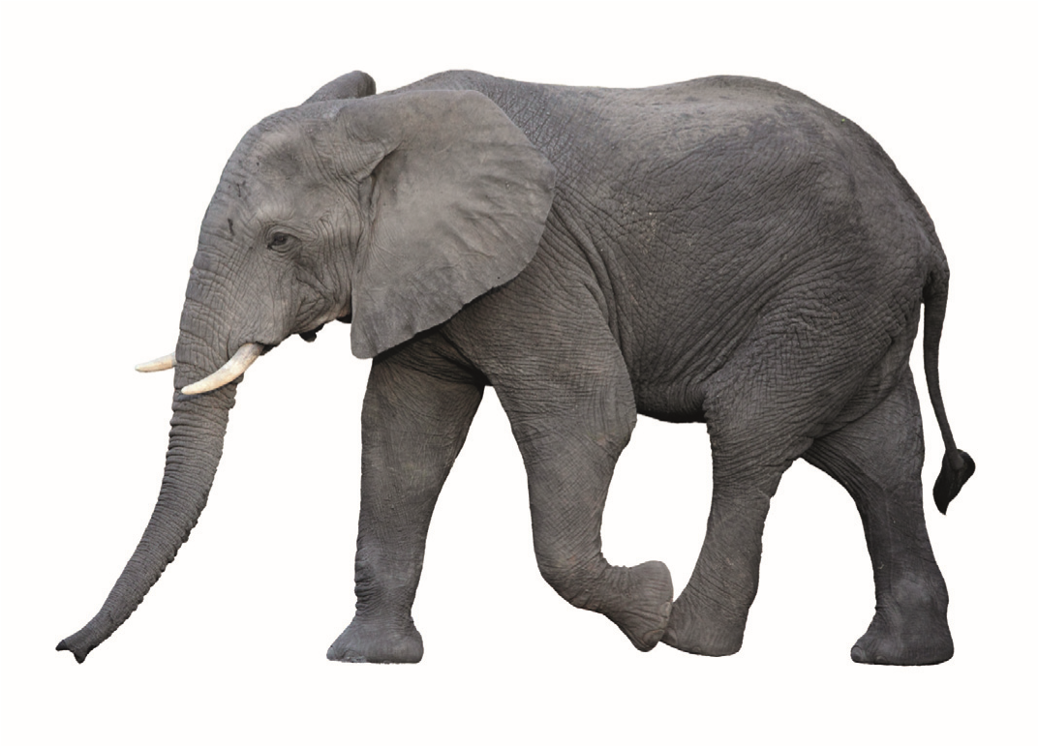

l

arge

ear

s

tusk

t

r

unk

* 1. Elephants are adapted to survive.

Draw a line to match each **adaptation** with the **reason** why it helps the elephant survive.

**adaptation reason**

|  |  |  |
| --- | --- | --- |
| large ears |  | pull grass from ground |

|  |  |  |
| --- | --- | --- |
| trunk |  | keep elephant cool |

|  |  |  |
| --- | --- | --- |
| tusks |  | used to fight other elephants |

[1]

* 1. The chart shows the population of elephants in different parts of Africa in 1981 and 1989.

population of elephants in thousands

500

400

300

200

100

0

W

e

st Af

ri

c

a

E

a

st Af

ri

c

a

South Af

ri

c

a

C

e

nt

ra

l Af

ri

c

a

1981

1989

location

* + 1. In which part of Africa was the **largest** decrease in the population of elephants between 1981 and 1989?

[1]



* + 1. Humans caused the changes in elephant populations between 1981 and 1989.

Suggest **two** ways humans caused these changes.

1





2





[2]

1. The diagram shows part of a flower that is pollinated by bees.

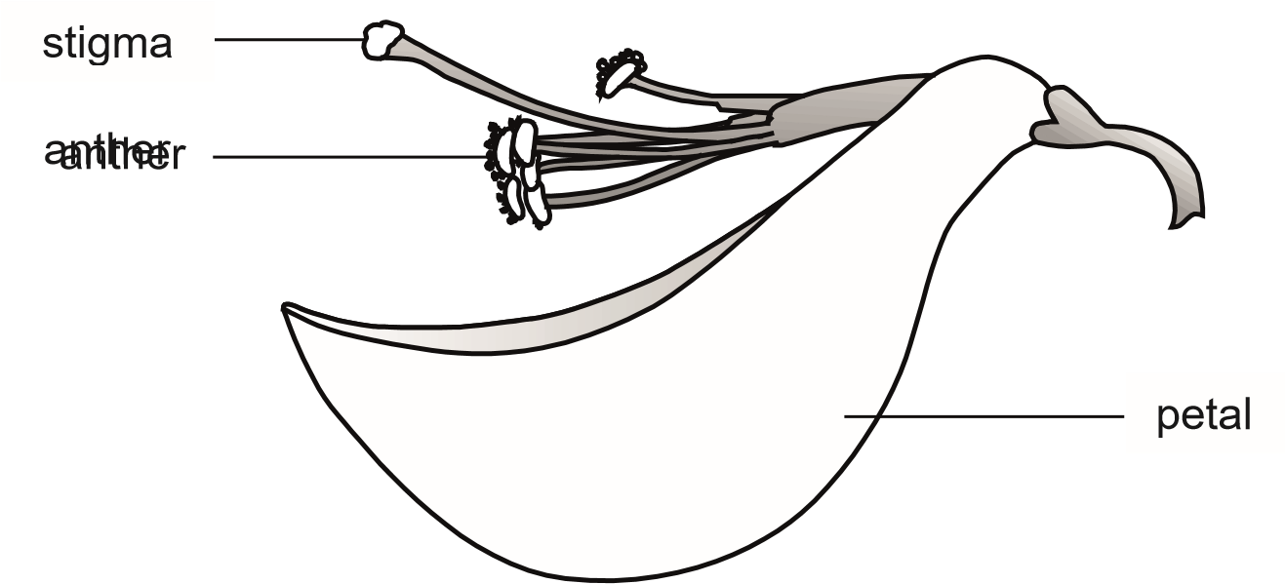

anther

The male and female parts of the flower are protected by petals.

* 1. Write down **one** other function of the petals.

[1]



* 1. Write down **one** function of the anther.

[1]



* 1. The diagram shows a bee pollinating this flower.

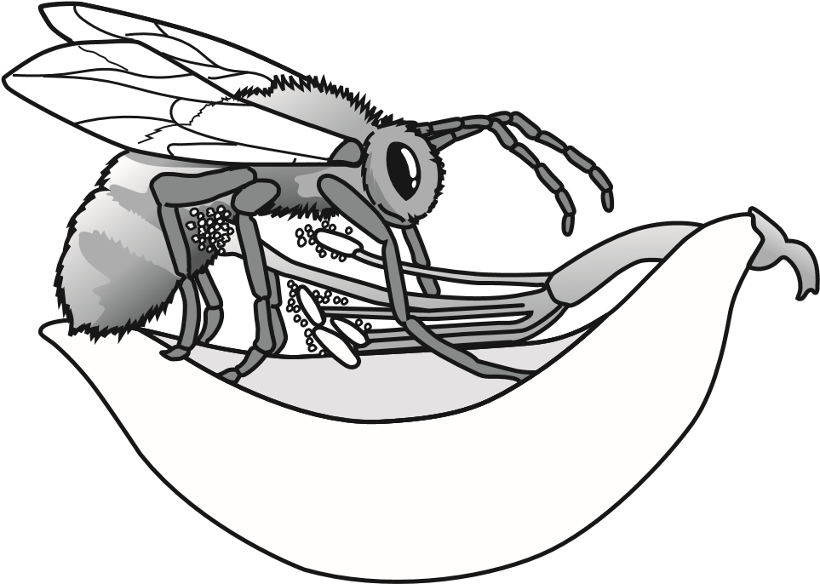

* + 1. Describe what happens **during** pollination.

[1]



* + 1. Describe what happens **after** pollination.



[2]

