**- Mark Scheme /**



**Question Answer Marks AO Element Notes Guidance**

1 **1**

B - 5

|  |  |  |  |  |  |
| --- | --- | --- | --- | --- | --- |
|  | 2 |  | **sodium carbonate** +  **calcium hydroxide** →  sodium hydroxide +  **calcium carbonate**  if 2 marks not scored 1 mark for  a correct name of one of the  carbonates or calcium  hydroxide |  | **2** |
|  | 3 |  | magnesium sulfate (1)  hydrogen (1) |  | **2** |
|  | 4 |  | 2 (CH4) (1)  4 (H2) (1) |  | **2** |

5 147 (2) **2**

If 2 marks not scored: 1 mark for 4 × 1 **OR** 4 (for H) **OR** 2 × 35.5**OR** 71 for C*l*

6(a) circle round the COOH group **1**

6(b) 5 **1**

7 potassium iodide (on left) (1) **2**

potassium chloride (on right)(1)

**- Mark Scheme /**



**Question Answer Marks AO Element Notes Guidance**

8(a) 179.3 (g) **1**

|  |  |  |  |  |  |  |  |  |  |  |  |  |  |
| --- | --- | --- | --- | --- | --- | --- | --- | --- | --- | --- | --- | --- | --- |
|  | | | 8(b) | | |  | | A (1)  the gradient / slope is the  steep(est) (1) | |  | | **2** | |
|  | | | | 8(c) | |  | | 360 (cm 3)  3) | |  | | **1** | |
|  | | 8(d)(i) | | |  | | decreases rate / reaction slower  (1) | |  | | **1** | |
|  | 8(d)(ii) | | | | |  | | increases rate / reaction faster  (1) | |  | | **1** | |
|  | | | 9(a) | | |  | | circle around one or both the  C=C groups | |  | | **1** | |

9(b) 4 **1**

|  |  |  |  |  |  |
| --- | --- | --- | --- | --- | --- |
|  | 10 |  | (hydrochloric acid + zinc) →  zinc chloride (1) + hydrogen  (1) |  | **2** |

**- Mark Scheme /**



**Question Answer Marks AO Element Notes Guidance**

|  |  |  |  |  |  |
| --- | --- | --- | --- | --- | --- |
|  | 11(a) |  | measuring volume of  carbon dioxide (1) |  | **3** |

use of gas measuring apparatuse.g. syringe / inverted measuringcylinder full of water (1)

(measure gas volume) at timeintervals (1)

11(b) 31.25 (g) **1**

|  |  |  |  |  |  |  |  |  |  |  |
| --- | --- | --- | --- | --- | --- | --- | --- | --- | --- | --- |
|  | | 11(c)(i) |  | | decreases (rate) / slower (rate)  (1) | |  | | **1** | |
|  | 11(c)(ii) | | |  | | increases (rate) / faster (rate)  (1) | |  | | **1** | |

12 sodium hydroxide (1) **2**

hydrogen (1)

|  |  |  |  |  |  |
| --- | --- | --- | --- | --- | --- |
|  | 13 |  | 36  if 2 marks not scored: 1 mark for  C = 2 ⋅ 12 **OR** 24 |  | **2** |

14 2 (O2) (1)

**2**

2 (H2O) (1)

15(a) 4 (NO) **1**

**- Mark Scheme /**



**Question Answer Marks AO Element Notes Guidance**

15(b) heat released / heat given out **1**

15(c) oxygen added (to NO) **1**

|  |  |  |  |  |  |  |  |  |  |  |
| --- | --- | --- | --- | --- | --- | --- | --- | --- | --- | --- |
|  | 15(d) | |  | | acidic oxide  **AND**  nitrogen is a non-metal | |  | | **1** | |
|  | | 16 | |  | | 4 (Li) (1)  2 (Li2O) (1) | |  | | **2** | |

17 4 (H2) (1)

**2**

2 (H2O) (1)

18(a) 5.0 (%) **1**

18(b) oxygen **1**

**- Mark Scheme /**



**Question Answer Marks AO Element Notes Guidance**

18(c) any **two** from: **2**

• more hydrogen in Universe (orreverse argument)

• more helium in Universe (orreverse argument)

• more oxygen on Earth (orreverse argument)

• more magnesium on Earth (orreverse argument)

• more iron on Earth (or reverseargument)

• more silicon on Earth (orreverse argument)

• more sulfur on Earth (orreverse argument)

19 **M1** 2 (C) **2**

**M2** O2

20 217 (2) **2**

if 2 marks not scored 1 mark for F = 2 × 19 **OR** 38 (1)

21 potassium iodide (1) **2**

potassium bromide (1)

|  |  |  |  |  |  |
| --- | --- | --- | --- | --- | --- |
|  | 22 |  | 50.0 (cm 3)  3) |  | **1** |

**- Mark Scheme /**

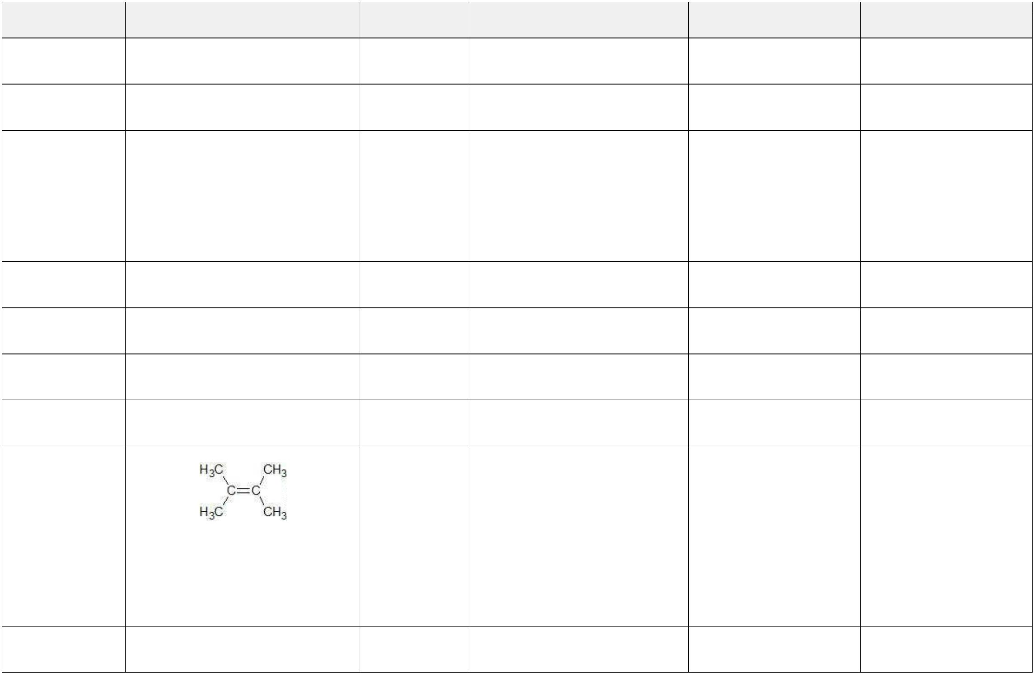

**Question Answer Marks AO Element Notes Guidance**

|  |  |
| --- | --- |
|  | +  23(a) NH4  **1** |
|  | 23(b) PH4 I **1** |

24(a) 93.94 / 31 and 6.06 / 1 **2**

**OR** 3.03 and 6.06

**OR** 1 : 2 ratio (1)

PH2 (1)

24(b) P2H4

**1**

25 Mg3(PO4)2

**1**

26(a) addition **1**

26(b) CH2

**1**

26(c) **2**

one C=C (1)

fully correct structure (1)

27(a)(i) cobalt carbonate **1**

**- Mark Scheme /**



**Question Answer Marks AO Element Notes Guidance**

27(a)(ii) lead iodide **1**

|  |  |  |  |  |  |
| --- | --- | --- | --- | --- | --- |
|  | 27(b) |  | 2 AgNO3 + Na2CO3 →  Ag2CO3 + 2 NaNO3 |  | **2** |

formula of silver carbonatecorrect (1)

fully correct equation (1)

|  |  |  |  |  |  |  |  |
| --- | --- | --- | --- | --- | --- | --- | --- |
|  | 27(c) |  | 2+ + 2I – → PbI  Pb |  | 2 |  | **2** |

2+ and I – on left of equation Pb (1)

fully correct equation (1)

28 Ca3(PO4)2

**1**

29(a) 5 (mol) **1**

29(b) 10 (mol) **1 ecf (a)** x 2

29(c) 80 **1**

29(d) 800 (g) **1 ecf (b)** x **(c)**

30(a) 3 **1**

**- Mark Scheme /**

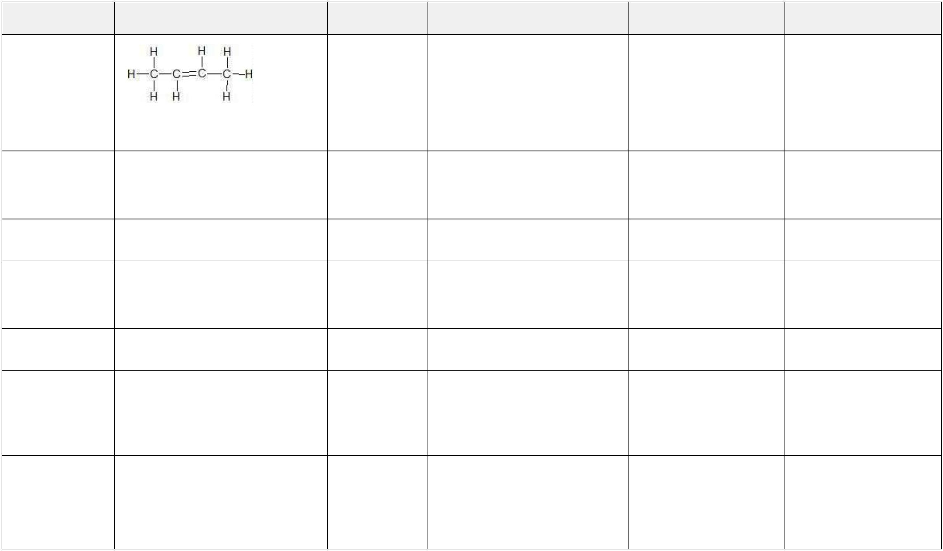

**Question Answer Marks AO Element Notes Guidance**

30(b) **2**

(1)

but-2-ene (1)

30(c) CH2 (1)

**2**

CH2 (1)

31(a) 78 (%) **1**

31(b) fractional (1) **2**

distillation (1)

31(c) acid rain **1**

|  |  |  |  |  |  |
| --- | --- | --- | --- | --- | --- |
|  | 31(d) |  | nitrogen and oxygen (from the  air) react (in the engine) (1) |  | **2** |

(due to) high temperatures (1)

31(e) nitrogen (1) **3**

carbon dioxide (1)

platinum (1)

**- Mark Scheme /**



**Question Answer Marks AO Element Notes Guidance**

|  |  |
| --- | --- |
|  | 31(f) CH4 + 1½O2 → CO + 2H2O **2** |

CO and H2O as products andmethane as reactant (1)

rest of the equation (1)

|  |  |  |  |  |  |
| --- | --- | --- | --- | --- | --- |
|  | 32(a) |  | improves conductivity/better  conductor (1) |  | **2** |

lower (operating) temperature(1)

|  |  |  |  |  |  |
| --- | --- | --- | --- | --- | --- |
|  | 32(b) |  | positive: 2O 2 + 4e 2– → O – (1)  2– → O – (1) |  | **2** |

negative: A*l* 3+ + 3e– → A*l* (1)

|  |  |  |  |  |  |
| --- | --- | --- | --- | --- | --- |
|  | 32(c) |  | anodes or carbon react with  oxygen (1) |  | **2** |

(form) carbon dioxide (1)

33 H2O **and** CO **or** C formed (1)

**2**

|  |  |  |  |
| --- | --- | --- | --- |
|  | 2C4H10 + 9O2 → 8CO + 10H2O  (1) |  | **allow** correctly  balanced alternatives  with CO and/or C  formed |

34(a) 0.7 (%) **1**

34(b) sodium **1**

**- Mark Scheme /**



**Question Answer Marks AO Element Notes Guidance**

34(c) any **two** differences e.g.: **2**

• more chlorine / hydrogen / magnesium / oxygen / sodium in oceans than in biosphere **ORA**

• less carbon / silicon / calcium in oceans **ORA**

35 10 (C) (1) **2**

16 (HC*l*)

|  |  |  |  |  |  |
| --- | --- | --- | --- | --- | --- |
|  | 36 |  | (FeC6N6) 6) 4– / (Fe(CN) 4–  4– / (Fe(CN) 4– |  | **1** |

37 3 (H2) (1)

**3**

⇌ (1)

2 (UH3) (1)

38 zinc chloride **1**

39 2 (P2O5)

**1**

40 3 **1**

[Total: 112]