**1**

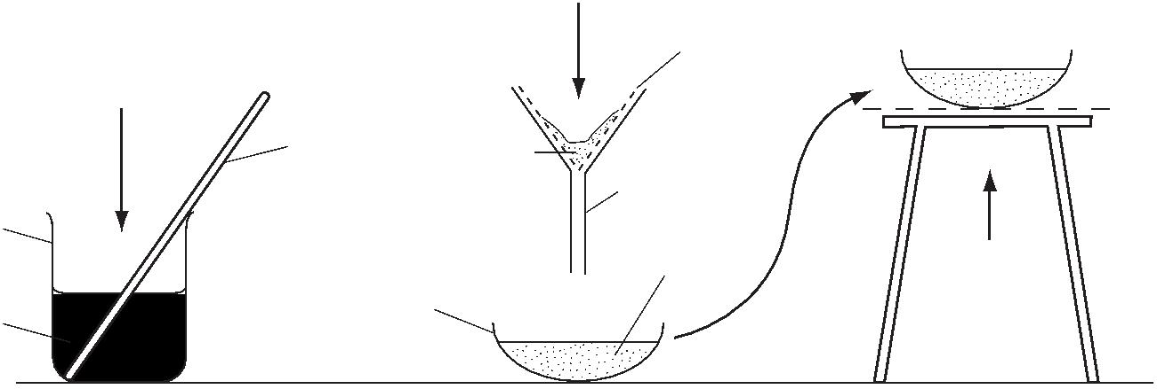

**1** Some students carried out the experiment shown in the diagram.

contents

of beaker

mixture of powdered copper filter

metal and copper(II) paper

sulfate crystals

glassrod

residue

funnel beaker

filtrate

evaporating heat

basinwater

What is left in the evaporating basin after gentle heating?

**A** copper

**B** copper(II) hydroxide

**C** copper(II) oxide

**D** copper(II) sulfate

[1]

[Total: 1]



**2**

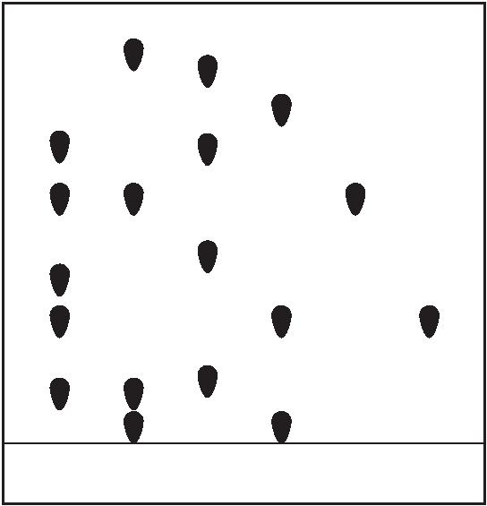

**2** Ethanol is produced by fermentation of a mixture of plant sugars.

Describe how ethanol can be separated from the rest of the fermentation mixture by fractional distillation.

In your answer:

**•** describe how to do the fractional distillation

**•** explain how ethanol is separated from the rest of the fermentation mixture using fractional

distillation.

..................................................................................................................................................

..................................................................................................................................................

..................................................................................................................................................

..................................................................................................................................................

..................................................................................................................................................

..................................................................................................................................................

..................................................................................................................................................

.................................................................................................................................................. [4]

[Total: 4]

|  |  |  |
| --- | --- | --- |
| **3** |  | Chromatography can be used to separate a mixture of ions from different transition element  compounds.  Four samples, **R**, **S**, **T**, and **U**, each containing transition element ions, were placed on a piece of  chromatography paper.  Two solutions, **Y** and **Z**, each containing only one type of transition element ion were also placed  on the same piece of chromatography paper. |

The results of the chromatography are shown.

R S T U Y Z

**3**

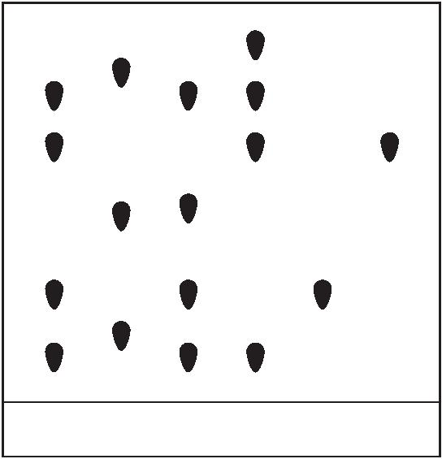

**(a)** Which sample, **R**, **S**, **T** or **U**, contains the same ions as both solution **Y and** solution **Z**?

........................................................................................................................................... [1]

|  |  |  |  |
| --- | --- | --- | --- |
|  | **(b)** |  | Which sample, **R**, **S**, **T** or **U**, does **not** contain the same ions as either solution **Y** or solution  **Z**? |

........................................................................................................................................... [1]

|  |  |  |  |
| --- | --- | --- | --- |
|  | **(c)** |  | In which sample, **R**, **S**, **T**, or **U**, has the greatest number of transition element ions been  separated? |

........................................................................................................................................... [1]

[Total: 3]

**4** The question is about dyes.

**(a)** Chromatography can be used to separate a mixture of dyes. **S**, **T**, **U** and **W** are four different mixtures of dyes.

**S**, **T**, **U** and **W** were placed on a piece of chromatography paper.

Two pure dyes, **X** and **Y**, were also placed on the same piece of chromatography paper.

The results of the chromatography are shown.

S T U W X Y

**(a)** Which mixture, **S**, **T**, **U** or **W**, contains dye **X** but **not** dye **Y**?

........................................................................................................................................... [1]

**(b)** Which mixture, **S**, **T**, **U** or **W**, contains the smallest number of dyes?

........................................................................................................................................... [1]

**(c)** Which mixture, **S**, **T**, **U** or **W**, contains neither dye **X** nor dye **Y**?

........................................................................................................................................... [1]

[Total: 3]

**4**

|  |  |  |
| --- | --- | --- |
| **5** |  | Complex carbohydrates are natural condensation polymers. They can be broken down into colourless  monomers which can then be separated and identified. |

**X** is a complex carbohydrate.

Starting with a sample of **X**, describe how to produce, separate, detect and identify the monomers which make it up.

Your answer should include:

● the name of the process used to break down **X** into its monomers

● two types of substance that can be used to break down **X**

● the name of the process used to **separate** the monomers

● the method used to **detect** the monomers after they have been separated

● the method used to **identify** the monomers after they have been separated and detected.

..................................................................................................................................................

..................................................................................................................................................

..................................................................................................................................................

..................................................................................................................................................

..................................................................................................................................................

..................................................................................................................................................

..................................................................................................................................................

..................................................................................................................................................

..................................................................................................................................................

..................................................................................................................................................

..................................................................................................................................................

.................................................................................................................................................. [6]

[Total: 6]

**6** Plants convert glucose into complex carbohydrates.

**5**



|  |  |  |  |
| --- | --- | --- | --- |
|  | **(a)** |  | A unit of glucose can be represented as HO OH |

Complete the diagram to show the complex carbohydrate formed from **three** units of glucose. Show all of the atoms and all of the bonds in the linkages.

[2]

**(b)** Complex carbohydrates break down to form simple sugars.

State **two** ways that complex carbohydrates can be broken down into simple sugars.

1 ........................................................................................................................................

2 ........................................................................................................................................ [2]

|  |  |  |  |
| --- | --- | --- | --- |
|  | **(c)** |  | Name a suitable technique for separating and identifying the individual sugars formed when  complex carbohydrates are broken down. |

........................................................................................................................................... [1]

[Total: 5]

**7** The gases Ar, CO2, N2 and O2 are in clean, dry air.

CO, NO, NO2 and SO2 are gases commonly found in polluted air.

**(a)** What percentage of clean, dry air is N2?

Give your answer to the nearest whole number.

........................... % [1]

**(b)** Name the process used to separate O2 from clean, dry air.

........................................................................................................................................... [2]

**(c)** State **one** major adverse effect of the pollutant SO2.

........................................................................................................................................... [1]

**(d)** NO and NO2 are produced in car engines.

Describe how oxides of nitrogen form in a car engine.

...........................................................................................................................................

...........................................................................................................................................

........................................................................................................................................... [2]

**6**



|  |  |  |  |
| --- | --- | --- | --- |
|  | **(e)** |  | Many cars have catalytic converters in their exhaust systems. In a catalytic converter, most  of the CO and NO formed in a car engine is changed into less harmful products. |

Identify these products and state the metal catalyst used.

products ............................................................................................................................

catalyst ............................................................................................................................. [3]

**(f)** CO is formed from the incomplete combustion of fossil fuels such as methane.

Write a chemical equation to show the incomplete combustion of methane.

........................................................................................................................................... [2]

[Total: 11]

**8** The structure of compound **S** is shown.

H

O H H

C

C C C

O

C C

H C O H

H

The melting point of pure **S** is 159 °C.

The boiling point of pure **S** is 200 °C.

**(a)** What is the physical state of pure **S** at 100 °C?

Explain your answer

...........................................................................................................................................

........................................................................................................................................... [2]

**7**



|  |  |  |  |
| --- | --- | --- | --- |
|  | **(b)** |  | Which **one** of these statements about an impure sample of compound **S** is correct?  Tick **one** box. |

The melting point of impure **S** is 159 °C and

the boiling point is above 200 °C.

The melting point of impure **S** is below 159 °C and

the boiling point is 200 °C.

The melting point of impure **S** is 159 °C and

the boiling point is 200 °C.

The melting point of impure **S** is below 159 °C and the boiling point is above 200 °C.

[1]

[Total: 3]

**9** Copper(II) sulfate crystals, CuSO4.5H2O, are hydrated.

Copper(II) sulfate crystals are made by reacting copper(II) carbonate with dilute sulfuric acid.

The equation for the overall process is shown.

CuCO3 + H2SO4 + 4H2O → CuSO4.5H2O + CO2

**step 1** Powdered solid copper(II) carbonate is added to 50.0 cm

3 of 0.05 mol / dm3 sulfuric acid until the copper(II) carbonate is in excess.

**step 2** The excess of copper(II) carbonate is separated from the aqueous copper(II) sulfate.

**step 3** The aqueous copper(II) sulfate is heated until the solution is saturated.

**step 4** The solution is allowed to cool and crystallise.

**step 5** The crystals are removed and dried.

|  |  |  |  |
| --- | --- | --- | --- |
|  | **(a)** |  | Name a different substance, other than copper(II) carbonate, that could be added to dilute  sulfuric acid to produce copper(II) sulfate in **step 1**. |

........................................................................................................................................... [1]

|  |  |  |  |
| --- | --- | --- | --- |
|  | **(b)** |  | Name the process used to separate the aqueous copper(II) sulfate from the excess of  copper(II) carbonate in **step 2**. |

........................................................................................................................................... [1]

**(c)** The solution of aqueous copper(II) sulfate was heated until it was saturated in **step 3**.

**8**

**(i)** Suggest what is meant by the term *saturated solution*.

................................................................................................................................

................................................................................................................................

................................................................................................................................ [2]

**(ii)** What evidence would show that the solution was saturated in **step 3**?

................................................................................................................................ [1]

**(iii)** Why should the aqueous copper(II) sulfate **not** be heated to dryness in **step 3**?

................................................................................................................................ [1]

[Total: 6]

**10** Titanium is extracted from an ore called rutile. Rutile is an impure form of titanium(IV) oxide, TiO2.

Rutile is mixed with coke and heated in a furnace through which chlorine gas is passed. The product is gaseous titanium(IV) chloride, TiC*l*4.

Titanium(IV) chloride, TiC*l*4, is heated with an excess of magnesium, in an atmosphere of argon.

After titanium(IV) chloride is heated with magnesium, the unreacted magnesium is removed by adding an excess of dilute hydrochloric acid to the mixture.

The dilute hydrochloric acid also dissolves the magnesium chloride.

The dilute hydrochloric acid does **not** react with the titanium or dissolve it.

|  |  |  |  |
| --- | --- | --- | --- |
|  | **(a)** |  | Give **two** observations and write a chemical equation for the reaction that occurs when dilute  hydrochloric acid reacts with magnesium. |

1 ........................................................................................................................................

2 ........................................................................................................................................

chemical equation ............................................................................................................. [3]

|  |  |  |  |
| --- | --- | --- | --- |
|  | **(b)** |  | Name the process that is used to separate the titanium from the mixture after all the magnesium  has been removed. |

........................................................................................................................................... [1]

**(c)** Titanium does not react with the dilute hydrochloric acid or dissolve in it.

Suggest why titanium does **not** react with dilute hydrochloric acid.

........................................................................................................................................... [1]

[Total: 5]

**9**



**11** Titanium is extracted from an ore called rutile. Rutile is an impure form of titanium(IV) oxide, TiO2.

Rutile is mixed with coke and heated in a furnace through which chlorine gas is passed. The product is gaseous titanium(IV) chloride, TiC*l*4.

TiO2(s) + 2C(s) + 2C*l*2(g) → TiC*l*4(g) + 2CO(g)

The gaseous titanium(IV) chloride produced is condensed into the liquid state. The titanium(IV) chloride is then separated from liquid impurities.

|  |  |  |  |
| --- | --- | --- | --- |
|  | **(a)** |  | Suggest the name of the process by which liquid titanium(IV) chloride could be separated from  the liquid impurities. |

........................................................................................................................................... [1]

**(b)** Carbon monoxide, CO(g), is also produced in the reaction.

Why should carbon monoxide **not** be released into the atmosphere?

........................................................................................................................................... [1]

[Total: 2]

|  |  |  |  |  |  |  |  |  |
| --- | --- | --- | --- | --- | --- | --- | --- | --- |
| **12** |  | The table gives information about the solubility of copper and selenium in an organic solvent and  in water. The organic solvent boils at 30 °C. | | | | | | |
|  | | | element |  | solubility in  organic solvent |  | solubility in  water |

copper insoluble insoluble

selenium soluble insoluble

Use the information in the table to suggest how you could obtain pure, dry samples of copper andselenium from a mixture of copper powder and selenium powder.

..................................................................................................................................................

..................................................................................................................................................

..................................................................................................................................................

..................................................................................................................................................

..................................................................................................................................................

.................................................................................................................................................. [4]

[Total: 4]

**10**

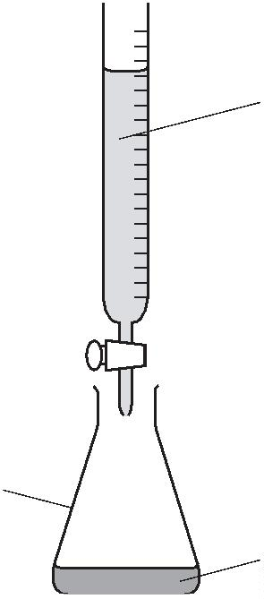

|  |  |  |
| --- | --- | --- |
| **13** |  | Ink used for writing is a mixture of dyes.  These dyes can be separated by paper chromatography. |

Describe how to separate a mixture of dyes using paper chromatography.Include a labelled diagram in your answer.

..................................................................................................................................................

..................................................................................................................................................

..................................................................................................................................................

..................................................................................................................................................

.................................................................................................................................................. [4]

[Total: 4]

|  |  |  |
| --- | --- | --- |
| **14** |  | The concentration of a dilute acid can be found by reacting it with aqueous sodium hydroxide using  the apparatus shown. |

aqueous

sodium hydroxide

conical flask

dilute acid

**11**

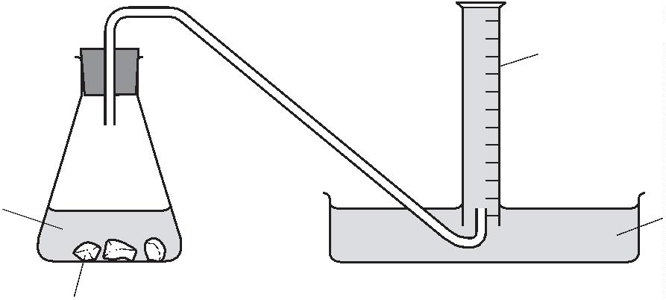

|  |  |  |  |
| --- | --- | --- | --- |
|  | **(a)** |  | What piece of apparatus should be used to add exactly 25.0 cm 3 of dilute acid to the conical  3 of dilute acid to the conical  ﬂask? |

........................................................................................................................................... [1]

**(b)** A few drops of litmus solution are added to the conical ﬂask.

Explain why litmus solution is added to the conical ﬂask.

...........................................................................................................................................

........................................................................................................................................... [1]

**(c)** Aqueous sodium hydroxide is then added to the dilute acid until it is in excess.

Describe the change in the colour of the litmus solution in the conical ﬂask.

from .................................................................to ....................................................... [2]

[Total: 4]

|  |  |  |
| --- | --- | --- |
| **15** |  | The apparatus shown is used to investigate the rate of reaction between calcium carbonate and  hydrochloric acid at 30 °C. |

A

hydrochloric acid water

calcium carbonate

**(a)** Name the piece of apparatus labelled **A** in the diagram.

........................................................................................................................................... [1]

**(b)** Describe how this apparatus can be used to find the rate of reaction.

...........................................................................................................................................

...........................................................................................................................................

........................................................................................................................................... [2]

[Total: 3]

**16** Give the name of the process that is used:



**12**

**(a)** to obtain water from aqueous sodium chloride

........................................................................................................................................... [1]

**(b)** to separate an insoluble solid from a liquid

........................................................................................................................................... [1]

**(c)** to separate the components of petroleum

........................................................................................................................................... [1]

**(d)** to separate a mixture of coloured dyes.

........................................................................................................................................... [1]

[Total: 4]

**17** Air is a mixture. Nitrogen and oxygen are the two most common gases in air.

**(a)** What is meant by the term *mixture*?

...........................................................................................................................................

........................................................................................................................................... [1]

**(b)** State the percentage of oxygen, to the nearest whole number, in clean dry air.

........................................................................................................................................... [1]

|  |  |  |  |
| --- | --- | --- | --- |
|  | **(c)** |  | Describe the steps in the industrial process which enables nitrogen and oxygen to be separated  from clean dry air. |

Use scientific terms in your answer.

...........................................................................................................................................

...........................................................................................................................................

...........................................................................................................................................

...........................................................................................................................................

...........................................................................................................................................

...........................................................................................................................................

........................................................................................................................................... [3]

**(d)** Which physical property of nitrogen and oxygen allows them to be separated?

........................................................................................................................................... [1]

**13**

[Total: 6]

|  |  |  |
| --- | --- | --- |
| **18** |  | Silver chloride can be made by reacting aqueous sodium chloride with aqueous silver nitrate.  The other product of the reaction is sodium nitrate. The chemical equation for the reaction is shown. |

NaC*l*(aq) + AgNO3(aq) → AgC*l*(s) + NaNO3(aq)

A student attempted to make the maximum amount of **sodium nitrate** crystals. The process involved three steps.

|  |  |  |  |  |
| --- | --- | --- | --- | --- |
|  | **step 1** |  | The student added aqueous sodium chloride to aqueous silver nitrate and stirred.  Neither reagent was in excess. | |
|  | **step 2** |  | The student filtered the mixture. The student then washed the residue and added  the washings to the filtrate. |

**step 3** The student obtained sodium nitrate crystals from the filtrate.

**(a)** Describe what the student observed in **step 1**.

........................................................................................................................................... [1]

**(b)** Why was the residue washed in **step** 2?

...........................................................................................................................................

........................................................................................................................................... [1]

**(c)** Give the names of the **two** processes which occurred in **step 3**. [2]

|  |  |  |  |
| --- | --- | --- | --- |
|  | **(d)** |  | The student started with 20 cm 3 of 0.20 mol / dm3 NaC*l* (aq).  3 of 0.20 mol / dm3 NaC*l* (aq). |

Determine the amount of NaC*l*(aq) used.

amount of NaC*l*(aq) used = ........................... mol [1]

**14**

**(e)** The yield of NaNO3 crystals was 90%.

Calculate the mass of NaNO3 crystals made.

mass of NaNO3 crystals made = ........................... g [3]

**(f)** Write a chemical equation for the action of heat on sodium nitrate crystals.

........................................................................................................................................... [2]

[Total: 10]

|  |  |  |
| --- | --- | --- |
| **19** |  | Dodecane is an alkane containing 12 carbon atoms. Ethanol can be manufactured from dodecane  in a two-stage process. |

In **stage 1**, each molecule of dodecane is converted into three molecules of ethene and one molecule of another hydrocarbon.

**(a)** Name the process which occurs in **stage 1**.

........................................................................................................................................... [1]

**(b)** Write a chemical equation for the reaction which occurs in **stage 1**.

........................................................................................................................................... [2]

In **stage 2**, ethene reacts with steam to produce ethanol.

**(c)** State **two** conditions needed for **stage 2**.

1 ........................................................................................................................................

2 ........................................................................................................................................ [2]

**(d)** Name the type of reaction which occurs in **stage 2**.

........................................................................................................................................... [1]

**(e)** Suggest how to test the purity of the ethanol produced.

...........................................................................................................................................

........................................................................................................................................... [2]

[Total: 8]

**15**

**20** Suggest the name of a process to obtain ethanol from a mixture of ethanol and water.

.................................................................................................................................................. [1]

[Total: 1]

|  |  |  |
| --- | --- | --- |
| **21** |  | Carbon and magnesium are both insoluble in water.  Carbon does **not** react with hydrochloric acid but magnesium reacts to form a soluble salt and a  gas which escapes into the air. |

Suggest how you could prepare a pure dry sample of carbon from a mixture of carbon powder andmagnesium powder.

..................................................................................................................................................

..................................................................................................................................................

..................................................................................................................................................

..................................................................................................................................................

..................................................................................................................................................

.................................................................................................................................................. [3]

[Total: 3]

|  |  |  |
| --- | --- | --- |
| **22** |  | Aluminium reacts with hydrochloric acid to form aluminium chloride and a gas which ‘pops’ with a  lighted splint. |

**(a)** Identify this gas.

........................................................................................................................................... [1]

|  |  |  |  |
| --- | --- | --- | --- |
|  | **(b)** |  | Suggest a practical method for investigating the rate of this reaction involving collection of the  gas.  You may include a labelled diagram in your answer. |

...........................................................................................................................................

...........................................................................................................................................

...........................................................................................................................................

........................................................................................................................................... [3]

**16**

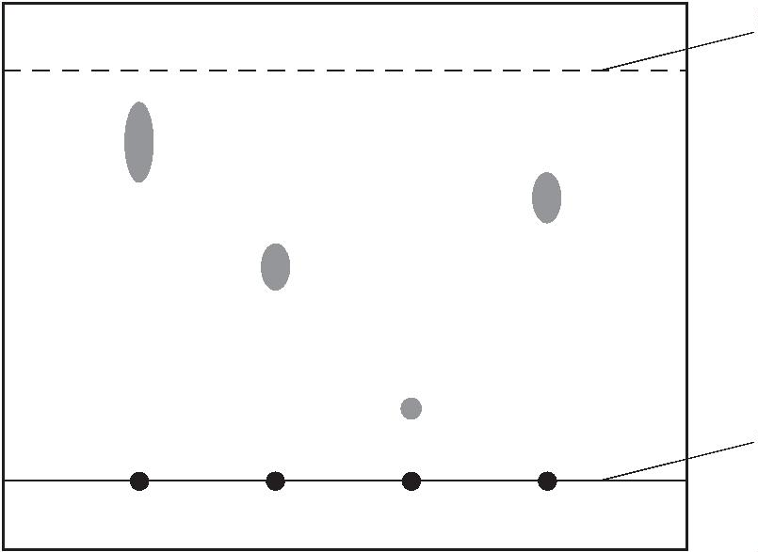

[Total: 4]

**23** Sulfur and zinc are both insoluble in water.

Sulfur does **not** react with hydrochloric acid but zinc reacts to form a soluble salt and a gas which

escapes into the air.

Suggest how you could prepare a pure dry sample of sulfur from a mixture of sulfur powder andzinc powder.

..................................................................................................................................................

..................................................................................................................................................

..................................................................................................................................................

..................................................................................................................................................

..................................................................................................................................................

.................................................................................................................................................. [3]

[Total: 3]

**24** The paper chromatogram below was obtained from four different dyes.

Which dye has an *R*f value of 0.7?

solvent front

baseline

A B C D

[1]

[Total: 1]

**17**

|  |  |  |
| --- | --- | --- |
| **25** |  | Describe how to separate the following. Give a description of the procedure used and explain why  this method works. |

Magnesium hydroxide from a mixture of magnesium hydroxide and zinc hydroxide.

procedure..................................................................................................................................

..................................................................................................................................................

explanation................................................................................................................................

.................................................................................................................................................. [3]

[Total: 3]