**- Mark Scheme /**



**Question Answer Marks AO Element Notes Guidance**

1(a) 22 s **1**

1(b) P (1) **2**

the gradient / slope of the graphis steep(est) (1)

1(c) 0.9 (g) **1**

|  |  |  |  |  |  |  |  |  |  |  |  |  |
| --- | --- | --- | --- | --- | --- | --- | --- | --- | --- | --- | --- | --- |
|  | | 1(d)(i) | | |  | | (increasing temperature)  increases / faster (1) | |  | | **1** | |
|  | 1(d)(ii) | | | | |  | | (larger pieces of carbonate)  decreases / slower (1) | |  | | **1** | |
|  | | | 2(a) | | |  | | speeds up rate of reaction /  makes reaction faster | |  | | **1** | |
|  | | | 2(b) | | |  | | any suitable source, e.g. from  car engines / lightning / high  temperature furnaces | |  | | **1** | |
|  | | | | 2(c) | |  | | irritates eyes / nose / mouth /  skin / airways / lungs | |  | | **1** | |

3(a) 179.3 (g) **1**

|  |  |  |  |  |  |
| --- | --- | --- | --- | --- | --- |
|  | 3(b) |  | A (1)  the gradient / slope is the  steep(est) (1) |  | **2** |

**- Mark Scheme /**



**Question Answer Marks AO Element Notes Guidance**

|  |  |  |  |  |  |  |  |  |  |  |  |  |  |
| --- | --- | --- | --- | --- | --- | --- | --- | --- | --- | --- | --- | --- | --- |
|  | | | | 3(c) | |  | | 360 (cm 3)  3) | |  | | **1** | |
|  | | 3(d)(i) | | |  | | decreases rate / reaction slower  (1) | |  | | **1** | |
|  | 3(d)(ii) | | | | |  | | increases rate / reaction faster  (1) | |  | | **1** | |
|  | | | 4(a) | | |  | | measuring volume of  carbon dioxide (1) | |  | | **3** | |

use of gas measuring apparatuse.g. syringe / inverted measuringcylinder full of water (1)

(measure gas volume) at timeintervals (1)

4(b) 31.25 (g) **1**

|  |  |  |  |  |  |  |  |  |  |  |
| --- | --- | --- | --- | --- | --- | --- | --- | --- | --- | --- |
|  | | 4(c)(i) |  | | decreases (rate) / slower (rate)  (1) | |  | | **1** | |
|  | 4(c)(ii) | | |  | | increases (rate) / faster (rate)  (1) | |  | | **1** | |

5(a) thermal decomposition **1**

5(b) **M1** basic (oxide ) **2**

**M2** calcium is a metal (oxide)

**- Mark Scheme /**



**Question Answer Marks AO Element Notes Guidance**

|  |  |  |  |  |  |  |  |  |  |  |
| --- | --- | --- | --- | --- | --- | --- | --- | --- | --- | --- |
|  | | 6 |  | | removal of oxygen / addition of  hydrogen / gain of electrons /  decrease in oxidation number | |  | | **1** | |
|  | | 7 |  | | carbon gains oxygen (from  Fe2O3) / oxygen (from Fe2O3)  combines with carbon | |  | | **1** | |
|  | 8(a) | | |  | | (zinc is) more reactive than  iron | |  | | **1** | |
|  | 8(b) | | |  | | 3+ (1)  Fe | |  | | **2** | |

accept / take / gain electrons(1)

|  |  |  |  |  |  |
| --- | --- | --- | --- | --- | --- |
|  | 9 |  | speeds up a (chemical) reaction  (1) |  | **2** |

not used up or unchanged (atend) (1)

|  |  |  |  |  |  |
| --- | --- | --- | --- | --- | --- |
|  | 10 |  | fewer **OR** less molecules **OR**  moles + on right **OR** in product  (1) **ORA** |  | **2** |

equilibrium shifts to the right(1)

11(a) iron(II) hydroxide **1**

**- Mark Scheme /**



**Question Answer Marks AO Element Notes Guidance**

|  |  |  |  |  |  |
| --- | --- | --- | --- | --- | --- |
|  | 11(b) |  | any **two** from:  • it (iron(II) hydroxide) is  oxidised |  | **2** |

• to form iron(III) (hydroxide)/(oxide)

• by (iron(II) hydroxide reacting with) air / oxygen

11(c) (green ppt) remains **1**

|  |  |  |  |  |  |  |  |  |  |  |
| --- | --- | --- | --- | --- | --- | --- | --- | --- | --- | --- |
|  | 12(a) | |  | | any value between and including  92–102 s | |  | | **1** | |
|  | 12(b) | |  | | 34 (cm 3)  3) | |  | | **1** | |
|  | | 12(c) | |  | | line steeper than original and  starting from 0 (1) | |  | | **2** | |

line ends up at same finalvolume **AND** levels off at or before 90s (1)

12(d) increases rate / goes faster **1**

12(e) decreases rate / goes slower **1**

13(a) carbon dioxide **1**

**- Mark Scheme /**



**Question Answer Marks AO Element Notes Guidance**

|  |  |  |  |  |  |
| --- | --- | --- | --- | --- | --- |
|  | 13(b) |  | anhydrous copper(II)  sulfate / white copper(II) sulfate  (1) |  | **2** |

turns blue (1)

**OR**

anhydrous cobalt(II) chloride / blue cobalt(II) chloride(1)

turns pink / red (1)

14(a) 2 (Fe) (1) **2**

3 (C*l* 2) (1)

14(b) reversible reaction **1**

15(a) hematite **1**

|  |  |  |  |  |  |
| --- | --- | --- | --- | --- | --- |
|  | 15(b) |  | iron oxide loses oxygen / oxygen  transferred from iron oxide to  carbon / carbon takes oxygen  away from iron oxide |  | **1** |

16(a) **1**

decomposition

16(b) 31.7 (g) **1**

17(a) water / H2O

**1**

**- Mark Scheme /**

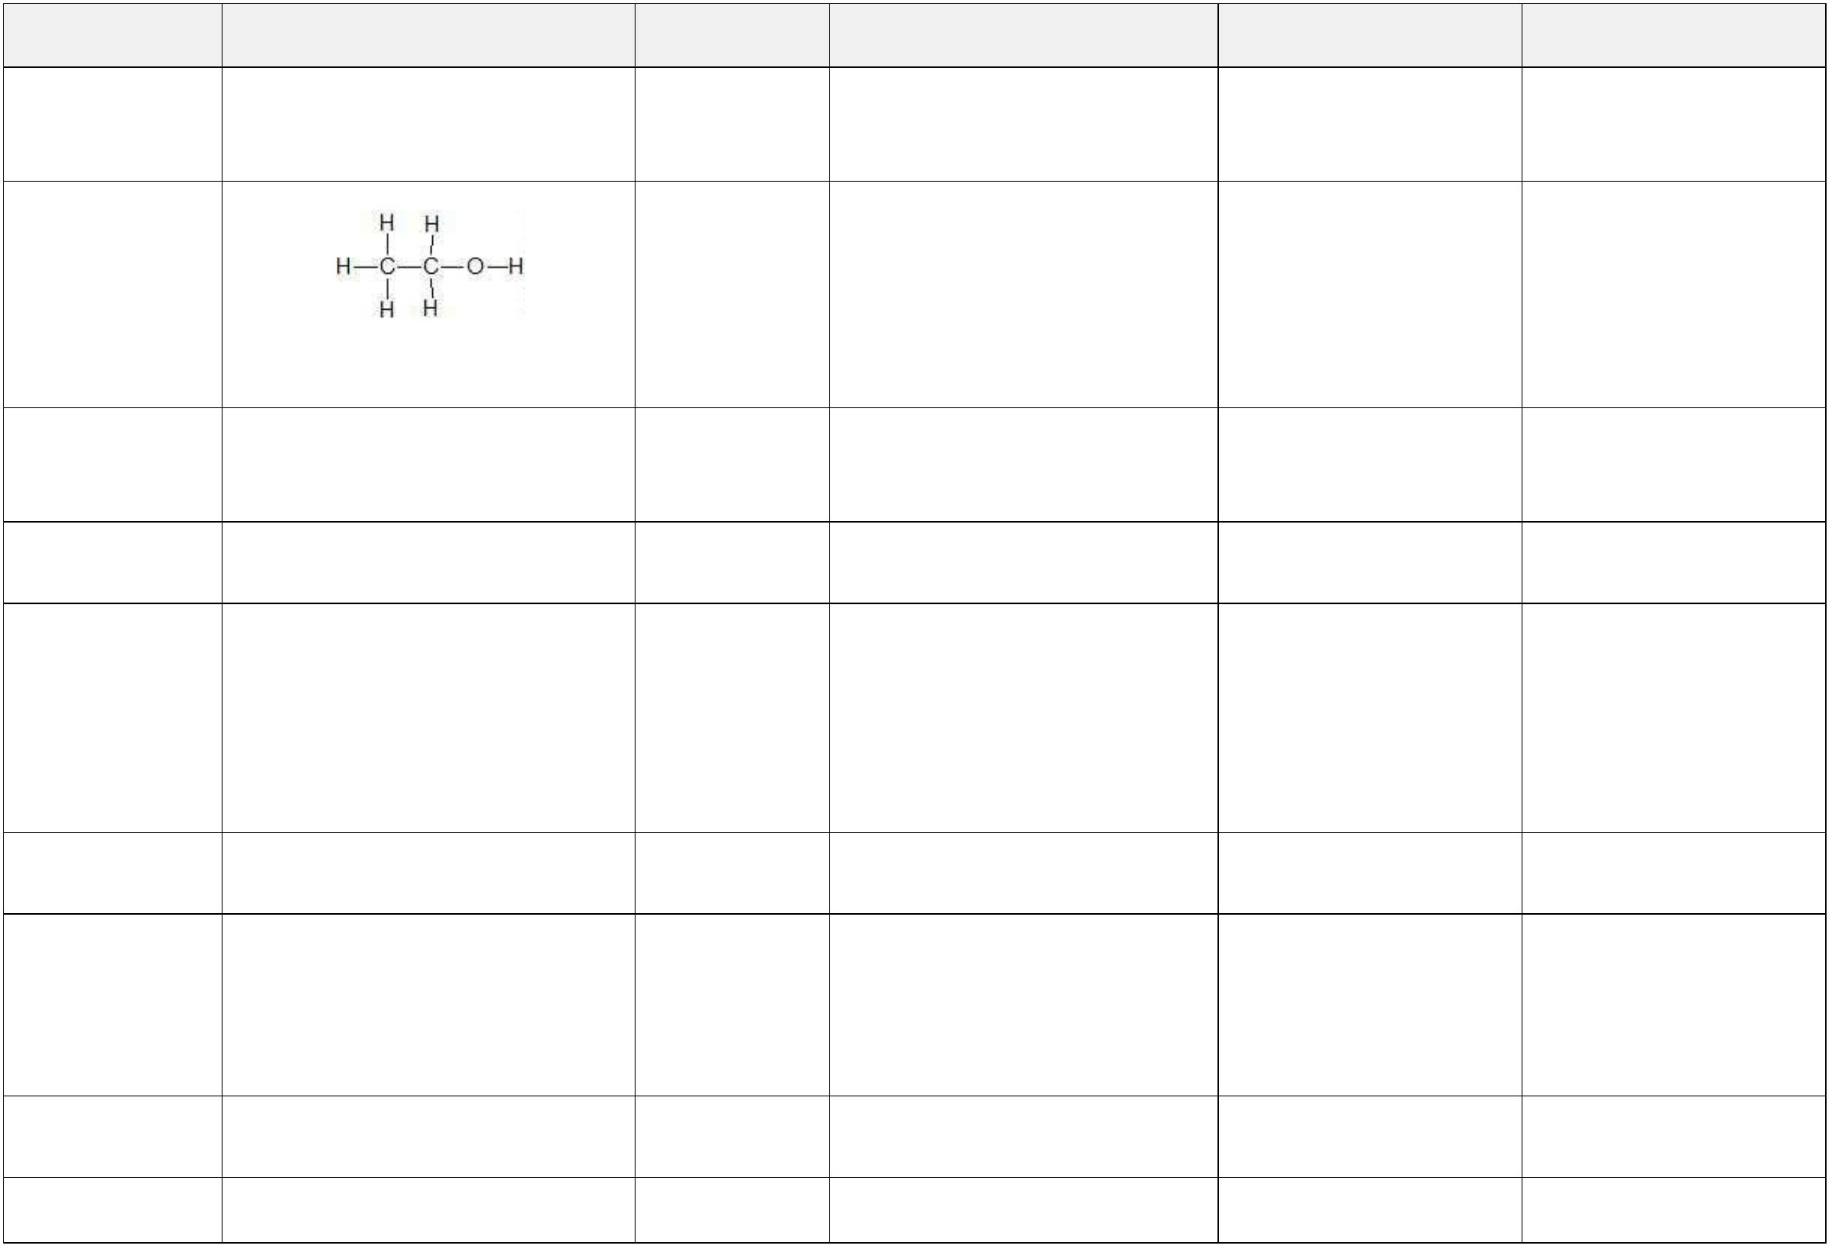

**Question Answer Marks AO Element Notes Guidance**

|  |  |  |  |  |  |
| --- | --- | --- | --- | --- | --- |
|  | 17(b) |  | speeds up reaction / increases  the rate of reaction |  | **1** |

17(c) **1**

|  |  |  |  |  |  |
| --- | --- | --- | --- | --- | --- |
|  | 18(a) |  | gas released / gas escapes / gas  lost |  | **1** |

18(b) 0.7 (g) **1**

|  |  |  |  |  |  |
| --- | --- | --- | --- | --- | --- |
|  | 18(c) |  | line steeper than original and  starting from 0 and 200.0 g (1) |  | **2** |

line ends up at same final mass**AND** levels off at or before 104 s(1)

18(d) 0.22 (g) **1**

18(e) large pieces → 0.005 **1**

small pieces → 0.030

powder → 0.100

19(a) reversible reaction **1**

19(b) heat / warm **1**

**- Mark Scheme /**



**Question Answer Marks AO Element Notes Guidance**

|  |  |  |  |  |  |
| --- | --- | --- | --- | --- | --- |
|  | 20(a) |  | burning fossil  fuels / volcanoes / heating  (sulfide) ores |  | **1** |
|  | 20(b) |  | substance which speeds up a  reaction / substance which  increases the rate of reaction |  | **1** |

20(c) pH 4 **1**

|  |  |  |  |  |  |
| --- | --- | --- | --- | --- | --- |
|  | 20(d) |  | erodes buildings (made of  carbonate rocks) / wears away  buildings (made of carbonate  rocks) / reacts with  mortar / corrodes iron  work / corrodes metal |  | **1** |

21(a) any **two** from: **2**

• faster rate of fizzing

• solid dissolves quicker / disappears

quicker / gets smaller quicker

• fizzing stops quicker

• dissolving stops quicker

**- Mark Scheme /**



**Question Answer Marks AO Element Notes Guidance**

21(b) any **three** from: **3**

• temperature

• volume (of acid)

• concentration (of acid)

• mass / amount (of CaCO3)

• particle size / surface area (ofCaCO3)

22(a) **M1** less ester **2**

**M2** equilibrium moves left **AND**because forward reaction isexothermic

22(b) **M1** more ester **2**

**M2** (equilibrium moves right) to replace water

|  |  |  |  |  |  |
| --- | --- | --- | --- | --- | --- |
|  | 23 |  | **M1** (a substance which)  increases the rate of a  reaction |  | **2** |

**M2** without being used up (at theend) **OR** unchanged (chemically) at the end **OR** without changing mass

**- Mark Scheme /**



**Question Answer Marks AO Element Notes Guidance**

|  |  |  |  |  |  |
| --- | --- | --- | --- | --- | --- |
|  | 24 |  | **M1** particles/molecules in  explanation |  | **4** |

**M2** (particles) move faster / more energy

**M3** more collisions per second**OR** greater collision rate

**M4** more of the (colliding)molecules/particles havesufficient energy (activationenergy) to react / more of thecollisions have sufficient energy(activation energy) to react

25(a)(i) **M1** Ni / Nickel **2**

**M2** (it) loses or donates electrons

25(a)(ii) redox **1**

|  |  |  |  |  |  |  |  |  |  |  |
| --- | --- | --- | --- | --- | --- | --- | --- | --- | --- | --- |
|  | 25(b) | |  | | 2+ + 2e(–)  **M1** Pb → Pb  + + e(–) → Ag  **M2** Ag | |  | | **2** | |
|  | | 25(c) | |  | | most reactive: nickel / Ni  lead / Pb  least reactive: silver / Ag | |  | | **1** | |

**- Mark Scheme /**



**Question Answer Marks AO Element Notes Guidance**

|  |  |  |  |  |  |
| --- | --- | --- | --- | --- | --- |
|  | 26(a) |  | chromium(III) oxide loses  oxygen / it loses  oxygen / oxidation number of  chromium decreases |  | **1** |
|  | 26(b) |  | energy of reactants greater than  energy of products **ORA** |  | **1** |

27 3 (H2) (1)

**3**

⇌ (1)

2 (UH3) (1)

|  |  |  |  |  |  |  |  |  |  |  |
| --- | --- | --- | --- | --- | --- | --- | --- | --- | --- | --- |
|  | 28(a) | |  | | 54 (cm 3)  3) | |  | | **1** | |
|  | 28(b) | |  | | **S** on any portion of the graph  above 2.0 min and below 3.8  min | |  | | **1** | |
|  | | 28(c) | |  | | steeper gradient starting at 0,0  (1) | |  | | **1** | |

ends up at same volume (70 cm

3) (1)

28(d) decreases rate / goes slower **1**

28(e) increases rate / goes faster **1**

**- Mark Scheme /**



**Question Answer Marks AO Element Notes Guidance**

29 **M1** increases

**4**

**M2** increases **M3** decreases

**M4** decreases

|  |  |  |  |  |  |
| --- | --- | --- | --- | --- | --- |
|  | 30 |  | colourless liquid  collects / condenses at top of the  tube (1) |  | **2** |

copper(II) sulfate turns white (1)

|  |  |  |  |  |  |
| --- | --- | --- | --- | --- | --- |
|  | 31 |  | line in shape of upward curve  (1) |  | **2** |

line below the curve for alltemperatures (1)

|  |  |  |  |  |  |
| --- | --- | --- | --- | --- | --- |
|  | 32 |  | loss of oxygen / gain of  electrons / decrease in oxidation  number |  | **1** |

33(a) (symbol for reversible reaction) **1**

⇌

33(b) add water **1**

|  |  |  |  |  |  |
| --- | --- | --- | --- | --- | --- |
|  | 34(a) |  | carbon dioxide released / gas  released |  | **1** |

**- Mark Scheme /**



**Question Answer Marks AO Element Notes Guidance**

34(b) 2.2 (g) **1**

|  |  |  |  |  |  |
| --- | --- | --- | --- | --- | --- |
|  | 34(c) |  | initial gradient of line steeper  and starts at 250–0 (1) |  | **2** |

levels out at 247.8g (1)

|  |  |  |  |  |  |  |  |  |  |  |  |  |
| --- | --- | --- | --- | --- | --- | --- | --- | --- | --- | --- | --- | --- |
|  | | | 34(d) | |  | | 20 °C → 0.16  40 °C → 0.64  30 °C → 0.32 | |  | | **1** | |
|  | | | | 35 | |  | | oxygen removed from the zinc  oxide / zinc oxide loses  oxygen / it loses oxygen | |  | | **1** | |
|  | | 36(a)(i) | | | |  | | any value between 5.0 and  5.5 min (inclusive) | |  | | **1** | |
|  | 36(a)(ii) | | | |  | | 3  96 cm | |  | | **1** | |
|  | | | 36(b) | |  | | initial gradient of line less steep  and starting at 0–0 (1) | |  | | **2** | |

levelling off at a lower volume(1)

**- Mark Scheme /**



**Question Answer Marks AO Element Notes Guidance**

|  |  |  |  |  |  |
| --- | --- | --- | --- | --- | --- |
|  | 37 |  | gas syringe drawn / measuring  vessel dipping into trough of  water drawn (1) |  | **3** |

gas syringe or measuring cylinder correctly labelled (1)

workable apparatus e.g. airtight(1)

|  |  |  |  |  |  |
| --- | --- | --- | --- | --- | --- |
|  | 38 |  | 11.5 (cm 3 / min)  3 / min) |  | **1** |
|  | 39 |  | oxygen removed from the  copper oxide / copper oxide  loses oxygen / it loses oxygen |  | **1** |

40(a) gradient gets less **1**

|  |  |  |  |  |  |
| --- | --- | --- | --- | --- | --- |
|  | 40(b) |  | concentration of HC*l* is  decreasing |  | **1** |

40(c) 120 (s) **1**

[Total: 128]