NAME: ………………………………………………………… INDEX NO. ………………….…………
SCHOOL: ………………………………………………………. CANDIDATE’S SIGN. …………............
DATE……………………………………..………………………

232/3
PHYSICS
PAPER 3 (PRACTICAL)
TIME: 2¹/₄ HOURS

SET 7
FORM 3

INSTRUCTIONS TO CANDIDATES:
- Write your name and index number in the spaces provided above.
- Sign and write the date of the examination in the spaces provided above.
- You are supposed to spend the first 15 minutes of the 2 ½ hours allowed for this paper reading the whole paper carefully.
- Marks are given for a clear record of the observation actually made, their suitability, accuracy and the use made of them.
- KNEC mathematical tables and silent non-programmable electronic calculators may be used.
For Examiners’ Use Only
Question 1 | c | f | g(i) | g(ii) | g(iii) | h
Max Score | 2 | 7 | 5 | 2 | 2 | 2
Candidate’s score

TOTAL
 | Part I |  |  |  | Part II
Question 2 | b | d | e | f | b | c
Max Score | 1 | 8 | 5 | 2 | 3 | 1
Candidate’s score

TOTAL

GRAND TOTAL

This paper consists of 4 printed pages. Candidates should check to ascertain that all pages are printed as indicated and that no questions are missing.

1. You are provided with the following;
- A piece of candle
- Plane mirror
- Metre rule
- A thin lens mounted on a lens holder
- A cardboard with cross-wire at its centre
- A piece of plasticine
- A white screen
Proceed as follows;
- Set up the apparatus as shown in figure 1.
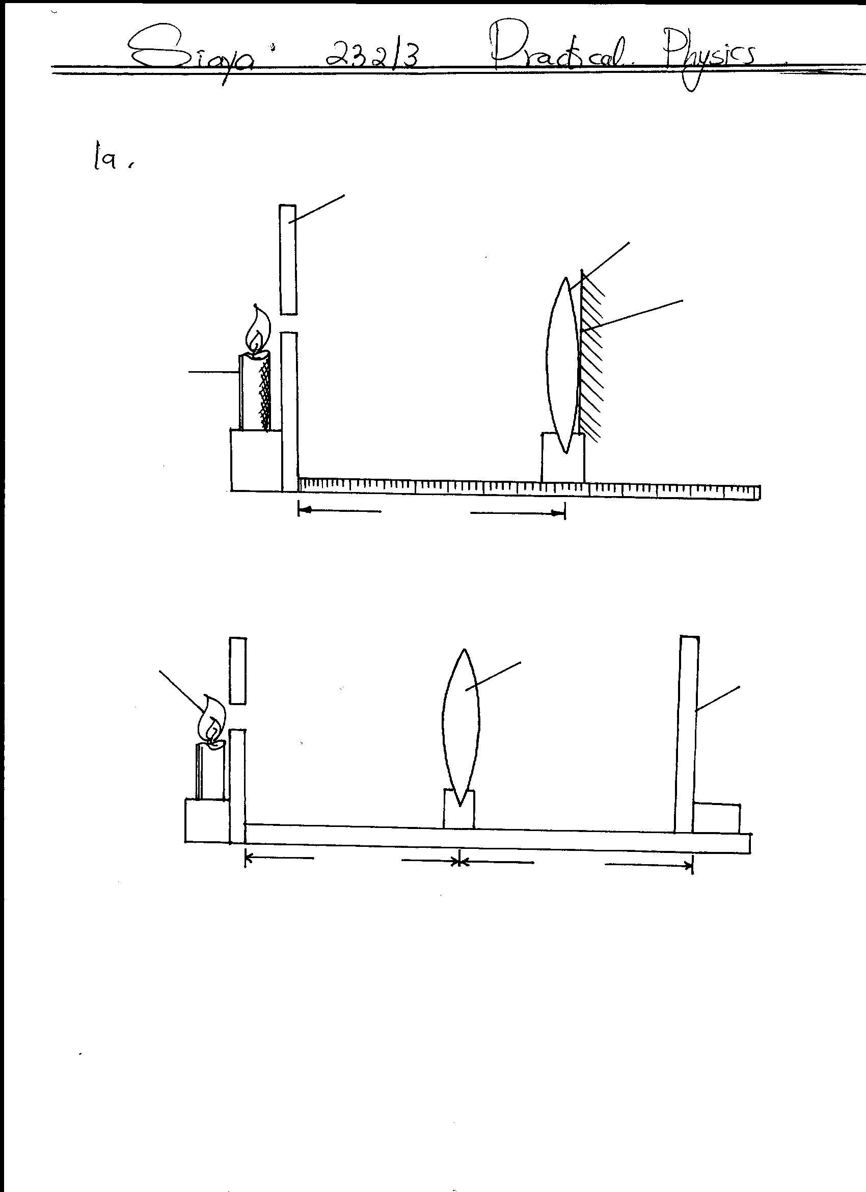
Plane mirror
Figure 1
Lens
Candle
Cardboard with cross-wire at centre
d
x

Ensure that the candle frame is at the same height as the cross wires. The plane mirror should also be attached to the lens as shown using a piece of cellotape. Plasticine can be used to fix the metre rule to the table.
- Place the cardboard with cross-wire at the centre at the O mark of the metre rule.
- Move the object along the metre rule until a sharp image of the cross wire is formed alongside the object cross-wire.
Measure the length d using the metre rule.
d:……………………………………………………………………m (2mks)
- Now arrange the candle flame, the lens, the object and the screen as shown below.
Screen
Lens
Candle
u
v
Figure 2

- Adjust the distance between the lens and the object O to each of the distances given in the table. For every value of u, adjust the position of the screen until a sharp image of the cross wires appear on the screen. Measure the value of v and record in the table.

- Repeat the procedure (e) above for each of the other values of u and complete the table below.
Table 1
u(cm) | 35 | 40 | 45 | 50 | 55 | 60 | 70
v(cm)
uv(cm³)
u+v(cm)
(7mks)
g)i) Plot the graph of uv against u+v. (5mks)

ii) From your graph, calculate the slope, S (2mks)

iii) Use the graph to determine the focal length. (2mks)

h) How is the focal length obtained in (i) above related to d obtained in (c). Explain your answer. (2mks)

2. PART I
You are provided with the following;
- A spiral spring
- One stand, one boss and one clamp
- A metre rule
- A stop watch
- A set of masses
Proceed as follows;
- Arrange the set up as shown below.
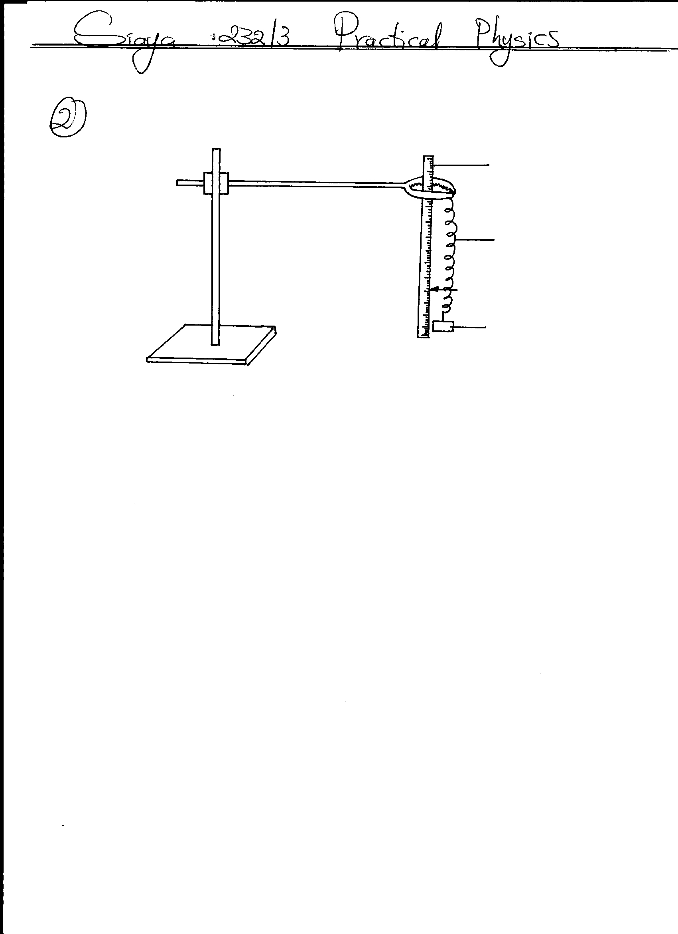
Metre rule
Spiral spring
Pointer
Mass

- Note the reading of the pointer of the spring when no mass is suspended from its hook.
L_{o}=…………………………………………….cm (1mk)
- Attach a 50g mass on the spiral spring and measure the length L of the spring with the mass 50g on the spring, slightly displace the spring downwards and note the time for 20 oscillations. Record your results in the table 2 below.
- Repeat procedure (c) above for 100g, 120g, 150g, 200g and 250g. Complete the table below.
Table 2
Mass M(g) | 50 | 100 | 120 | 150 | 200 | 250
L(cm)
e=L-L_{o}(cm)
Time, t for 20 oscillations (s)
Log t
Log e
(8mks)
e) Plot the graph of log t against log e. (5mks)

f) Given that;
Log t intercept = ½ log 16π²
A
Determine the value of A (2mks)

PART II
You are provided with the following apparatus;
- One new dry cell
- One cell holder
- Switch, K
- An ammeter
- A voltmeter
- A variable resistor, rheostat or potentiometer
- Seven connecting wires, at least 4 of which with crocodile clips
- A bulb holder
- A torch bulb 2.5V (for 2 dry cells)
- Set up the apparatus as shown below.
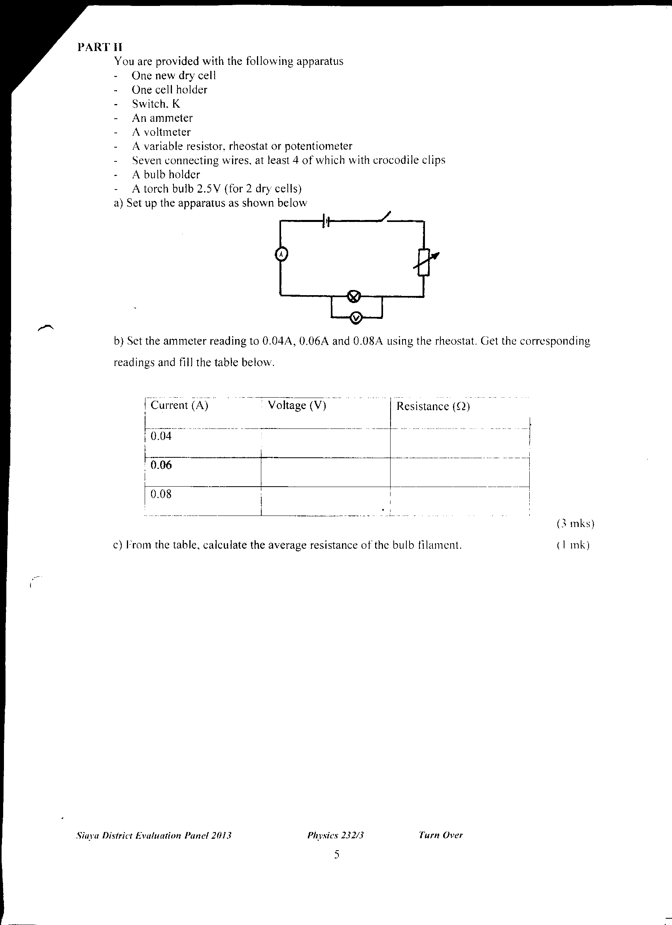

- Set the ammeter reading to 0.04A, 0.06A and 0.08A using the rheostat. Get the corresponding readings and fill the table below.
Table 3
(3mks)
Current (A) | Voltage (V) | Resistance (Ω)
0.04
0.06
0.08
c) From the table, calculate the average resistance of the bulb filament. (1mk)

