**NAME: ………………………………………………...…...… Adm no………………..**

**SIGNATURE…………………………………. DATE……………………….**

**232 / 3**

**PHYSICS**

**(PRACTICAL)**

**2 ½ HOURS**

**SET 4**

**FORM 3**

**INSTRUCTION TO CANDIDATES**

1. *Write your name and index number in the spaces provided above.*
2. *Sign and write the date of examination in the spaces provided above.*
3. *Answer* ***ALL*** *the questions in the spaces provided in the question paper.*
4. *You are supposed to spend the first 15 minutes of the 2 ½ hours allowed for this paper reading the whole paper carefully before commencing your work*
5. *Marks are given for a clear record of the observation actually made, their suitability, accuracy and the use made of them.*
6. *Candidates are advised to record their observations as soon as they are made.*
7. *Mathematical tables and electronic calculators may be used.*
8. ***Candidates should check the question paper to ascertain that all the pages are printed as indicated and that no questions are missing*.**

**For Examiner’s Use Only**

**Question 1**

|  |  |  |  |  |  |
| --- | --- | --- | --- | --- | --- |
|  | **a** | **b** | **c** | **d** | **Part**  **B** |
| **Maximum score** | **5** | **8** | **1** | **1** | **5** |
| **Candidate’s score** |  |  |  |  |  |

**Total  
Question 2**

|  |  |  |  |  |
| --- | --- | --- | --- | --- |
|  | **a** | **b** | **c** | **d** |
| **Maximum Score** | **2** | **6** | **8** | **4** |
| **Candidate’s score** |  |  |  |  |

**Total  
 Grand total**

**7 printed pages**

1. This question has two parts A and B

**PART A:**

You are provided with the following apparatus

-Three optical pins

-a soft board

-a rectangular glass bock

-a plane paper

-a ruler and a protractor

Proceed as follows

(a) (i) Draw two perpendicular lines AB and CD to intersect at O,the centre of the paper

C

P3

x

Y=60mm

45mm

85mm

P1

P2

O

D

A

B

θ

**(ii)** Place two pins P 1 and P2 on CD such that OP1 =45mm and OP2=85mm

**(iii)** Place a third pin P3 such that its distance x is perpendicular to CD and 5mm from it. Also P3 will be

60mm from AB, this will be distance Y and it will remain constant throughout the experiment

**(iv)** Record the value of Y in cm

Y=……………………………………………………………………………………cm **(1 mark)**

**(v)** Adjust the glass block until the image of the pins P1,P2 and object pin P3 appear to be in straight line

when viewed through the glass block

**(vi)** Measure the angle θ which the glass block makes with AB

θ=………………………………………………………………………..cm **(1 mark)**

**(vii)** Repeat the experiment with P3 being placed at position X=10mm,20mm,25mm and 30mm.Obtain the corresponding values of θ and fill the table below

**(3 marks)**

|  |  |  |  |  |  |  |
| --- | --- | --- | --- | --- | --- | --- |
| X(mm) | 5 | 10 | 15 | 20 | 25 | 30 |
| θ(⁰) |  |  |  |  |  |  |

**(b) (i)** Plot a graph of θ (vertical axis) against x **(5 marks)**

(ii) Using your graph,determine the value of X1 when θ= 40o

X1=…………………………………………………………………………………….. **(1 mark)**

(iii) Determine the thickness t, of the glass block using the formula **(2 marks)**

t= 21 x X1

y

……………………………………………………………………………………………………………………………………………………………………………………………………………………………………………………………………………………………………………………............................................................................

(c) On the plane paper,trace the outline of your glass block and measure the thickness t

t=……………………………………………………………………………………….. **(1 mark)**

(d) Submit the plane sheet of paper you have used together with this question paper **(1 mark)**

PART B

You are provided with the following apparatus:

* A voltmeter 0 – 3 or 0 – 5V)
* An ammeter (0 – 1A)
* 10Ω resistor (fixed).
* A switch.
* One dry cell and a cell holder.
* Six connecting wires.

(i)Connect the above apparatus as shown in the circuit diagram **below** with the switch S open.

A

10Ω

S

V

1. With the switch S open record E the voltmeter reading.

E = _________________________________ (1mark)

1. Close the switch and record V, the voltmeter reading and I, the ammeter reading.

V = ____________________________ (1mark)

I = _______________________________ (1mark)

1. Given that: E – V = Ir

Find r for the dry cell. (2 marks)

………………………………………………………………………………..

2.You are provided with the following apparatus

* Ametre rule
* Amass marked M
* Six 20g masses
* A spiral spring
* Astop watch
* A complete stand
* A balance for sharing

Arrange the apparatus as shown in the figure 8.9a below

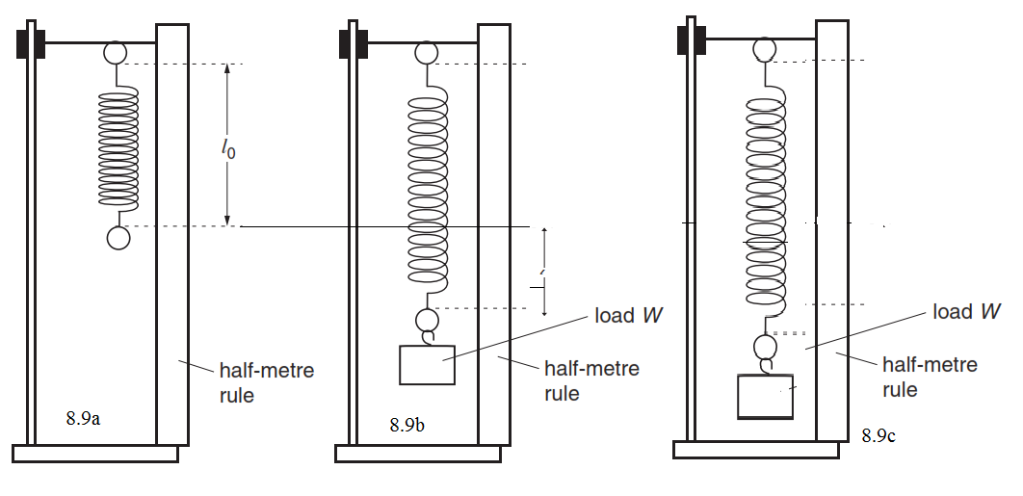

Attach the mass marked M to the free end of the spring to exert a downward tension Mg in newtons as shown in figure 8.9(b) above. If the mass causes an extension L called static extension then Mg=kL where k is the spring constant and g is acceleration due to gravity

1. state the static extension L caused by M in cm

……………………………………………………………………… (½mark)

1. Using the balance weigh M (½mark)

………………………………………………………………………….g

1. Determine the spring constant k in Newton per meter if g=9.8 ms-2 (1mark)

………………………………………………………………………………………………………………………………………………………………………………………………….. ………………………………..

(b) Pull the mass M down a further distance x below the equilibrium position as shown in figure 8.9c.Release the mass so as to oscillate up and down

Repeat the experiment for several other values of M shown in the table and record the corresponding value of period T in the table **(6 marks)**

|  |  |  |  |  |  |  |  |
| --- | --- | --- | --- | --- | --- | --- | --- |
| Mass m(g) | 20 | 40 | 60 | 80 | 100 | 120 | 150 |
| Extension L(cm) |  |  |  |  |  |  |  |
| Time for 10 oscillations |  |  |  |  |  |  |  |
| Periodic time T(s) |  |  |  |  |  |  |  |
| T2(s2) |  |  |  |  |  |  |  |

(c) Plot a graph of L in metre against T2 (5marks)

From your graph determine

**(i)** the slope of the graph **(2 marks)**

………………………………………………………………………………………

…………………………………………………………………………………………

**(ii)** The intercept of the L axis  **(1 mark)**

…………………………………………………………………………………

**(d)** If the Ms is the effective mass of the spring, the period T of the oscillating system is given by

**L= g.T2 - g Ms**

**4π2 k**

Using the formula of equation above, calculate

**(i)** Acceleration due to gravity g  **(2 marks)**

……………………………………………………………………………………………………………………………………………………………………………………………………………………………………………..

**(ii)** The effective mass Ms of the spring  **(2 marks)**

………………………………………………………………………………………………………………………………………………………………………………………………………………………………………………

**SET 4**

**PHYSICS PRACTICAL MARKING SCHEME**

**AND CONFIDENTIAL**

Each student will require the following apparatus

-Three optical pins

-a soft board

-a rectangular glass bock

-a plane paper

-a ruler and a protractor

-a voltmeter

-an ammeter

-a10 ῼ resistor

-one dry cell

-a stand with clamp

-Amass marked M (100g)

-Six 20g masses

-A spiral spring

-Astop watch

-A weighing balance for sharing

1.PART A

(IV) 6.0 cm

(vi) 19o

(vii)

|  |  |  |  |  |  |  |
| --- | --- | --- | --- | --- | --- | --- |
| X(mm) | 5 | 10 | 15 | 20 | 25 | 30 |
| θ(⁰) | 19 | 28.5 | 31.0 | 40.0 | 47.0 | 54.0 |

Award ½ mark for each entry upto amaximum of 3 mks

(b)(i) graph is a straight line

Axis labeled with units -1mk

Scale –simple and uniform -1mk

Plotting –all points plotted -2mks

Line- straight line/best line of fit 1mk

(ii) X-read from students graph 1mk , 20mm

(iii) correct substitution -1mark

Answer with units 1mk

(c) correct reading of t from the outline 1mk,

Correct use of plane paper -1mk

PART B

1. E=1.5 V 1mk
2. V= value less than 1.5V 1mk

I=………………….mark students value 1mk

1. 1.5 –V = Ir 1mk

r=……………. 1mk

. **Question 2**

1. 2.5cm√
2. 100g√
3. K=mg√

L

Calculation will depend on the value of m recorded and the value of L obtained by the student

K= 1.96Nm-1√

(b)

|  |  |  |  |  |
| --- | --- | --- | --- | --- |
| Mass m(g) | Extension L cm | Time for 10 oscill | Period T | T2  x 10-2 |
| 20 | 1.1 + 0.1 | 2.43 | 0.243 | 5.905 |
| 40 | 2.0 | 2.90 | 0.290 | 8.410 |
| 60 | 2.9 | 3.44 | 0.344 | 11.834 |
| 80 | 3.8 | 3.78 | 0.378 | 14.288 |
| 100 | 4.7 | 4.25 | 0.425 | 18.062 |
| 120 | 5.6 | 4.69 | 0.469 | 21.966 |
| 150 | 6.5 | 5.12 | 0.572 | 26.214 |

Labeling of axis -√1mk

Scale simple and uniform -√1mk

Plotting of all points -√2mks

Straight line with positive gradient -√1mk

1. correct computation, √ ½mk

Substitution √½mk

Correct answer √1mk

( 0.25m/s + 0.05)√

1. from equation of a straight line y=mx +c

Slope= g√

4π 2

g= 4π 2 x slope√

= 0.25 x 4 x (3.142)2√

= 9.86 m/s2√

(ii) Vertical intercept = -gMs√

K

Ms = 9.86 x 1.96 x 10-1

= 3.975 x 10-5kg 0r 0.03975g√