**SET 6**

**PHYSICS 232/3**

**MARKING SCHEME**

**QUESTION ONE**

You are providd with the following;

- A 40m1 glass beaker

- A Bunsen burner

- A thermometer

- A stop Watch

- A tripod stand and a measuring cylinder 100ml

- A wire gauze

- A source of heat

Set up the apparatus as shown in the diagram below.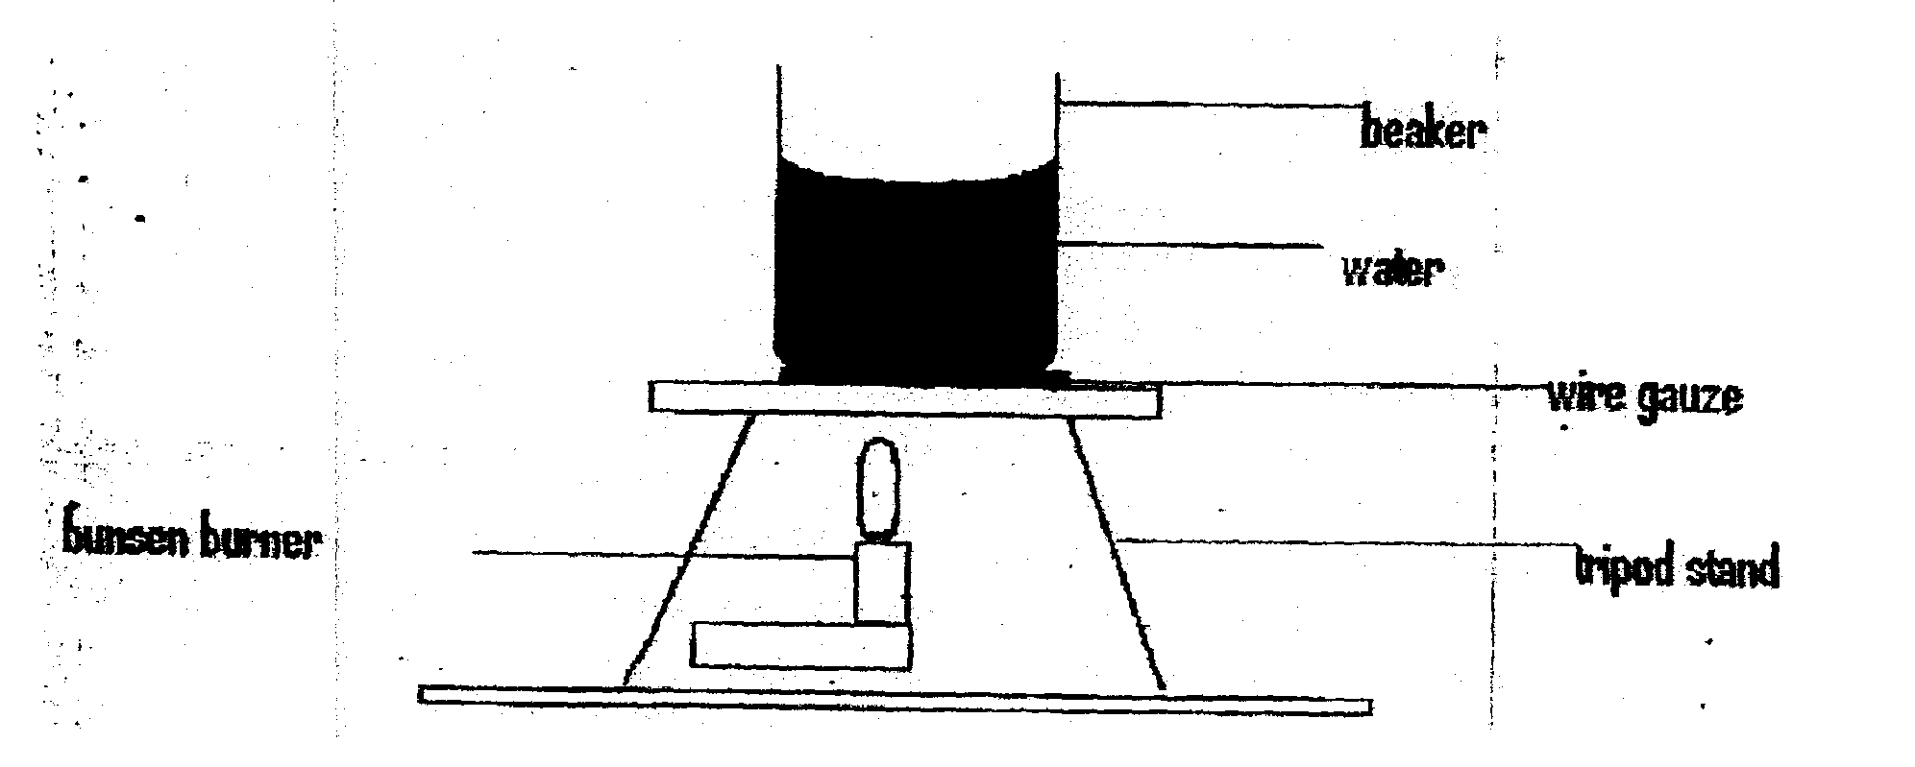

**Beaker**

**Water**

**Wire gauze**

**Tripod stand**

**Burnsen burner**

Measure 100cm3 of water and pour it into the beaker. Take the initial temperature of the water.

T0 27oc (1 mark)

Now heat the water to a temperate of 90°C. Switch off the gas tap and place a thermometer into the beaker and start the stop watch when the temperature is 650C. Take the temperatur T°C of water every two minutes.

Record your results in the table below.

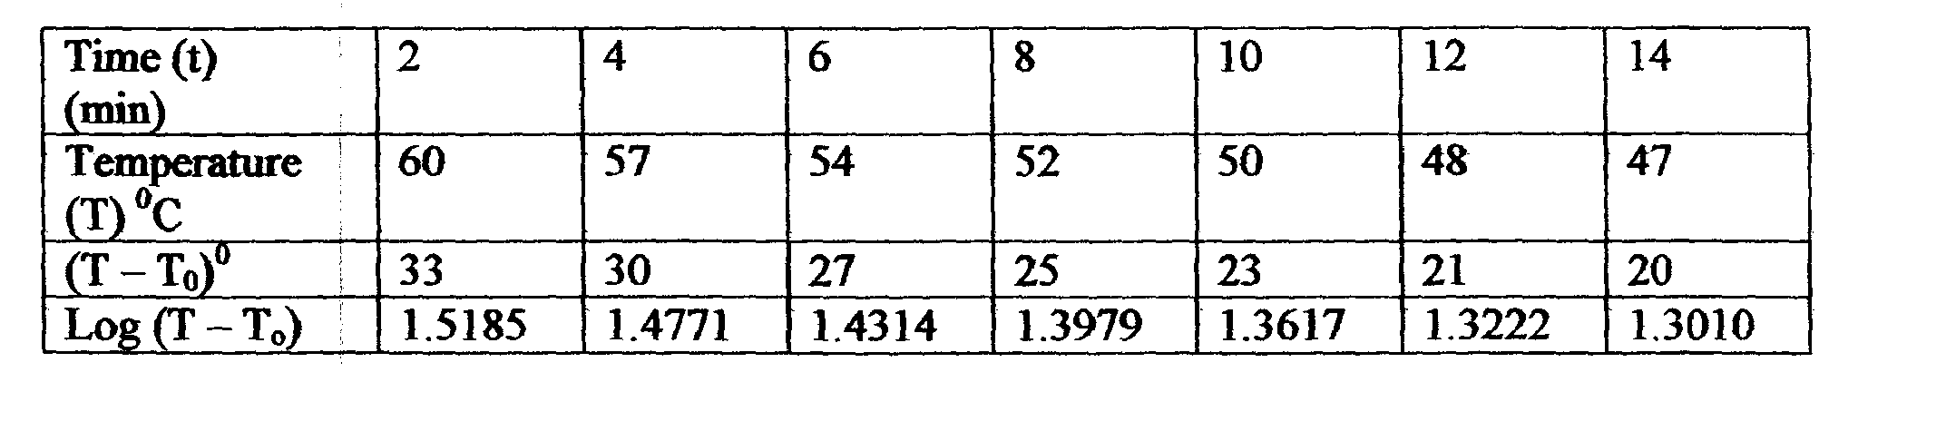

(i) Plot graph of Log (T — To) against Time (t) (5 marks)

(ii) Find the value K of log (T — To) when t =0 (2 marks)

*K =1. 56 shown the graph*

Determine the antilog of K. (2 marks)

Antilog K= 36.31

(iii) Calculate the temperature of the surrounding TR using the expression

Antilog K 65 - TR (3 marks)

36.31 =65-TR

TR=65-36.31

TR = 28.69°C

QUESITON TWO

This question has two parts A and B. answer both parts

PART A

You are provided with the following:

- A meter rule

- Two identical l00g masses

- About 200m1 of liquid L in 250m1 beaker

- Three pieces of thread, each about half metre long

- Stand with clamps

- Tissue paper

**Proceed as fol’ows:**

(a) Using a stand and one piece of thread, suspend the metre rule in air such that it balancçs horizontally.

Record the position of the centre of gravity.

G.=500 mm

**NOTE:** The metre rule should remain suspended at this point through out the experiment.

(b) Set up the apparatus as in figure 2 below.

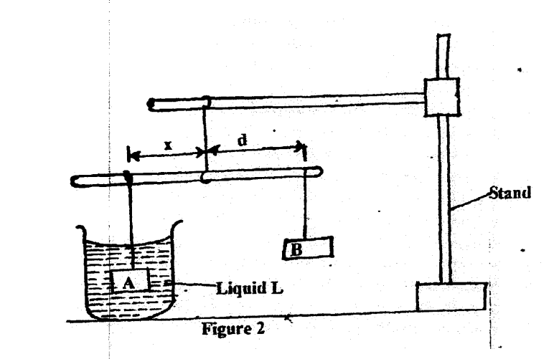

**Figure 2**

**Stand**

**Liquid L**

**Liquid L**

Suspend the sums A at a distance x = 50mm. Adjust the position of mass B until it balances mass A immersed in liquid L.

Record the ditance d, of mass B from the pivot.

Repeat the saiie process for other values of x in table 2 below and complete the table.

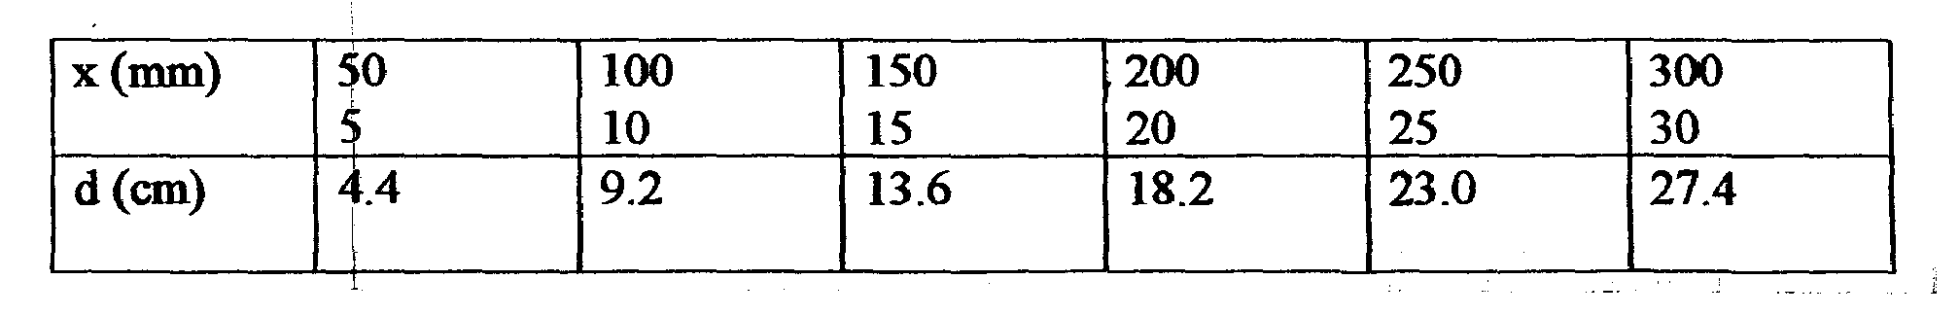

Graph

(d) Determine the slope , S of the graph

Gradient = DY = 14-0

DS 15-C

= 0.9333 (2 marks)

(e) Given S = F, where F is the apparent weight of objects A in the liquid L and W is W the actual weight of A, find: -

W

i) The va1ue F (2 marks)

0.9333 = F/1

F = 09333N

(ii) The up thrust, U

U=1-0933 U=W-F

U=0.0667N (3 marks)

**PART B**

You are provided with the following:

- A concave mirror with holder

- A screen

- A meter rule

- A candle

- A match box (to be shared)

***Proceed as follows:***

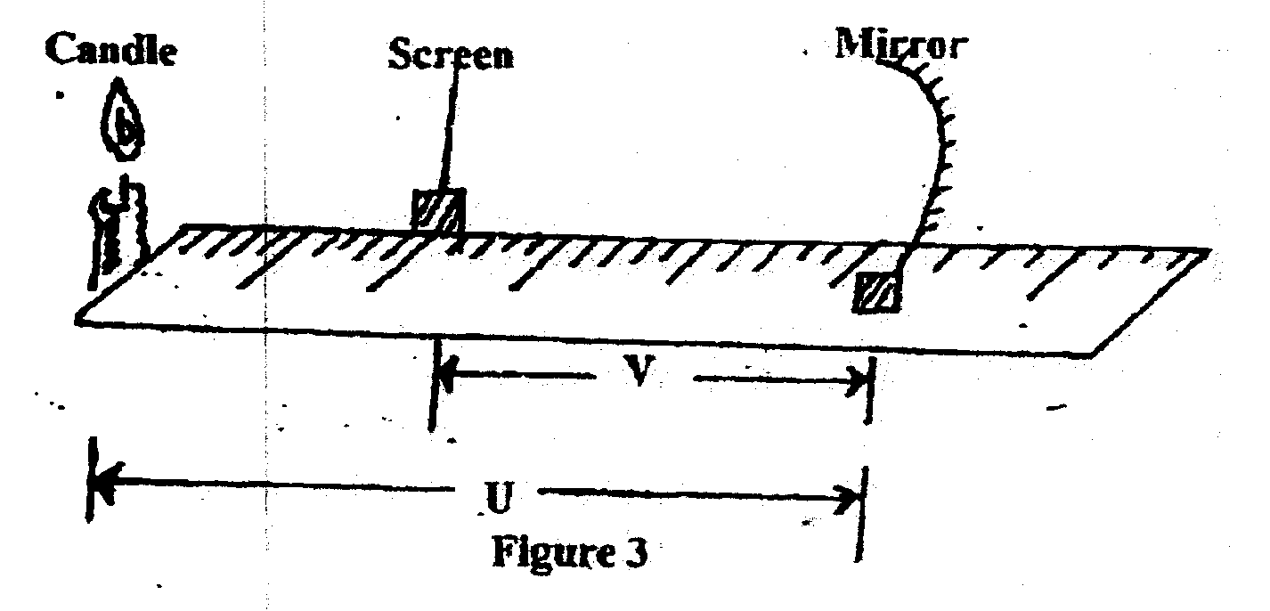(f) Set p the apparatus as in figure 3 below.

**Mirror**

**Screen**

Candle

Figure 3

(g) Put th object at a distance u = 30cm from the mirror. Adjust the position of the screen until a sharp image is formed on the screen. Record the distance V.

(h) Repeat procedure (g) above for the distance u=40cm and record the new distance V. complete the table below

|  |  |  |  |
| --- | --- | --- | --- |
| U(cm) | V(cm) | M=V/U | (m+1) |
| 30 | 22.5 | 1.333 | 2.333 |
| 40 | 30.1 | 1.329 | 2.329 |

(i) Given, $f=\frac{V}{(m+1)}$ calculate the values off hence determine the average value fav (3mks)

f1= 22.5 = 9.657cm

2.333

f2 = 30.1 = 12.924cm

2.329

fav= f1+f2 = 9.657+12.924

2 2

=11.2905cm

**SET 6**

**CONFIDENTIAL INTSRUCTIONS TO SCHOOLS**

**FORM THREE**

**QUESTION ONE**

***Each candidate will require the following***

1. One 400ml glass beaker
2. A burnsen burner
3. One thermometer
4. One stop watch
5. A tripod stand
6. One 100ml measuring cylinder
7. A wire gauze
8. A source of heat

**Question two**

***Each candidate will require the following***

1. One metre rule
2. Two identical 100g masses with one labelled **A** and the other labelled **B**
3. About 200ml of water in 250ml beaker labeled **L**
4. Three pieces of thread, each about half- metre long
5. Stand with clamps
6. Some tissue paper
7. One concave mirror of focal length 10cm
8. One curved mirror holder
9. A screen
10. One metre rule
11. A candle
12. A match box (to be shared)