**SET 5**

**PHYSICS PAPER 3**

**MARKING SCHEME**

1. b) I = 0.12 0.01A✓1



V = 2.6 0.1V ✓1



c) E = 3.3 0.2V ✓1 maximum range, E = 3.5V



d)

|  |  |  |  |  |  |  |
| --- | --- | --- | --- | --- | --- | --- |
| Length L (cm) | 100 | 70 | 60 | 50 | 40 | 20 |
| I (A) | 0.12 | 0.19 | 0.2 | 0.24 | 0.28 | 0.42 |
| P.d (V) | 2.6 | 2.5 | 2.4 | 2.35 | 2.3 | 2.0 |
| E – V (v) | 0.9 | 1.0 | 1.1 | 1.15 | 1.2 | 1.5 |

Use the E of the student in the row containing the values of E – V(f)

2

|  |  |  |  |  |  |  |
| --- | --- | --- | --- | --- | --- | --- |
| Angle i | 10 | 20 | 30 | 40 | 50 | 60 |
| Distance a (cm) | 4.5 | 4.2 | 3.9 | 3.6 | 3.3 | 3.0 |

+ 0.2 cm

All correct values max 5mks

Each correct value 1mk

(h) Slope S = Δ y

Δ x

= (4.5 – 3.75) cm √ M1 correct substitution

(10 – 35)

= - 0.75 = -0.03cm √ A 1

25

(i) From the graph amax is when i = o i.e 4.8cm

(j) a = mi + k

m is the slope = - 0.03cm √ A 1

k is the y intercept = 4.8cm √ A 1

(k) Width of refracting glass block

W = 6.0cm + 0.2cm √ A 1

(i) For i = 300, x = w = 6.0cm = 1.538 √ A 1

a 3.9cm

(m) X represents refractive index of the glass block √ A 1

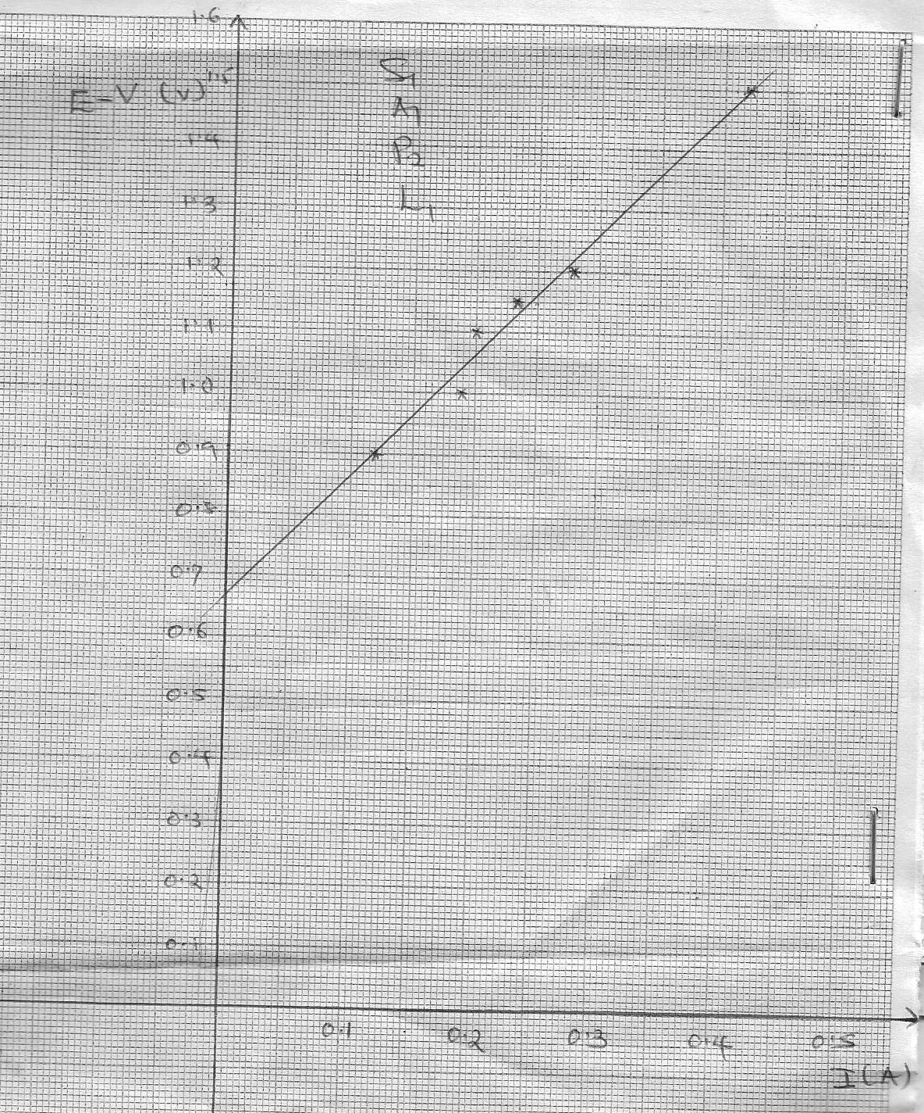

f) Slope = ✓1

= ✓1

g) E = V + Ir

E – V = rI + C✓1

r = internal resistance = slope = 2Ω ✓1