Name: ……………………………………………….……………… Index No. …………………………
School: …………………………………………………………..…. Candidate’s Sign. …………............
Date: ………………………………............................................

232/2
PHYSICS
PAPER 2 (Theory)
TIME: 2 HOURS

SET 7

FORM 3

INSTRUCTIONS TO THE CANDIDATES:

- Write your name and index number in the spaces provided above
- This paper consists of two sections A and B.
- Answer all questions in section A and B in the spaces provided.
- All working must be clearly shown in the spaces provided.
- KNEC mathematical tables and silent non-programmable electronic calculators may be used.

For Examiners’ Use Only
SECTION | QUESTION | MAXIMUM SCORE | CANDIDATE’S SCORE
A | 1-12 | 25
B | 13 | 10
B | 14 | 09
B | 15 | 12
B | 16 | 07
B | 17 | 08
 | 18 | 09
 | TOTAL | 80

This paper consists of 11 printed pages. Candidates should check to ascertain that all pages are printed as indicated and that no questions are missing.

SECTION A (25 MARKS)
1. A ray is incident on two mirrors inclined at 60⁰ as shown in the diagram below. (2mks)
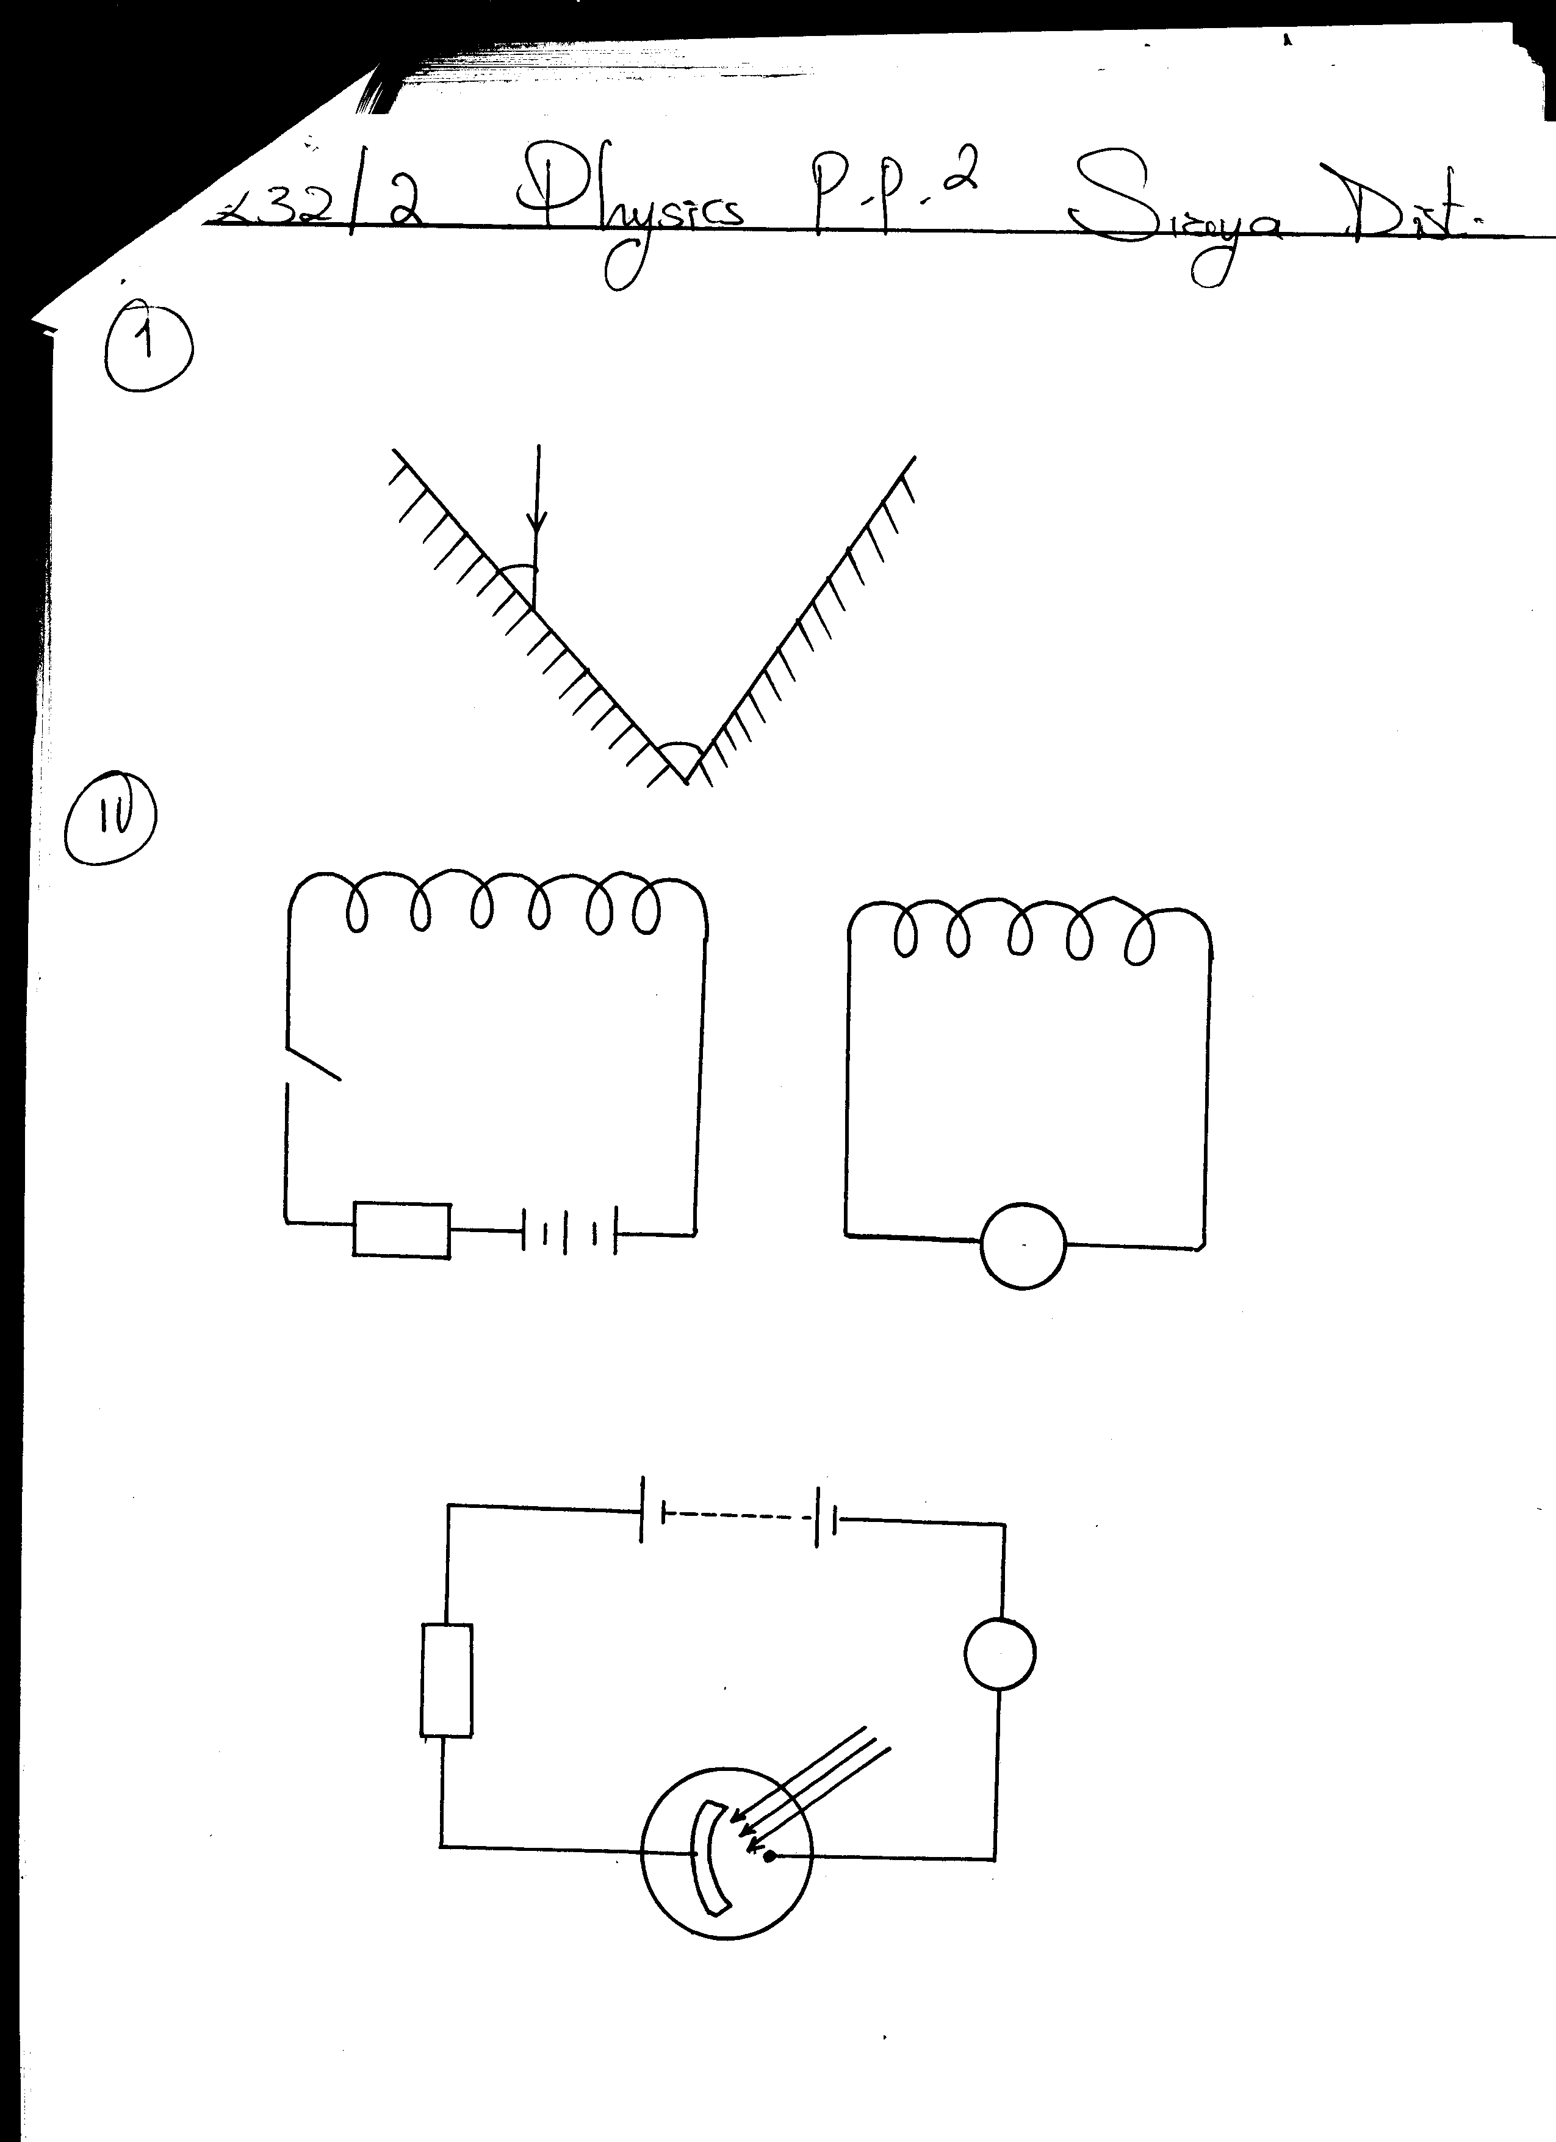
40⁰
60⁰
Mirror B
Mirror A

Determine the angle of reflection on mirror B, hence trace the path of the ray as it leaves mirror B.
2. State and explain the observation made when an acetate rod rubbed with fur is brought close to the cap of a negatively charged electroscope. (2mks)
…..……………………………………………………………………………………………………… …..………………………………………………………………………………………………………
3. State how polarization is reduced in a dry cell. (1mk)
…..……………………………………………………………………………………………………… …..………………………………………………………………………………………………………
4. Distinguish between a P-type and a N-type extrinsic semiconductors. (2mks)
…..……………………………………………………………………………………………………… …..………………………………………………………………………………………………………
…..……………………………………………………………………………………………………… …..………………………………………………………………………………………………………
5. State one similarity and one difference between the gamma rays and x-rays based on the mode of generation of the radiations.
i) Similarity (1mk) .………………………………………………………………………………………………………… …..………………………………………………………………………………………………………
ii) Difference (1mk)
…..……………………………………………………………………………………………………… …..………………………………………………………………………………………………………
6. X-rays are produced by a tube operating at 10⁴ Volts. Calculate the wavelength of the radiation.
(Take h=6.63x10⁻³⁴Js, e=1.6x10⁻¹⁹C, c =3x10⁸m/s) (3mks)

7. State how a vertical trace can be obtained on the screen of a cathode ray oscilloscope. (1mk) …..……………………………………………………………………………………………………… …..………………………………………………………………………………………………………
8. A boat sends a sound signal in the middle of Lake Victoria and an echo is heard after 6 seconds. Determine;
i) The depth of the lake. (2mks)

ii) The frequency of the signal stated in (i) above. (1mk)
(Take speed of sound in water = 1440ms⁻¹, wavelength = 0.4m)

9. A concave mirror produces an erect image of magnification 2. If the focal length of the concave mirror is 30cm, find the distance of the object from the mirror. (3mks)
(Hint: the image is virtual)

10. State Lenz’s law of electromagnetic induction. (1mk)
…..……………………………………………………………………………………………………… …..………………………………………………………………………………………………………
11. The coils P and S are connected as shown below. P is connected to a battery, rheostat and a switch K. S is connected to a galvanometer G.
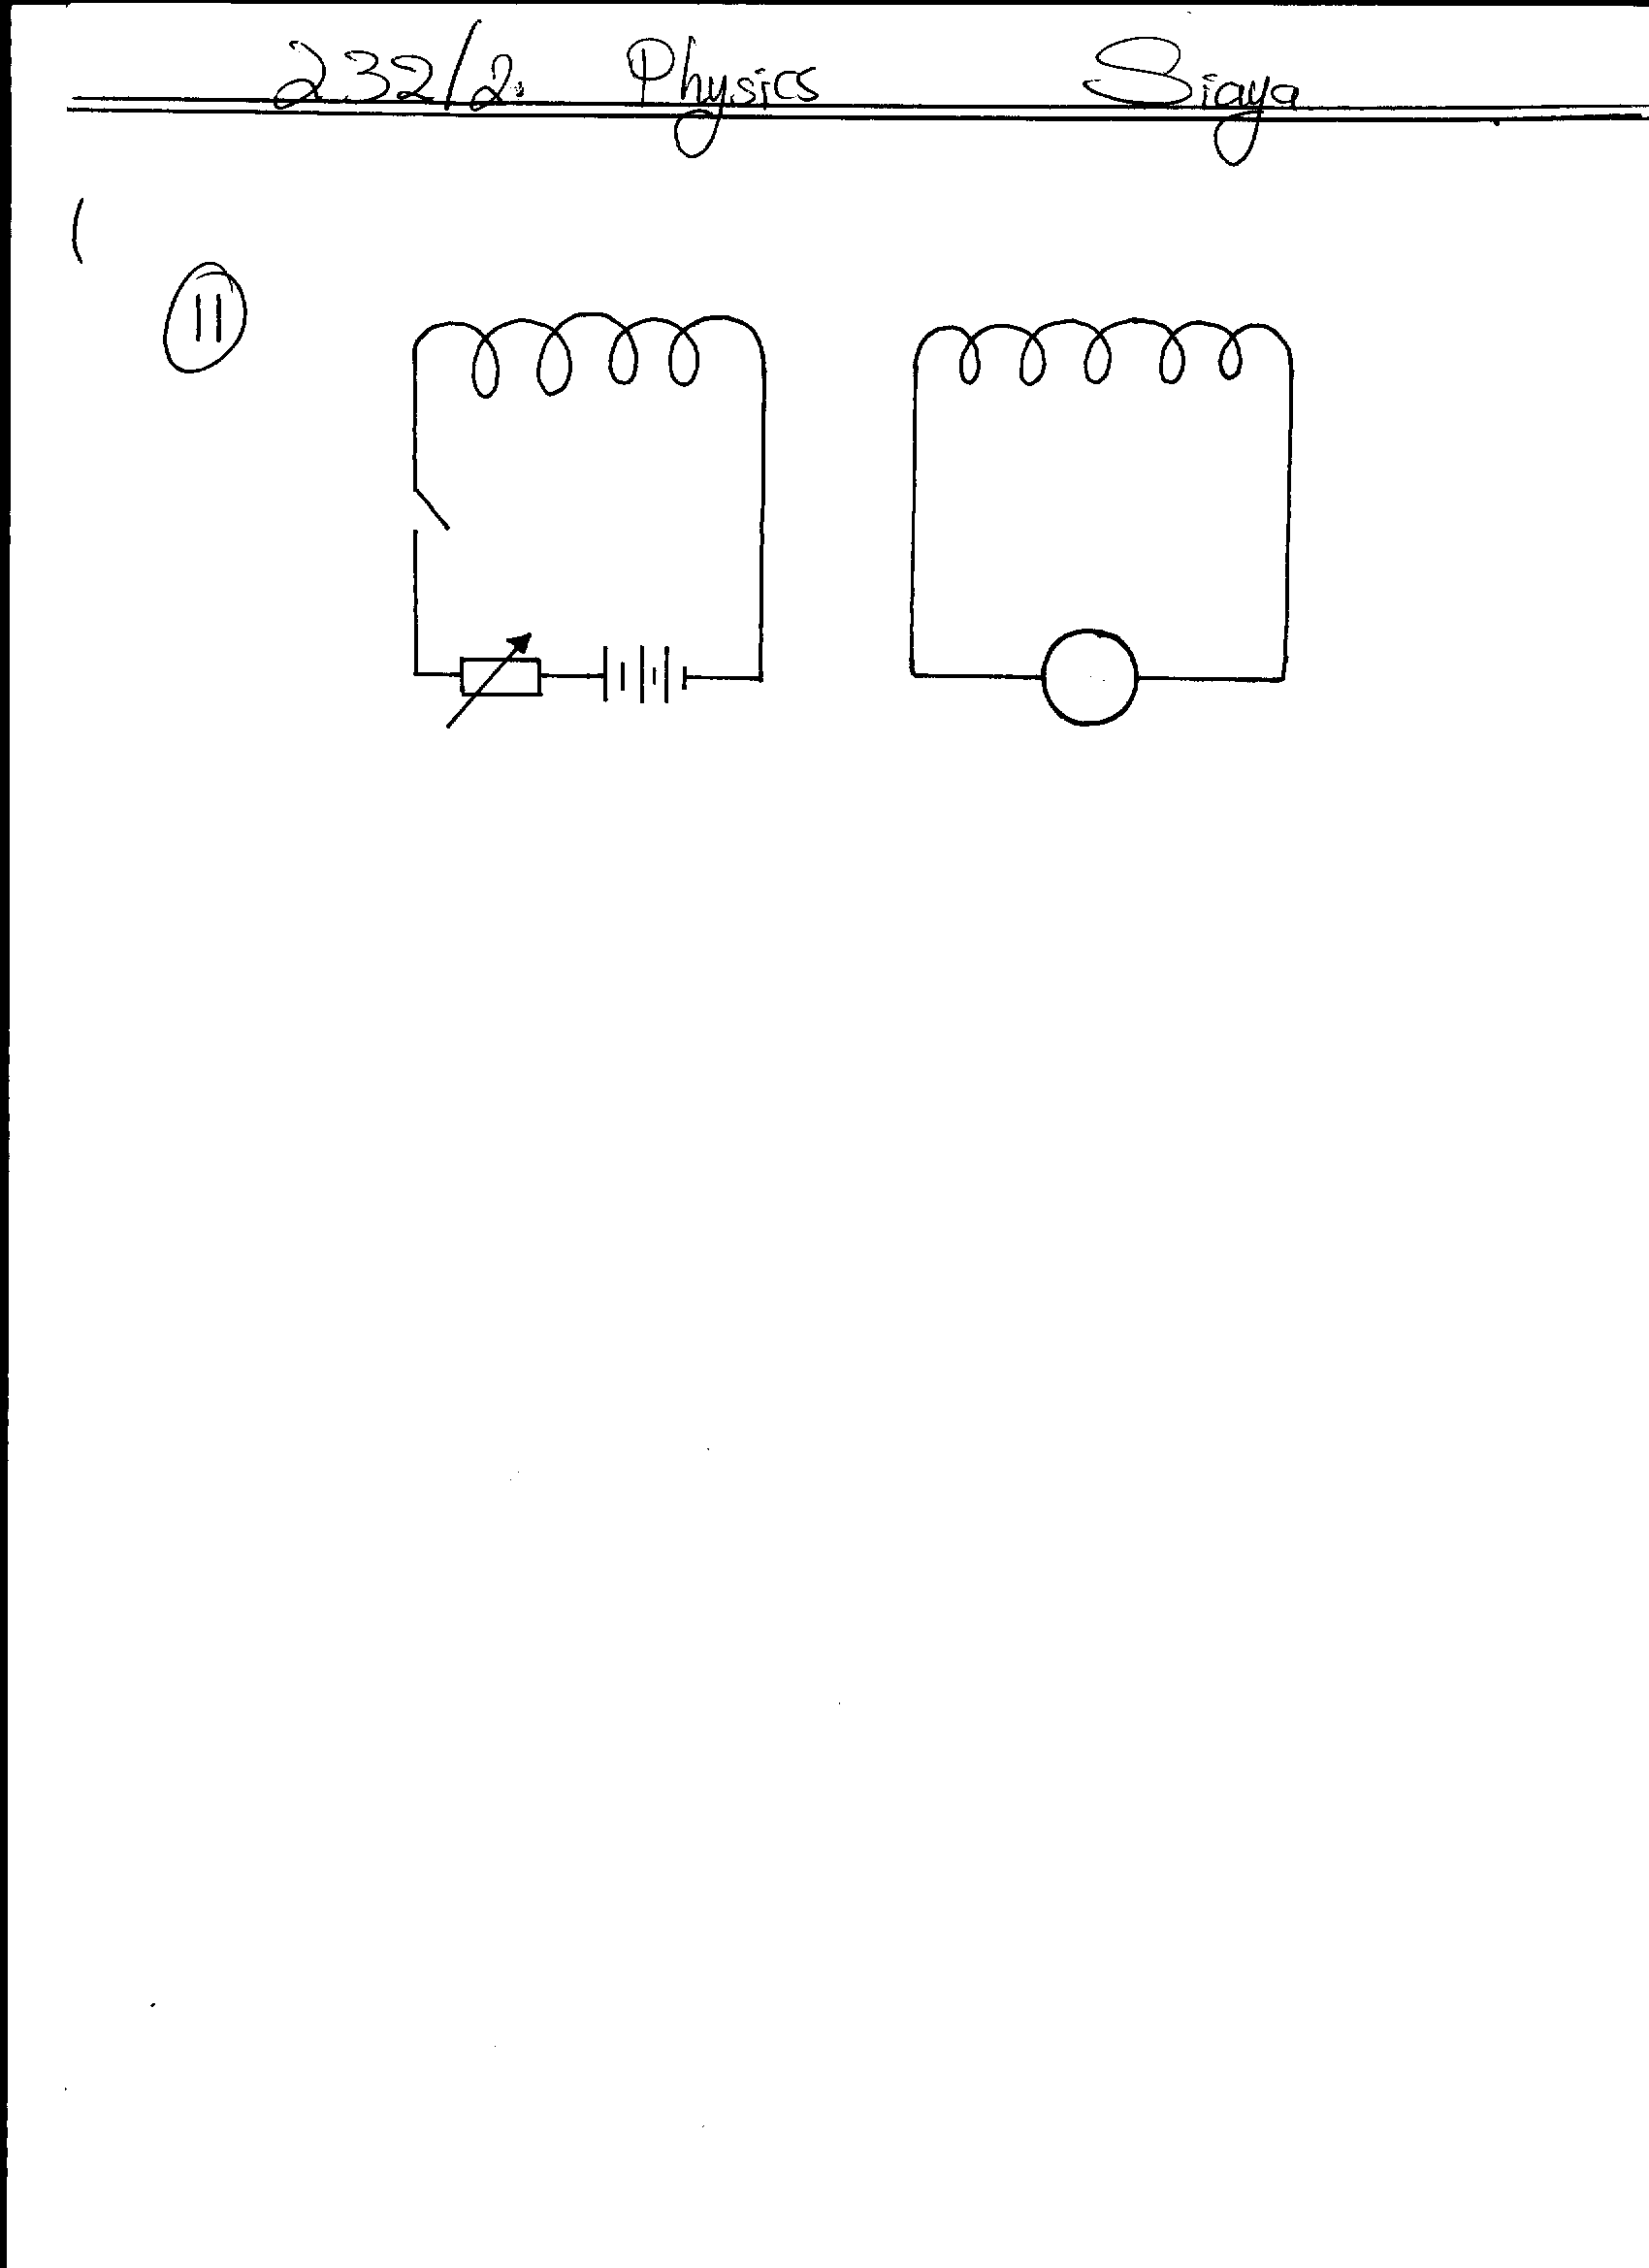
K
P
G
S

State the behaviour of the pointer on G in the following cases;
- When K is switched on (closed) (1mk)
…..……………………………………………………………………………………………………… …..………………………………………………………………………………………………………
- When K is opened. (1mk)
…..……………………………………………………………………………………………………… …..………………………………………………………………………………………………………
12. A current of 5mA passes through a wire of length 1.0m, radius 1.0x10⁻⁴mm and resistivity 1.1x10⁻⁶Ωm. Calculate the rate at which heat is given off by the wire. (Assume temperature is constant.) (3mks)

SECTION B (55 MARKS)
13. a) Define the term photoelectric effect. (1mk)
…..……………………………………………………………………………………………………… …..………………………………………………………………………………………………………
b) The diagram below shows a circuit to investigate the photoelectric effect using a photocell.
R
mA
N
M
Ultraviolet light

i) Explain why the millimeter shows a reading when ultraviolet light is shone as in the diagram. (3mks)
…..……………………………………………………………………………………………………… …..……………………………………………………………………………………………………… …..………………………………………………………………………………………………………

ii) State with a reason how the millimeter reading is affected when the intensity of light is increased. (2mks)
…..……………………………………………………………………………………………………… …..………………………………………………………………………………………………………
iii) State one practical application of a photocell. (1mk)
…..……………………………………………………………………………………………………… …..………………………………………………………………………………………………………
c) A laser beam of intensity 2x10⁻¹Nm⁻² and wavelength λ=5x10⁻⁷m hits a wall 5m away. How many photons per second are emitted? (3mks)
(Take h=6.6x10⁻³⁴Js, c=3x10⁸ms⁻¹)

14. a) Differentiate between a nuclear fussion and nuclear fission. (2mks)
…..……………………………………………………………………………………………………… …..………………………………………………………………………………………………………
b) The equation below represents a nuclear reaction.
218
84
P_{o}
218
85
A
+
q
p
Y

i) Determine the values of p and q. (1mk)
p………………………………..………………………..
q…………………………………..……………………..
ii)Identify Y…………………………………………………………………....……. (1mk)

c) The figure below represents deflection of various radiations from a radioactive source S placed in electric field between two plates X and Y.
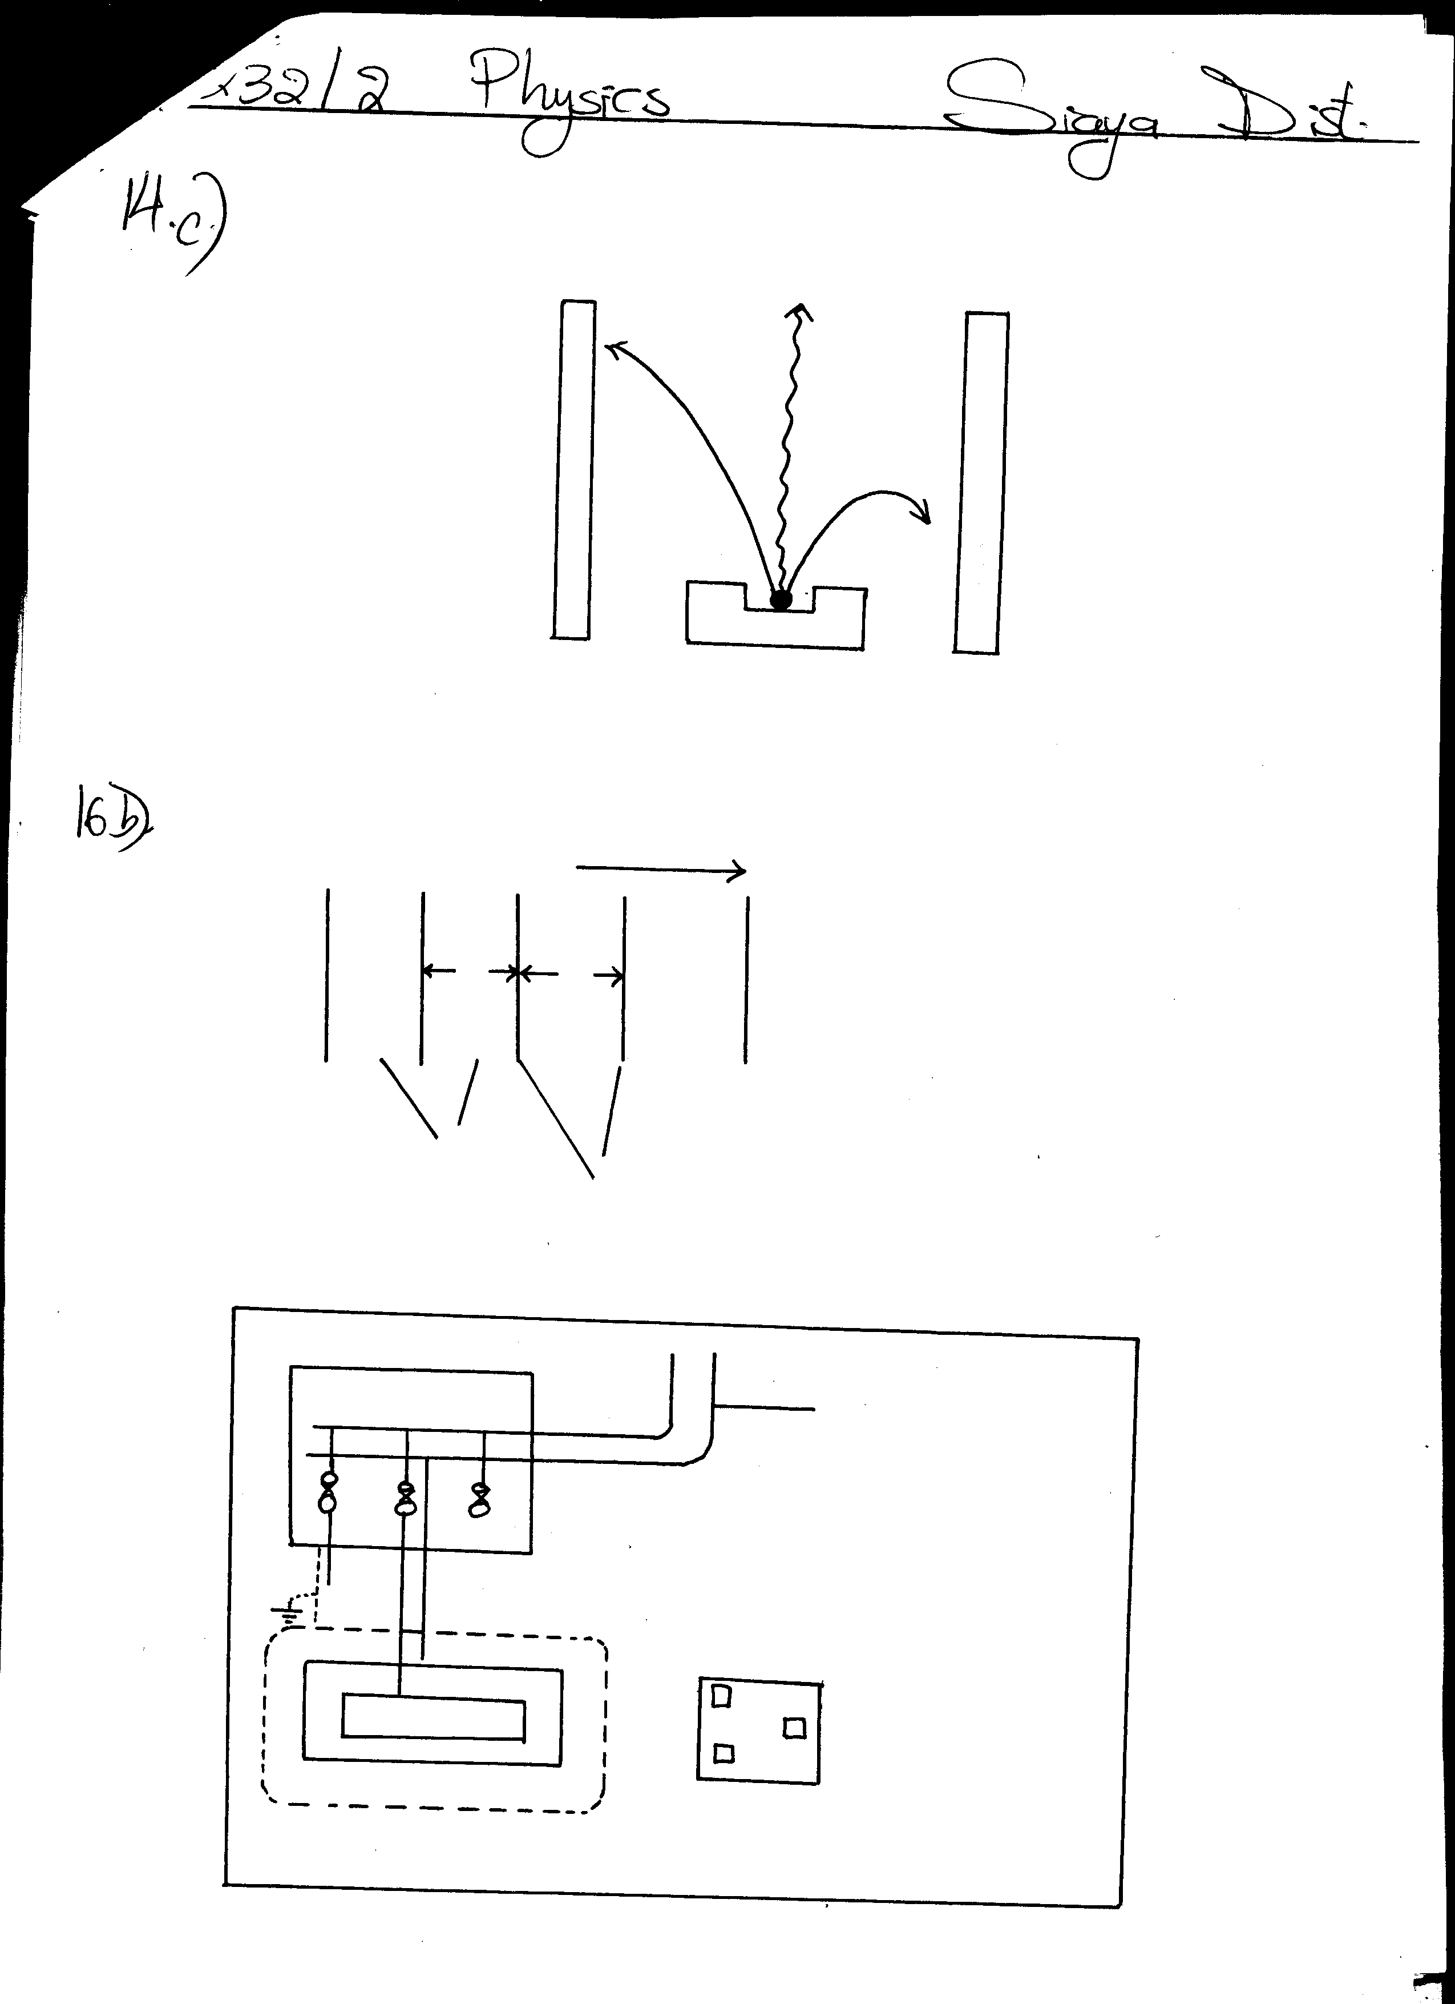
M
S
Y
+
X
-
P

Identify the radiations marked with letters M and P. (1mk) M…………………………………………………………………………………
P……………………………………………………………………………………
d) What do you understand by the term ‘Random decay’ (1mk)
…..……………………………………………………………………………………………………… …..………………………………………………………………………………………………………
e) A sample of radioactive substance initially has 8x10²⁵ particles. The half life of the sample is 98 seconds. Determine the number of particles that will have decayed after 294 seconds. (3mks)

15. a) State Snell’s law. (1mk)
…..……………………………………………………………………………………………………… …..………………………………………………………………………………………………………
b) Find the angle of incidence of a ray of light on one phase of a 60⁰ prism if the ray is just totally internally reflected on meeting the next face. (3mks)
(Take refractive index of glass = 1.5)

c) Explain why glass prisms are preferred for use in periscopes to plane mirrors. (1mk)
…..……………………………………………………………………………………………………… …..………………………………………………………………………………………………………
d) i) State two ways in which a photographic camera is different from the human eye. (2mks)
…..……………………………………………………………………………………………………… …..………………………………………………………………………………………………………
ii) Determine graphically in the space below the position, size and nature of the image of an object 2cm high placed 30cm away from a diverging lens of focal length 20cm. (5mks)
(Use the scales vertically: 1cm rep 1cm, horizontally: 1cm rep 10cm)

16. a) Differentiate between a transverse wave and a longitudinal wave. (2mks)
…..……………………………………………………………………………………………………… …..………………………………………………………………………………………………………
b) Water ripples are caused to travel across the surface of a shallow tank by means of a suitable straight vibrator.
The distance between successive crests is 3.0cm and the waves travel 25.2cm in 1.2s.
3cm
3cm
Crests
Troughs

Calculate:
i) The velocity of the waves. (2mks)

ii) The frequency of the vibrator. (3mks)

17. a) State any two disadvantages of direct transmission of electricity from power generating stations at a large current through the transmission cables. (2mks) ..……………………………………………………………………………….……………………… …..………………………………………………………………………………………………………
b) The diagram below represents part of a domestic wiring system.
Consumer unit
From main switch
Live
neutral

30A

5A

30
A

To light circuit
To cooker
circuit
socket
H

i) Identify any two mistakes in the wiring above and explain how they should be corrected. (4mks)
…..……………………………………………………………………………………………………… …..………………………………………………………………………………………………………
…..……………………………………………………………………………………………………… …..………………………………………………………………………………………………………
ii) Identify the circuit H represented above. (1mk)
…..……………………………………………………………………………………………………… …..………………………………………………………………………………………………………
c) Complete the wiring to the socket in the wiring system H above. (1mk)
18. a) The figure below represents a circuit diagram of three resistors connected to a 12V battery.
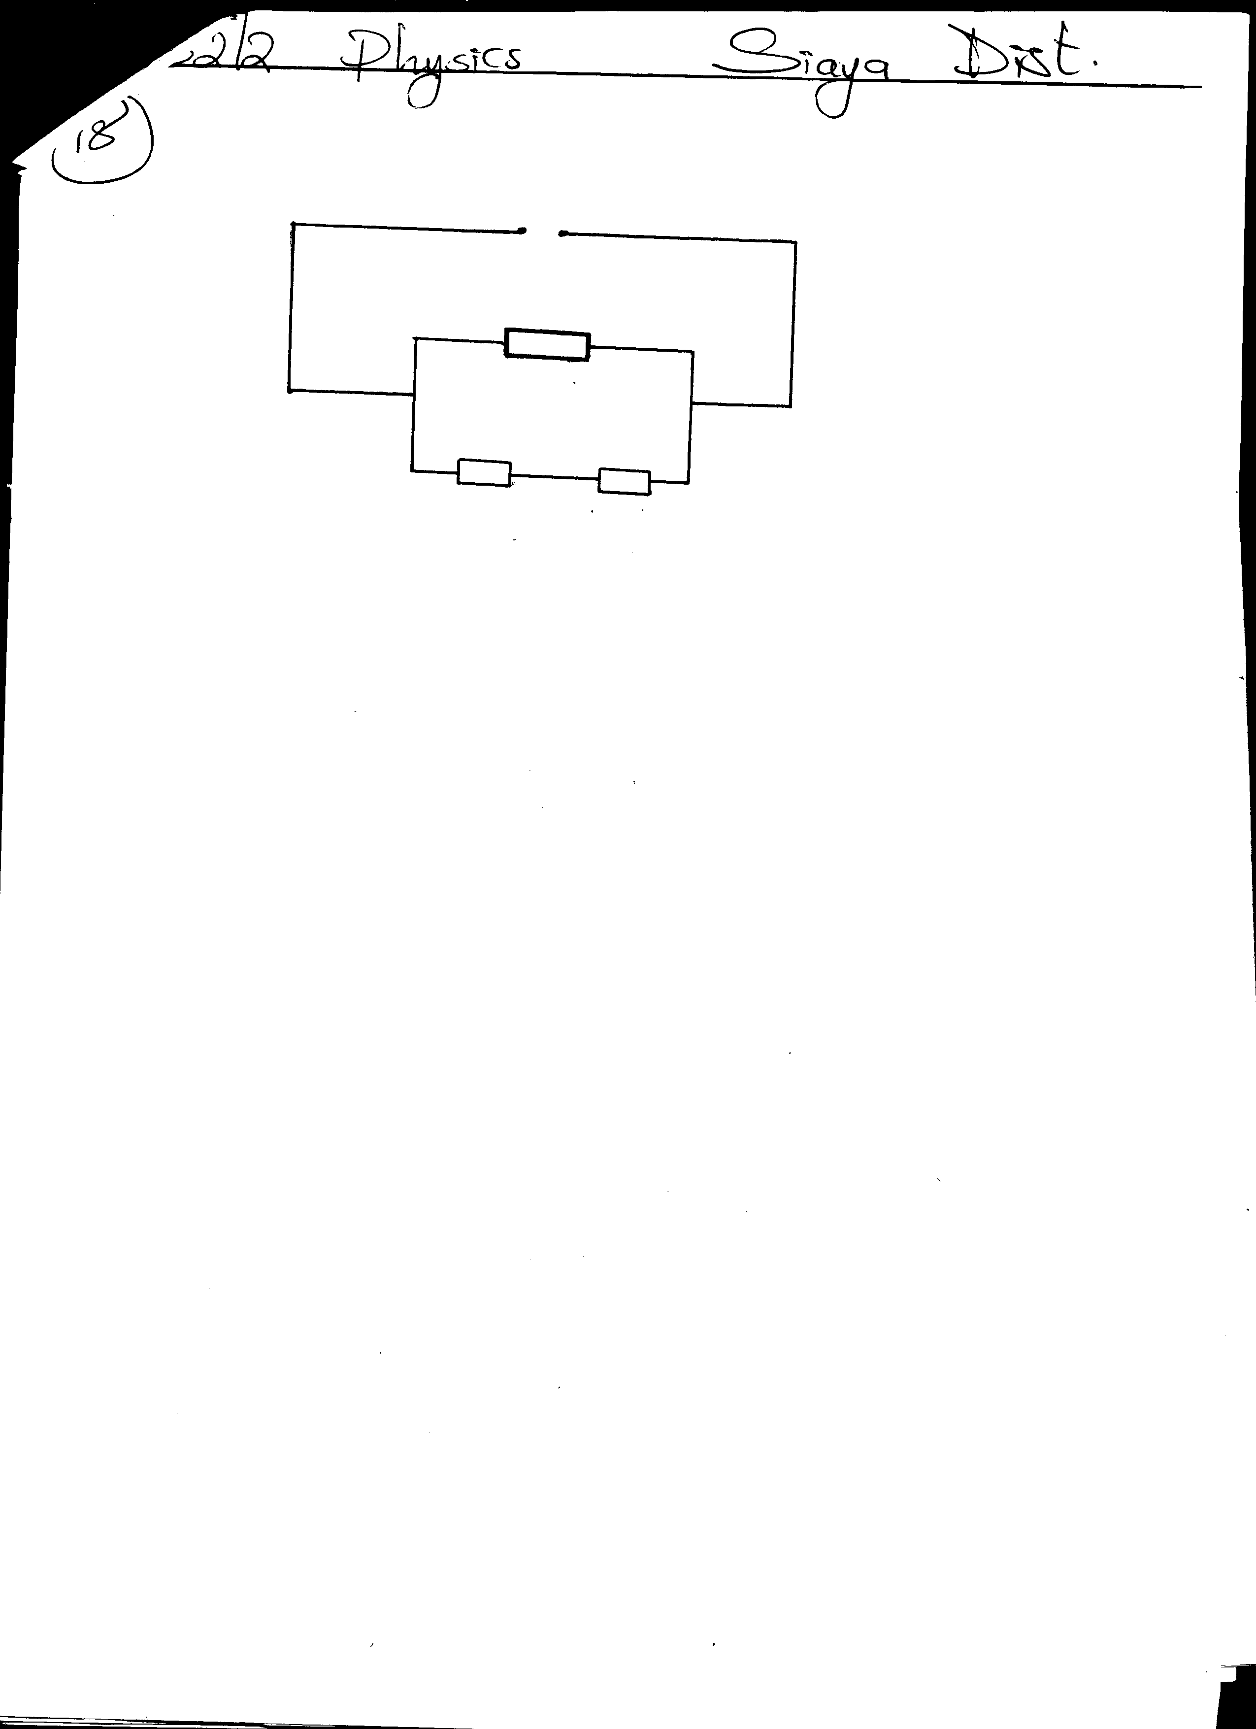
12V
5Ω
4Ω
3Ω

Determine;

i) The effective resistance for the arrangement above. (2mks)

ii) The potential difference across the 3Ω resistor. (3mks)

b) The figure below shows part of the circuit containing two capacitors C₁ and C₂.
C₁=2μF
C₂
P
Q

If C₁=2μF and the Pd across PQ is 150V while the total charge in the capacitors is 1.8x10⁻⁴ coulombs. Determine the capacitance of C₂. (4mks)

