**Name: …………………………………………………………… Admission No. ………………………**

**School: …………………………………………………………. Candidate’s Sign. …………...............**

**Date: ………………………………….**

**232/2**

**PHYSICS**

**PAPER 2**

**TIME: 2 HOURS**

**SET 6**

**FORM THREE**

**INSTRUCTIONS TO CANDIDATES:**

* *Write your* ***name*** *and* ***index number*** *in the spaces provided above*
* *This paper consists of* ***two*** *sections* ***A*** *and* ***B.***
* *Answer* ***all*** *questions in section* ***A*** *and* ***B*** *in the spaces provided.*
* *All working* ***must*** *be clearly shown in the spaces provided.*
* *Scientific calculators and KNEC Mathematical tables may be used.*

**For Examiners’ Use Only**

|  |  |  |  |
| --- | --- | --- | --- |
| **SECTION** | **QUESTION** | **MAXIMUM SCORE** | **CANDIDATE’S SCORE** |
| **A** | **1-11** | **25** |  |
| **B** | **12** | **13** |  |
| **13** | **05** |  |
| **14** | **12** |  |
| **15** | **13** |  |
|  | **16** | **12** |  |
|  | **TOTAL** | **80** |  |

*This paper consists of 11 printed pages. Candidates should check to ascertain that all pages are printed as indicated and that no questions are Missing*

**SECTION A ( 25 MARKS)**

***Answer all the questions in this section in the spaces provided***

1. Sketch a distance –time graph of a wave of amplitude 0.75cm and frequency 2Hz over a time

Interval of 2 seconds in the space provided below. (2 marks)

………………………………………………………………………………………………………..

………………………………………………………………………………………………………..

………………………………………………………………………………………………………..

2. Give **one** reason why manganese (IV) oxide is used in a dry cell. (1 mark)

………………………………………………………………………………………………………..

………………………………………………………………………………………………………..

3. Figure 1 below shows reflected rays from an object 0 placed near a plane mirror. Complete the diagram

to show the position of the object and the image. (2 marks)

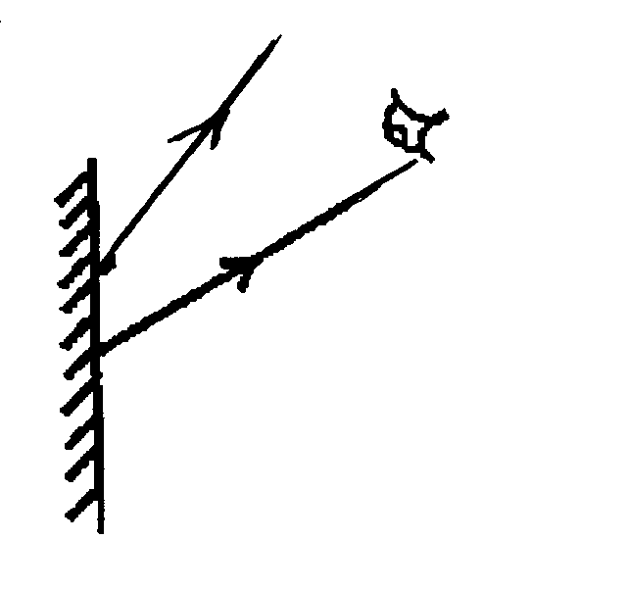

**Fig 1.**

4. A magnetized bar is passed over a Bunsen flame several times. When tested its found to be demagnetized

explain this observation. (2 marks)

………………………………………………………………………………………………………..

………………………………………………………………………………………………………..

5. The figure 2 below shows a vertical object, 0 placed in front of a convex mirror. On the same diagram,

draw the appropriate rays and locate the Image formed (2 marks)

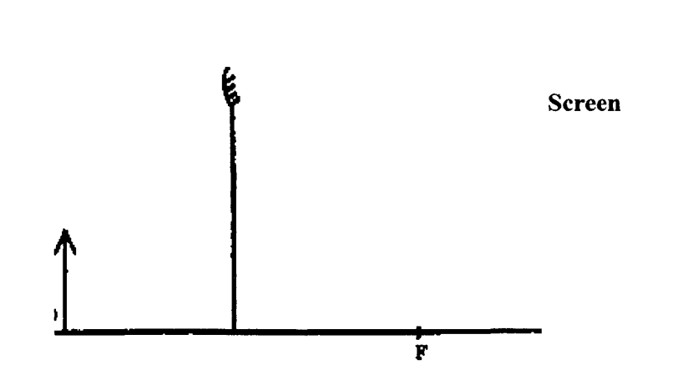

**Fig.2**

6. The ammeter in the figure 3 below reads O.20A when the switch S is closed. Determine the internal

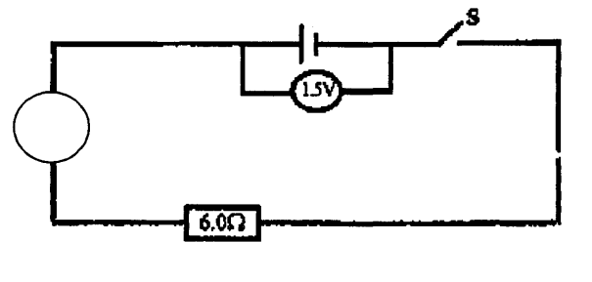 resistance of the cell. (3 marks)

**A**

7. The refractive index of paraffin is 1.47 and that of glass is 1.45. Determine the critical angle of

a ray traveling from the glass to paraffin. (3marks)

………………………………………………………………………………………………………..

………………………………………………………………………………………………………..

………………………………………………………………………………………………………..

………………………………………………………………………………………………………..

8. A negatively charged polythene strip is held close to the point attached to the cap of an electroscope as

shown below in figure 4.

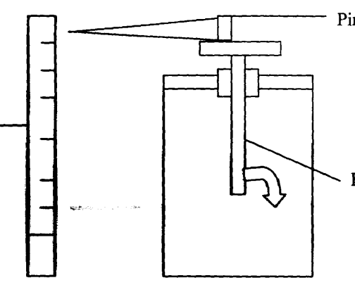

**Pin**

**Polythine strip**

**Fig 4**

**Electroscope**

State what happens to the leaf when the polythene strip is brought near the pin. (2 marks)

………………………………………………………………………………………………………..

………………………………………………………………………………………………………..

9. In an experiment to magnetize two substances **A** and **B** using a current two curves were obtained as

shown below: in fig 5

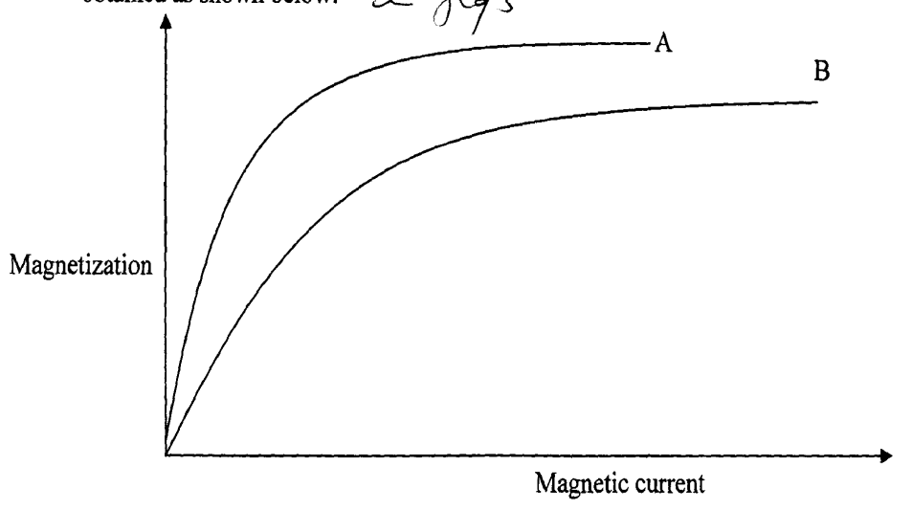

**Fig.5**

Explain the difference between A and B with respect to the domain theory. (2 marks)

………………………………………………………………………………………………………..

………………………………………………………………………………………………………..

10. The figure 6 shows the displacement of a particle in a progressive wave incident on a boundary between

deep and shallow regions.

Shallow

Deep

(i) Complete the diagram to show what is observed after the boundary (2 marks)

………………………………………………………………………………………………………..

………………………………………………………………………………………………………..

(ii) Explain the observation (1 mark)

………………………………………………………………………………………………………..

………………………………………………………………………………………………………..

11. A disc siren has 120 holes and rotated at a constant speed making 0.2 rev/s. If air is blown towards the

holes sound is produced:

(a) Calculate the frequency of sound produced (2mark)

(b) What is the effect of blocking every alternate hole? (1 mark)

………………………………………………………………………………………………………..

………………………………………………………………………………………………………..

**SECTION B (55 MARKS)**

***Answer all the questions in this section in the space provided***

12.Study the circuit diagram below and answer the questions that follow.

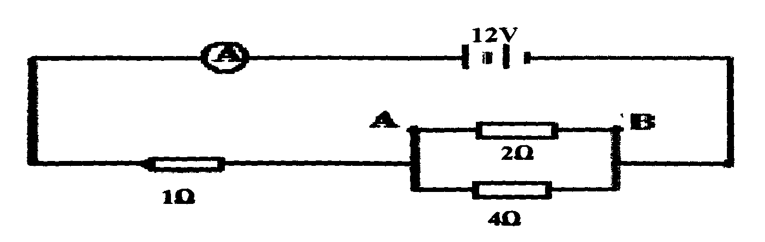

(a) Calculate

(I) The current flowing through the ammeter. (3mks)

(ii) The P.d. across AB (2mks)

(iii) The current through the 4Ω resistor (2mks)

(b) The graph below shows the relationship between voltage and the current obtained from an experiment

performed by form four students

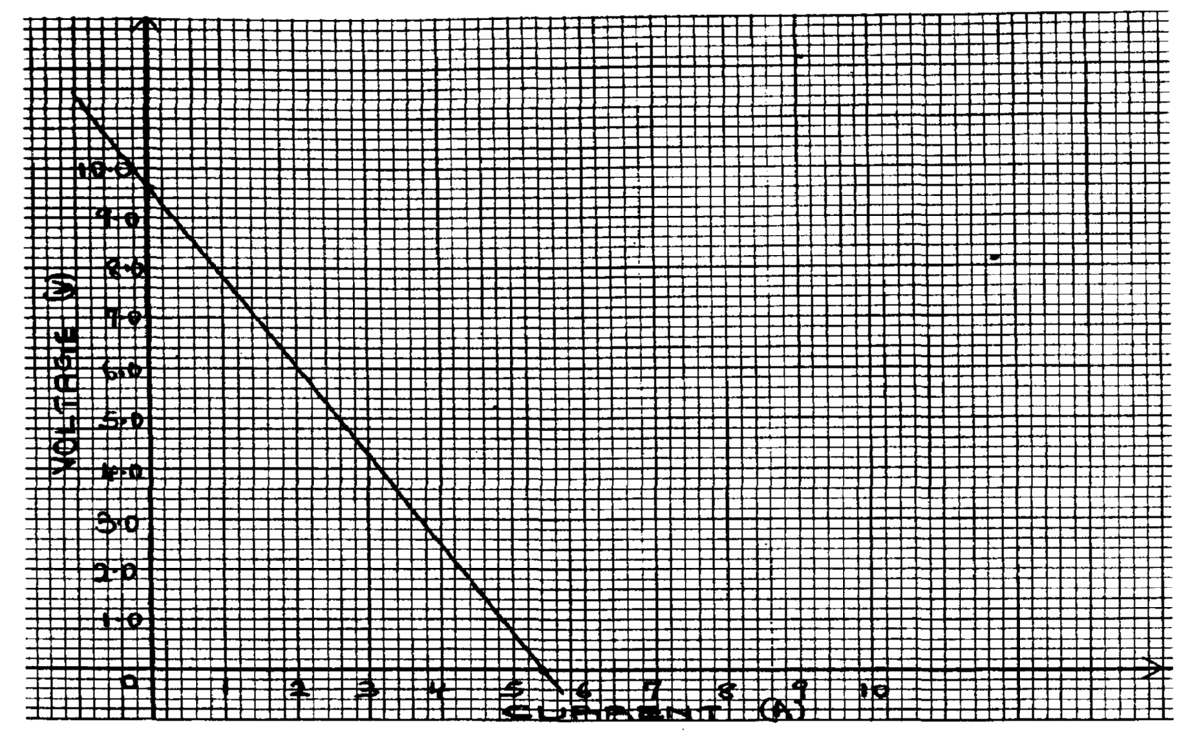

1. Draw the circuit that could be used to obtain the results shown on the graph. (2marks)
2. From the graph determine the e.m.f. ( 1 mk)
3. Determine the internal resistance of the battery (3mks)

13. (a) In an experiment to observe interfence of light waves a double slit is placed close to the source as

shown in fig 8 below

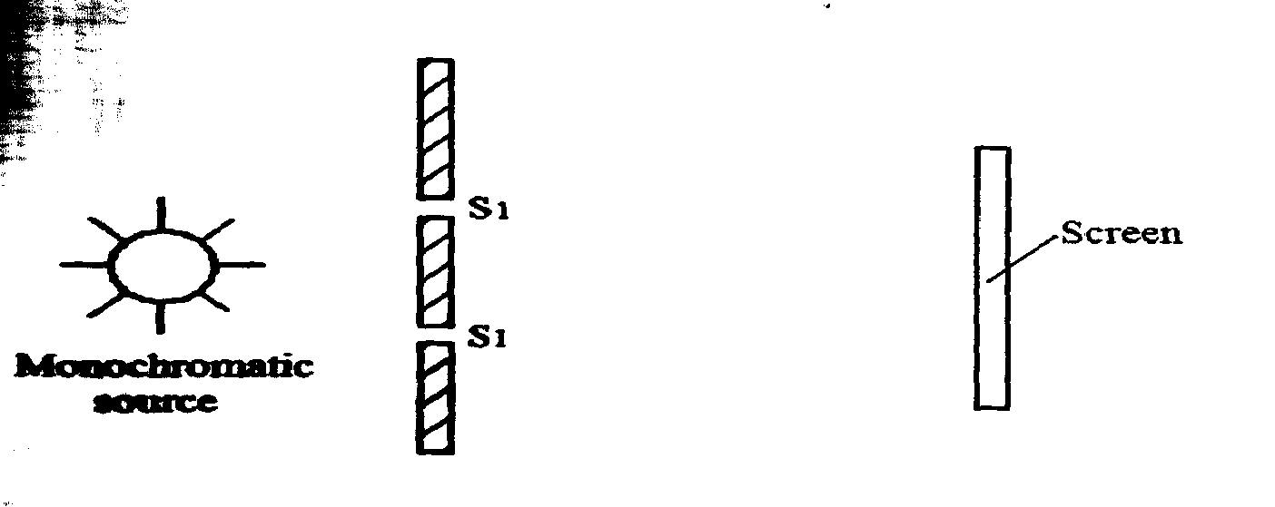

monochromatic source

(i) What is monochromatic Source. (1mk)

………………………………………………………………………………………………………..

………………………………………………………………………………………………………..

(ii) State the function of the double slit (1mk)

………………………………………………………………………………………………………..

………………………………………………………………………………………………………..

(c) Briefly describe what is observed on the screen (lmk)

………………………………………………………………………………………………………..

………………………………………………………………………………………………………..

(d) Briefly explain what is observed on the screen when

(i) The slit separation S1S2 is reduced (lmk)

………………………………………………………………………………………………………..

………………………………………………………………………………………………………..

(ii) White light source is used in place of monochromatic source. (1mk)

………………………………………………………………………………………………………..

………………………………………………………………………………………………………..

14. a) State the motor rule. (1 mark)

………………………………………………………………………………………………………..

………………………………………………………………………………………………………..

b) Sketch the resultant field pattern around the following current carrying conductors and show the

direction of the forces acting on the conductors. (2marks)

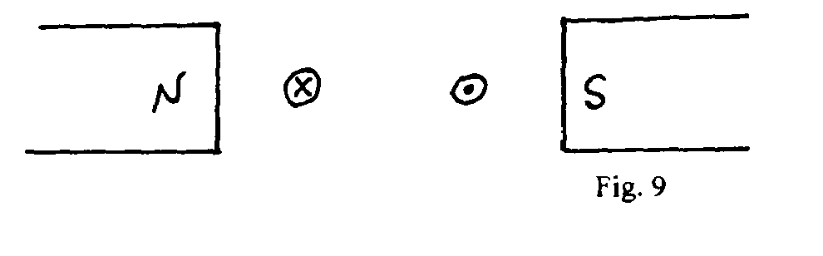

Fig. 9

c) Figure 10 shows an electric bell.

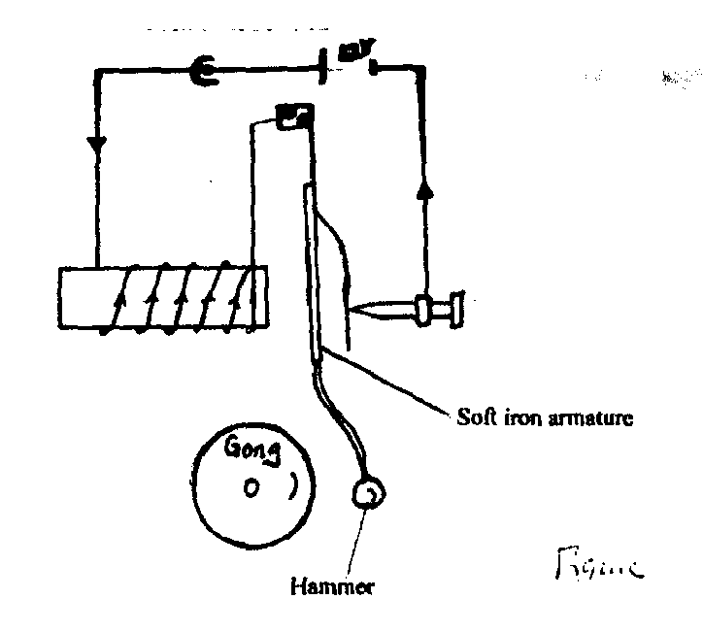 Push button switch

**Figure 10**

Soft iron armature

Hammer

i) Describe how the electric bell works

………………………………………………………………………………………………………..

………………………………………………………………………………………………………..

(ii) State what would happen if the armature is made of steel

………………………………………………………………………………………………………..

………………………………………………………………………………………………………..

iii) What adjustment should be done to the system to make it operate effectively with a lower

voltage battery? (1 mark)

d) Explain briefly how a loud speaker can be used as a microphone. (3 marks)

………………………………………………………………………………………………………..

………………………………………………………………………………………………………..

………………………………………………………………………………………………………..

………………………………………………………………………………………………………..

15 (a) (i) State **two** properties of electric field lines. (2mks)

………………………………………………………………………………………………………..

………………………………………………………………………………………………………..

………………………………………………………………………………………………………..

………………………………………………………………………………………………………..

(ii) With the help of a diagram explain how a lightning arrestor works. (4mks)

………………………………………………………………………………………………………..

………………………………………………………………………………………………………..

………………………………………………………………………………………………………..

………………………………………………………………………………………………………..

………………………………………………………………………………………………………..

………………………………………………………………………………………………………..

(b) (i) Define the term capacitance of a capacitor. (1 mk)

………………………………………………………………………………………………………..

………………………………………………………………………………………………………..

(ii) Other than area of overlap of plates and the separation distance between plates. State any

other factor that affects the capacitance of a capacitor. (1 mk)

………………………………………………………………………………………………………..

………………………………………………………………………………………………………..

(iii) Write down an equation relating three factors in b(ii) above to the capacitance of a capacitor. (1 mk)

………………………………………………………………………………………………………..

………………………………………………………………………………………………………..

(c) 2 F capacitor is charged to a potential of 200V, then the supply is disconnected. The capacitor is then

connected to another uncharged capacitor. The potential difference across the parallel arrangement is

80V. Find the capacitance of the second capacitor. (4mks)

16. a) The graph figure 11 below shows the relationship between I/u and I/v for a converging mirror where u

and v are the object and image distances respectively.

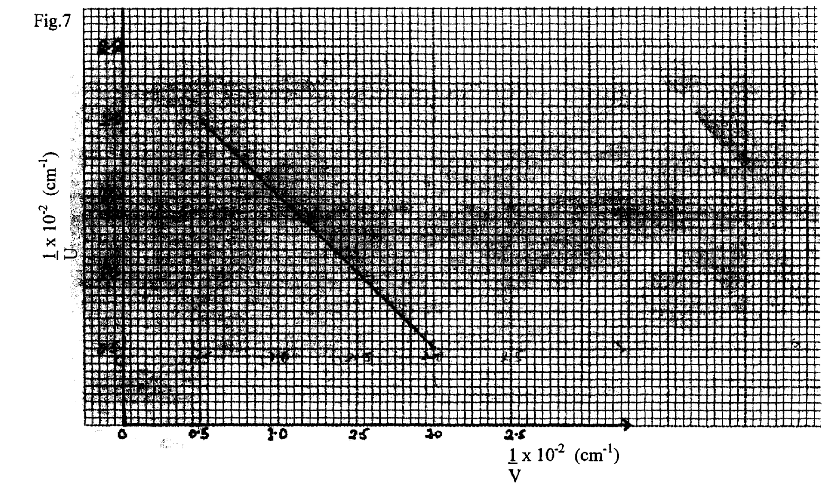

**figure 11**

a) From the graph, determine the focal length, f of the mirror (5mks)

b) State **two** conditions necessary for total internal reflection to occur. (2mks)

………………………………………………………………………………………………………..

………………………………………………………………………………………………………..

c) The figure l2 below shows the path of a ray of light passing through a rectangular block of Perspex placed

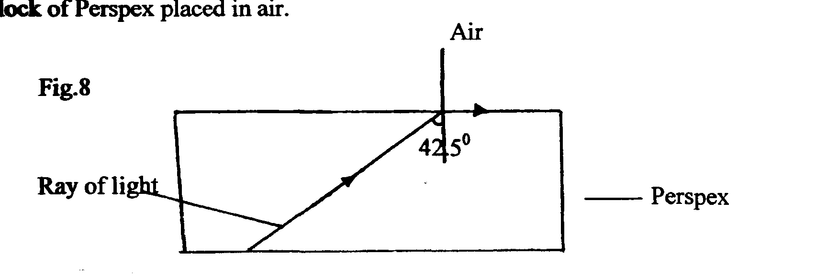 in air.

42.5o

(i) Calculate the refractive index of Perspex. (2mks)

(ii) A ray of light now travels from a transparent medium of refractive index 2.4 into the Perspex as

shown below in figure 13

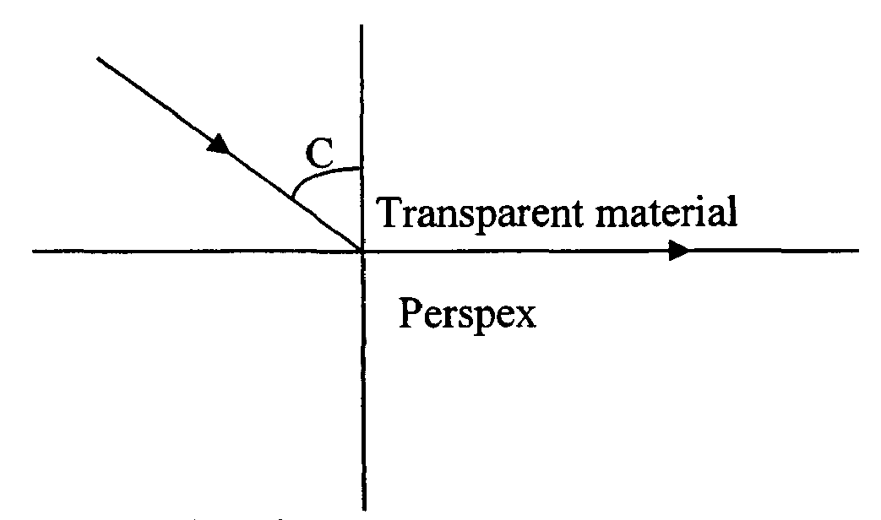

(i)Calculate the critical angle, C. (3mks)