**SET 8**

**PHYSICS PAPER 2**

**MARKING SCHEME**

1.

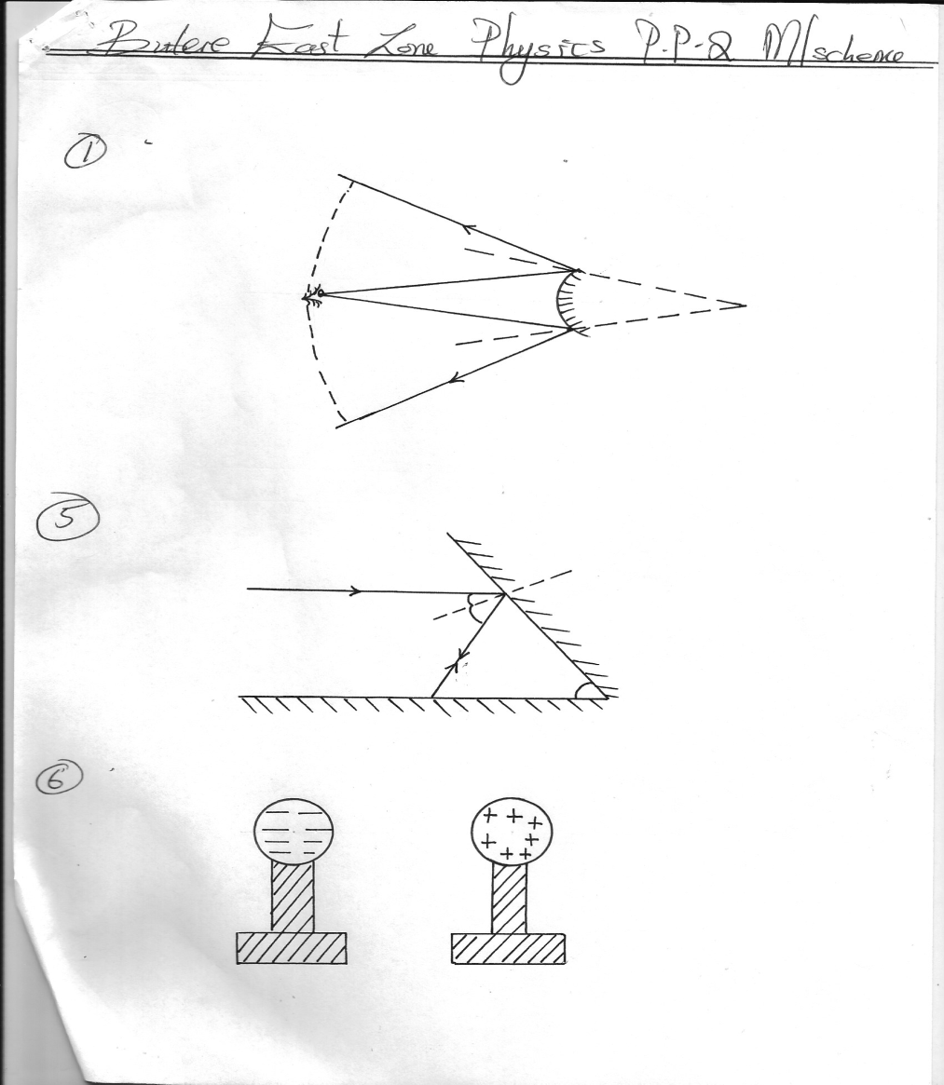

Wider field of view

½ mk-normal

½ mks-rays

1mrk-wide field of view

normal

2. ni Sin1 =n2Sin2 √1

1.33 x Sin 30 = n2 Sin 24√1

n2 = 1.33 x sin 30

sin 24

= 1.33 x 0.5

0.4067

n2 = 1.635 √1

3. 2d = s√1

t

= 2x 600

3.5

= 342.86m/s

4. Used in shielding of machine sensitive to magnetism√1

5.

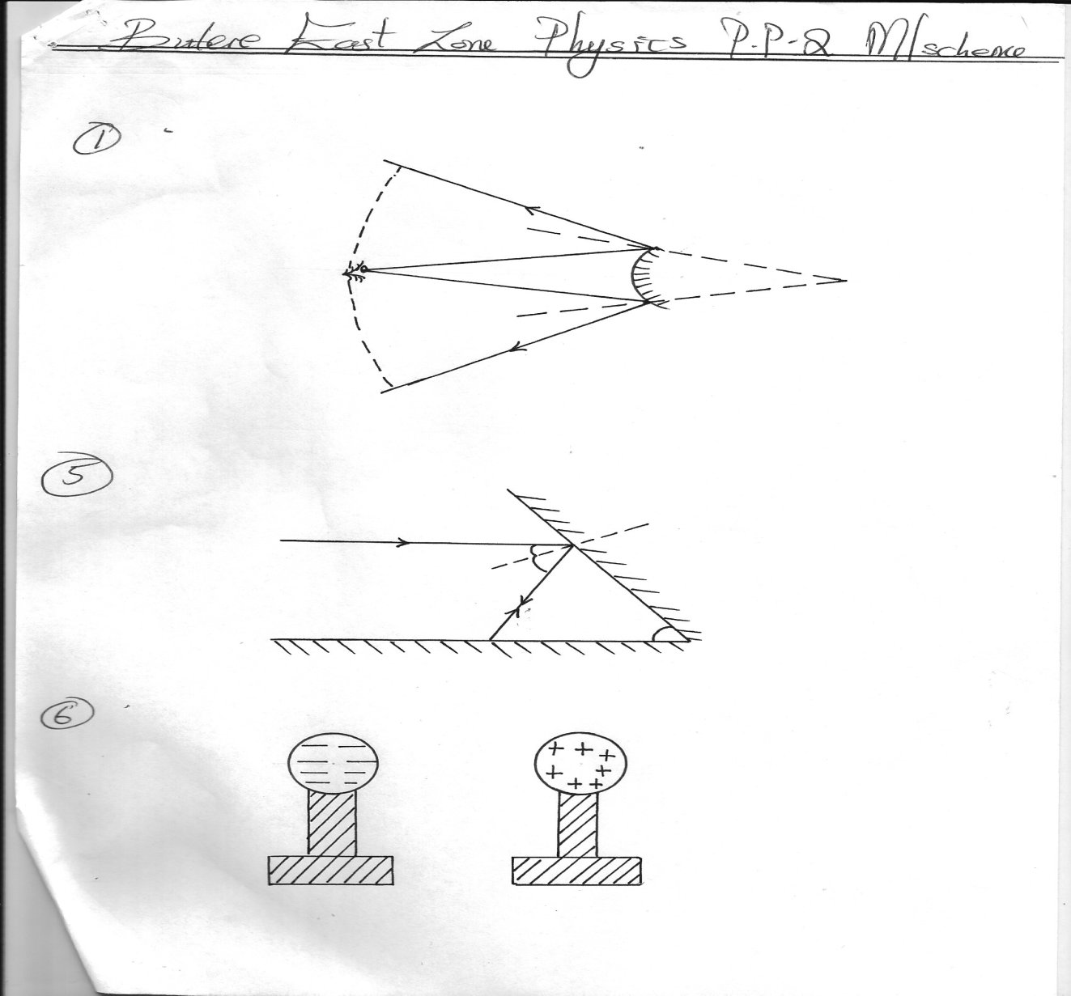

45o

45o

45o

M2

M1

B

A

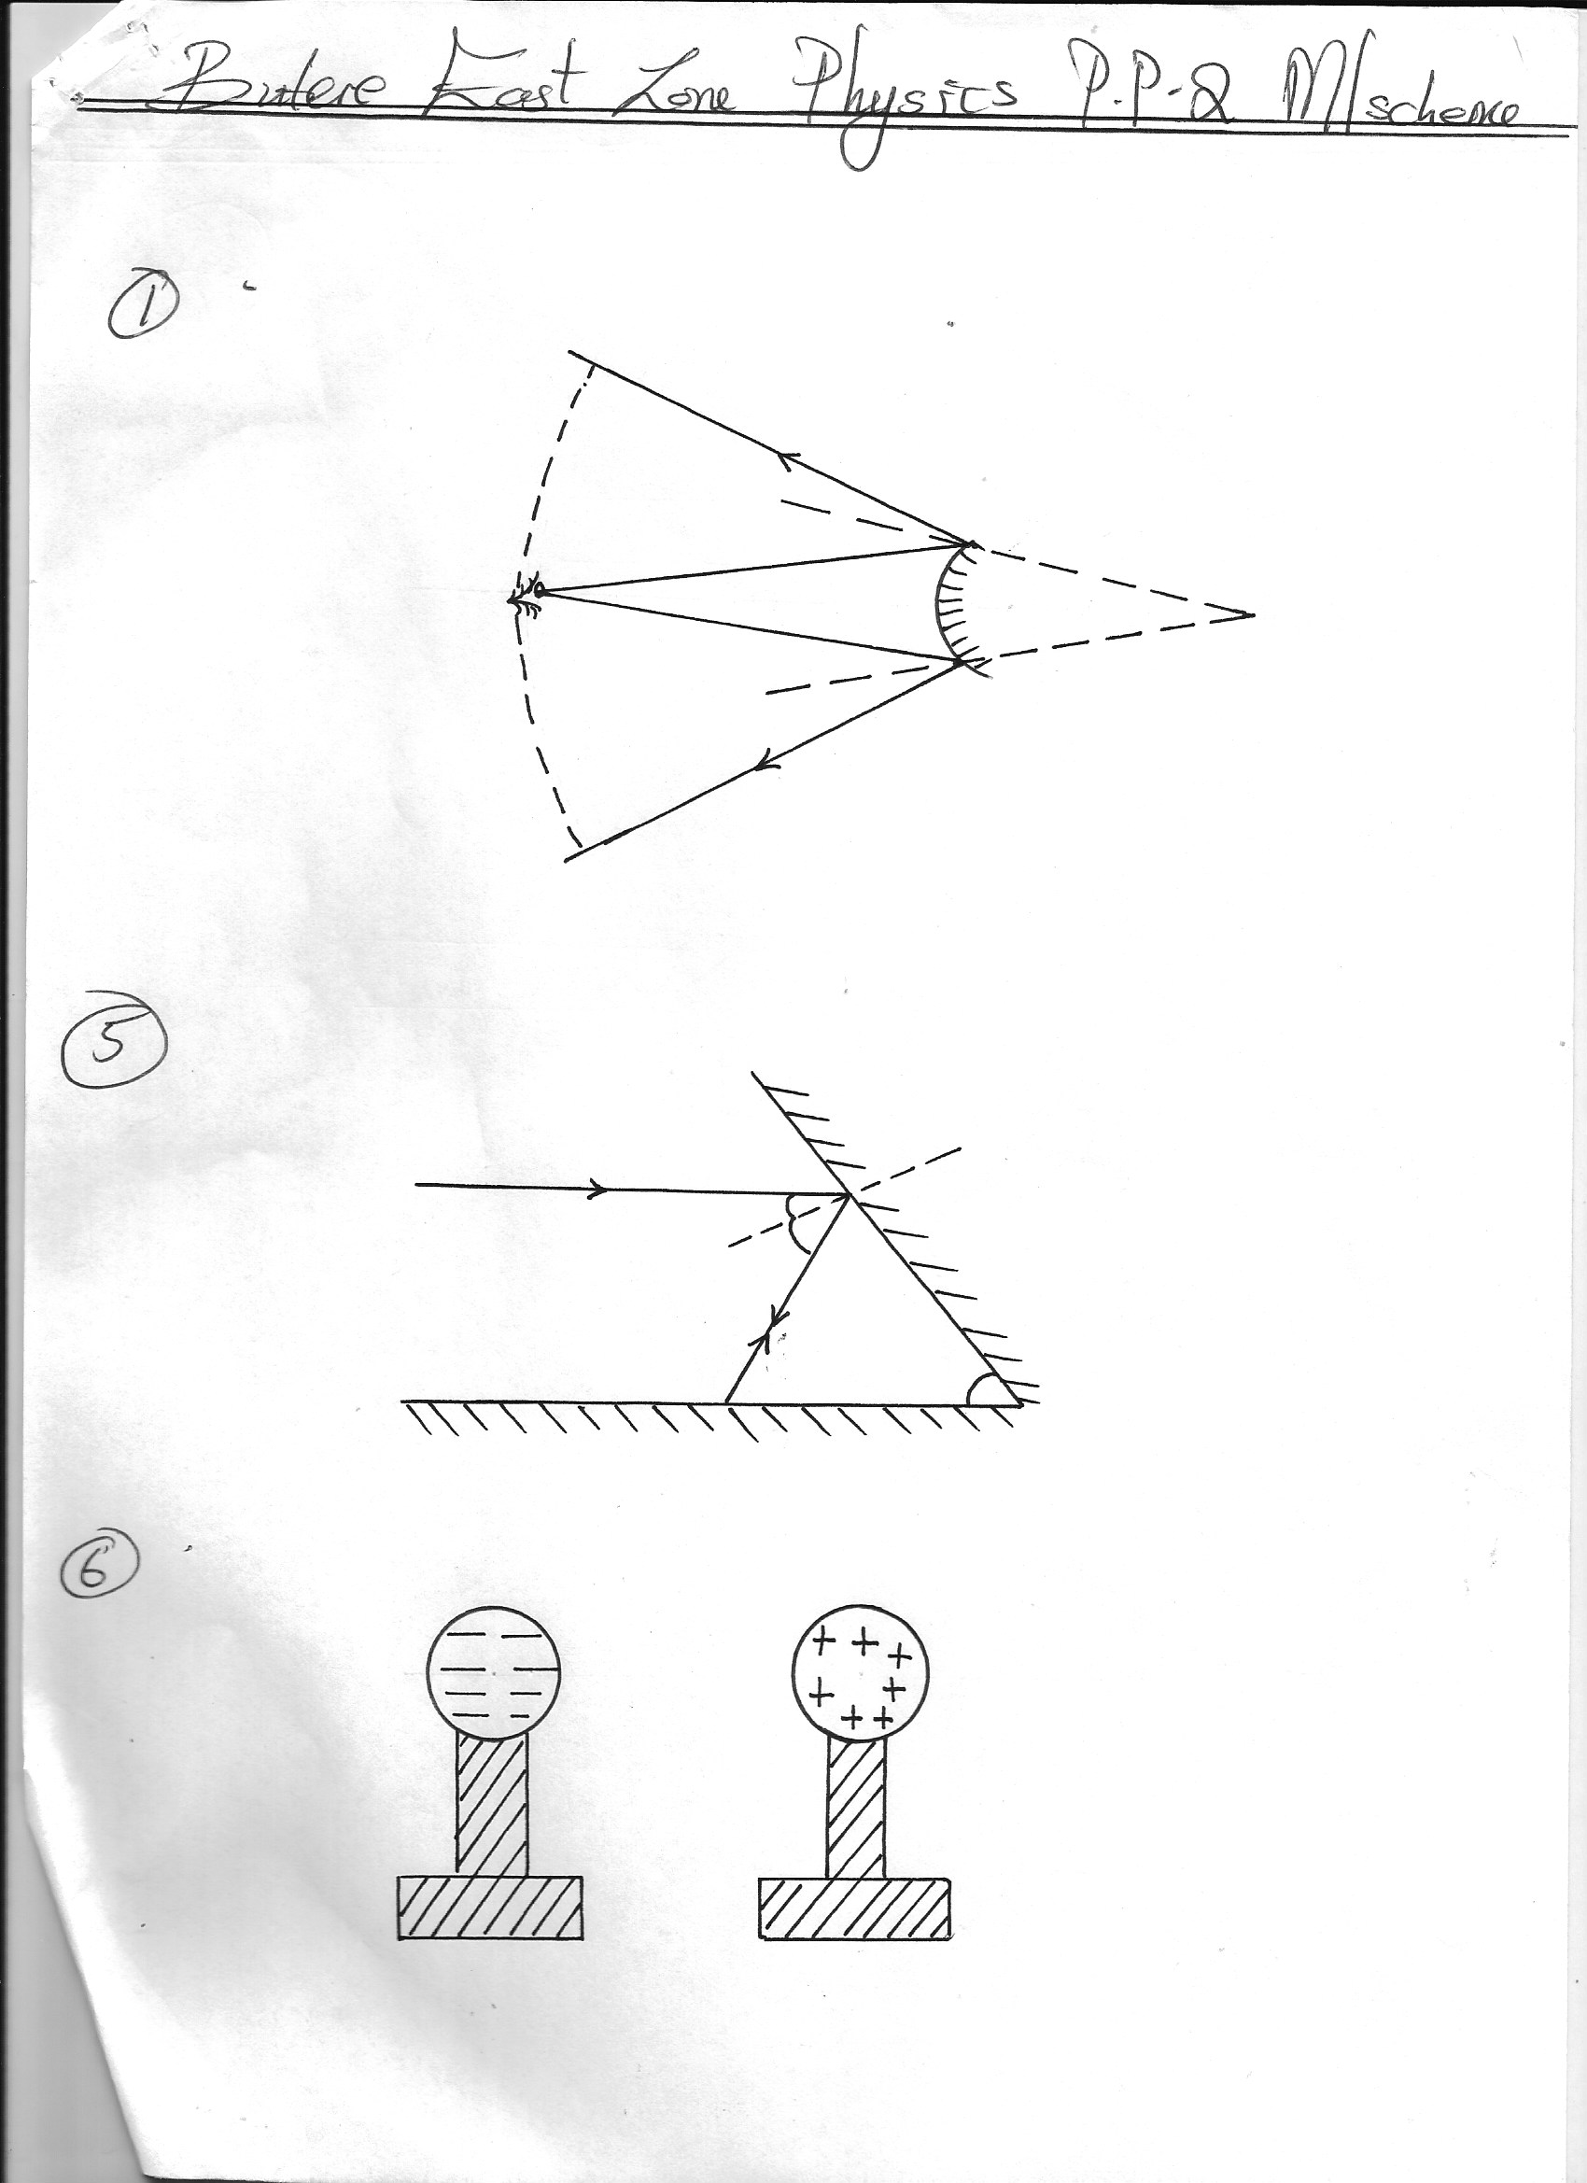6.

7. T = 8 x 10-2S

f = 1

8x 10-2

=12.5HZ √1

ﻼ = v/f

125 m/s

12.5s-1 √1

= 10m √1

8. When the voltage falls down below 1.8V√1

When the relative density of the electrolyte falls below 1.12 √1

9. Emf is the voltage across the cell when supply 90 current while p.d is the voltage across the cell supplying current √ 2mrks

10. (a) When is switch is closed, current flows through the circuit and the core becomes magnetized . The electromagnet induces magnetism in the soft iron armature, which is the attracted to the poles of the√1 electromagnet. The hamener attached to the a mature thus strike the gong√1

(b) 1. The straight core can be replaced by the u-shaped core

2. Increase number of turns (any 1√ 1mrk)

11. - Large current can be drawn from them

- They can be kept in a discharged condition for a very long time before the cells is ruined

(any 1=1mrk)

***SECTION B (55MARKS)***

12. (a) (i) State that like poles repel, and unlike poles attract

(ii) - Repulsion occurs only for like poles

* Attraction occurs for both unlike poles ,and poles of a magnet and a magnetic material.

(iii) Steel is a material that takes long to be magnetized and retains its magnetism for equally a long time while soft Iron are easily magnetized and at the same , they lose their magnetism easily√1

(iv) Because as the current flowed through the steel bar the domains were being aligned in the same direction√1 hence magnetizing the steel bar. The strength of the magnet could not, Increases further since all the domains were aligned in the same direction hence magnetically saturated.√1

(v) 1. By hammering the magnet in an east –west direction√1

2. By heating and cooling the magnet √1

(b) (i)

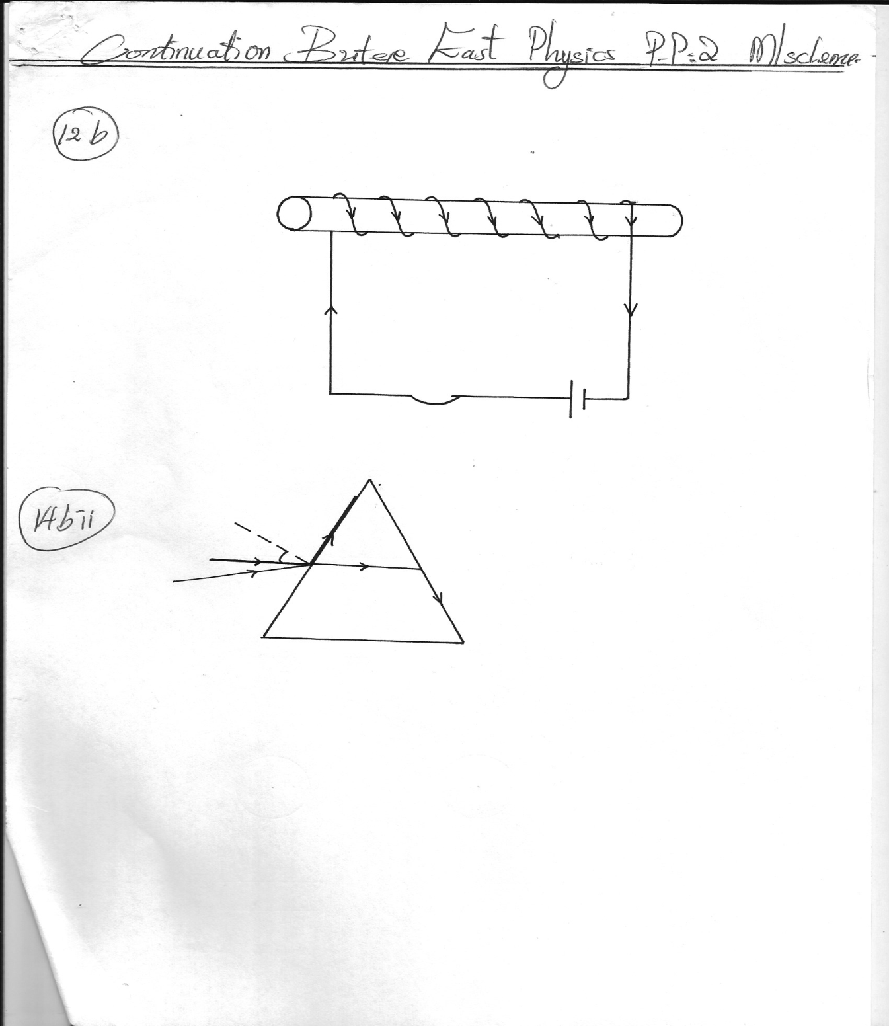

**x**

**y**

(ii) X -North

Y – South

(iii) 1. By Increasing the number of turns on the solenoid

2. By Increasing the amount of current passing through the wire

3. By Reducing the length of the core of the solenoid

4. Using a suitable shape of the core i.e the u-shaped core (Any 2mrks)

13. (a) States that the current flowing through a conductor is directly proportional to the difference across it provided the temperature and other physical condition are kept constant.

(b) (i) On the graph

(ii) (I) Slope = -1/ ﻻ√1 E = V + I

-1/ﻻ = -1.206 I = E –v/ﻻ

ﻻ = 0.829Ω

(II) emf = X – Intercept

= 15 x 10-2V

(c) Rr = R1 + R2

= 16 +4 =20Ω

=8 + 12

= 20Ω √½

1 = 1 + 1

R1 R1  R2

= 1 + 1 = 2 + 1

20 20 20 10

R1 =10Ω √ ½

SERIES = R1 +R2√

=10 + 8 √ ½ = 18Ω √1 (3mrks)

14. (a) 1. The rays must be moving from a more optically dense medium to a less optically dense medium

2. The angle of incidence should be greater than critical angle√1

(b) (i) ang = C/V

3.0 x 108

1.88 x 108

= 1.596

(ii)

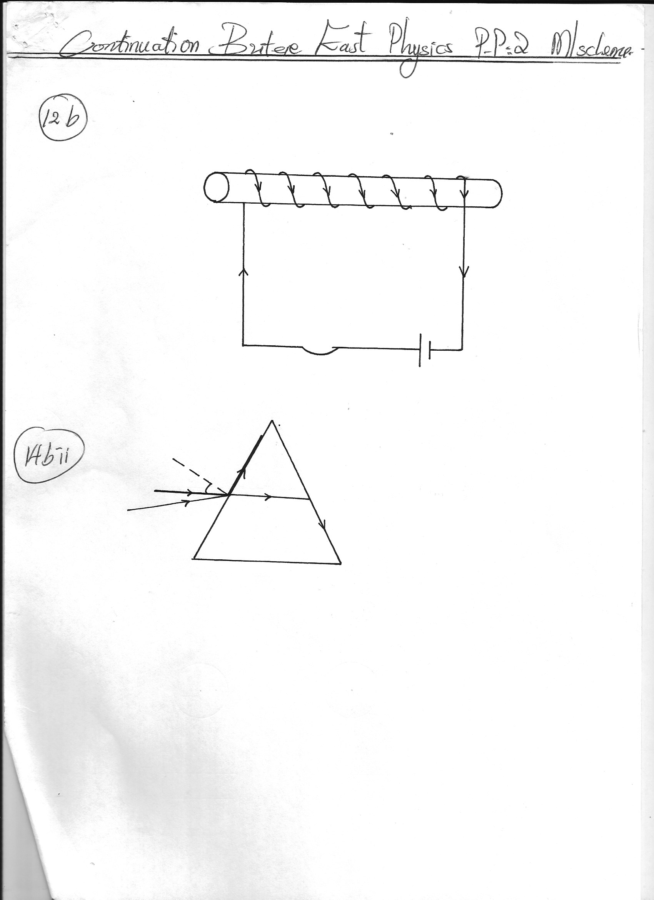

n = 1

Sin C

Sin C = 1/η

1/1.596 √1 =38.80√1

(iii) Sin ө = ang√1

Sin r

Sin ө = 1.596 Sin 31.2o√1

= 55.77o

15. (a) (i) q = CIV√1

= 0.3Μf = 4.5 V√1

= 1.35 μC√1

(ii) CT = C1 + C2

= 0.3 + 0.5

= 0.8 Μf

(b) (i) Voltmeter, reading = 4.5V

(ii) Voltmeter reads 4.5V and then the reading goes down

(iii) Capacitor C1 shares a charges with C2. Since q =CV , and the values of C1 and C2 remains constant, it implies that when charges q reduces ,V must also reduce , hence the voltmeter goes down.

(c) (i) The reading on the millimeter is initially high but gradually reduces to zero

(ii)

+A

-B

R

When the capacitor is connected to the battery, negative charges flow from negative terminals of the battery to plate B of the capacitor as shown in the figure. At the same rate, negative charges flow from the other plate A of the capacitor towards the positive terminals of the battery. Due to this equals positive and negative charges appears on the plate and opposes the flow of electrons which causes them

(d) (i) The p.d across R become zero . This is because there is no current flowing when the capacitor is fully charged (V =0)

(ii) As the charge increases, the potential difference across the capacitor plate increases ,when the charging current reduces to zero, the potential difference across the plate will be the same as the battery voltage that is 5√.

16. (a) Longitudinal waves the vibration of particles is in the direction parallel to the direction of the wave travel in transverse. Waves the vibration of the particles is at right angles to the direction of the wave travel √ 2mrks

(b) (i) Intensity of sound heard reduces√1

(ii) Intensity of sound heard increases √1

(iii) - Some sound is transmitted through the support of the jar.

* It is not possible to pump out all the air from the jar

(Any 1=1mrk)

