**SET 6**

**PHYSICS 232/2**

**MARKING SCHEMES**

**SECTION A**

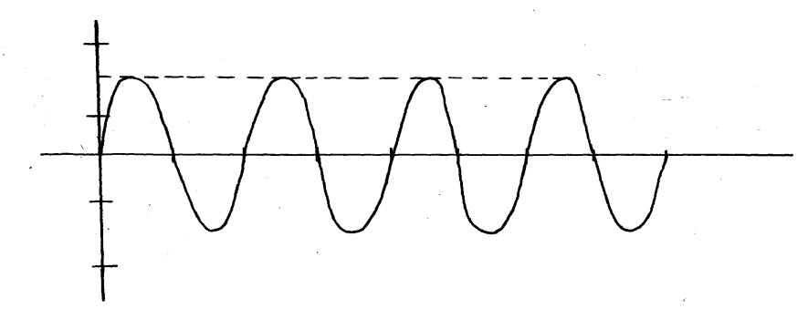1.

Distance (cm)

(cm)

-1.0

-0.5

0.5

1.0

Time sec

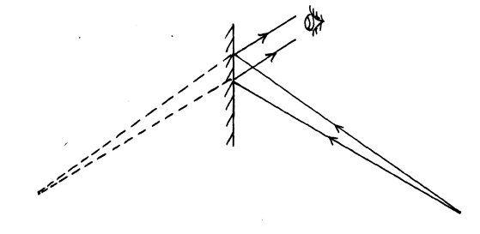2. to minimize polarization

Position of object

.

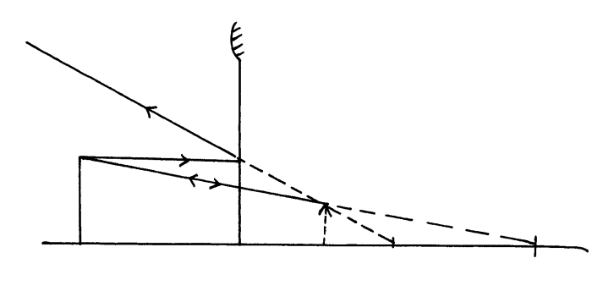3.The heating disorients magnetic dipoles.

**Screen**

4

**C**

**F**

5. E = I ( R+r)

1.5 = 0.2 ( 6 + r)

1.5 -1.2 = 0.2 v

r= 1.5Ω

6.

7. The leaf collapses as the pin discharges positive charges induced on it due to action at a point.

8. A is easily magnetized and forms a stronger magnet.

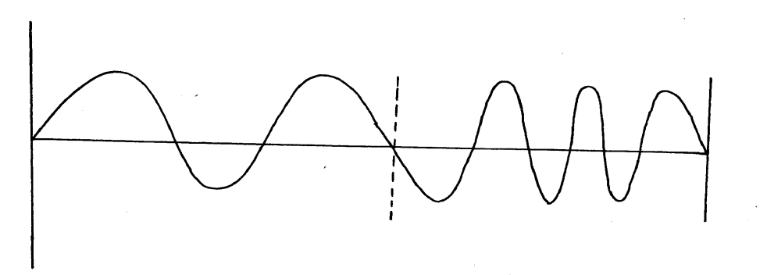9.

**Shallow**

**Deep**

(i)

(ii) Velocity reduce and wave length decreases since the frequency remains the same

Altitude does not change since there is no loss of energy.

10. (a) F = No of holes x rev/s

= 120 x 0.2 = 24Hz

(b) the frequency reduces

11. (a) RT = 1 + 2 x 4 = 1 + 8 = 2.33Ω

I = v = 12 = 5.15A

RT 2.33

1. N = IR = 5.15 x 8

6

= 6.87v

1. I = v = 6.87

R 4

= 1.72A

A

v

(b) (i)

1. E f = 9.6V
2. E = V + Ir

V = Ir + E

- r = gradient of graph

-r = 9.6 – 0

0- 5.4

r = 1.778Ω

1. Light of one colour

(b) to act as a coherent source of waves.

(c) Dark and light fringes are formed.

(e) (i) the distance between the interface pattern is increased because of increase in resolution power.

(ii) A central white fringe is formed followed by coloured fringes.

14. if the left hand is held with the thumb the first finger and the second finger normally at right angles

so that the first finger points the direction of the magnetic field and the second finder in the direction of

the current, the thumb points in the direction of the motion

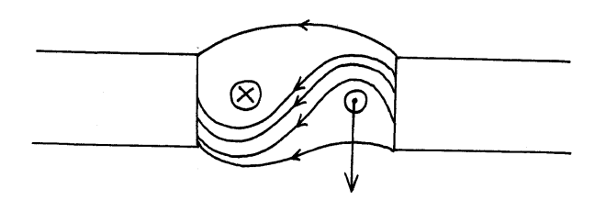(b)

S

N

(c) (i) When the switch is closed current flows and the core is magnetized. The magnetism is induced on the

soft iron armature which is then attracted. The harmer then strikes the gong. Attraction

of the armature makes the contact the magnetism does off and the armature returns

1. Strike once
2. Increase the no of turns.

(d)

15(a) they leave the surface of a charged body at right angles

They are directed away from positive charges and towards the negative charges

The closer the field lines the stronger the field there.

(ii) The moving clouds get charged by friction; when a charged cloud passes over a lightning arrestor it induces an opposite charged on it. Because of the structure of the arrestor at the top it releases charges due to action at a point into the air which discharges the charged cloud as shown in the diagram

The arrestor acts as a easy way of discharging the clouds because it is a good conductor.

(b) (i) the charge stored per unit voltage.

(ii) The type of dielectric material between the plates

1. C = εd

A

(c) charge stored when both capacitors are connected

Q = CV = 4.0 x 10-4

Total C = 2 x 10-6 + C2

Hence

4.0 x 10-4 = ( 2.0 x 10 -6 +C2) 80

C2 = 4.0 x 10-5 F

16. at 1/u intercept = 0, 1/v = 2.5 x 10-2cm-1

∴ 1/f = 1/v = 2.5 x 10-2 cm-1

F = ( 2.5 x 10 -2) cm

= 40cm

(b) Light must be travelling from a denser medium to a less dense /rarer

- the angle of incidence must be greater than the aritificial angle

(c) (i) n = sin 90 = 1

sin C sin C

= 1

Sin 42.5 = 1.48

Sin C = 1 2 = 1 9 x 9 2

= ½.4 x 1.48

= 0.6167

C= 38.07o