SET 5
232/2
PHYSICS
PAPER 2
MARKING SCHEME

1.
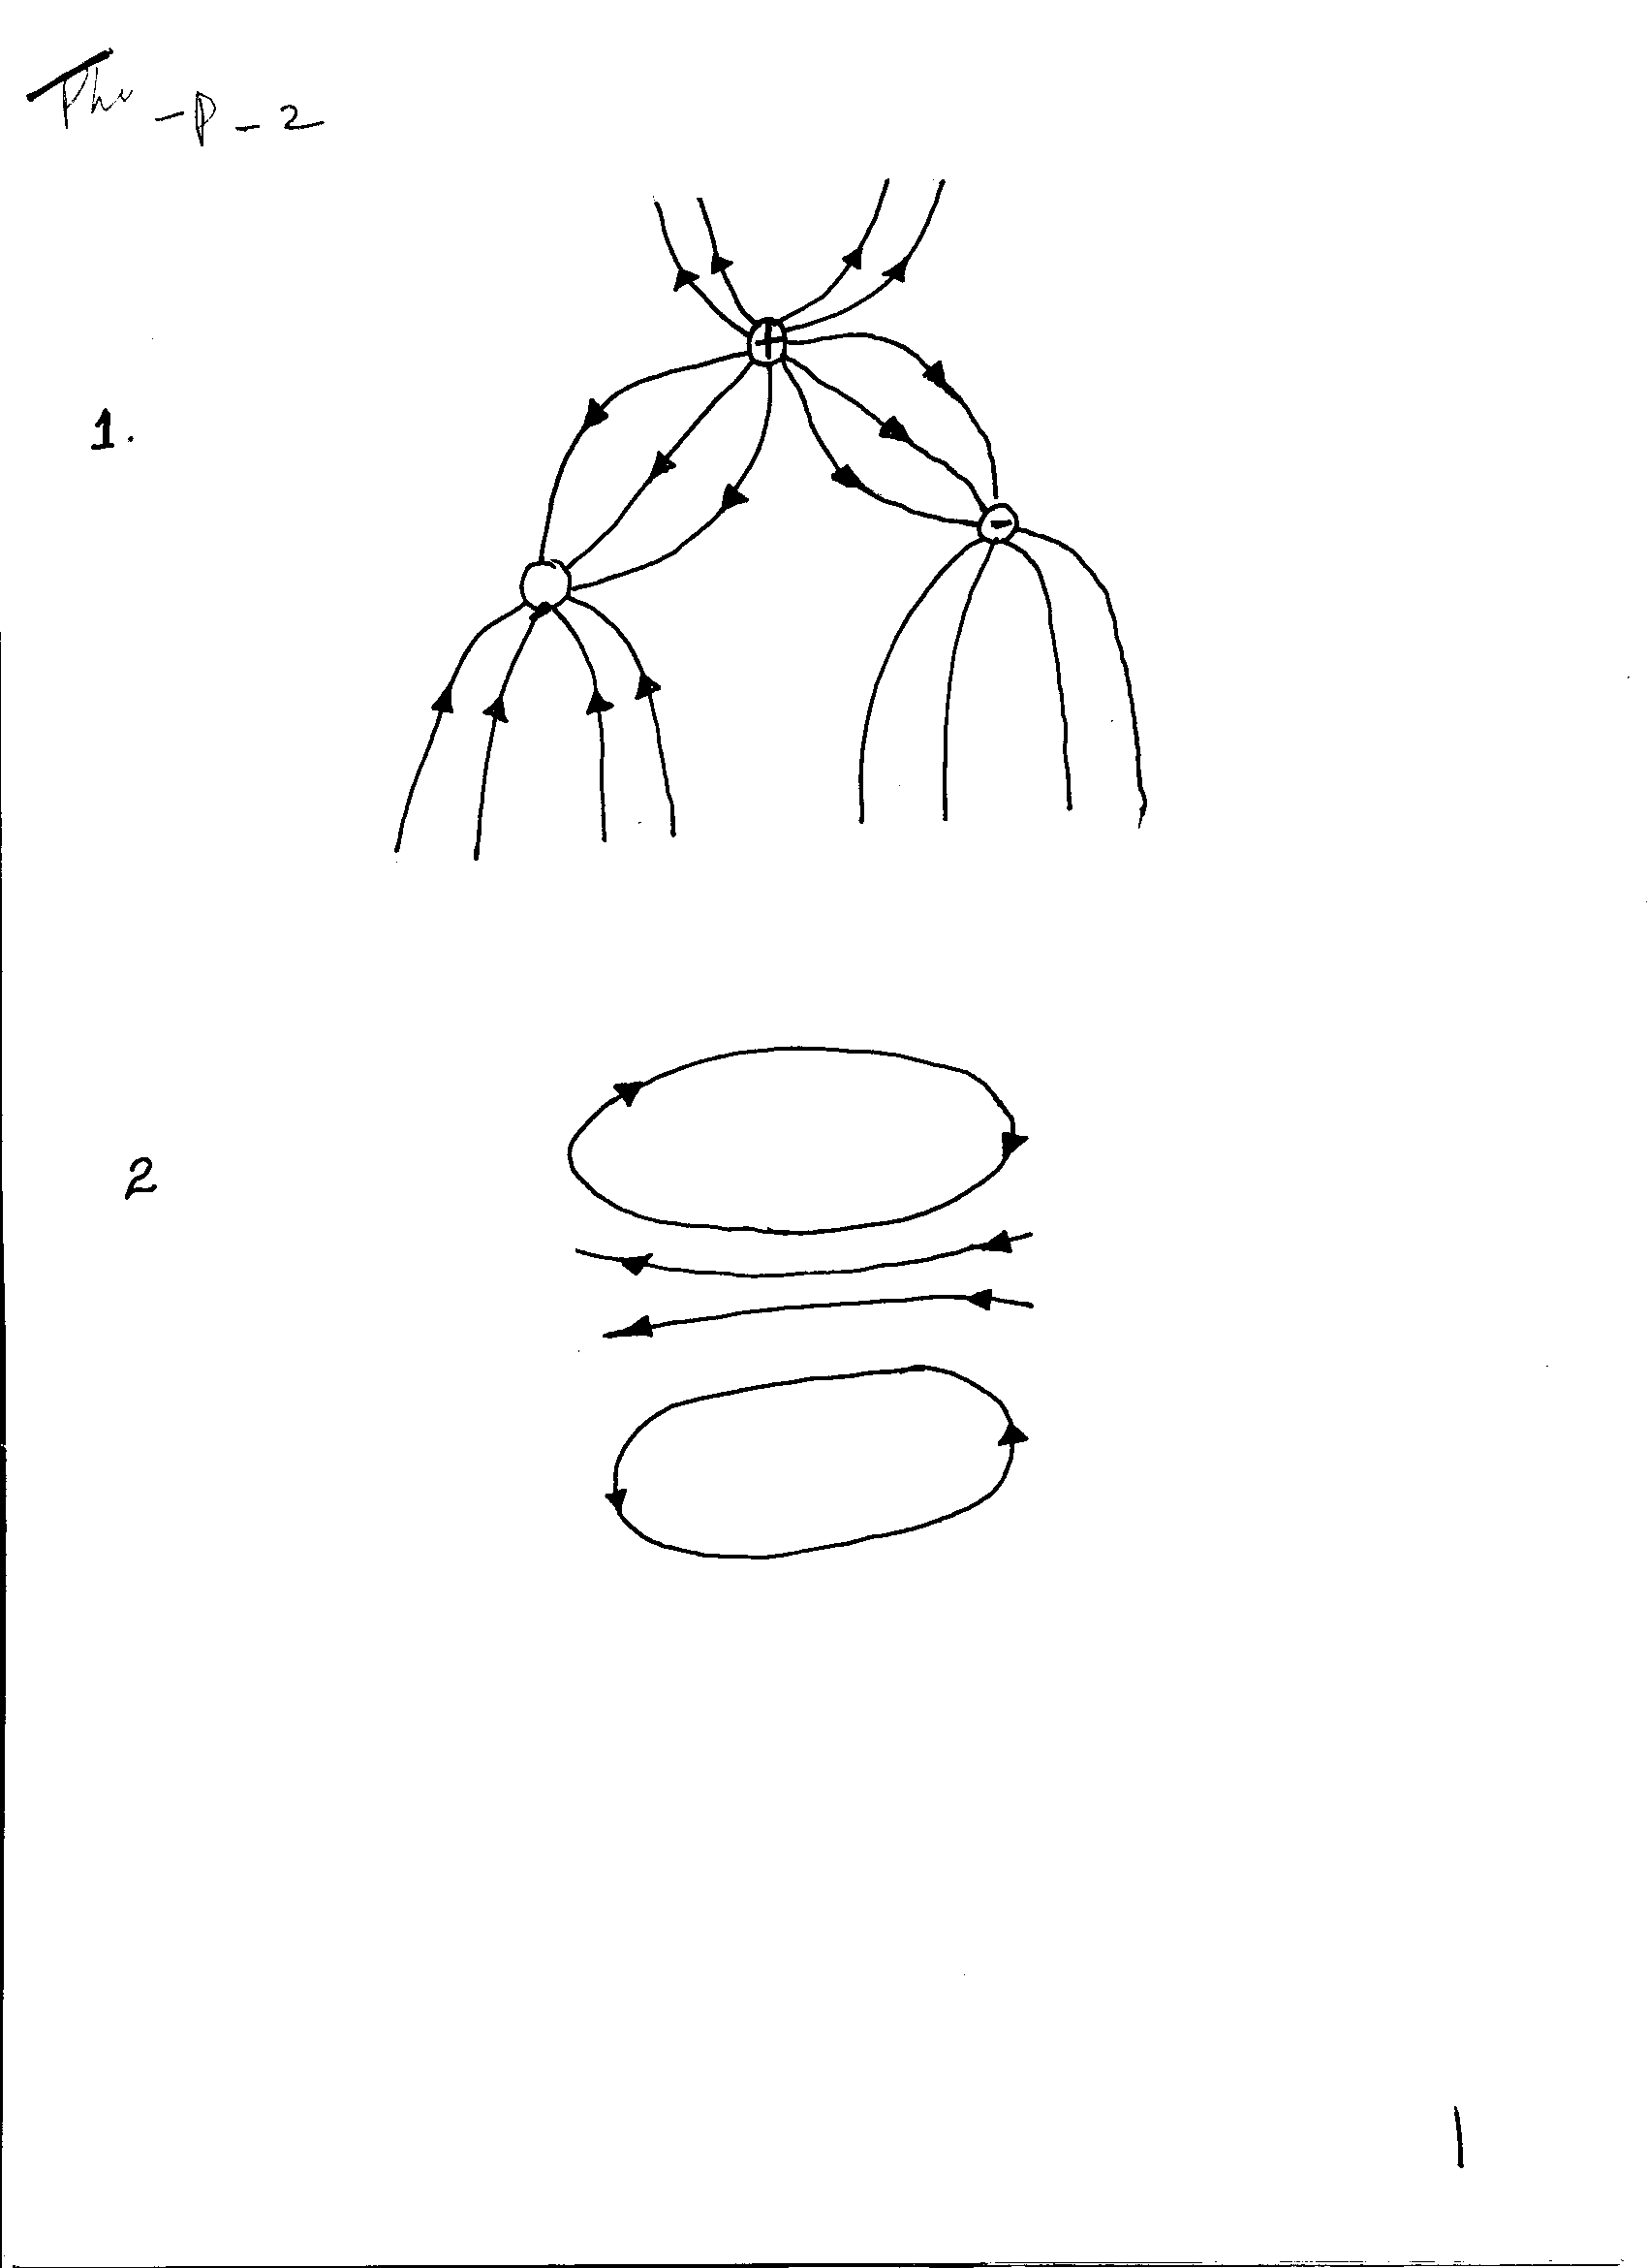
Pattern 1 mk
Direction 1 mk
2.
Pattern 1 mk
Direction 1 mk
Correct values of f and $λ$✓
3.
$\begin{aligned}λ=0\text{.}4m \\ T=0\text{.}2s \\ ∴f=\frac{1}{T}=\frac{1}{0\text{.}2}={\text{55}}^{−1} \\ ∴v=fλ \\ 0\text{.}4x5 \\ 2m/s\end{aligned}$ ✓

4.
Convex mirror
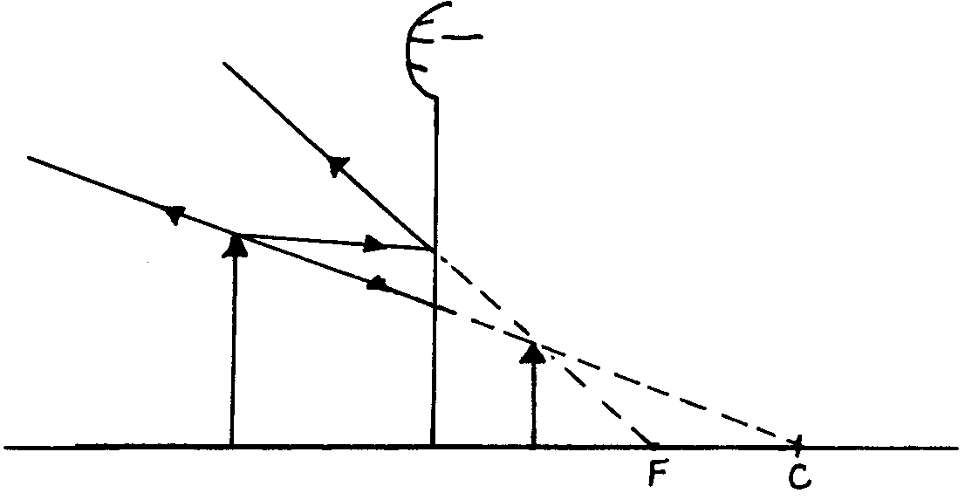
2 correct rays 2 mks

5. (i) Zinc (1mk)
(ii) The bulbs go off due to polarization effect (1mk)
6. Effectiveness resistance = $R+\frac{r}{2}$

Effective e. m. f = E

∴Current = effective e. m .f✓
Effective resistance

$I=\frac{E}{k+r2}$✓
7.
. n; sin ө; = n_{r} sin ө_{r}✓
1.3 sin 35⁰ = 1.5 sin ө_{r}
ө_{r} = 29.8⁰
sin r = sin i✓
n
= sin 29.8
1.5

= 0.3313
r = 19.39✓
8. The image remains unaffected✓by the change from a small circular hole to a small square hole.
9. At saturation point all the dipoles are facing one direction ✓

10. Power = $\frac{V^{2}}{R}$
R = $\frac{V^{2}}{P}$
R_{A} = $\frac{{\text{240}}^{2}}{\text{1000}}$ = 57.6 S²
✓
R_{B} = $\frac{{\text{240}}^{2}}{\text{2500}}$ = 23.04 S²

$\frac{R_{A}}{R}=\frac{\text{57}\text{.}6}{\text{23}\text{.}\text{04}}$ = 2.5✓

11. л = $\left(\frac{\text{360}}{θ}\right)$ - 1 =
$\frac{\text{360}}{\text{74}}$-1 = 3.8649
No of images =3
SECTION II
12 a). –Has higher end. P
– Has lower internal resistanceP
- Gives steady current for longer timeP
- Give larger currentP (Any first 2)

b) Not to be over charged
Not to be left in uncharged state for a long time
Terminals should be wiped clean
Topping to be done by battery water
Not to be left on the floor but on an insulator.

c) Negative charges on the rod initially neutralize the positive charges on leaf and plate
hence leaf collapses.
- As rod comes to cap electronic are repelled to the leaf making it to collapseP
- But a rod comes closer to cap, the excess negative charges on the rod induce negative
Charges on leaf leading to rising on the leaf P
13.
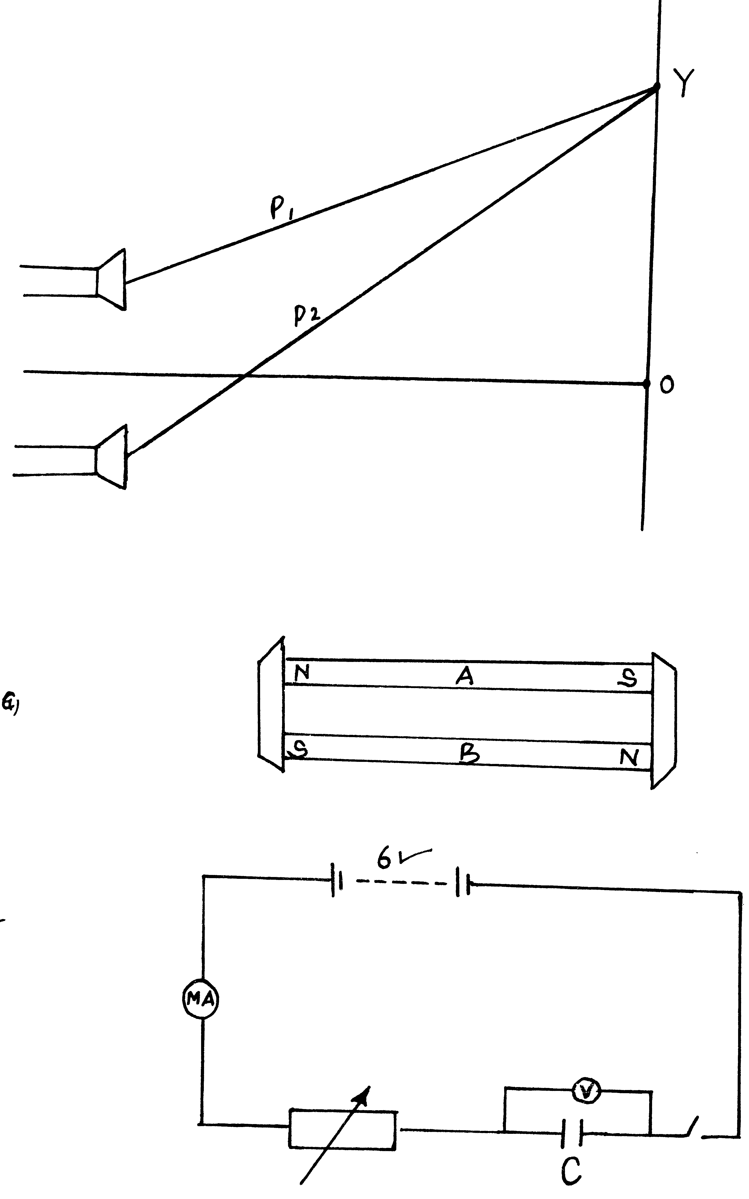
Keeper
Keeper
- Left side - South.
- Right side - North
ii). Keepers being magnetic material get magnetized throughP
Induction with opposite pole to that of the pole of magnet in contract.
This makes the dipoles to be arranged P
in a closed loop continuous chain thus enhancing attraction P
Hence magnet does not lose their magnetism. (9mks)

14. a) - The distance of separation
- The nature of the dielectric material
- The area of overlap. <any two>

Switch
Rheostat

Voltmeter across capacitorP
MA, cell, rheostat and c in parallel. P
jj).

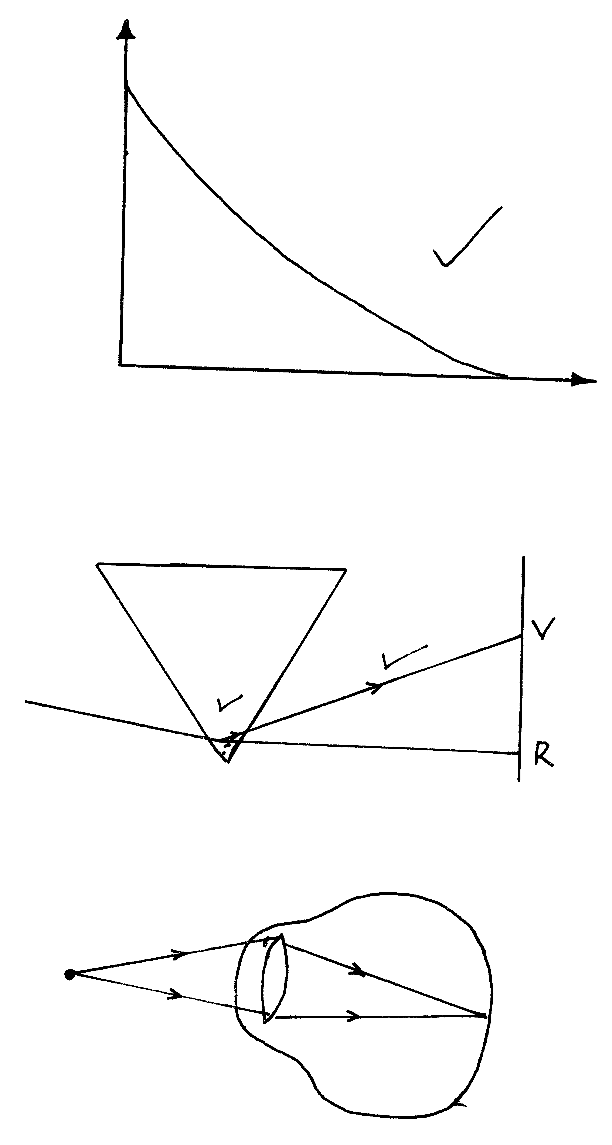
I (mA)
t (s)

iii). Stopwatch is used to take different times taken for different current valuesP
c). $\frac{1}{\text{CT}}=\frac{1}{3}+\frac{1}{9}=\frac{4}{9}$P
CT =$\frac{9}{4}$= 2.25mfP
Total charge Q=CV =2.25 x 10⁻⁶f x 10P
= 2.25 x 10⁻⁵cP
pd across 3$μ$F
$\frac{Q}{C}=\frac{2\text{.}\text{25}X{\text{10}}^{−5}}{3X{\text{10}}^{−5}}$= 0.75X10² = 7.5volts.
pd across 5πf capacitor = 10- 7.5 = 2.5 voltsP
charges stored in 5πf capacitor Q = cv.
= 5x10⁻⁶ x 2.5P
= 12.5 x 10⁻⁶
= 1.25 x 10⁻⁵ cP (10 mks)

15 a)
Splitting inside prism

Splitting outside
ii) V and R correctly locatedP
iii). Yellow colourP
16. a.)
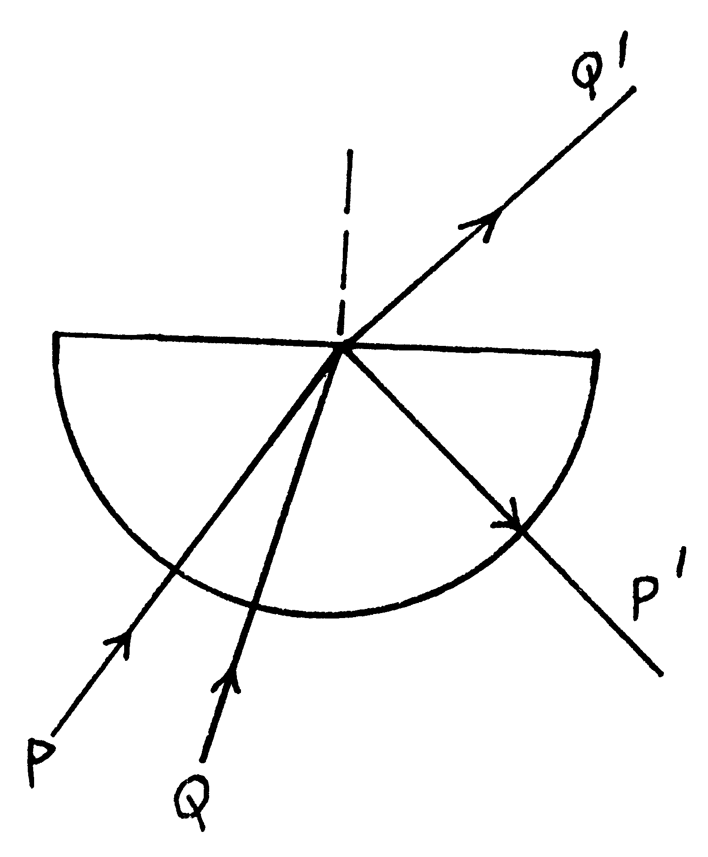
(b) Retroactive index л = $\frac{1}{\text{sin}c}$ = $\frac{1}{\text{sin}{\text{44}}^{0}}$ =1
17. a) P= $\frac{V^{2}}{R}$ = R= $\frac{P^{2}}{V}$= $\frac{(\text{250})^{2}}{\text{2000}}=\frac{\text{250}X\text{250}}{\text{2000}}$=31.25Ω

b) I =$\frac{P}{V}$
= I total =$\left[\frac{\text{2000}}{\text{250}}+\frac{\text{300}}{\text{250}}+\frac{\text{750}}{\text{250}}\right]$=12.2A Choice of fuse = 15A

18. a)
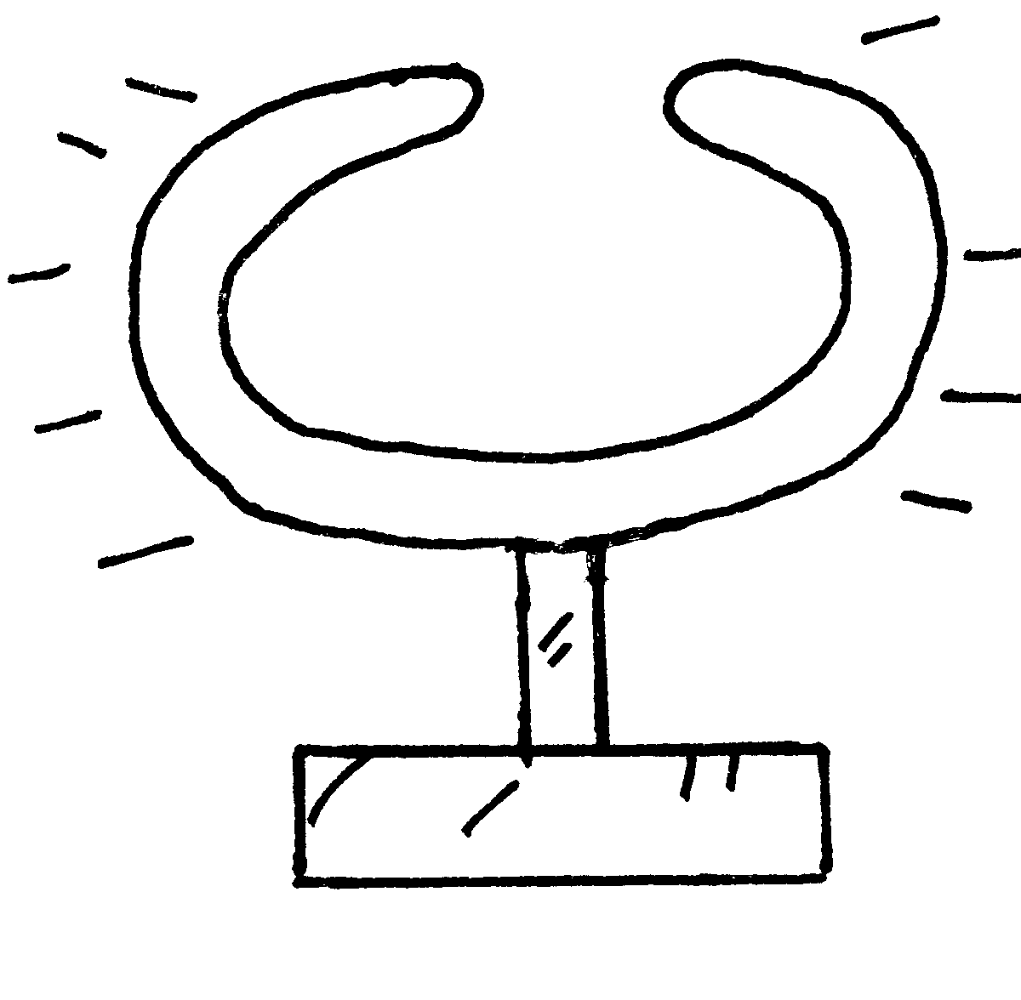
Uniform distribution outside conductor
b) No change on leaf
No charge inside charged hollow conductor

19 . (a) The energy of the election is despated at the lamp
wire due to its resistance as heat ;
- which the wire get red hot and the white hot it gives out
light and heat energy ;

E = I² Rt ;

- E = VIt ;
= 12 x 3 x 20 ;
= 720J ;

(b) (i) The resistance of the wire increase with increase in current and hence the
potential difference a cross it ;
- The wire becomes hotter increasing the opposition to the
Flow of current ;
- The wire is a non Ohmic conductor ( doesn’t obey ohm’s law);

(ii) I : Resistance doubles ; since
Resistance ∝ length;
II – The resistance reduces to ¼ the original value ;
Resistance =$\frac{ρL}{A}$
But A = π($\frac{D}{2}$)²
20. Let the distance between the two cliffs be x

Speed = $\frac{\text{Dis}\text{tan}\text{ce}}{\text{Totaltime}}$ = $\frac{2d}{t}$

From cliff A 340 = $\frac{2{\text{xX}}_{1}}{2}$
X₁ = 340m ;

From cliff B 340 = $\frac{2{\text{xX}}_{2}}{5}$
X₂= 850m
Distance between cliffs
= 340 + 850
= 1190m;

