Name: …………………………………………………………… Index No. …………………………
School: …………………………………………………………. Candidate’s Sign. …………............
Date: ………………………………............................................

232/1
PHYSICS
PAPER 1
TIME: 2 HOURS

SET 7
FORM 3

INSTRUCTIONS TO THE CANDIDATES:
- Write your name and index number in the spaces provided above.
- Answer all the questions both in section A and B in the spaces provided below each question
- All workings must be clearly shown; marks may be awarded for correct steps even if the answers are wrong.
- Mathematical tables and silent electronic calculators may be used.
(Take acceleration due to gravity g= 10ms⁻² Density of water 1g/m⁻³)
For Examiners’ Use Only

SECTION | QUESTION | MAXIMUM SCORE | CANDIDATE’S SCORE
Section A | 1-12 | 25
Section B | 13 | 09
Section B | 14 | 14
Section B | 15 | 14
Section B | 16  17 | 09  09
Section B | TOTAL | 80

This paper consists of 8 printed pages. Candidates should check to ascertain that all pages are printed as indicated and that no questions are missing.

SECTION A (25 MARKS)
1. What is relative density? (1mk)
…..………………………………………………………………………………………………………......
…..…………………………………………………………………………………………………………..
2. A uniform mixture consists of 30cm³ of water and 40cm³ of ethanol. If the densities of water and ethanol
are 1g/cm³ and 0.85g/cm³respectively. Determine the density of the mixture. (3mks)

3.a) State the law of levers. (1mk)
……………………………………………………………………………………………………………......
………………………………………………………………………………………………………………..
b) A metre rule is balanced on the 30cm mark by a 50g mass placed on the zero centimetre mark.
Calculate the weight of the metre rule. (3mks)

4. Water flows steadily along a horizontal pipe at a volume rate of 4x10⁻³m³s⁻¹. If the cross-section of the
pipe is 20cm², calculate the velocity of the fluid. (3mks)

5. The earth moves around the sun at a constant speed. Explain why it is true to say that the earth is
accelerating. (1mk)
………………………………………………………………………………………………………………..
………………………………………………………………………………………………………………..
6. State two factors that determine the spring constant of a helical spring. (2mks)
………………………………………………………………………………………………………………..
……………………………………………………………………………………………………………….
7. Derive the following equation of linear motion. (3mks) S=ut + ½ at²

8. State the kinetic theory of matter. (1mk)
………………………………………………………………………………………………………………..
………………………………………………………………………………………………………………..
9. In the set up shown in the figure below, it is observed that the level of the water initially drops before
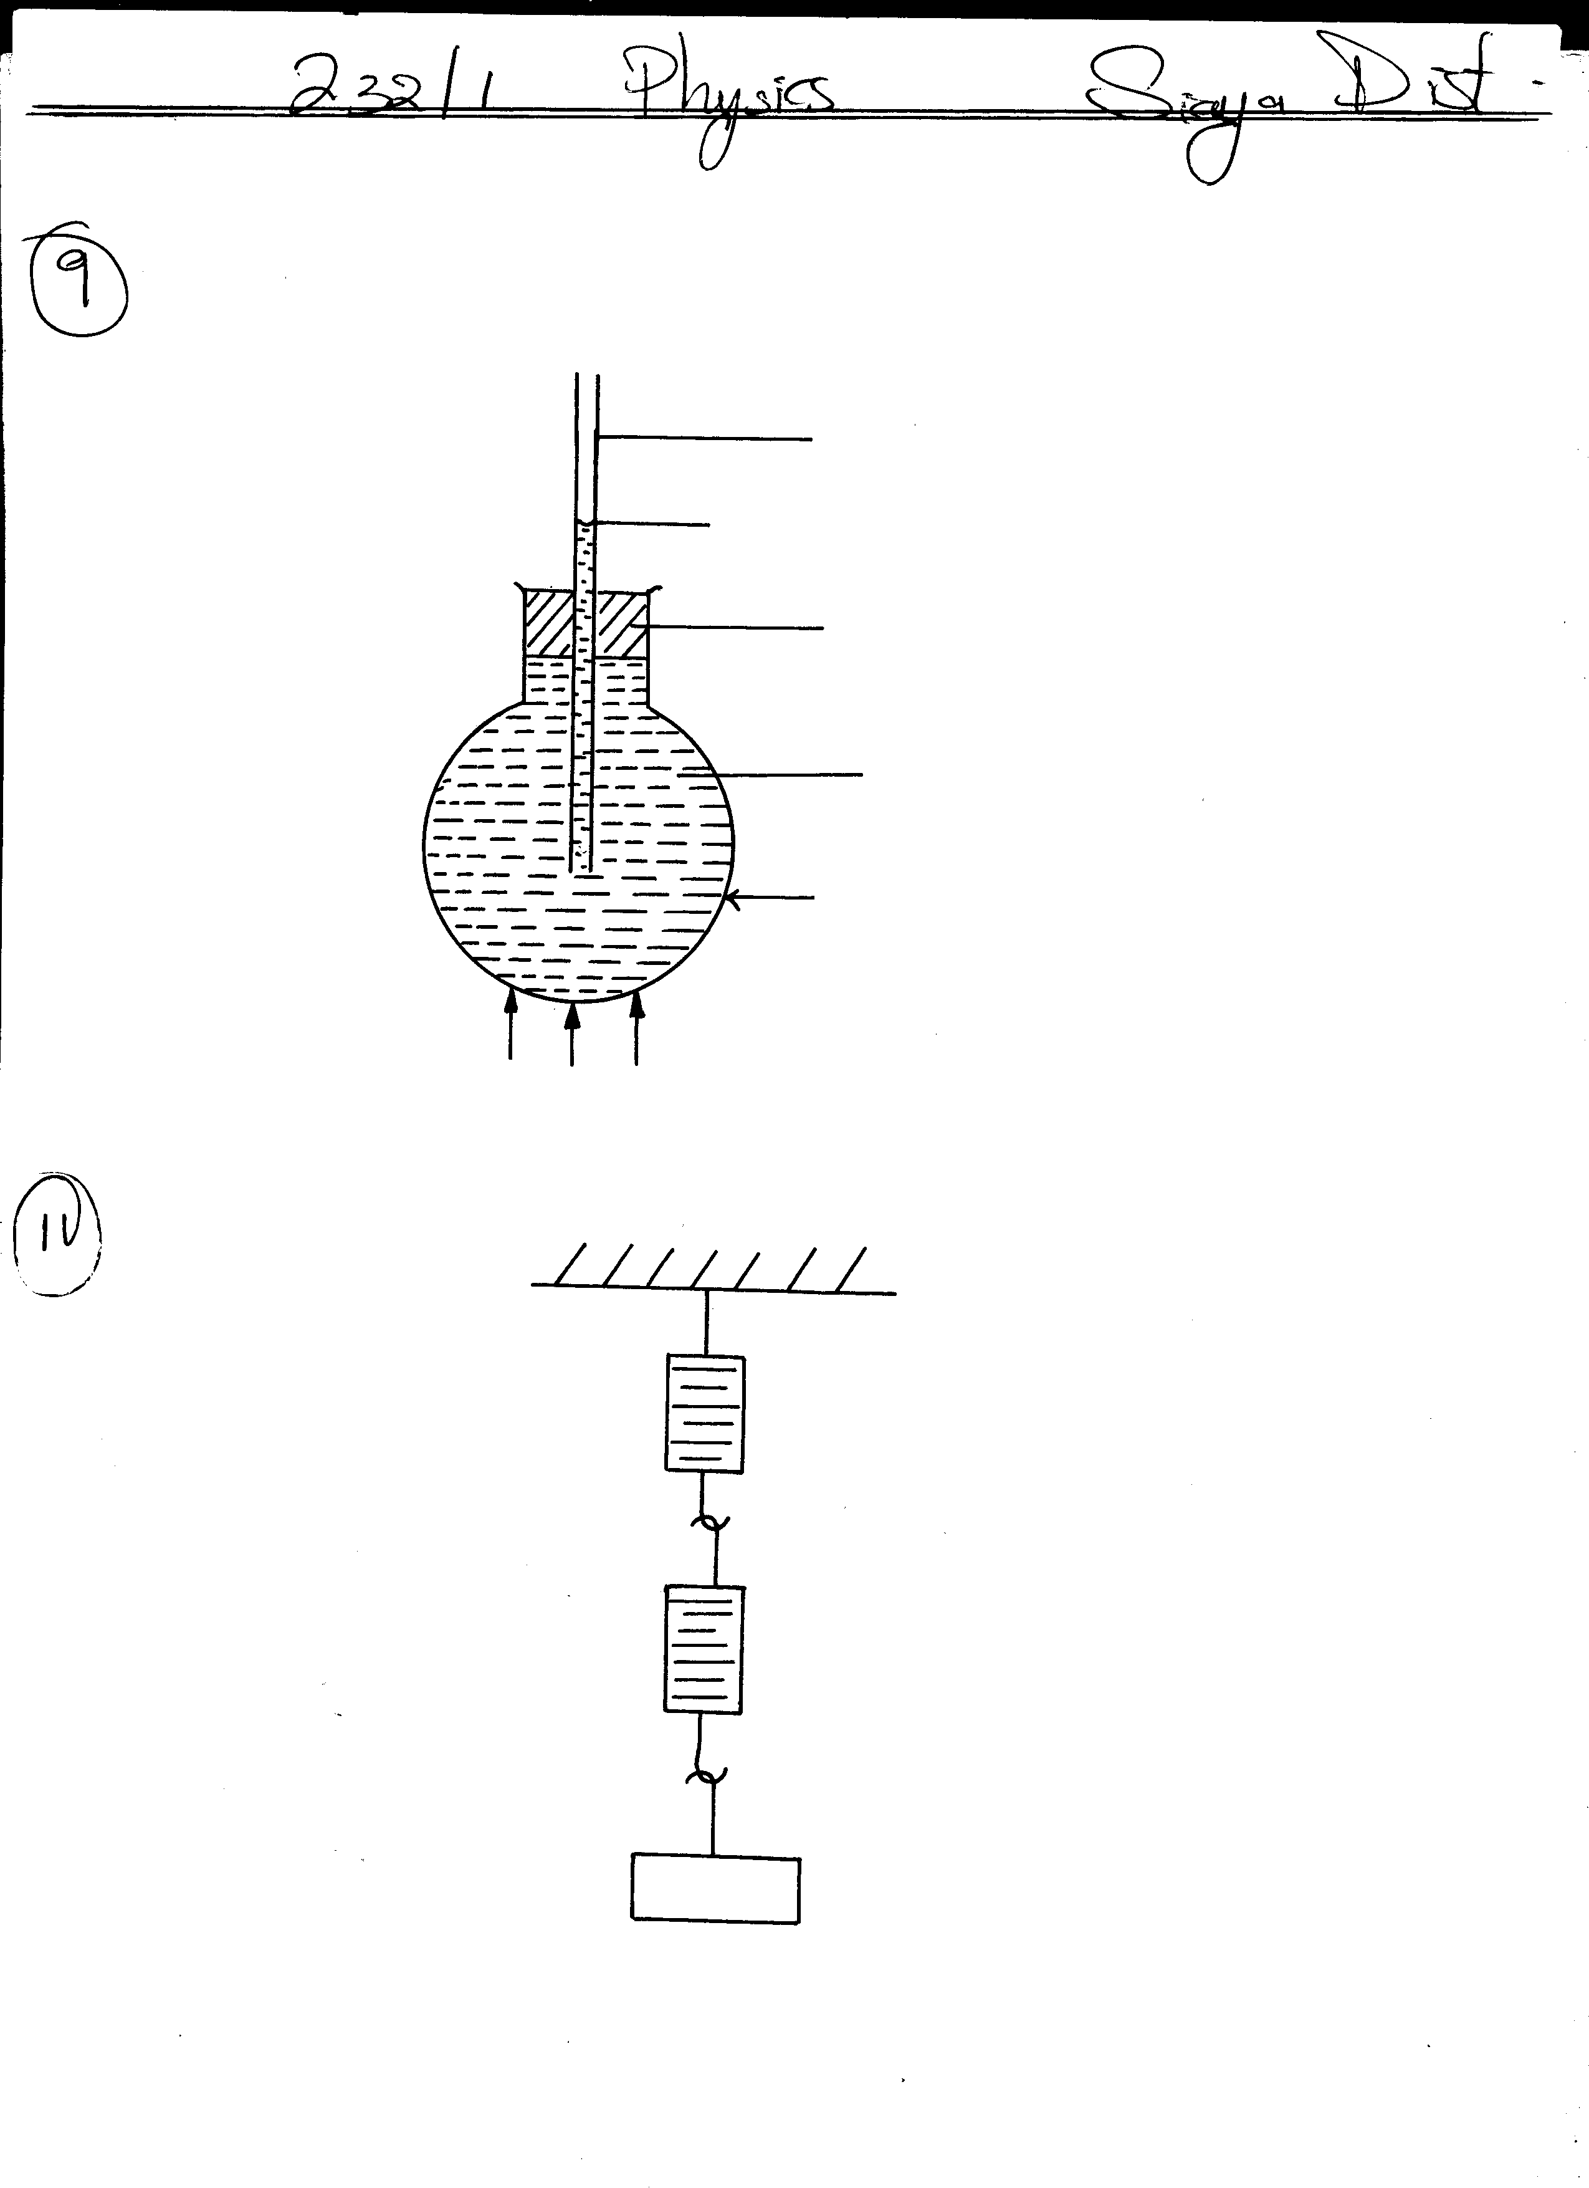
starting to rise.
Glass tube
Water level
Cork

Colored water
Glass flask

HEAT
Explain this observation. (2mks)
………………………………………………………………………………………………………………..
………………………………………………………………………………………………………………..
10. What is a Newton? (1mk)
………………………………………………………………………………………………………………
………………………………………………………………………………………………………………
11. Two identical spring balances A and B each weighing 0.8N are arranged as shown below.
What are the readings of A and B? (2mks)
A
B
30N

A: …………………………………………………………………………....
B: ……………………………………………………………………………
12. Suggest two assumptions to be made in an experiment to estimate the diameter of an oil molecule.
(2mks)
………………………………………………………………………………………………………………
………………………………………………………………………………………………………………
SECTION B (55 MARKS)
13. a) List three effects of force. (3mks)
……………………………………………………………………………………………………………....
………………………………………………………………………………………………………………
………………………………………………………………………………………………………………
b) Define mechanical advantage of a machine. (1mk)
……………………………………………………………………………………………………………...
……………………………………………………………………………………………………………...
c) A man uses an inclined plane to lift 100kg load through a vertical distance of 8m. The inclined plane
makes an angle of 30⁰ with the horizontal. If the efficiency of the machine is 80%, calculate;
i) The velocity ratio of the machine. (1mk)

ii) The effort needed to move the load up the inclined plane at a constant velocity. (3mks)

d) What is a transducer? (1mk)
…………………………………………………………………………………………………………….
…………………………………………………………………………………………………………….
14. a) Explain the meaning of these terms; (2mks)
i) Instantaneous velocity
……………………………………………………………………………………………………………...
……………………………………………………………………………………………………………...
ii) Acceleration due to gravity
……………………………………………………………………………………………………………...
……………………………………………………………………………………………………………...

b) The table below shows results obtained by a physics student in an experiment to determine acceleration
due to gravity, g using a simple pendulum.
Length, l (m) | 1.20 | 1.40 | 1.60 | 1.80 | 2.00 | 2.20
Time for 10 oscillations t(s) | 21.80 | 23.50 | 25.10 | 26.70 | 28.10 | 29.50
Period, T (s)
T² (S²)
i) Complete the table above. (2mks)
ii) Plot a graph of T² (y-axis) against l on the grid provide. (5mks)

iii) Determine the gradient of the graph. (2mks)

iv) Given that the graph obeys the law of the equation T=2π√^{l}/_{g}, determine g from the graph. (3mks)

15. a) Distinguish between these terms;
i) Heat capacity and specific heat capacity. (2mks)
………………………………………………………………………………………………………………
………………………………………………………………………………………………………………
ii) Latent heat of fusion and specific latent heat of fusion. (2mks)
………………………………………………………………………………………………………………
………………………………………………………………………………………………………………
b) In an experiment to determine the specific latent of heat of vaporization of water, the following results
were obtained.
- Mass of calorimeter = 250g
- Mass of calorimeter + water = 750g
- Mass of ice at 0⁰C in the calorimeter = 20g
- Final temperature when dry steam is passed over the calorimeter = 25⁰C
- Mass of condensed steam = 25g
Given that the latent heat of fusion of water is 3.36x10⁵ JKg⁻¹, the specific heat capacity of copper is
400Jkg ⁻¹ k⁻¹ and specific heat capacity of water is 4200JKg⁻¹K⁻¹. Determine the heat gained by;
i) Ice (2mks)

ii) Water (2mks)

iii) Calorimeter (2mks)

c) If L_{V} is the specific latent heat of vaporization of water, use an appropriate equation to find L_{V}. (4mks)

16. a) State the law of floatation. (1mk)
………………………………………………………………………………………………………………
………………………………………………………………………………………………………………
b) An object weighs 1.04N in air, 0.64 N when fully immersed in water and 0.72N when fully immersed in a liquid. If the density of water is1000kg/m³, find the density of the liquid. (4mks)

c) Give a reason why a steel rod sinks in water while a ship made of steel floats on water. (2mks)
……………………………………………………………………………………………………………..
……………………………………………………………………………………………………………..
d) The figure below shows a hydrometer which is suitable for measuring the densities of liquids varying
between 1.0 and 1.2 g/cm³.
On the diagram indicate the level corresponding to 1.0 and 1.2 g/cm³. (2mks)
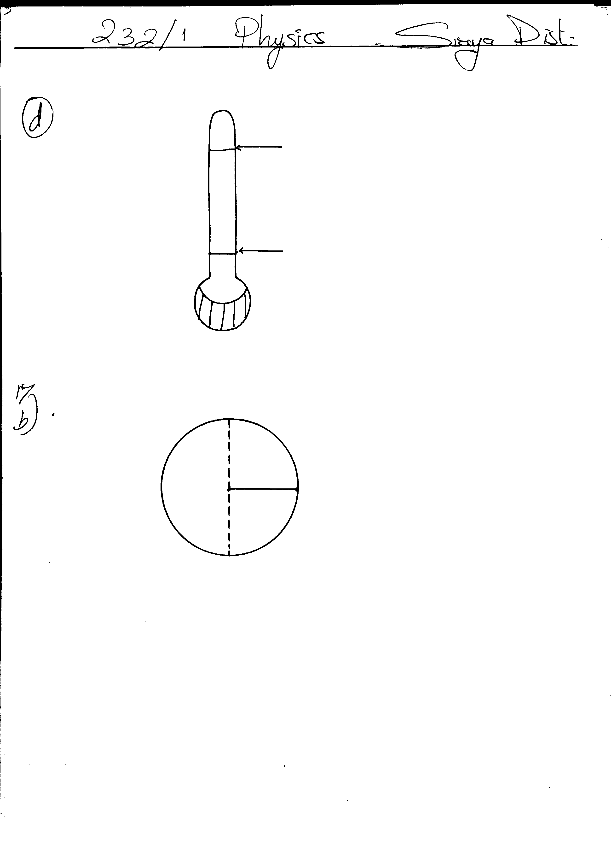
A:
B:

17. a) Define angular velocity. (1mk)
……………………………………………………………………………………………………………...
……………………………………………………………………………………………………………...
b) The diagram below shows an object of mass 2.0kg whirled in a vertical circle of radius 0.8m at a
uniform speed of 50ms⁻¹.
2.0Kg
r=0.8m
A
O
B

Determine;
i) The centripetal force on the object. (2mks)

ii) The tension in the string when the object is at A. (2mks)

iii) The tension in the string when the object is at B. (2mks)

c) The speed of rotation is gradually increased until the string snaps. At what point is the string likely to
snap? Explain. (2mks)

