NAME: ……………………………………………………ADM NO. …………………………..........................
SCHOOL: ………………………………………..... CANDIDATE’S SIGN. ………….....................
DATE: ……………………………..................
232/1
PHYSICS
PAPER 1
TIME: 2 HOURS

SET 6
FORM THREE

INSTRUCTIONS TO THE CANDIDATES:

- Write your name and index number in the spaces provided above.
- Answer all the questions both in section A and B in the spaces provided below each question
- All workings must be clearly shown; marks may be awarded for correct steps even if the answers are wrong.
- Mathematical tables and silent electronic calculators may be used.
- Take gravitational acceleration = 10m/s² and π =3.142.

For Examiners’ Use Only
SECTION | QUESTION | MAXIMUM SCORE | CANDIDATE’S SCORE
Section A | 1-12 | 25
Section B | 13 | 12
 | 14 | 14
 | 15 | 10
 | 16 | 08
 | 17 | 11
 | TOTAL | 80

This paper consists of 12 printed pages. Candidates should check to ascertain that all pages are printed as indicated and that no questions are missing.

1. 50 drops of a liquid were released from a burette which was originally reading 22cm³ to give new reading of 56cm³. Calculate the volume of each drop. (2mrks)

2. A uniform plank of wood weighing 50N and of length 5m is suspended by two ropes A and B 1.5m apart. A is 2m from end and B is 1.5m from the other end as shown in fig 1 below. A block of weight 100N is suspended from the centre of the plank.

Calculate the tension T_{A} on the string A. (3mrks)
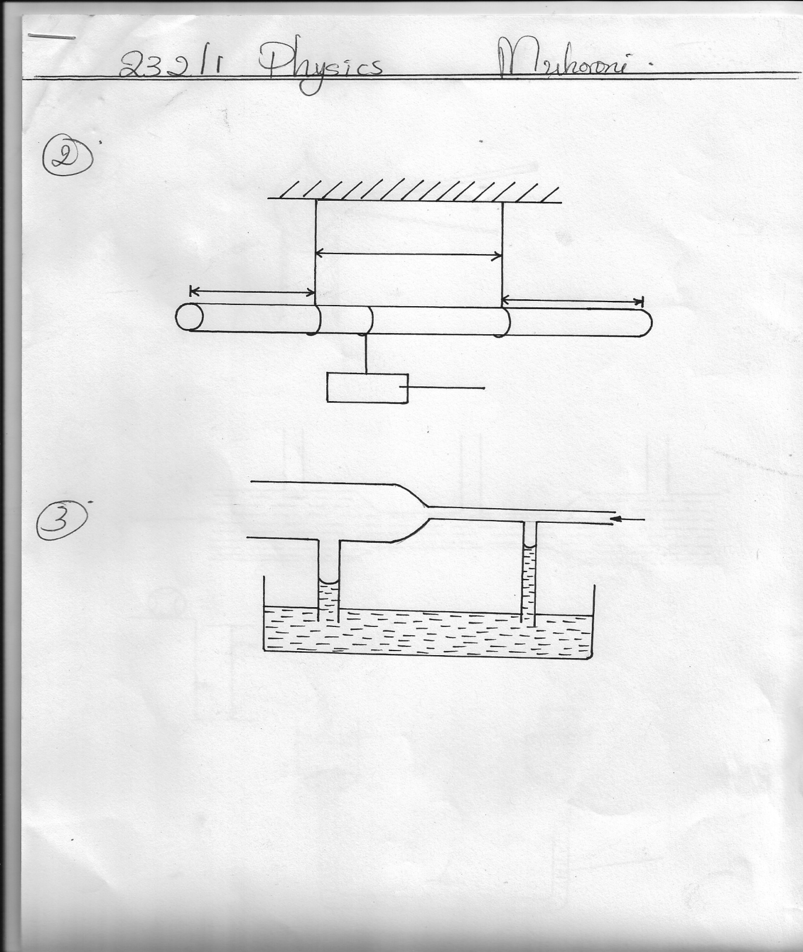

2.0m
1.5m
1.5m

100N

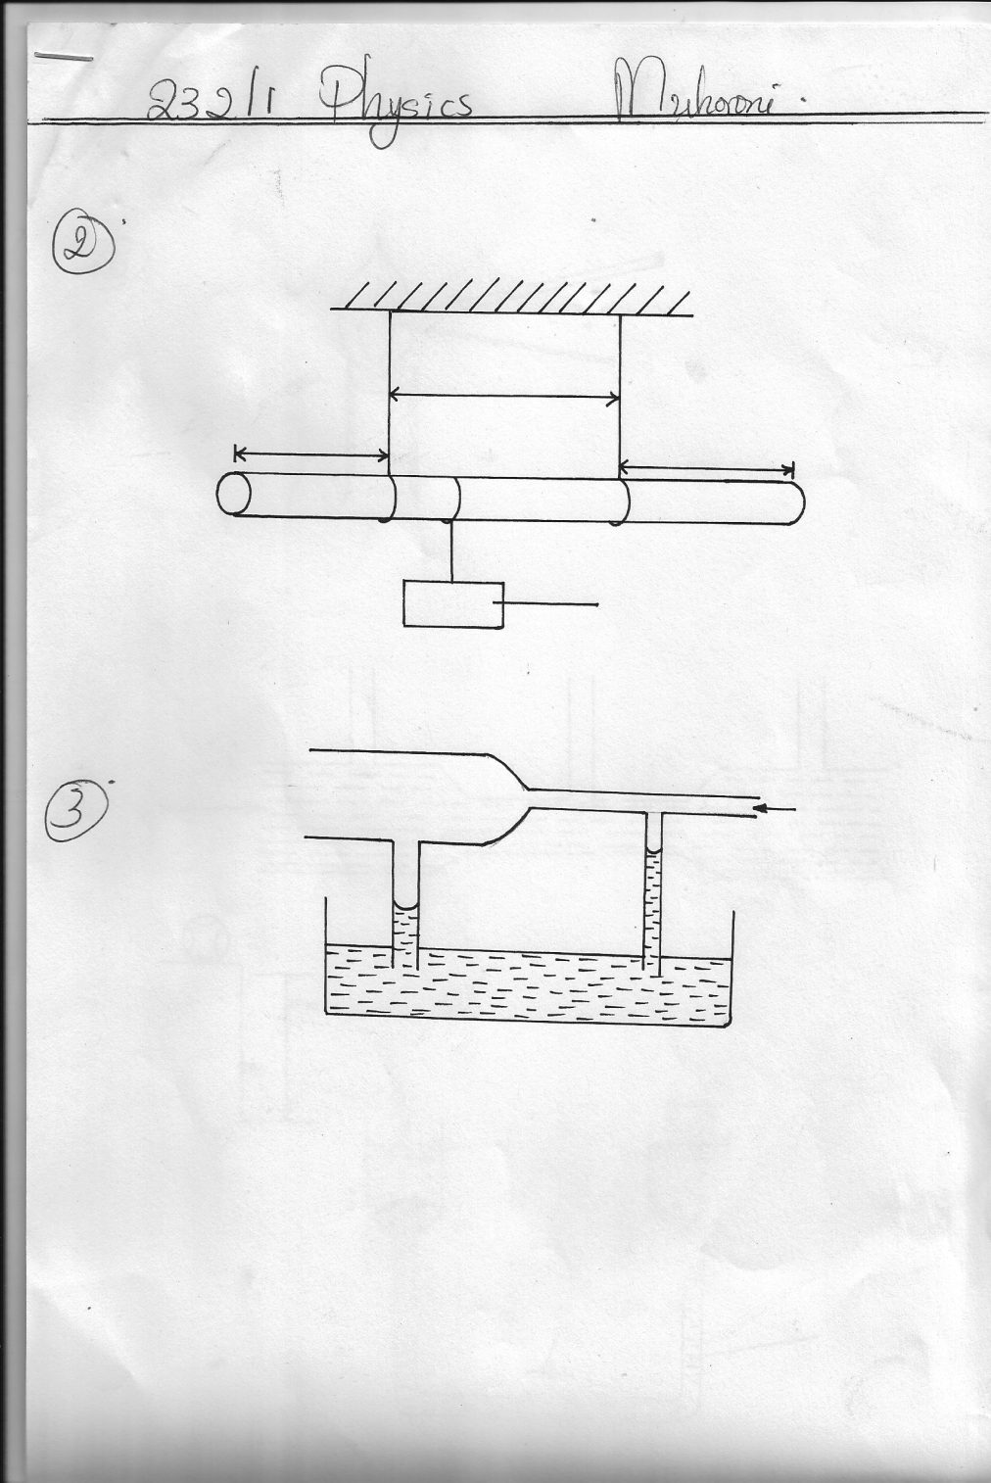
3. The fig below shows a horizontal tube with two vertical pipes X and Y dipped in water. Air flows through the tube from right to Left. The water level in X is low lower than in Y.
X
Y
Air

Explain this observation (2mrks)
....................................................................................................................................................................
.....................................................................................................................................................................
4. Some water is heated in a beaker from 0⁰ C sketch the graph of mass y axis verses temperature for the water.
(1mrk)

5. Two aluminum rods A and B of the same length are held over a burner flame. Equal pleads of wax are attached to the ends as shown below.
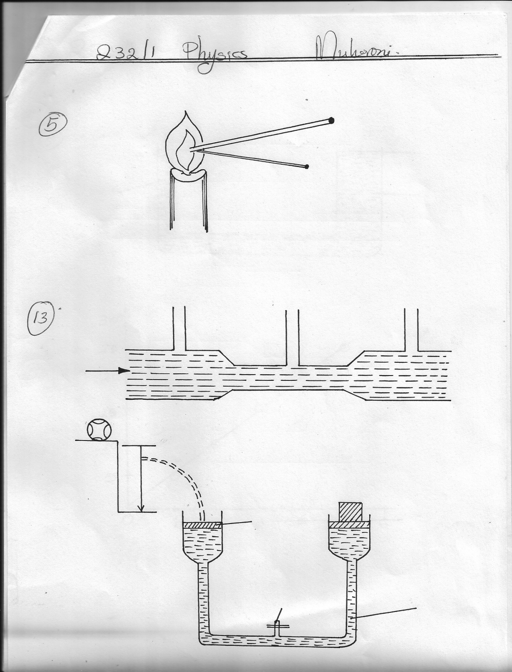
B
A

It is observed that the wax on A melts faster. Explain (2mrks)
.....................................................................................................................................................................
.....................................................................................................................................................................
6. A steel sphere A is released in a tall transparent water jar containing water. At the same time and height another similar steel sphere B is released in air sketch on the axes below the velocity time graphs for sphere A and B.

velocity
velocity

time time
Sphere A Sphere B (2mrks)
7. Water is not a suitable barometric liquid. Explain (1mrk)
....................................................................................................................................................................
....................................................................................................................................................................
8. A pipe of diameter 6cm is connected to another of diameter 30mm. If water flows in the wider pipe at a speed of 4ms⁻¹ .Determine the speed of the water in the narrow pipe. (3mrks)

9. A body is projected vertically upwards from the top of a building. Assuming that it lands at the base of the building .Sketch the velocity time graph for this motion. (2mrks)

10. A student heated equal amount of water in two aluminium containers A and B by a flame of equal hotness. If A was bigger than B, in which container will it take longer time to boil the water and why? (2mrks)
......................................................................................................................................................................
.....................................................................................................................................................................
....................................................................................................................................................................
11. 0.2 kg of copper at80⁰C is put in a well lagged brass calorimeter of mass 0.1kg containing 0.16kg of sea water at 20⁰C. Calculate the final steady temperature of the mixture.
Take specific heat capacity of Copper = 400 Jkg⁻¹k⁻¹
Brass = 380J kg⁻¹k⁻¹
Sea water = 3900J kg⁻¹k⁻¹ (3mrks)

12. State two features that make the clinical thermometer more sensitive. (2mrks)
....................................................................................................................................................................
......................................................................................................................................................................
SECTION B (55MARKS)
13. (a) The figure below represents a tube through which a liquid is flowing as shown by the arrow
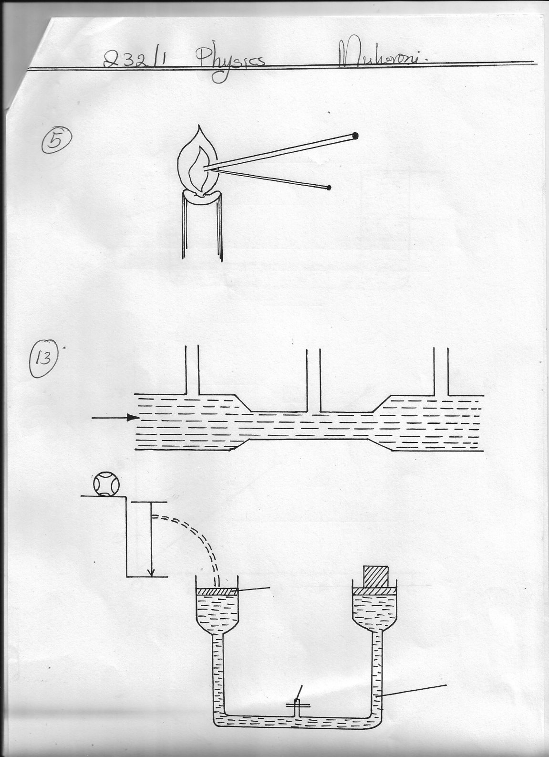
Z
y
X

On the diagram show the relative positions of the level of the liquid in sections marked X, Y and Z. (1mrk)
(b) A lown sprinkler has 20 holes each of cross- sectional area 2x 10⁻²cm² is connected to a hose pipe of cross- section area 2.4cm² . If the speed of water in the hose pipe is 1.5m/s. (3mrks)
(i) Calculate the flow rate in the hose pipe. (3mrks)

(ii) The speed of water as it emerges from the hose pipe (3mrks)

14. The figure below shows a ball of mass 50kg being thrown from the top of a wall 20m high with a horizontal velocity of 20m/s. It struck the piston A of hydraulic lift and no water splashed out .The other piston B had a weight of 25200N placed on it. Assuming the top was opened at the time the ball struck the piston A.
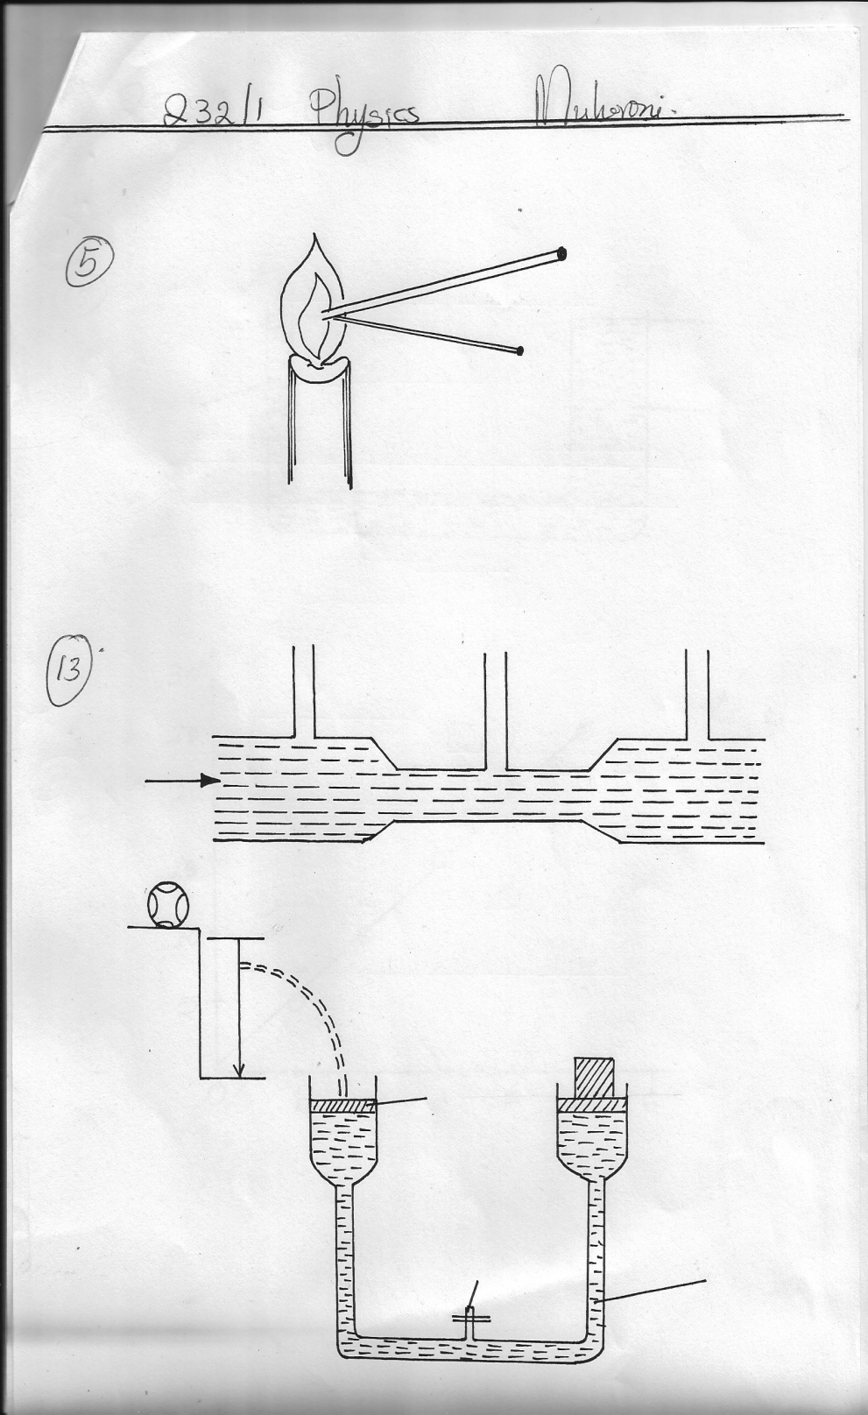
Ball

20m/s
20m

A =50cm³
Tap
252Ω
water

Determine
(i) The time taken by the ball to strike the surface of piston A. (3mrks)

(ii) The distance from the foot of the wall to where it hit piston A. (2mrks)

(iii) The vertical velocity with which the ball struck piston A. (2mrks)

(iv) The force with which the ball struck piston A. (2mrks)

(iv) The area of piston B if the load on piston B did not move and that the two pistons were initially at the same level. (2mrks)

15. (a) State the principal of transmission of pressure. (1mrk)
.....................................................................................................................................................
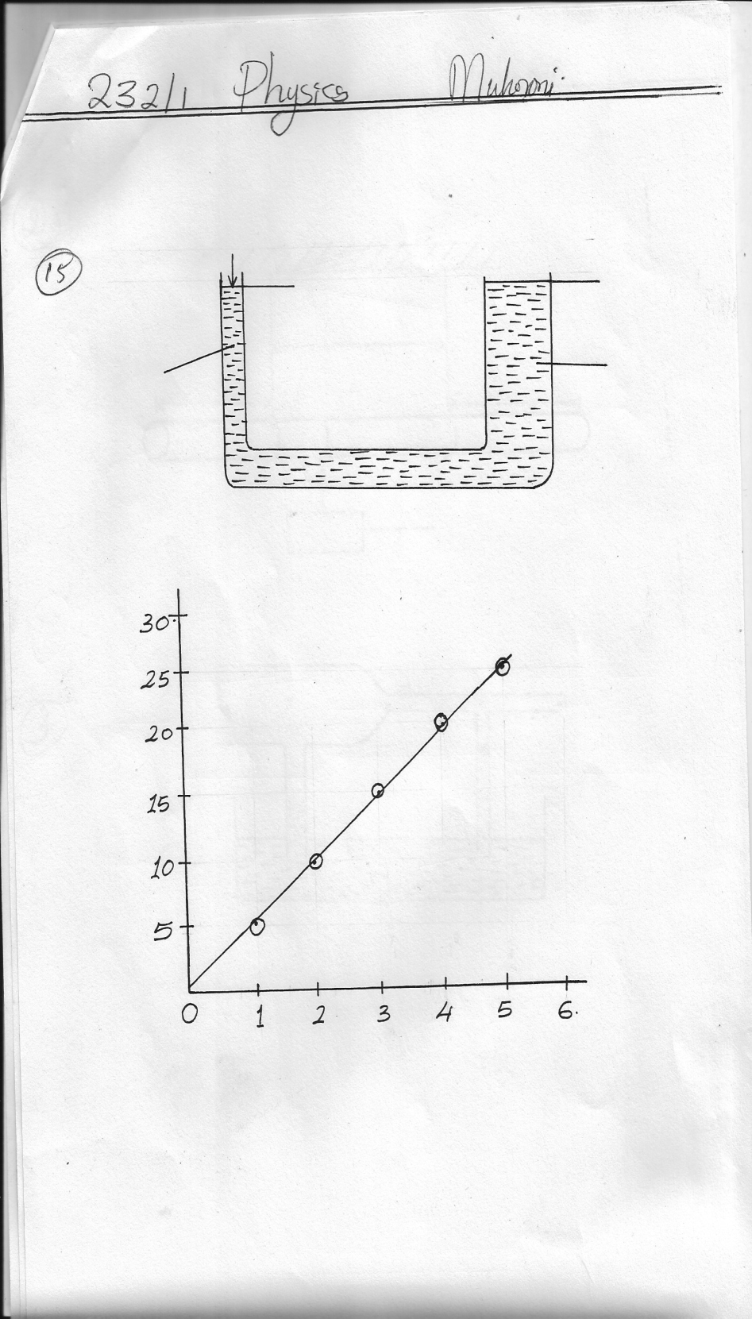
(b) The figure below shows the principle of a hydraulic force.
50N
2cm2
X
Y
Smaller piston
100cm²
Larger piston

16. (a) State the pressure law for ideal gas. (1mrk)
.....................................................................................................................................................
(b) At 20ºC the pressure of a gas is 50cm of mercury . At what temperature would the pressure of the gas fall by 30cm of mercury. Give the temperature in degree celsius. (3mrks)

(c) Define the absolute zero of the Kelvin temperature scale. (1mrk)
.....................................................................................................................................................
(d) A hole of area 2.0cm² at the bottom of a tank 2m deep is closed with a cork. Determine the force on the cork when the tank is filled with water. Take density of water = 1000kg/m³ and g = 10m/s²
(4mrks)

17. (a) Define specific heat capacity. (1mrk)
.......................................................................................................................................................
(b) In an experiment to determine the latent heat of water, steam at 100ºC was passed into water contained in a well lagged copper calorimeter.
- Mass of calorimeter = 60g
- Initial mass of water = 80g
- Initial room temperature of water = 15ºc
- Final temperature of mixture =45ºc
- Final mass of water + calorimeter + condensed steam = 160g
Specific heat capacity of water= 4200 J kgk⁻¹ and specific heat capacity of copper = 390 J kg⁻¹k⁻¹

Calculate :
(i) Mass of condensed steam (1mrk)

(ii) Given that L_{v} is the specific latent heat of the vaporization of steam,
(a) Write an expression for the latent heat of vaporization of steam (2mrks)

(b) Determine the value of L_{v} (2mrks)

18. (a) State Hooke’s law (1mrk)
.......................................................................................................................................................
(b) The graph shows the variation of extension of a helical spring with the load hanging on it.
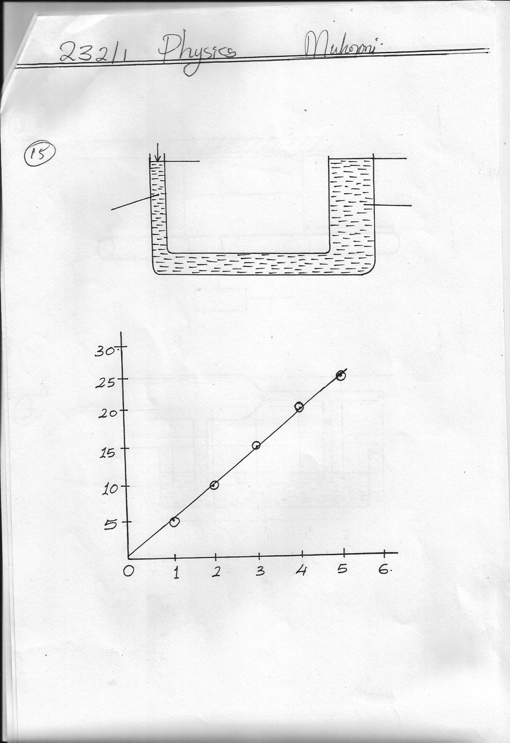
30
25
20
15

10
5

Extension (cm)

Load (N)
0 1 2 3 4 5 6

Determine from the graph the proportionality constant of the spring. (3mrks)

(c) State two factors that affect the proportionality constant of a vertical string. (2mrks)
...............................................................................................................................................................
..............................................................................................................................................................
(ii) Given that the L v is the specific latent heat of vaporization of steam
(a) Write an expression for the latent heat of vaporization of steam. (2mrks)

(b) Determine the value of the Lv. (2mrks)

