**Name: …………………………………………………………… Adm No. ………………**

**School: …………………………………………………………. Candidate’s Sign. ……**

**Date: ………………………………...**

**232/1**

**PHYSICS**

**PAPER 1**

**TIME: 2 HOURS**

**SET 5**

**FORM 3**

**INSTRUCTIONS TO THE CANDIDATES:**

* Write your **nameand admission number** in the spaces provided above.
* Answer ***all*** the questions both in section **A** and **B** in the spaces provided below each question
* All workings ***must*** be clearly shown; marks may be awarded for correct steps even if the answers are wrong.
* Mathematical tables and silent electronic calculators may be used.

**For Examiners’ Use Only**

|  |  |  |  |
| --- | --- | --- | --- |
| **SECTION** | **QUESTION** | **MAXIMUM SCORE** | **CANDIDATE’S SCORE** |
| Section A | 1-11 | 25 |  |
| Section B | 15 | 14 |  |
| 16 | 12 |  |
| 17 | 16 |  |
| 18 | 13 |  |
| **TOTAL** | **80** |  |

*This paper consists of 11 printed pages. Candidates should check to ascertain that all pages are printed as indicated and that no questions are missing.*

**SECTION A (25 MARKS)**

***Answer ALL the questions in this section in the spaces provided.***

1. Figure 1 shows a micrometer screw gauge being used to measure the diameter of a ball bearing.

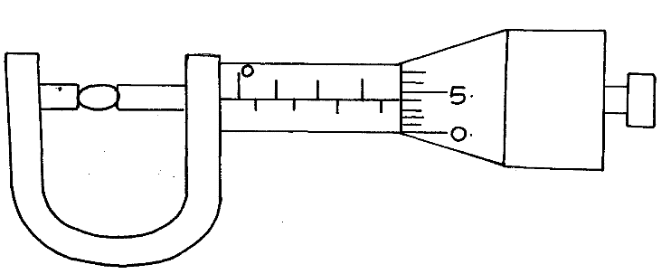

**Figure 1**

If the instrument has a negative zero error of 0.01mm, record the actual diameter of the ball bearing. (2mk)

………………………………………………………………………………………………

2. Figure 2. shows drops of mercury and water on a glass surface,

**Mercury drop**

**Water drop**

**Figure 2**

**Glass**

Explain the difference in the shapes of the drops. (2mks)

……………………………………………………………………………………………

…………………………………………………………………………………………………

…………………………………………………………………………………………………

3. State why diffusion is faster in gases than in liquids. (1mk)

…………………………………………………………………………………………………

…………………………………………………………………………………………

1. When a Bunsen burner is lit above a wire gauze, it is observed that the flame initially burns above the gauze shown in figure 3 (i). After sometime, the flame burns below as well as above the gauze as shown in figure 3(ii).

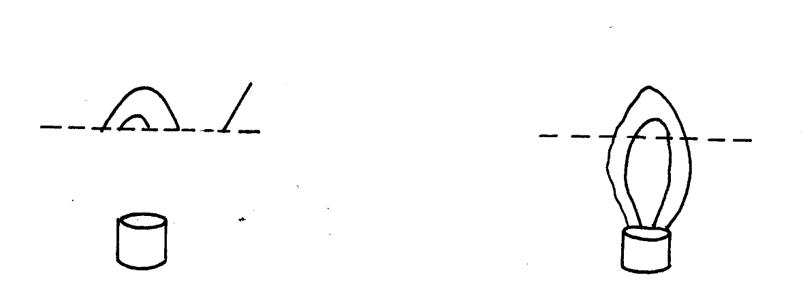

**Gauze**

**Fig 3**

**(ii)**

**(i)**

Explain the observation. (2mks)

………………………………………………………………………………………………

………………………………………………………………………………………………

………………………………………………………………………………………………

1. The height of mercury column in a barometer density 13600kg/ m-3, at a place is 64cm. What would be the height of a column of paraffin in barometer at the same place.

(Density of paraffin = 8.0 x 102 kg /m3). (3mks)

1. In an experiment to demonstrate Brownian motion, smoke was placed in a smoke cell and observed using a microscope. The smoke particles were seen moving randomly in the cell. Explain the observation. (1mk)

…………………………………………………………………………………………………

………………………………………………………………………………………………

1. A paper vane in a horizontal axis was placed above a Bunsen burner as shown in figure 4.

When the burner was lit, the paper vane begun to rotate. Explain the observation. (2mks)

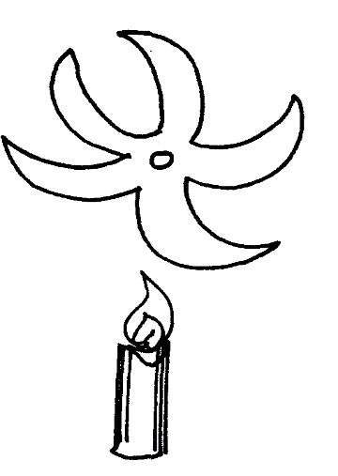

**Lit Candle**

**Figure 4**

………………………………………………………………………………………………

…………………………………………………………………………………………………

…………………………………………………………………………………………………

1. An electric kettle with shiny outer surface is more efficient than one with a dull outer surface, give a reason for this. (1mk)

…………………………………………………………………………………………………

…………………………………………………………………………………………………

1. What is the reason why trailers carrying heavy loads have many wheels. (1mk)

………………………………………………………………………………………………

…………………………………………………………………………………………………

1. Two flasks **A** and **B** were placed on a horizontal surface as shown in figure 5.

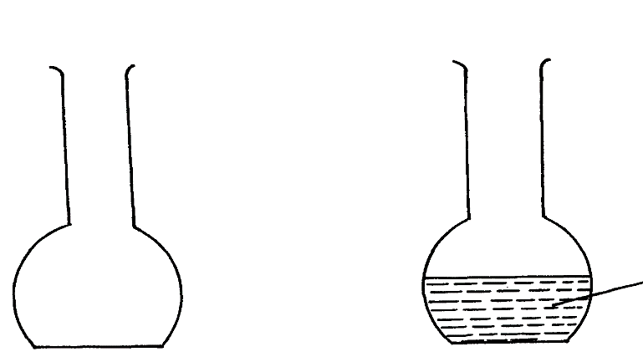

**Figure 5**

**A**

**B**

**Water**

State and explain which flask is more stable. (2mks)

…………………………………………………………………………………………………

…………………………………………………………………………………………………

11. State Newton’s second law of motion. (1mk)

…………………………………………………………………………………………………

…………………………………………………………………………………………………

12. A pipe of diameter 12mm is connected to another of diameter18mm. if water flows in the wider pipe at the speed of 2m/s, determine the speed of water in the narrow pipe. (3mks)

…………………………………………………………………………………………………

…………………………………………………………………………………………………

…………………………………………………………………………………………………

13. On the axes provided in the figure 6, sketch the graph showing variation in pressure with volume of a fixed mass of gas that obeys Boyle’s law. (1mk)

**Pressure (pa)**

**Volume ( cm3)**

**Figure 6**

14. An oil drop has a volume of 0.01mm3. When it is placed on the surface of water, it spreads out to form a circular patch of area 500cm2.

(i) Calculate the size of the molecule of the oil. (2mks)

(ii) State **one** assumption made in (i) above. (1mk)

………………………………………………………………………………………………

…………………………………………………………………………………………………

SECTION II (55 MARKS)

*Answer* ***ALL*** *questions in this section in the spaces provided*

15. (a) State Pascal’s Principle. (1mk)

…………………………………………………………………………………………………………….

(b) The diagram in figure 7 below shows hydraulic brake system.

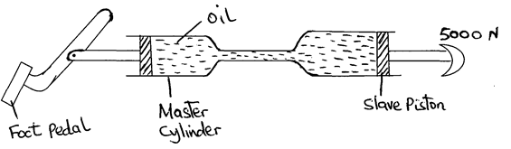

Oil

Master cylinder

Slave piston

5000N

Foot pedal

**Fig 5**

Figure 7

A force of 20N is applied on the foot pedal to a piston of area 50cm2 and this causes a stopping force of 5000N.

**Determine;**

(i) Pressure in the master cylinder. (3mks)

(ii) Area of the slave piston. (3mks)

(iii) Velocity ratio of the system (3mks)

c) The height of mercury column in a barometer density 13600kg/ m-3, at a place is 64cm. What would be the height of a column of paraffin in barometer at the same place?

(Density of paraffin = 8.0 x 102 kg /m3). (3mks

1. a) A machine is a device that enables work to be done more easily and conveniently. State any two ways in which a machine makes work easier. (2Marks)

………………………………………………………………………………………………………………………………………………………………………………………………………………………………………………………………………………………………

b) Figure 8 shows a wheel and axle being used to raise a load W by applying an effort E. The radius of the wheel is R and of the axle is r.



Figure 8

i) Show that the velocity ratio (V.R) of this machine is given by $\frac{R}{r}$ (3Marks)

ii) Given that r = 5cm, R = 50cm, determine the effort required to raise a load of 200N if the efficiencyof the machine is 90%. (4Marks)

iii) It is observed that, the efficiency of the machine increases when it is used to lift large loads. Give a reason for this. (1Mark)

………………………………………………………………………………………………………………………………………………………………………………………………

iv) State two reasons why efficiency of a machine is always less that 100%. (2mks)

1. a) i) State three necessary assumptions made in the study of the fluid flow. (3Mark)

……………………………………………………………………………………………………………………………………………………………………………………………………………………

ii) Highlight any **two** conditions under which the flow of the fluid becomes turbulent. (2Marks)

……………………………………………………………………………………………………………………………………………………………………………………………………………………………………………………………………………………………………………………………….

b) Figure 9 below shows the cross section of an aeroplane wing, with the aeroplane moving in the direction shown by the arrow.

Figure 9

i) Sketch the streamlines to show how air flows past the wing as the aeroplane moves (1Mark)

ii) Explain how dynamic lift of the aeroplane is caused by the wing. (3Marks)

………………………………………………………………………………………………………………………………………………………………………………………………………………………………………………………………………………………

c) The figure 10 below shows a pith ball placed in flask. When a jet of air is blown over the mouth of the flask as shown, the pith ball is observed to rise from the bottom.

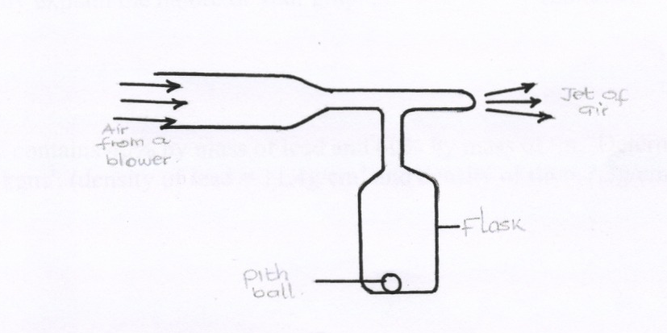

Jet of air

air from a blower

Flask

figure 10

Pith ball

Explain this observation. (2 marks)

………………………………………………………………………………………………

………………………………………………………………………………………………

c) A water pipe of diameter 5.2cm is connected to another pipe of diameter 1.3cm. The speed of water in the smaller pipe is 3ms-1. Calculate,

i) The speed of water in the larger pipe. (2Marks)

ii) The mass flux if the density of water is 1g/cm3.(2 Marks)

1. The tape in figure 11 below was obtained from an experiment using a ticker timer of frequency 50Hz. The tape was pulled by a trolley.

8cm

2cm

Figure 11

If the trolley that was pulling the tape was accelerating,

i) Show on the diagram, the direction of acceleration of the trolley. (1Mark)

ii) Calculate the acceleration of the trolley. (3Marks)

b) A stone is allowed to fall freely from the top of a tower 60 metres high. At the same time, a second stone is thrown vertically upwards with a velocity of 20m/s from the ground. Find;

i) The time taken by the two stones before they meet. (4Marks)

ii) The height at which the two stones meet. (2Marks)

d) A rifle of mass 4.0 kg fires a bullet of mass 12.0 g with a muzzle velocity of 700 ms-1. Assuming that the rifle is free to move. Find the velocity of recoil. (3mks)