Name………………………………………………………… adm.no……………..……

232/1
PHYSICS
PAPER 1
2HOURS

SET 4
FORM 3
INSTRUCTIONS
Write your name and index numbers in the spaces provided above.
This paper consists of TWO sections : A and B.
Answer ALL the questions in section A and B in the spaces provided
ALL working MUST be clearly shown
Mathematical tables and electronic calculators may be used.

For Examiner’s Use Only
Section | Question | Maximum score | Candidate’s Score
A | 1-13 | 25
B | 14 | 10
B | 15 | 10
B | 16 | 12
B | 17 | 11
B | 18 | 12
B | Total Score | 80

This paper consists of 13 printed pages. Students should check the question paper to ensure that all pages are printed as indicated and no questions are missing

SECTION A: 25 marks

1. A stone of mass 40g was completely immersed in a liquid. The levels of liquid are shown in the figure
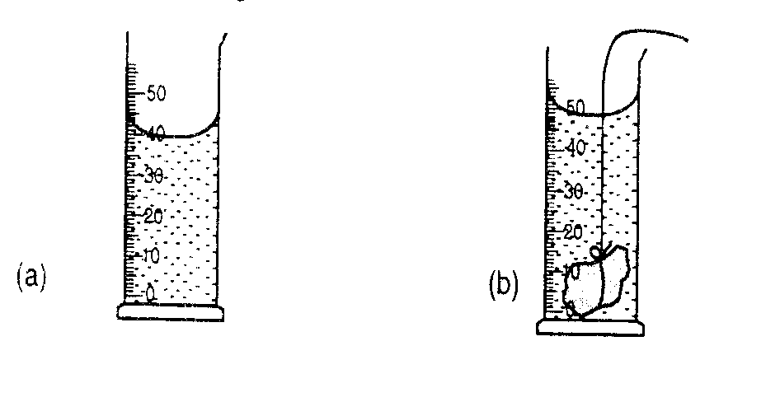

Determine the density of the stone in SI units. (3 marks)

……………………………………………………………………………………………………………………..

………………………………………………………………………………………………………………………

……………………………………………………………………………………………………………………..

2. A micrometer is used to measure the diameter of a uniform wire.
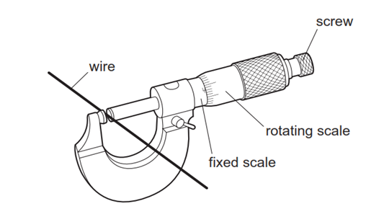
The magnified scale is shown below
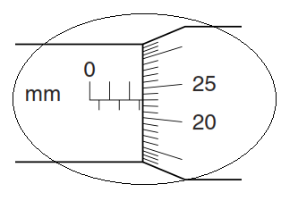
What is the radius of the wire (2 marks)

………………………………………………………………………………………………………………………………………………………………………………………………………………………………………………
………………………………………………………………………………………………………………………
3. The figure below shows an experimental set up for estimating the diameter of an oil molecule.
d
Wooden planks
Tray
Water
Oil path
Lycopodium powder

Estimate the size of an oil molecule if a drop of oil of volume 6 .0 x 10⁻¹⁰m³ forms a patch of area 0.0804m² on a water surface (2 marks)

……………………………………………………………………………………………………………………..

…………………………………………………………………………………………………………………….

4. An object is weighed on earth as shown in figure 1(a) and another planet as shown in figure 1(b)
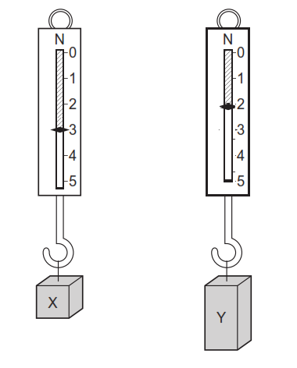
Given that acceleration due to gravity g on earth is 10N/kg. determine

(i) mass of the object (2 marks)

……………………………………………………………………………………………………………..

……………………………………………………………………………………………………………..

(ii) Acceleration due to gravity on the other planet. (2 marks)

……………………………………………………………………………………………………………………..

…………………………………………………………………………………………………………………….

5. The figure below shows water drops on two surfaces. In (a) the glass surface is smeared with wax while in (b) the glass surface is clean.
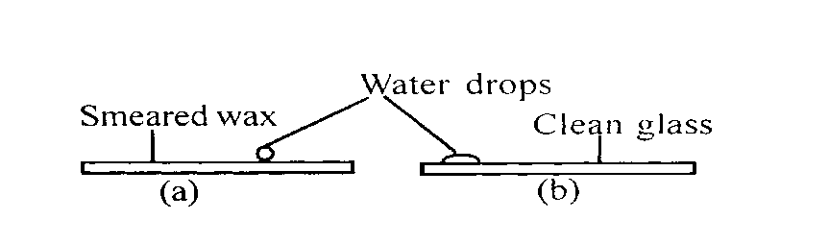
Explain the difference in the shapes of the drops. (2 marks)

………………………………………………………………………………………………………………………
………………………………………………………………………………………………………………………
6. The figure below shows a pulley system being used to raise a load

Effort

Load

Given that the size of the load is 500N and the effort applied is 200N, calculate the efficiency of the machine
(3 marks)

…………………………………………………………………………………………………………………….

……………………………………………………………………………………………………………………

…………………………………………………………………………………………………………………….

7 . Water flows in a horizontal smooth pipe. State the changes that would be observed in the nature of the flow if the speed of the water is steadily increased from low to high value. (1 mark)
……………………………………………………………………………………………………………………………………………………………………………………………………………………………………………….8. The diagram shows a uniform balanced beam, pivoted about its centre.
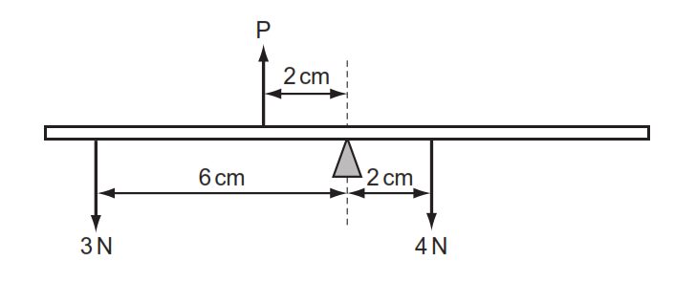
What is the value of force P (2 marks)

…………………………………………………………………………………………………………………….

……………………………………………………………………………………………………………………

……………………………………………………………………………………………………………………

9. Give a reason why a clinical thermometer should never be sterilized using boiling water (1 mark)

…………………………………………………………………………………………………………………..

10.Abimetallic strip is made from brass and iron
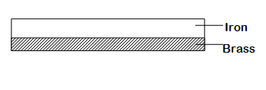
Sketch a diagram to show the appearance of the bimetallic strip if it is heated (1 mark)

11. Acar traveling at 10m/s is brought to rest at a distance of 25m after the brakes are applied. Calculate its acceleration (2 marks)
………………………………………………………………………………………………………………………

………………………………………………………………………………………………………………………
12. The graph below shows how the velocity of a ball bearing falling in a liquid column varies with the resultant down ward force.

Resultant
force (N)
15

10

5

0 2 4 6 8
Velocity (ms⁻¹)
Determine the terminal velocity of the ball bearing (1 mark)

………………………………………………………………………………………………………………………
13. The figure below was used to demonstrate absorption of radiation by different surfaces
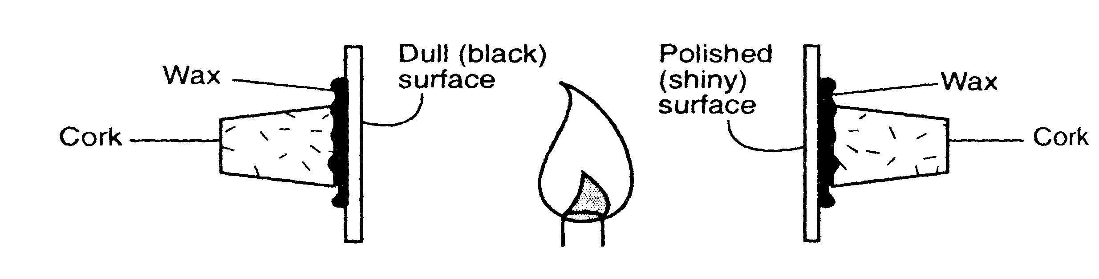
It is observed that the cork on attached to the metal plate with dull surface falls off earlier than one on the polished surface. Explain (1 mark)

…………………………………………………………………………………………………………………

…………………………………………………………………………………………………………………

……………………………………………………………………………………………………………………

SECTION B( 55MARKS)

14.(a)When a fountain pen is taken in a high flying aero plane, it leaks. A ball point pen does not have this problem. Explain how the ball point is able to overcome this problem. (1 mark)

……………………………………………………………………………………………………………….

………………………………………………………………………………………………………………

(b)The figure below shows a hydraulic lift

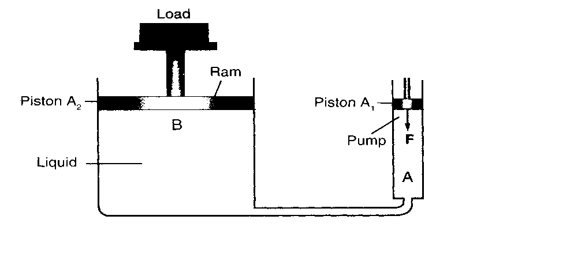
Given that the area of piston B is 18cm² and that of piston A is 3.0 cm².And a force of 2N is applied to piston A, find the force produced on the larger piston B that lifts the load. (3 marks)

……………………………………………………………………………………………………………………

……………………………………………………………………………………………………………………

……………………………………………………………………………………………………………………

(c).The figure below shows a water U-tube manometer used to measure the gas pressure of a gas cylinder
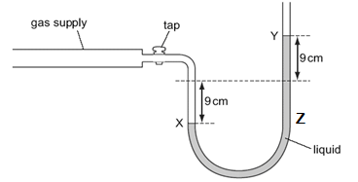

Given that the atmospheric pressure is equal to 101400pa, determine the gas pressure . (2 marks)

……………………………………………………………………………………………………………………

………………………………………………………………………………………………………………………

(d) The figure below shows a simple barometer. The vertical tube is fixed in position.
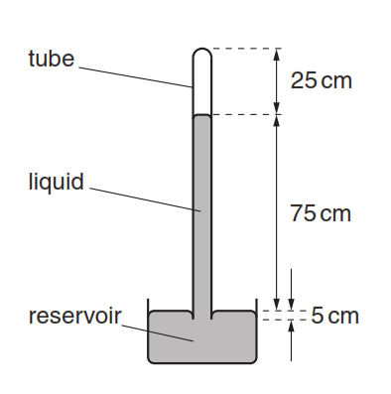
(i) Suggest why mercury is preferred over water for use in the barometer. (1 mark)
.......................................................................................................................................................................................................................................................................................................................................................................
……………………………………………………………………………………………………………………..
(ii) What occupies the space in the tube, above the liquid? (1 mark)

.................................................................................................................................................................................
(iii) Three distances are marked on figure
Which distance enables the atmospheric pressure to be deduced? (1 mark)

.............................................................................................................................................................................

(e) The tube is accidentally knocked at the top, so that a small crack is caused at the top of the tube. Air leaks in through the crack.
Describe what effect, if any, this has on the level of the liquid in the tube. (1 mark)

...........................................................................................................................................................................

15 (a).State Charles’s law for an ideal gas (1 mark)

……………………………………………………………………………………………………………………

…………………………………………………………………………………………………………………….

(b).The set up shows an arrangement to determine the relationship between temperature and volume of a gas at constant pressure

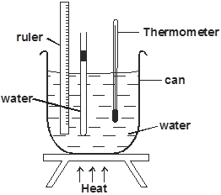
(i) List down the measurements required in this experiment (2 marks)

…………………………………………………………………………………………………………………

…………………………………………………………………………………………………………………

…………………………………………………………………………………………………………………

(ii) The graph below shows results obtained in an experiment to verify pressure law
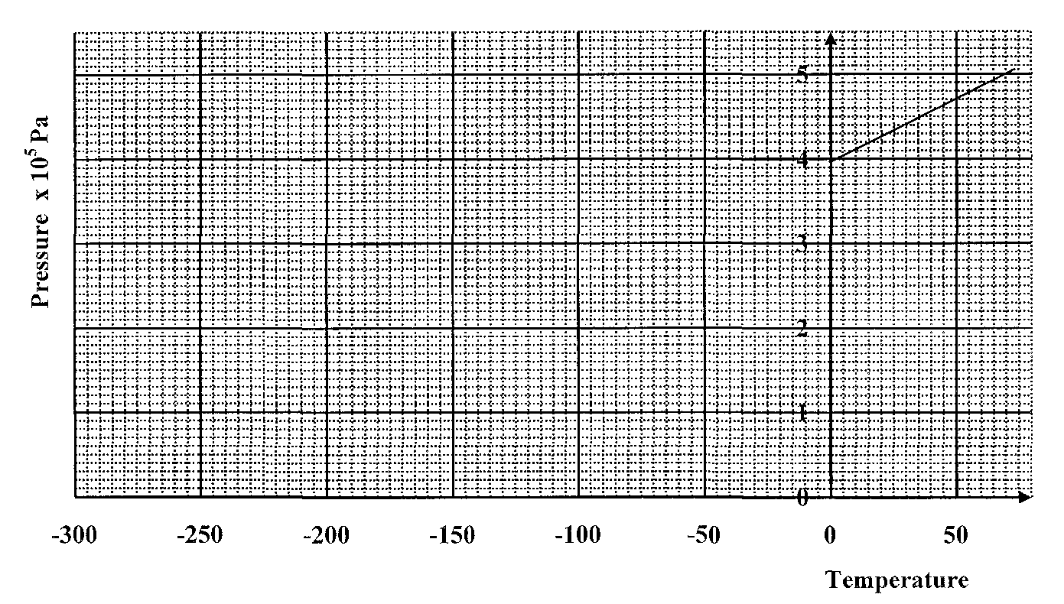
- Determine the pressure of the air at 0ºC (1 mark)

……………………………………………………………………………………………………………

- Given that P=kT +C, use the graph to determine

Constant k (2 marks)

……………………………………………………………………………………………………………………..

…………………………………………………………………………………………………………………….

……………………………………………………………………………………………………………………..
The absolute temperature (1 mark)

…………………………………………………………………………………………………………………….

(c) A bicycle tyre is pumped to a pressure of 2.2 x 10⁵Pa at 23ºC .After a race the pressure is found to be
2.6 x 10⁵Pa.Assuming the volume of the tyre did not change, what is the temperature of the air in the tyre.
( 3 marks)

……………………………………………………………………………………………………………………

…………………………………………………………………………………………………………………..

16.(a) Define the term specific heat capacity of a substance (1 mark)

…………………………………………………………………………………………………………………..

……………………………………………………………………………………………………………………
(b)An immersion heater rated at 180W is placed in a liquid of mass 2kg.When the heater is switched on for 7.5minutes the temperature of the liquid rises by40ºC.Determine the specific heat capacity of the liquid
(3 marks)
…………………………………………………………………………………………………………………

………………………………………………………………………………………………………………..

………………………………………………………………………………………………………………..

(c) A certain powder of mass 0.10kg was heated in a container by an electric heater rated 50W for sometime. The graph below shows the variation of the temperature of the powder with time
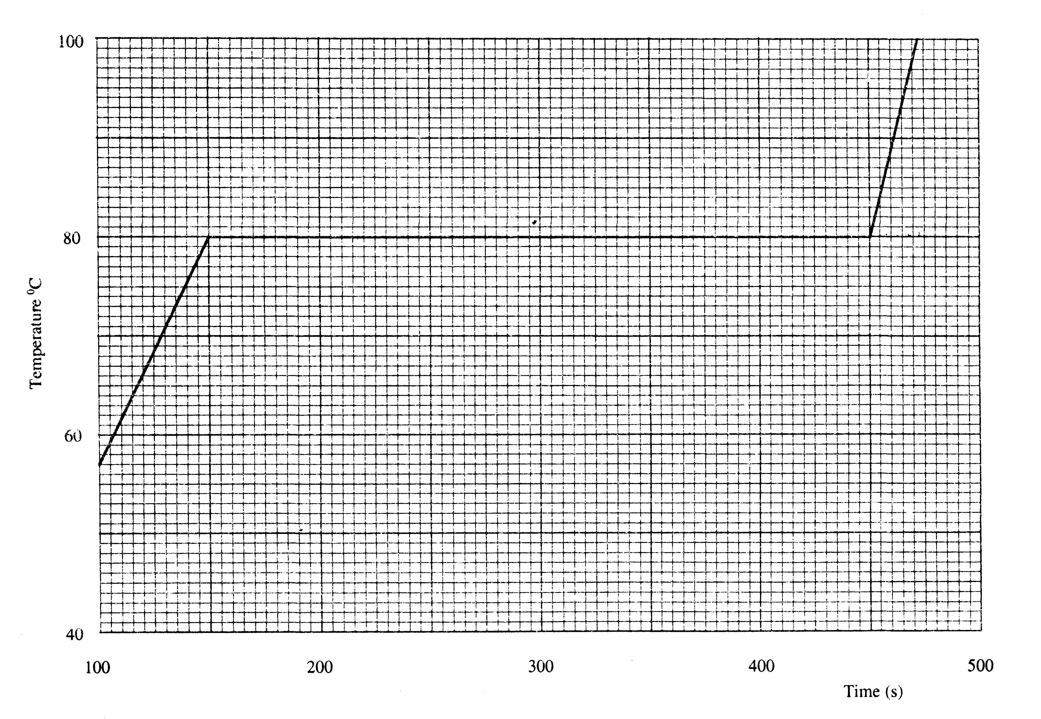
Use the graph to
- determine the melting point (1 mark)

………………………………………………………………………………………………………..
- Determine the quantity of heat supplied by the heater from the time the powder starts to melt to the time it has all melted. (3 marks)

………………………………………………………………………………………………………….

………………………………………………………………………………………………………..

…………………………………………………………………………………. ……………………

- Determine the specific latent heat of fusion of the powder assuming the container absorbs negligible amount of heat (3 marks)
………………………………………………………………………………………………………………………………………………………………………………………………………………………………………………
(d) Give a reason why the hand feels cold if a little ether is poured on it (1 mark)

………………………………………………………………………………………………………………………

………………………………………………………………………………………………………………………

17.(a) State Newton’s firs law of motion (1 mark)

…………………………………………………………………………………………………………………..

……………………………………………………………………………………………………………………

(b) An external force applied to a ball of mass 160g increases its velocity from 25cm/s to 275cm/s in 10seconds.Calculate the force applied (3 marks)

………………………………………………………………………………………………………………………………………………………………………………………………………………………………………………………………………………………………………………………………………………………………………
c). A stone is projected vertically upwards .On the axes provided, sketch a displacement time graph for the motion of the stone till it hits the ground on return (2 marks)

disp
time

(d) A modem car with a strengthened passenger cage has regions at the front and the back which can collapse in a crash. See figure below
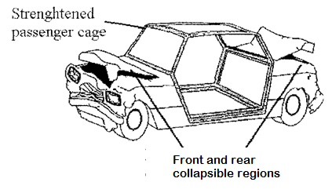
(i). Explain how the collapsible regions should reduce passenger injury in a car crash. (2 marks)
…………………………`……………………………………………………………………………………………………………………………………………………………………………………………………………….
(ii) An object of mass 150 kg moving at 20m/s’ collides with a stationary object of mass 90kg, they couple after collision. Determine their common velocity after collision. (3 marks)
………………………………………………………………………………………………………………………………………………………………………………………………………………………………………………
18. (a) The figure below shows how the speed of an object varies during a period of 30s.
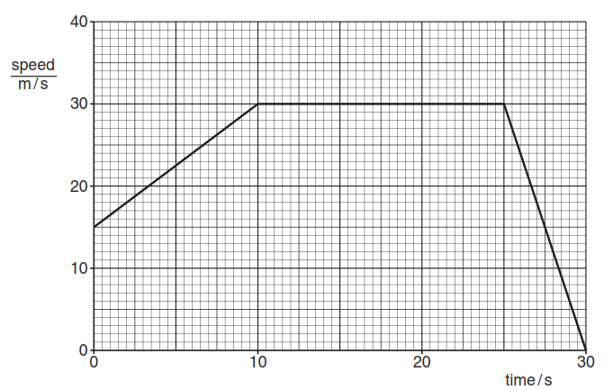
- Find the acceleration of the car in the first 10s (2 marks)
………………………………………………………………………………………………………………………………………………………………………………………………………………………………………………………………………………………………………………………………………………

- Determine the total distance covered by the car (3 marks)
………………………………………………………………………………………………………………………………………………………………………………………………………………………………………………
(b). In an experiment, forces are applied to a spring as shown in the figure below. The results of this experiment are shown on the graph alongside the spring arrangement.
Q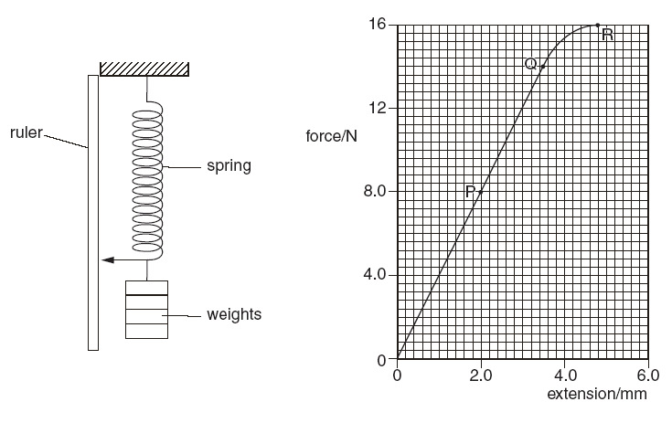
(i) State Hooke’s law (1 mark)
………………………………………………………………………………………………………………………………………………………………………………………………………………………………………………………………………………………………………………………………………………………………………
(ii) The part OP of the graph shows the spring stretching according to the expression
F = kx.
Use values from the graph to calculate the value of k. (2 marks)

………………………………………………………………………………………………………………………

……………………………………………………………………………………………………………………..

……………………………………………………………………………………………………………………..

(c) A motor is used on a building site to raise a block of stone. The weight of the block is 720N and it is raised
20m in 30seconds.Calculate
(i) The work done (2 marks)
…………………………………………………………………………………………………………………..

………………………………………………………………………………………………………………….

…………………………………………………………………………………………………………………..

(ii) The useful power supplied by the motor (2 marks)

…………………………………………………………………………………………………………………..

SET 4
MARKING SCHEME CHEMISTRY PAPER 233/2
1. Density = mass/volume✓
=40/10✓
=4.0g/cm³
=4000kg/m³✓
2. 2.50 +0.23 =2.73mm✓
3. t=volume of drop
Area of patch✓
= 6.0 x 10⁻¹⁰
0.0804✓
= 7.46 x 10⁻⁹m✓
4. (i) w=mg✓
3=10m
M=0.3kg✓
(ii) 2=0.3g✓
g=6.667N/kg✓
5. In (a) strong cohesive forces✓ between water molecules than adhesive between water and wax surface,in(b) adhesive forces ✓between water molecules and glass stronger
6. M.A=L/E
= 2.5✓
Eff=M.A x 100
V.R
=2.5 x 100✓
4
=62.5%✓
7. Flow becomes turbulent
8. Taking moments about the pivot
(Px2) +(4x2) =(3 x 6) ✓
W=5.0N✓
9. It will burst since the maximum ✓temperature it can measure is less than the temperature of boiling water.
10. Strip bends upwards✓ with brass down since brass expands more than iron

11. .v² =u² +2as
0= 100+2x25 x a✓
a= -2m/s²✓
12.6m/s✓

13. Dull black surface is a good absorber of radiation than shiny surface✓

SECTION B

14.(a) it has a small hole on its barrel that prevents leakage by balancing the pressure in and out✓

(b) F₁ = F₂✓
A₁ A₂
F₂ = 2 x 18✓
3
= 12N✓

(c) Pg = Pa +hρg
=101400 + 0.18 x 1000 x 10✓
=103200Pa✓
(d) (i) mercury is denser than water hence requires a shorter column of the tube
(ii) it is a vacuum
(iii) 75cm height
(e) air will exert pressure on the mercury, liquid level is pushed down in the tube

15.(a)Volume of a fixed mass of a gas is directly proportional to its absolute temperature provided its pressure is kept constant✓

(b)(i) temperature of the air✓ and volume ✓of the enclosed air

(ii) I. Read from graph y intercept, = 4.0 x 10⁵Pa✓

II from Y=mx +c
- Gradient = k✓
= 0.013Pa/ºC✓
- Absolute temperature- e✓xtrapolate the graph to touch temperature axis and read off

(c) P₁ =P₂
T₁ T₂✓

2.2 X 10⁵ = 2.6 X 10⁵✓
296 T₂
T₂ =349.8k✓

16.(a) Quantity of heat required to raise the temp of a unit mass of substance by one degree Celsius✓

(b) Pt =Mc∆Ө
180 x 450 = 2 x C x 40✓
C= 1012.5J/kgK✓

(c.(i) melting point = 80ºC✓
(ii) Q=Pt
= 50W x (450-150) ✓
=15000J✓
(iii)Pt=MLf
15000= 0.10 x Lf✓

Lf= 15000✓
0.1
=150000J/kg✓

(d) Latent heat required by the ether to evaporate is absorbed from the hand causing cooling effect✓

17. (a) A body in a state of rest remains at rest and if moving it continues to move in a straight line with uniform velocity unless compelled to do otherwise by some external force✓

(b) F=m(v-u)
t✓
= 0.16 ( 2.75 -0.25) ✓
10

=0.04N✓

(c)

(d).(i) On collision they collapse increasing the time collision✓. This reduces the rate of change of momentum of the passenger✓ thus the force of the impact is reduced✓
(ii)Total momentum = m₁u₁ + m₂u₂ ✓
before collision = 150 x 20 + 90 x 0
= 3000kgms⁻¹ ✓
Total momentum after collision = (m₁ + m₂)V ✓
(150 + 90) x V = 3000
V = = 12.5ms⁻¹ ✓
18. .(a)(i) a = 30-15✓
10
=1.5m/s²✓

(ii) total area under the graph✓
=750m✓
(b) (i) For an elastic material, extension is directly proportional to the force applied provided the elastic limit is
not exceeded.
(ii) slope of the graph✓
4N/mm✓
(c) (i) W=fxd✓
= 720 x 20
=14400J✓
(ii) P= work done/time
=14400/30✓
=480W✓

