**SET 8**

**PHYSICS PAPER 1**

**MARKING SCHEME**

1.Light lid builds high pressure in sufuria. The high pressure raises the boiling point of water exposing the potatoes to higher temperature

2. E = ½ Fe √1

= ½ x 2 0.015 √1

= 0.015J√1

3. - Area of base

- Position of centre of gravity√1

4. The thermometer bulb first receives the heat and expands creating more volume, the mercury then receives the heat and expands causing a rise.

5. P1P1 = P2 P2

P1 = A + Hℓwg = 100,000 NM-2

Volume is directly proportional toR3

R1 r3 = P2 R3

R3 = P1r 3 = 105000 x (1x 10-3)3√ 1

P2 100 000

R3= 1.05 x 10-9 m

R= 1.05 x 10-9 = 1. 0164 x 10-3m

D = 2.0328 X 10-3m 0r 2.0328 mm√1

6. Increases in friction lower the efficiency of a machine √1

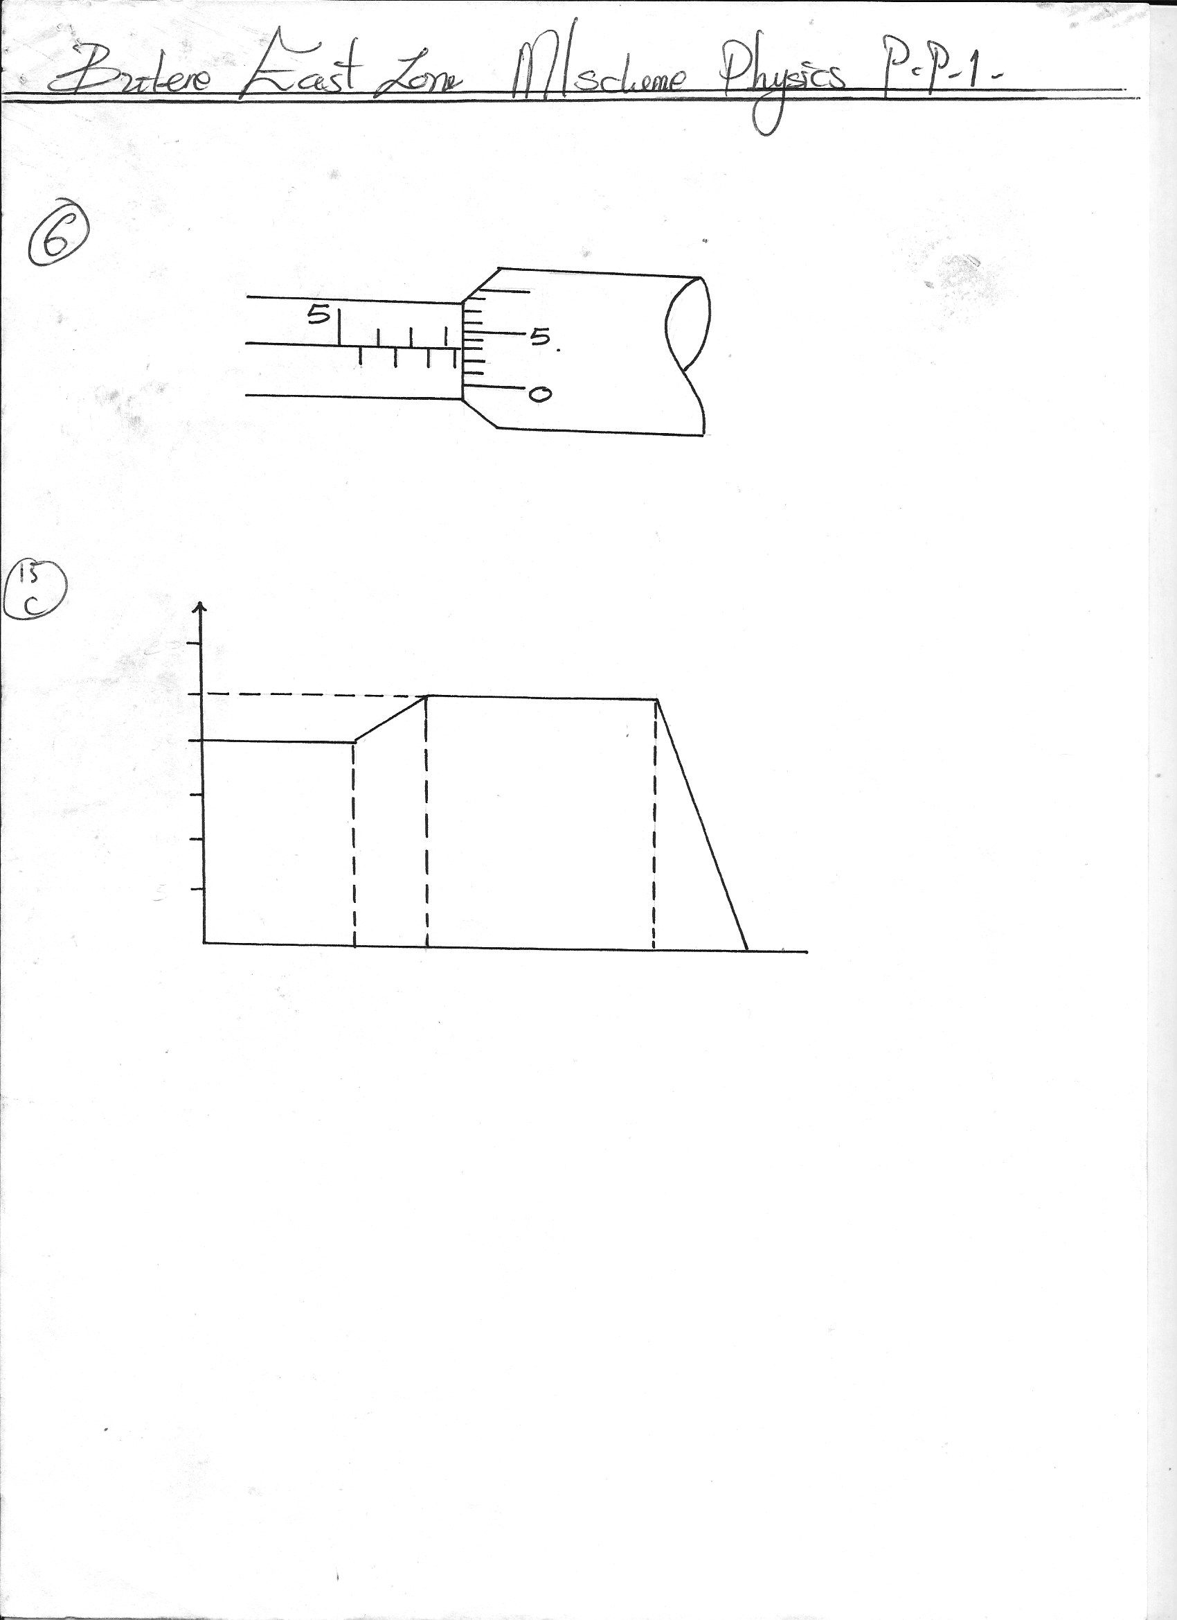7.

8. A 1V1 =A 2V2 √1

A2  = A1 V1

V2

=24 x 3√1

9

= 8cm2 √1

9. Stability increases √1 since centre of gravity is lowered (ice melts to a smaller volume of water)√1

**Displacement**

10.

**Time**

11. (a) The water melts at the top but the ice remains athmelted because water is a poor conductor of heat hence heat is not conducted downwards.

(b) The ice melts, heat is transmitted to it by convection

12. (a) (i) 133-(70 +50)√1

= 133 -120√1

= 13g√1

(ii) MwCw Dө + Mc Cc Dө √1

= 70 x 4200 x 25 + 50 x 900 x 25 √1

1000 1000

= 7350 + 4875

= 12225 J√1

(b) (i) Heat given =MLv + MCDө √1

= 13 x 10-3 Lv + 13 x 10-3 x 4200 x ( 100-30) √1

(ii) Heat gained by water = Heat given out by slens + calorimeter

12225 = 13 x 10-3Lv + 13 x10-3 x 4200 x 70√1

12225 = 13 x10-3 Lv + 3822

13 x 10-3 Lv = 8403√1

Lv = 646384.6 kg-1 √1

13. (a) (i) 16.5 = 44√1

r 16

r = 16.5 x 16 √1

44

R = 6cm √1

(b) V.R =R/r √1

= 16.5 √1

6

= 2.75√1

(c) (i) M.A – L/E √1

= 1200√1

300

= 4√1

(ii) n = M.A x 100% √1

V.R

= 4/6 x 100%

= 66.67% √1

14. (a) (i) The pressure of a fixed mass of a gas is inversely proportional to it’s volume provided the temperature is kept constant √1

(ii) The volume of a fixed mass of a gas is directly proportional to it’s absolute temperature at constant pressure √1

(b) (i) Check the student graph

(ii) at 0oC v= 4.7 ± 0.1√1

15. (a) V= u ± at√1

V2 = u2 ± 2as√1

S= ut ± ½ at2

(b) 100km/h = 100 x 1000

3600

= 27.78m/s√1

In 0.5 sec. the drive covers 27.78m/s x 0.55 = 13.89m

After applying brake

a = -4m/s2

u= 27.78 m/s

v=0

v2 = u2 + 2as √1

-2as = u2

S= u2

2a √1

= 27.78 = 96 .47m√1

 -2 (-4)

(c)

**50**

**60**

**110**

**125**

**5**

**10**

**15**

**20**

**25**

**30**

(ii) Average velocity = total distance covered

total time taken

Distance = Area under graph

=(20x 50)+ ½ (20 +25) 10+ (50x25)+ ½ (15x25)

= 1000 + 225 + 1250 + 187.5

= 2662.5 m√1

Total time = 125

Speed = 2662.5√1

125

= 21.3m/s√1

(iii) a = v-u √1

t

= 25 -20

10

= 0.5m/s√1

16. (a) For a system of colliding bodies the total linear movement remains. Constant provided no external forces act .√1

(b) m1 u1+ m2 v2 = m1 v1 +m 2v2 √1

10000x 10 + 2000 x (-20) = (10000+2000)v1√1

100000-40000=12000v1

V1 =60,000 √1

12000

= 5m/s-1√1

(ii) ft =change in movement √1

Ft = mv –mu

F = mv -mu

T

= (2000 x 5) – (2000 x-20)√1

2

= 25000N√1