**NAME: ….….……………..……………………….……………... INDEX NO: ………………….**

**SCHOOL: …….…………………………………..….…………. DATE: ………..………………**

**CANDIDATE’S SIGN: ………………….……………..….……**

**121/2**

**MATHEMATICS**

**PAPER 2**

**TIME: 2 ½ HOURS**

**SET 9**

**FORM 3**

***Kenya Certificate of Secondary Education (K.C.S.E)***

***FORM THREE***

**INSTRUCTIONS TO THE CANDIDATES:-**

* *Write your* ***name, school*** *and* ***index number*** *in the spaces provided above.*
* *Sign and write the* ***date*** *in the space provided above.*
* *This paper consists* ***two*** *sections:* ***Section I and Section II.***
* *Answer* ***all*** *the questions in* ***Section 1*** *and any****five*** *questions from* ***Section II.***
* *All working and answers* ***must*** *be written on the question paper in the spaces provided below each question.*
* *Show all the steps in your calculations, giving your answers at each stage in the spaces provided below each question.*
* *Non-programmable silent electronic calculators andKNEC mathematical tables may be used, except where stated otherwise.*
* *Marks may be given for correct working even if the answer is wrong.*
* *Candidates should check the question paper for error and omissions.*

**For Examiners’ Use Only.**

**Section I**

|  |  |  |  |  |  |  |  |  |  |  |  |  |  |  |  |  |  |
| --- | --- | --- | --- | --- | --- | --- | --- | --- | --- | --- | --- | --- | --- | --- | --- | --- | --- |
| **Questions** | 1 | 2 | 3 | 4 | 5 | 6 | 7 | 8 | 9 | 10 | 11 | 12 | 13 | 14 | 15 | 16 | **Sub**  **Total** |
| **Marks** |  |  |  |  |  |  |  |  |  |  |  |  |  |  |  |  |  |

**Section II**

|  |  |  |  |  |  |  |  |  |  |
| --- | --- | --- | --- | --- | --- | --- | --- | --- | --- |
| **GRAND TOTAL**  **Questions** | 17 | 18 | 19 | 20 | 21 | 22 | 23 | 24 | **Sub**  **Total** |
| **Marks** |  |  |  |  |  |  |  |  |  |

*This paper consists of 14 printed pages. Candidates should check to ascertain that all pages are printed as indicated and that no questions are missing.*

**SECTION I ( 50 MARKS)**

***Answer all questions in this section in the spaces provided.***

1. Without using calculator or mathematical tables evaluate $-2+8 ÷48 of 3 x 54$

$3 ÷8 x 24+3-6$ (3mks)

1. In a maths symposium there were 5 more girls than boys. The girls were given lunch allowance of shs. 50 each while boys were given shs. 60 each. The total lunch allowance paid to the students was shs. 1350. How many boys and how many girls attended the symposium. ( 3mks)
2. Use tables to simplify $\frac{1}{361 }$ + $\frac{1}{{0.872}^{2}}-\frac{1}{28.77 }$ (4mks)
3. The sum of all interior angles of a regular polygon is 2340o. Find the size of each exterior angle of the polygon. (4mks)
4. Given tan x = $\frac{3}{4}$, find sin x and cos x (2mks)
5. Solve the following equation without using logarithms tables. (3mks)

+ = 150

1. Onyango went to U.S.A with Kshs. 400,000 his air ticket was paid for the trip to U.S.A, while in USA he changed all his money to USA dollars and spent atotal to of was left with after the end of journey. Back home exchange rates are as below. (3mks)

Buying 1 $ = Kshs. 70

Selling 1 $ = kshs. 80

1. Find all the integral values of x which satisfy the inequalities (4mks)
$$8+x>4x-6 ≥3 ( 4-x)$$

2. Change the following decimal number into a fraction in its simplest form $\dot{0.670}\dot{6}$ (3mks)
3. Simplify the following expression

|  |  |  |
| --- | --- | --- |
| Left offset | Points on the chain | Right offset |
|  | To E |  |
| 40f | 200 |  |
| 30G | 180 |  |
|  | 150 | 60D |
| 45H | 110 |  |
|  | 60 | 40C |
|  | 40 | 50B |
|  | From A |  |

1. The table shows the area surveyed by a surveyor in M2. Using the right and left offsets and the points on the chain, determine the area covered by the plot ABCEDFGH

(3mks)

12. Given vector a= 4i – 3j + b = -5i – 4j , c = -7j find a-b +c ( 2mks)

̃

̃

̃

̃

̃

̃

13. A man wanted to import a machine to Kenya. The initial costs of the machine was Kshs. 40,000. He is to be charged an import duty of 125% on the initial cost. He expects the cost of sales to be 20% above the cost of the machine at that particular time. The dealer expects a profit of 25% on the current of the machine . Determine the final cost of the machine. (3mks)

14. Simplify without using tables 2 log 3 – log 90 + log 5 ( 3mks)

15. A line 2y + 6x + k = 0 passes through point ( 2,-3) and is perpendicular to the line Ay+%x + 6 = 0.

Determine the value of K and A (4mks)

16. In the ∆ ABE,AB=8cm,DC=5cm,BE = 6cm and DC $⇈$ AB. If the are of ∆ DEC = 50cm2 determine the

are of the figure ABCD. ( 3mks)

B

C

E

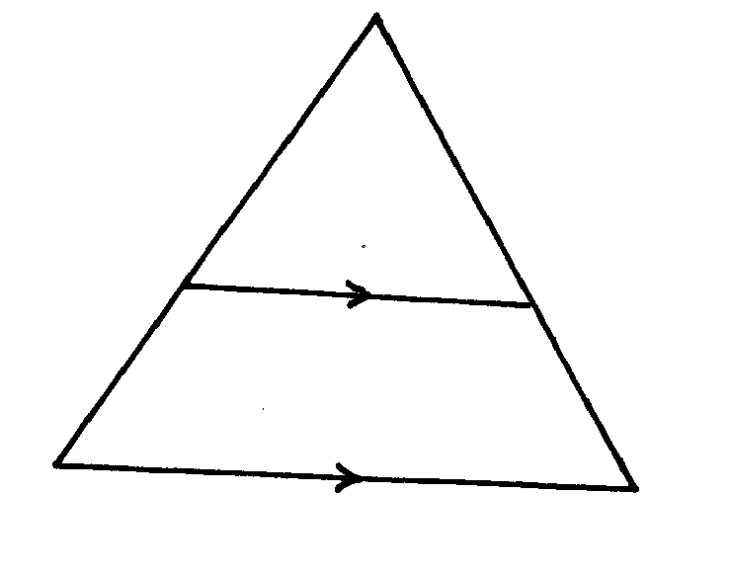

D

A

**SECTION II (50 MARKS)**

***Answer only five question from this section in the spaces provided.***

17. A bus P travels from Nairobi at a speed of 80km/hr towards Kisumu. Another bus Q travels towards

Nairobi from Kisumu at 70km/hr. Bus P started the journey at 8.00 a.m Bus Q started at 8.12 a.m. the distance between Nairobi and kisumu is 376km. determine

1. The time of their meeting (4mks)
2. The distance of P from Nairobi at meeting time (3mks)
3. The distance between P and Q 30 minutes after their meeting (3mks)

18. The coordinates of ∆ ABC are A9-1,1) B ( -5,2) and C (-3,5). The image of ABC under transformation

has coordinates A’(1,1), B’ (2,5), C’ ( 5,3)

(a) plot ABC and A’B’C’ on same grid (2mks)

(b) By construction find the centre and angle of rotation of A’B’C’ in a rotation of ABC (2mks)

(c) A’’’B’’’C’’’ is the image of ABC under reflection on the line x-y =0. Plot A’’B’’C’’ and write down its

coordinates. (3mks)

(d) A’’’(3,4) is the translation of A. Determine the translation and write down coordinates of B’’’ and

C ‘’’ (3mks)

19. The table below shows marks saved in a maths tests

|  |  |  |  |  |  |  |  |
| --- | --- | --- | --- | --- | --- | --- | --- |
| Marks | 0≤ $x<10$ | 10≤ $x<20$ | 20≤ $x<30$ | 30≤ $x<40$ | 40≤ $x<50$ | 50≤ $x<60$ | 60≤ $x<70$ |
| No. of students | 3 | 5 | 7 | 10 | Y | 6 | 1 |

1. Determine the value ( 2mks)
2. State the median and the modal (2mks)
3. Calculate the mean (3mks)
4. Calculate the median ( 3mks)

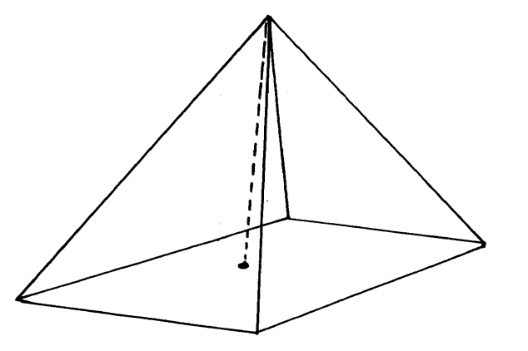20.

V

C

O

D

26cm

16cm

12cm

A

B

The above diagram is a rectangular pyramid. Determine

1. The length of the diagonal AC (2mks)
2. The height of the pyramid. (2mks)
3. The volume of the pyramid. (2mks)
4. The surface area of the pyramid. (4mks)

21. Aeroplanes P and Q leaves an airport at the same time. Aeroplane P moves at a speed of 600km/hr in the direction of 210o while Q leaves in the direction of 532oE at a speed of 720km/hr. using a scale of 1cm to represent 40km, determine

1. Position of the aeroplanes after 20minutes. (4mks)
2. The distance between P and Q after 20 minutes. (4mks)
3. (i) Bearing of P from Q (1mk)

(ii) Bearing of Q from P (1mk)

22. A train traveling between two stations starts from rest and accelerates at a constant rate for 10seconds,

then travels at constant velocity for 35 secodns and finally slows down at a constant rate for 25 seconds. The distance between the two stations is 1 kilometers.

1. Calculate the maximum velocity.
2. Draw the velocity – time graph for the journey.

1. Calculate the:-
2. Acceleration
3. The time it takes to cover half the journey .

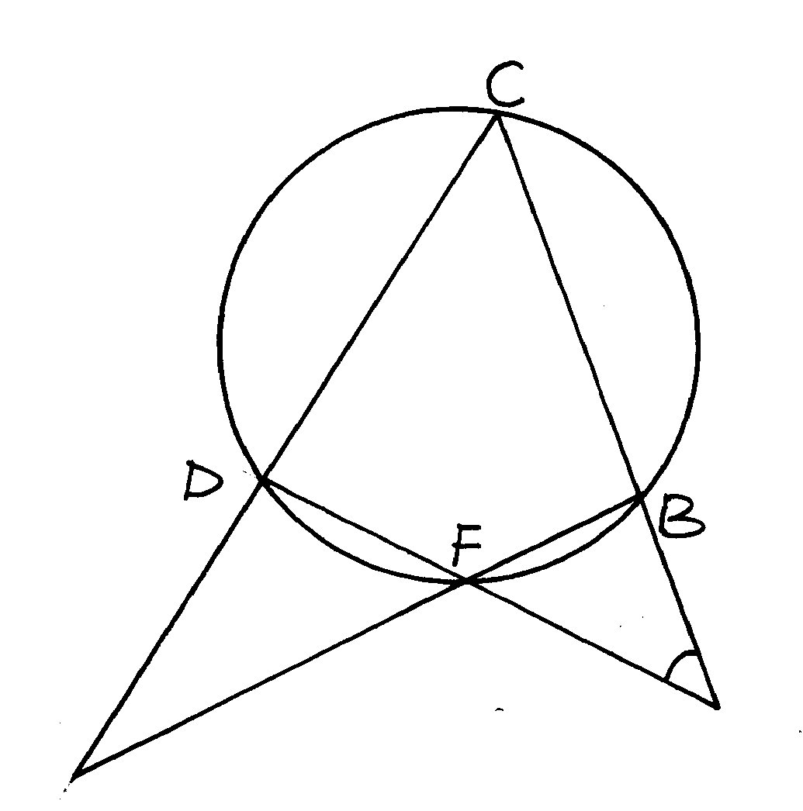23.

A

E

18

118o

In the figure below CAF = 180o, AFE = 118 o, and BCDF is a cyclic quadrilateral. Find, giving reasons, the size of following angles.

1. DFB (2mks)
2. EBA (2mks)
3. CDF (2mks)
4. DCB (2mks)
5. FED (2mks)

24. A firm planned to buy x plastic chairs for a total cost of Ksh.16,200. The supplier a greed to offer a

discount of Kshs. 60 per chair. The firm was then able to get three extra chairs for the same amount of money.

1. Write an expression in terms of x, for the:

(i) original price of each chair (1mk)

1. Price of each chair after the discount.
2. Form an equation in x and hence determine the number of chairs the firm bought. (5mks)
3. Calculate the discount offered to the school as a percentage. (3mks)