Name ……………………………………………………….. Index Number ………… Class…………..

121/2

**MATHEMATICS**

**Paper 2**

2½ Hours

**SET 7**

KENYA CERTIFICATE OF SECONDARY EDUCATION

**Instructions to candidates**

1. Write your name, index number and class in the spaces provided above.

2. The paper contains two sections: **Section I** and **Section II**.

3. Answer **all** the questions in **Section I** and any **five** questions from **Section II**.

4. All working and answers must be written on the question paper in the spaces provided below each question.

5. Marks may be awarded for correct working even if the answer is wrong.

6. Negligent and slovenly work will be penalized.

7. Non-programmable silent electronic calculators and mathematical tables are allowed for use.

**For Examiner’s use only**

**Section I**

|  |  |  |  |  |  |  |  |  |  |  |  |  |  |  |  |  |
| --- | --- | --- | --- | --- | --- | --- | --- | --- | --- | --- | --- | --- | --- | --- | --- | --- |
| 1 | 2 | 3 | 4 | 5 | 6 | 7 | 8 | 9 | 10 | 11 | 12 | 13 | 14 | 15 | 16 | Total |
|  |  |  |  |  |  |  |  |  |  |  |  |  |  |  |  |  |

|  |  |  |  |  |  |  |  |  |  |  |
| --- | --- | --- | --- | --- | --- | --- | --- | --- | --- | --- |
| 17 | 18 | 19 | 20 | 21 | 22 | 23 | 24 | Total |  |  |
|  |  |  |  |  |  |  |  |  | **Grand Total %** |

*This booklet contains 17 printed pages. Please confirm that all the pages exist and are properly printed before starting the exam.*

**SECTION I (50 MARKS)**

**Answer ALL Questions in this Section**

**1.** If the values of x and y in the ratio (2x2 + 3y2): (2x2 – 3y2) = 5: 3 also satisfy a quantity M given by  . Find the value of M. **(3 marks)**

**2.** The distance, y units, travelled by an ant as it traces the path ought to have been followed by the queen inside an ant-hill, measured from the ground level (x-axis) is given by y = 5x2 – 30x + 47. By expressing y in the form y = k(x + m) 2 + n where k, m and n are integers, state the values of k, m and n. **(3marks)**

**3.** A man deposits sh. 500,000 in an investment which pays 12% per annum interest compounded quarterly per year. Find the accumulated interest in his account after 4 years. **(3 marks)**

**4.** In an experiment to determine a local value of acceleration of free fall, a student made 11% error and 2.5% error in measuring length and computing periodic time  respectively of a pendulum. He also made a 2% error in approximating the value of. If, calculate the percentage error in obtaining. **(2marks**)

**5.** In a certain competition sweets are placed 6m apart from a point A up to another point B. There are 30 sweets in total. A container is placed at a point C, 30m before A. The competitor picks one sweet at a time and takes it to the container C, then goes for another sweet, until all are finished. If he starts at point C, determine the total distance travelled by the competitor. **(3marks)**

**6.** The co-ordinates of points A and B are (-3, 6) and (5, 24) respectively. If C is a point on the line AB such that AC: CB = 9:-5, find the coordinates of C.  **(3 marks)**

**7.** If and  find the value of in the formwhere a, b and c are rational numbers. **(3marks)**

**8.** The air resistance, R, against a body in motion varies partly directly to the square of velocity, v, and partly inversely as the cross-sectional area, A, of the object. When the velocity is 20 m/s and area is 2m2, the air resistance is 120,000 N and when the velocity is 50 m/s and area is 4m2, the air resistance is 520,000 N. Calculate the air resistance when the velocity is 40 m/s and area is 2.5 m/s. **(4 marks)**

**9.** Solve by competing the square: 6x2 + 11x - 10 = 0. **(3 marks)**

**10.** Two concentric circles have a radius of 6cm and 7.2 cm respectively. Find the length of the chord of the outer circle which is a tangent to the inner one. **(3marks)**

.O

**11.** A cone of radius 3 cm is made from a sector of a circle. If the area of the sector is 66 cm2, calculate the volume of the cone. **(4marks)**

**12.** A point P (4, 6) is mapped onto a point P1 (8 – 4) under a translation. If Q1 (5, 3) is the image of a point Q under the same translation, find the co-ordinate of Q. **(3marks)**

**13.** Solve the trigonometric equation below for.

4 Sin θ + 5 Cos θ = 0. **(3marks)**

**14.** Make  the subject of the formula:. **(3marks)**

15. A triangle ABC is such that AB = 10 cm and BC = 12 cm and angle ABC = 100o. Calculate the diameter of its circumcircle. **(3marks)**

**16.** Solve the equation log (x + 2) = log4 - log (x + 5). **(3marks)**

**Section II (50marks)**

**Answer any five questions in this section**

**17.a)** Using a matrix method solve the following equation. **(4 marks)**

3x + 2y = 6

4y+10x = 4

**b)** If and 

**i)** find. **(2 marks)**

**ii)** Hence find. **(1 mark)**

**c)** A shopkeeper buys 2 bags of sugar, 4 bales of flour and 3 bales of salt. He already has 1 bag of sugar, 2 bales of flour and 2 bales of salt. He sales each of bag of sugar at Ksh. 3,200, each bale of flour at Ksh. 600 and each bale of salt at Ksh. 500.Using matrix addition, subtraction and multiplication, determine his income after selling all the mentioned items. **(3 marks)**

**18.** The table below shows Kenya’s tax rates a certain year.

|  |  |
| --- | --- |
| Income (K£ p.a) | Tax rates ( Ksh Per £ ) |
| 1-5220 | 2 |
| 5221 – 10440 | 3 |
| 10441 – 15660 | 4 |
| 15661 – 20880 | 5 |
| 20881 and above | 6 |

In that, Mr.Omulloh livedin a company house for which he paid a nominal rent of sh. 1250 per month. He enjoyed an automatic personal relief of sh. 1,056 per month and a further life insurance relief of k. 600 per month. It is also known that he paid a per month net tax of sh. 3930. If his salary per year was sh. Y and his total taxable income was sh. Z per year,

**a)** Express Z in terms of Y. **(2 marks)**

**b)** How much tax was charged on sh. Z before any relief was given that year? **(2 marks)**

**c)** Use the table of tax rates above to determine the value of Z. **(4 marks)**

**d)** Find the value of Y. **(2 marks)**

**19.a)** Musa obtained a loan in which the rate of interest was charged at 3.5% quarterly. He cleared this loan by paying Kshs 24,805 at the end of 1½ years.

How much was the loan if the rate was on:

**i)** Simple interest. **(3 marks)**

**ii)** Compound interest. **(3 marks)**

**iii)** Calculate the difference between simple and compound interest. **(2 marks)**

**b)** A school bus was valued at sh 6,000,000 in January 2000. Each year, its value decreased by 12.5% of its value at the beginning of the year. Find the value of the bus in January 2005, giving your answer correct to 4 significant figures **(2 marks)**

**20.a)** Complete the table below for the function y = -2x2 – 7x + 4 **(2marks)**

|  |  |  |  |  |  |  |  |
| --- | --- | --- | --- | --- | --- | --- | --- |
| x | -5 | -4 | -3 | -2 | -1 | 0 | 1 |
| -2x2 | -50 | -32 |  | -8 |  | 0 |  |
| -7x | 35 |  | 21 |  |  | 0 |  |
| +4 | 4 | 4 | 4 | 4 | 4 | 4 | 4 |
| y = -2x2 – 7x + 4 | -11 |  | 7 |  |  | 4 | -5 |

**(b)** Draw the graph of y = -2x2 – 7x + 4 for -5 < x < 1. **(3marks)**

**(c)** Use your graph to solve

**(i)** -2x2 – 7x + 4 = 0 **(1mark)**

**(ii)** -2x2 – 4x – 2 = 0 **(2marks)**

**(iii)** -2x2 – 7x + 2 = 0  **(2marks)**

**21.** In the figure below, O is the centre of the circle of radius 3cm and AB is a chord such that its shortest distance from O is 1cm. CBD is a tangent to the circle at B.

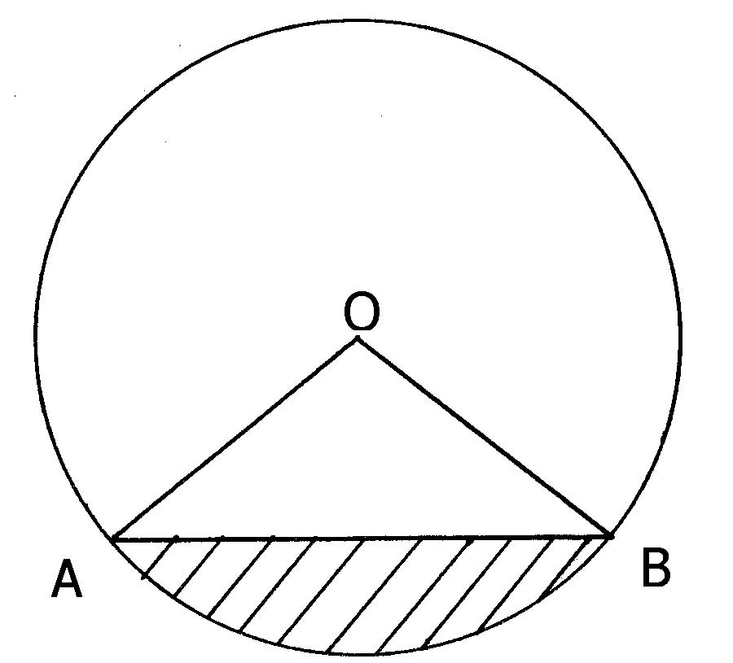

**D**

**C**

Calculate:

**a)** The length of the chord AB. **(2marks)**

**b)** Angle AOB **(2marks)**

**c)** The area of the minor sector OAB. **(2marks)**

**d)** The area of the shaded segment. **(2marks)**

**e)** The angle ABC.  **(2marks)**

**22.** The diagram **below** shows triangle **OAB**. **OA** = **a**, **OB** = **b**. **C** divides **OA** in the ratio 1:2 and **D** divides **OB** in the ratio 2:3 while **AD** and **BC** meets at **E**.

A

B

O

D

C

E

a) Find the following vectors in terms of **a** and **b**

**(i)** **OC**. **(1 mark)**

**(ii)** **CB**. **(1 mark)**

b) Given that **CE** = m**CB** and **AE** = n**AD**, where m and n are scalars, find:

**(i)** Two expressions for **OE**. **(3 marks)**

**(ii)** The values of m and n. **(3 marks)**

**(iii)** **OE** in terms of **a** and**b** only. **(1 mark)**

**(iv)** The ratio CE: EB. **(1 mark)**

**23.(a)** Three quantities P, Q and R are such that P varies directly as the square of Q and inversely as the square root of R.

**i)**  Given that Q increases by 5% and R decreases by 36%, find the percentage change in P. **(5 marks)**

**ii)** If P = 6 when Q = 12 and R = 25, find the value of P when Q = 15 and R = 81. **(3 marks)**

**b)** After the changes in (a) i) above, what would be the value of P found in (a) (ii) above. **(2 marks)**

**24.a)** The figure below shows a pulley system where a conveyer belt is tied round the two wheels. The radius of the larger wheel is 180cm and the distance between the centres of the wheels is 300cm and angle AMC=1400.

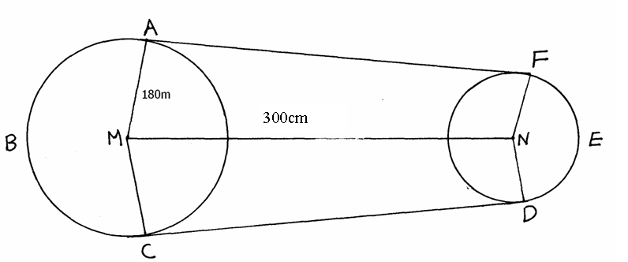

Determine

**(a)** the length of AF. **(2marks)**

**(b)** the length of the arc FED. **(4marks)**

**(c)** the length of the arc ABC. **(2marks)**

**(d)** the total length of the conveyor belt. **(2marks)**

**SET 7**

**MATHEMATICS MARKING SCHEME P2**

|  |  |  |  |
| --- | --- | --- | --- |
| 1. |  | M1  M1  A1 |  |
|  |  | 3mks |  |
| 2. |  | M1  M1  A1 | For all correct |
|  |  | 3mks |  |
| 3. |  | M1  M1  A1 |  |
|  |  | 3mks |  |
| 4. |  | M1  A1 |  |
|  |  | 2mks |  |
| 5. |  | B1  M1  A1 |  |
|  |  | 4mks |  |
| 6. |  | M1  B1  A1 |  |
|  |  | 3mks |  |
| 7. |  | M1  M1  A1 |  |
|  |  | 3mks |  |
| 8. |  | B1  M1  A1  B1 | For both eqns correct |
|  |  | 3mks |  |
| 9. |  | M1  M1  A1 |  |
|  |  | 3mks |  |
| 10. |  | M1  M1  A1 |  |
|  |  | 3mks |  |
| 11. |  | M1  M1  M1  A1 |  |
|  |  | 4mks |  |
| 12. |  | M1  M1  A1 |  |
|  |  | 4mks |  |
| 13. |  | M1  M1  A1 |  |
|  |  |  |  |
| 14. |  | M1  M1  A1 |  |
|  |  | 3mks |  |
| 15. |  | M1  M1  A1 |  |
|  |  | 3mks |  |
| 16. |  | M1  M1  A1 |  |
|  |  | 3mks |  |
| 17. |  | M1  M1  M1  A1  M1  A1  A1  M1  M1  A1 |  |
|  |  | 10mks |  |
| 18. |  | M1  A1  M1  A1  M1  M1  M1  A1  M1  A1 |  |
|  |  | 10mks |  |
| 19. | iii) S.I. = 24805 – 20500  = 4305  C.I. = 24805 – 20190  = 4610  Difference = 4610 – 4305  b) A = 6000,000 5  A = 6000000 ( 0.875)5  A = 3,077,453.613  = 3077000 ( 4s.f) | B1  M1  A1  M1  M1  A1  M1  A1  M1  A1 | (both interests) |
|  |  | 10mks |  |
| 20. | y = -2x2 – 7x + 4   |  |  |  |  |  |  |  |  | | --- | --- | --- | --- | --- | --- | --- | --- | | x | -5 | -4 | -3 | -2 | -1 | 0 | 1 | | -2x2 | -50 | -32 | -18 | -8 | -2 | 0 | -2 | | -7x | 35 | 28 | 21 | 14 | 7 | 0 | -7 | | +4 | 4 | 4 | 4 | 4 | 4 | 4 | 4 | | y = -2x2 – 7x + 4 | -11 | 0 | 7 | 10 | 9 | 4 | -5 |   b)    c) (i) -2x2 – 7x + 4 = 0 x = -4 or 0.5  ✓  x -1 0 1 2 3  y 9 6 3 0 – 3  ✓ | T2  P1  S1  C1  A1  M1  A1  M1  A1 | All values correct 2 |
|  |  | 10mks |  |
| 21. | d)11.08331-( ½ ×3×3 sin 141.06º  = 11.0831 – 2.82828  = 8.2548cm2 | M1  A1  M1  A1  M1  A1  M1  A1  M1  A1 |  |
|  |  | **10mks** |  |
| 22. | a) i) **OC** = **a**  ii) **OD** =  **b**  **CB** = **b** - **a**  b)i) **CE** = m( **b** - **a**)  **AE** = n(**b** - **a** )  **OE** = **a** + n(**b** – **a** )  = (1 – n) **a** + n**b**  **OE** = **a** + m( **b** - **a** )  = **a** + m **b**  (ii) 1 – n =  m =  1 – n =  n =  m =  n =  iii) **OE** = **a** + **b** - **a** )  = **a** + **b**  iv) CE : EB = 2 : 5 | B1  B1  B1  B1  B1  M1  M1  A1  B1  A1 | (AE stated)  (two equations)  (attempt to solve)  (both values 🗸) |
|  |  | 10mks |  |
| 23. |  | B1  M1  B1  M1  A1  M1  A1  M1  A1  M1  A1 |  |
|  |  | 10mks |  |
| 23. | (d)Length of belt  2(281.9)+189.1+691.2  =1,444.1cm | M1  A1  M1  M1  M1  A1  M1  A1  M1  A1 |  |
|  |  | 10mks |  |