SET 3
MATHEMATICS 121/2

MARKING SCHEME
1 | NOS Sf Logs  6.196 11.82 83.52 60.9675 6.196x 10º 1.182x 10¹ 8.352 - - 0.7921 - + 1.0728 1.8649 1.9218 1.9431÷3 1.9856  4 + 3.9431  4 | M 1  A1  M1  A1  4 | For correct logs  For √ addition and sub  For √ division by 4  √ answers
2. | 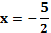 | M1  A1  A1  3 | Multiplying by 25  √factorization
3 |  | B1  B1  B1  3
4 | 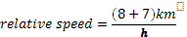  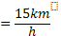  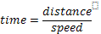  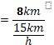 | M1  A1  03 | Relative speed  C.A.O
5 | 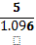  = | M1  M1  A1  03
6 | Log ₂(= log ₂x-log ₂4  Log ₂ (x+3) =log ₂ | M1  A1  02 | Dropping logs  C.A.O
7 | 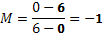 | B1  B1  B1  B1  04 | Gradient of L1  L1 correct inequalities  L2 correct inequalities  L3 correct inequalities
8 | ∠OTP 90 º  ∠POT =  =70º  ∠ROT= 110º (angles on a straight line)  ∠RST = 110º  2  = 55o angle at centre and circumference of the circle | B1  B1  B1  03
9 | 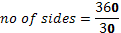 | M1  M1  A1  3
10. | 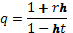  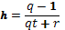 | B1  B1  B1  03
11 | (a)  -2d=20  (b) S₁₅= | B1  B1  M1  A1  04
12. | 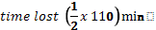  = | M1  M1  A1  03
13. | (a)  (b) ⁷ = (1-0.06)⁷  (1+x)⁷=(1-0.06)⁷  =1+7(-0.06)+23(-0.06)²+35(0.06)³  = | M1  A1  M1  A1  04
14. | ²  K=2  X=2y²  X=2(4) ²  =32 | M1  A1  02
15. | 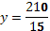  ∴  ∴  =3:2 | M1  M1  A1  03 | √ values of x and y  √ correct ratio
16 | ² = | B1  B1  B1  3
17 | 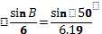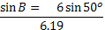  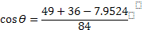 | M1  A1  M1  A1  M1  M1  A1  A1  M1  A1  10
18 | 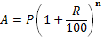  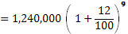  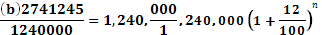  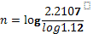  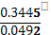  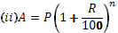  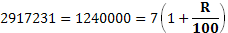⁷  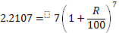  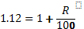
19 | x -2 -1 0 1 2 3 4 5 6  y -13 -6 -1 2 3 2 -1 -6 -13  X 0 3  y -3 3  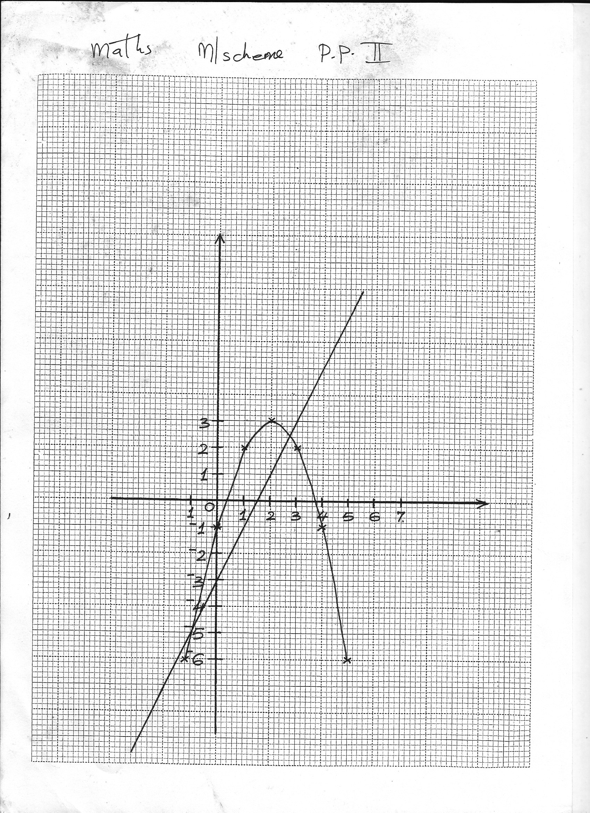
20 | Q  R  S  P  SQ = 5.8 ±0.1  P  S  Q  O  R  O  P  P  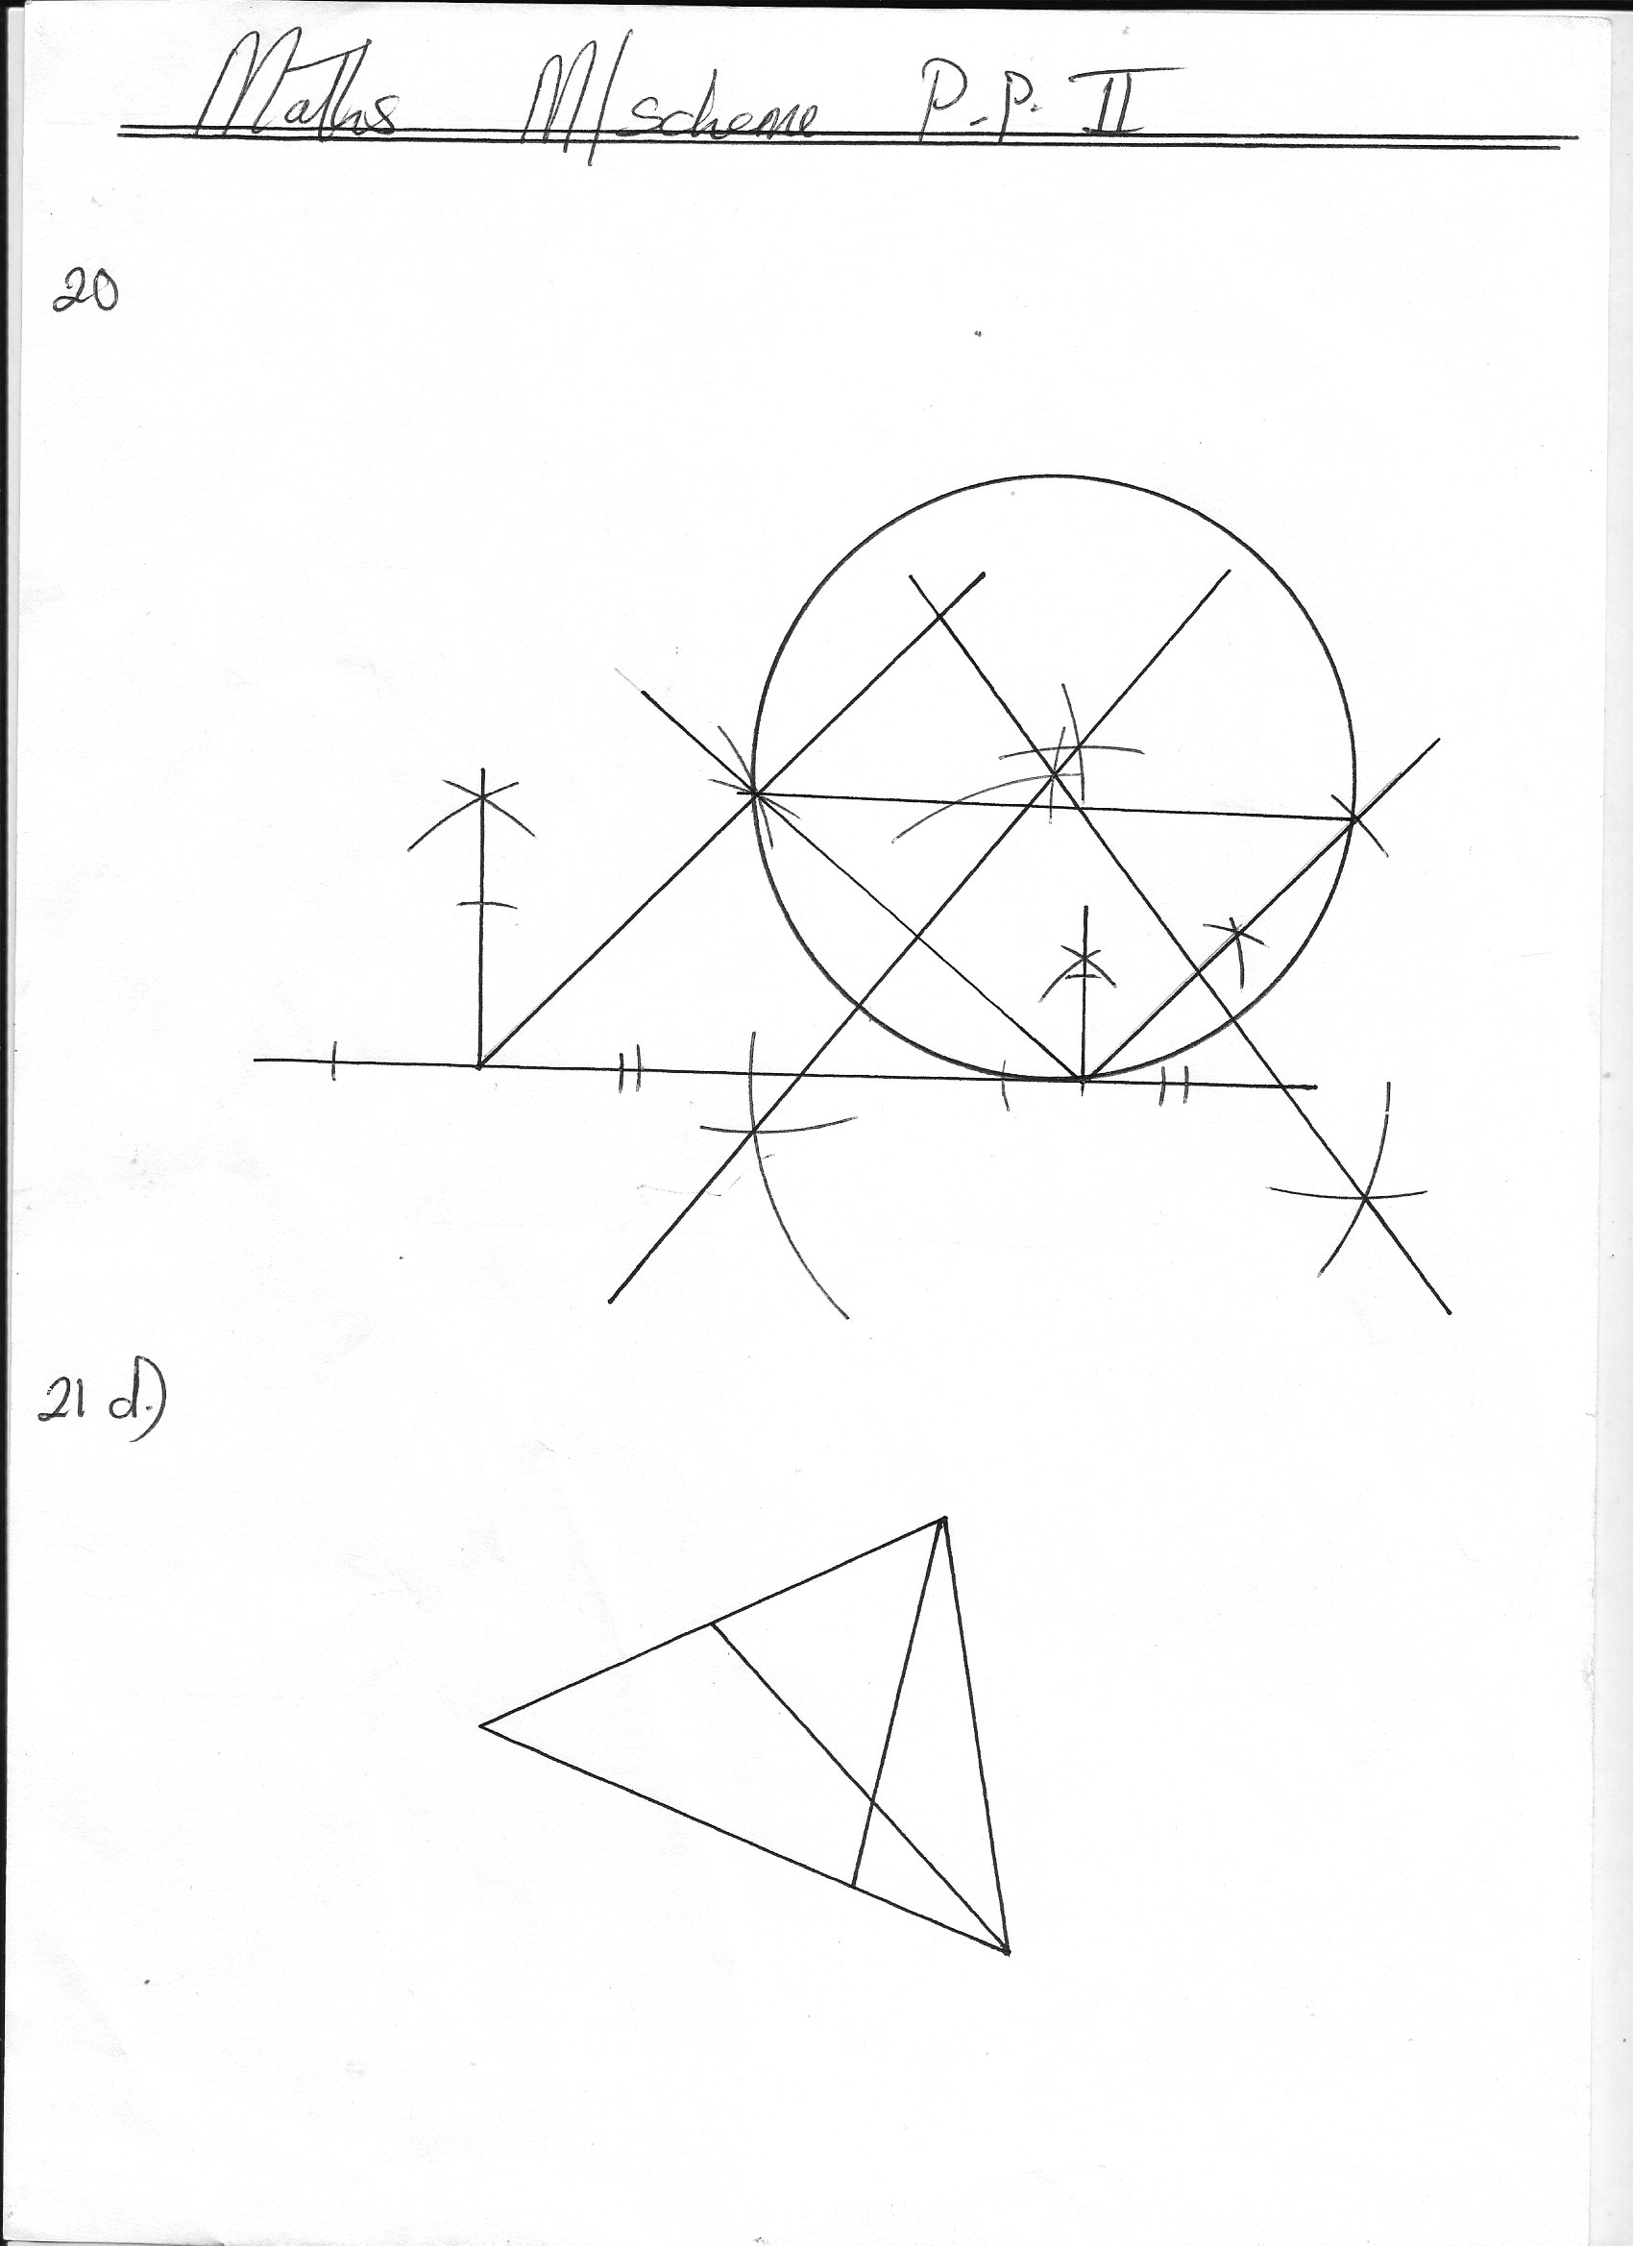  r=4cm  B1 construction 45o  B1 PS and SQ drawn  B2 completion of parallelogram  B1 SQ=5.8±0.1  B1 bisector of SQ  B1 bisector QR  B1 location of O  B1 circle drawn  B1 radius 4±0.1  10
21 | (a) =  A⁻¹=  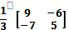  (b) =  =  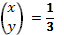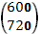  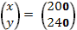  ∴  (c)  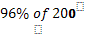  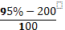  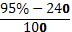  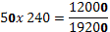  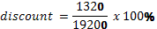  =. | B1  B1  B1  M1  M1  A1  M1  M1  M1  A1  10 | Determinant  Inverse  Premultiplying RHS by inverse
22. | O  4  N  A  B  2  M  3  1-t  S  X  1-S  t  1  (a) (i) AN = -a + 4/5 b  (ii) BM = -b + 2/5 a  (b)(i) OX= a + S(-a+ 4/5b)  OX=b+(-b+ 2/5a)  (c) a+ 5(-a+ 4/5b) = b ++(-b+2/5a)  1-s= 2/5t…(i)  1-t= 4/5s….(ii)  (2t +5s= 5)5  (5t+4s=5)s  10t+255 =25  10t+8s=10  17s =15  S= 15/17  t=-4/5(5/17)  t=5/17  OX= (1-15/17) a + 4/5(15/17) b  = 2/17 a + 12/17b | B1  B1  B1  B1  M1  M1  M1  A1  B1  B1  10
23 | ¼  ¾  H  1/3  2/3  C  C  C  C  1/5  4/5  1/5  4/5  1/5  4/5  4/5  1/5  L  L¹  L  L  L¹  L ¹  L  L  L¹  (b)(i) (H1C1L1) = ¾ x 2/3 x 4/5  = 2/5 or 0.4  (ii) P(HC¹L¹) or P(H¹CL¹) or P(H¹C1L¹)  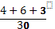  ©(i) PC1- P (none be late)  =  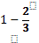  (ii)  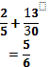 | B2  M1  A1  M1  A1  M1  A1  M1  A1  10
24 | 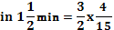  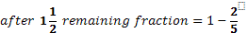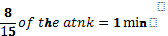  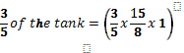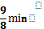  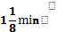 | B1  M1  A1  M1  A1  M1  M1  A1  M1  A1  10 | All the three fractions

