**SET 2**

**MATHEMATICS PP2 MARKING SCHEME.**

|  |  |  |  |  |  |
| --- | --- | --- | --- | --- | --- |
| 1 | |  |  | | --- | --- | | 0.0485  0.5850  89.2834 | **+**    **-** | | B1  M1  M1  A1  04 | **🗸** log of 3.846 and +  🗸 log S  + - &  CAO |
| 2  3 | M1  M1  A1  03 | M1  M1  A1 | Removal of root sign  Factorization |
| 4 | (x-y)6=1.x6.y0-6.x5.y1+15x4y2  -20x2y3    =x6-6x5+15x4y2-20x3y3  (0.98)6=(1-0.02)6 x=1,y=0.02  (0.98)6=16-6.15(0.02)+15(1)4(0.02)2  20(1)3(0.02)3  =1-0.12+0.006-0.00016  =0.8854 | M1  M1  M1  A1  04 | Allow substitution into the whole expression  CAO |
| 5 |  | M1  M1  A1  03 | L . H . S |
| 6 | SU.TU=QU.RU  SUx14=31x16  SU=31x16  14  =35.43cm | M1  M1  A1  03 | CAO |
| 7 |  | M1  M1  A1  03 |  |
| 8 |  | M1  A1  B1  03 | Or alternative  allow 27209.78  allow 7209.78 |
| 9 |  | M1  A1  B1  03 | Or alternative |
| 10 | x2+8x+y2-2y=1  x2+8x+42+y2-2y+(-1)2=1+16+1  (x+4)2+(y-1)2 =18  x= -4, y=1, r=  (-4,1) and radius = 4.243 | M1  M1  A1  03 | for both centre and radius. |

|  |  |  |  |
| --- | --- | --- | --- |
| 11 | BAD = 480  BDC = 240  BEC = 180 | B1  B1  B1  03 |  |
| 12 | 4x2-32x-20+k  b2 = 4ac  (-32)2=4x4(20+k)  64 = -20+k  K = 84 | M1  A1  02 |  |
| 13 |  | M1  A1  02 |  |
| 14 |  | B1  M1  M1  A1  04 |  |
| 15 |  | M1  M1  A1  03 |  |
| 16 |  | **B1**  **B1**  **B1**  **03** | bisector of at P  bisector of line PR  measure of QX |
| 17  (a) |  | **M1**  **A1** |  |
| b) | 1st 6000x2=12000  2nd6000x3 =18000  3rd6000x4 =24000  4th6000x5 =30000  5th 6000x6=36000  6th 6000x7=42000  7th 2280x8 1842  Tax due =Ksh.180,240pa  Less relief 18,000  Tax payable 162,240  PAYE = 13,520 | **M1**  **M1**  **M1**  **A1** | For the 1st 3slabs  For 18,240  Process of - relief  CAO |
| c | Total deduction  =13520+320+1000+2000+5000+500  =Ksh.22,340 | **M1**  **A1** | addition |
| d | 38280-22340  =Ksh.15,940 | **A1**  **10** |  |

18 a) y=2x2+5x – 12 for 8<x< 4

|  |  |  |  |  |  |  |  |  |  |  |  |  |  |
| --- | --- | --- | --- | --- | --- | --- | --- | --- | --- | --- | --- | --- | --- |
| X | -8 | -7 | -6 | -5 | -4 | -3 | -2 | -1 | 0 | 1 | 2 | 3 | 4 |
| 2X2 | 128 | 98 | 72 | 50 | 32 | 18 | 8 | 2 | 0 | 2 | 8 | 18 | 32 |
| 5X | -40 | -35 | -30 | -25 | -20 | -15 | -10 | -5 | 0 | 5 | 10 | 15 | 20 |
| -12 | -12 | -12 | -12 | -12 | -12 | -12 | -12 | -12 | -12 | -12 | -12 | -12 | -12 |

b) y = 2x2+5x-12

0=2x2+5x-12

y =0

2x2+5x-12=y x-3

-3x2-7x+3=0 x2

-6x2-15x+36= - 3y

-6x2-14x+6 = 0

-x+30 = -3y

-3y = - x+30

y = 1/3  x + 10

|  |  |  |  |  |  |  |  |
| --- | --- | --- | --- | --- | --- | --- | --- |
| x | -9 | -6 | -8 | 0 | 3 | 6 | 9 |
| y | 7 | 8 | 9 | 10 | 11 | 12 | 13 |

|  |  |  |  |
| --- | --- | --- | --- |
| 19  (a)  b  c | A=32x+1  Ar=9x  , ar2 =81 | **M1**  **M1**  **A1**  **B1**  **M1**  **M1** |  |
| d | ar4-ar6 | **A1**  **B1**  **M1**  **A1**  **10** | Both and d |

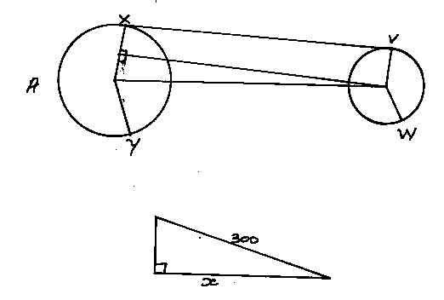20

a) length XV = 300 sm 700 M1

= 281.9cm A1

b) Arc length VBW = 



c) Length XAY



d) Length of the conveyor belt

=691.2+439+(2x281.9)

=1694.88