**Name……………………………………..………………... Index No …………………………..…...**

**School……………………………………………………… Date……………………………….……...**

**Candidate’s Signature …………………….………………**

**121/1**

**MATHEMATICS**

**Paper 1**

**Time: 21/2 Hours**

**SET 9**

**FORM 3**

***Kenya Certificate of Secondary Education (K.C.S.E)***

**INSTRUCTIONS TO THE CANDIDATES**

* *Write* ***your name*** *and* ***index number, school and sign*** *in the spaces provided above*
* *This paper contains two sections;* ***Section*** *1 and* ***Section 11****.*
* *Answer all the questions in* ***section 1*** *and only* ***five*** *questions from* ***Section 11***
* *All necessary workings and answers must be written on the question paper in the spaces provided below each question.*
* *Show all the steps in your calculations, giving your answers at each stage in the spaces below each question*
* *Marks may be given for correct working* ***even if*** *the answer is wrong.*
* *No n programmable silent electronic Calculators and KNEC Mathematical tables may be used* ***EXCEP****T where stated otherwise.*

**FOR EXAMINERS’S USE ONLY**

**Section 1**

|  |  |  |  |  |  |  |  |  |  |  |  |  |  |  |  |  |  |
| --- | --- | --- | --- | --- | --- | --- | --- | --- | --- | --- | --- | --- | --- | --- | --- | --- | --- |
| Question | 1 | 2 | 3 | 4 | 5 | 6 | 7 | 8 | 9 | 10 | 11 | 12 | 13 | 14 | 15 | 16 | Total |
| Marks |  |  |  |  |  |  |  |  |  |  |  |  |  |  |  |  |  |

**Section 1I** **GRAND TOTAL**

|  |  |  |  |  |  |  |  |  |  |
| --- | --- | --- | --- | --- | --- | --- | --- | --- | --- |
| Question | 17 | 18 | 19 | 20 | 21 | 22 | 13 | 24 | **Total** |
| Marks |  |  |  |  |  |  |  |  |  |

*This paper consists of 15 printed pages. Candidates should check carefully to ascertain that all the pages are printed as indicated and no questions are missing.*

**SECTION 1 (50 MARKS)**

***Answer all questions in the spaces provided.***

1. Use logarithms correct to 4 decimal places to evaluate. (4mks)

80.73log 5.948

$∛$ 0.006435

1. Make ***x*** the subject of the formula: (3mks)
$$d=\frac{xb}{\sqrt{x^{2}-b}}$$

2. Simplify the following and leave your answer in the form a+ b $√c$ where a, b and c are integers: (3mks)
3. Solve for x in the following logarithmic equation: ( 4mks)
4. Use the matrix method to solve the following simultaneous equations. (3mks)

5x+7y – 1 = 0

4x+ 5y -2 = 0

1. Peter was asked to round 2 $\frac{7}{15}$ to 2 decimal places but he instead truncated it to 2 decimal places. Calculate his percentage error resulting from the misread. (3mks)
2. Expand ( 1- )5 and use the first three terms of the expansion to find the value of ( 1.01)5. Give your answer to 4 figures. (4mks)
3. Find the radius and the centre of the circle: 2x2 + 2y2 – 6x + 10y = - 9 (3mks)
4. The fourth term of a GP is 48 and the seventh term is 384. Find the common ratio and hence calculate the sum of the first five terms. (4mks)
5. A group of five people can do a piece of work in 6hours. Calculate the time a group of 8 people, working at half the rate of the first group would take to complete the same work. (2mks)
6. A quantity P is partly constant and partly varies inversely as quantity. Given that P = 10 when t = 15 and P = 20 when t = $\frac{5}{4}$, find the law connecting P and t. (4mks)
7. A man invests Ksh. 10,000 in an account which pays 16% p.a. The interest is compounded quarterly. Find the amount in the account after 1 $\frac{1}{4}$ years. (2mks)
8. Given that cos 2xo = 0.8070, find x in the domain 0o (4mks)
9. The position vectors of points P and Q are $\left({ 3 \atop \begin{aligned}-1 \\ -4\end{aligned}}\right)$ and $\left({ 8 \atop \begin{aligned}-6 \\ 6\end{aligned}}\right)$ respectively. A point B divides PQ in the ratio 2:3 Find the co-ordinates of point B. (3mks)
10. 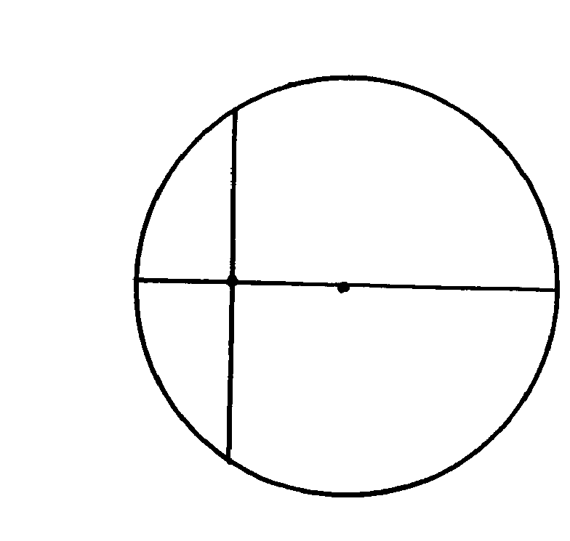 In the diagram below PQ is a diameter of the circle . AB is a chord which intersects the diameter at aright angle at point N. Given that NQ =\ 2cm and AN= 6cm, calculate the radius of the circle. (2mks)

6cm

2cm

N

B

Q

A

P

1. In the figure below ( not drawn to scale) PAQ is a tangent to the circle at A . Find angles DAB and BAQ. ( 2mks)

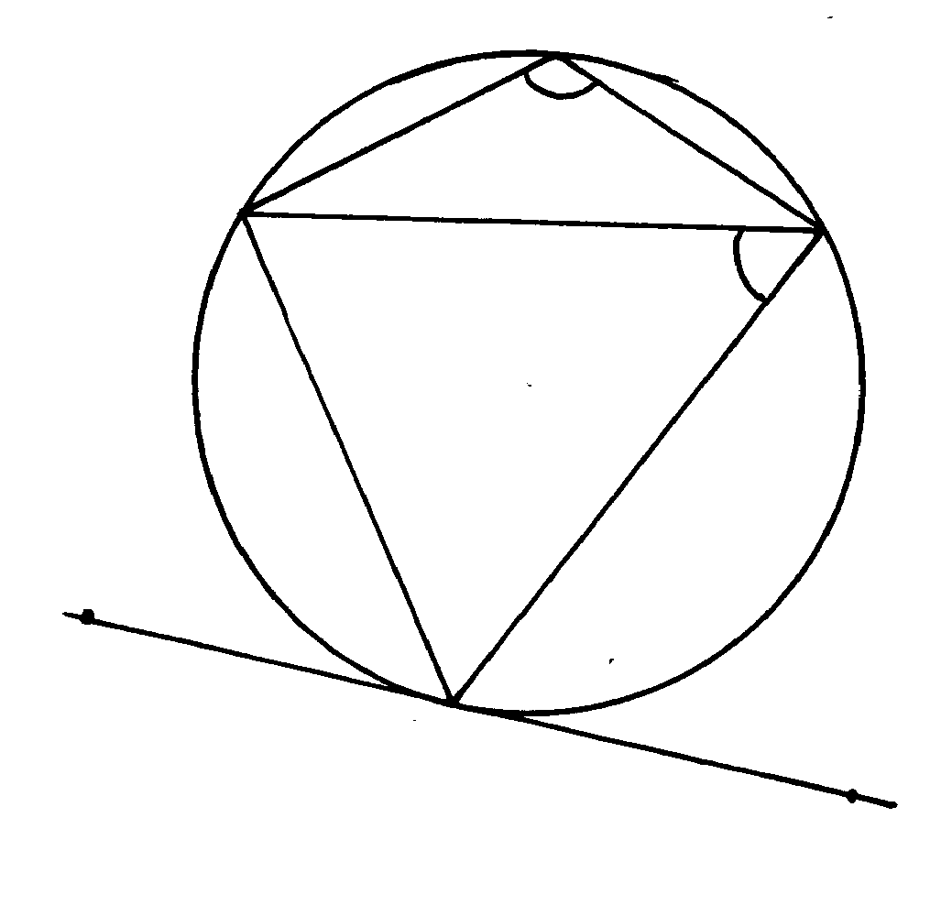

Q

P

A

D

B

C

110o

52o

1. Given that y = 8 sin x – 6 Cos x, complete the
2. Table below for the missing values of y, correct to 1 decimal place. (2mks)

|  |  |  |  |  |  |  |  |  |
| --- | --- | --- | --- | --- | --- | --- | --- | --- |
| X | 0o | 15o | 30o | 45o | 75o | 90o | 105o | 120o |
| Y=8sin x -6 sin x | -6 | -1.8 | 3.8 | 3.9 | 2.4 | 0 |  | -3.9 |

1. On the grid provided below, draw the graph of y= 8 sin 2x – 6 cosx in the range 0o 120otake the scale 2cm for 15o on the horizontal axis and 2cm for 2 units on the vertical axis. (4mks)
2. Use the graph to estimates
3. The maximum value of y (1mk)
4. The value of x for which 4 sin 2x=3 cos x + 1 (3mks)
5. Two balls are drawn one at a time without replacement from a box containing 3 red, 4 white and 3 blue balls.

Draw a tree diagram to help you solve the following questions:

Determine the probability that

1. Both are red (2mks)
2. The first is white and the second is blue (2mks)
3. Both are of the same colour (2mks)
4. At least one is white (2mks)
5. At most one is red (2mks)
6. The relationship between the variable x and y is known to be of the from y = kxn where k and n are constant. For some fixed values of x, vales of y were obtained experimentally. The corresponding values of x and y are given in the table below.

|  |  |  |  |  |
| --- | --- | --- | --- | --- |
| X | 2 | 5 | 10 | 20 |
| Y | 2 | 4 | 10 | 25 |

(6mks)  
 (6mks)

By drawing a suitable straight line graph, determine:

1. The value of K and n. (2mks)
2. The equation connecting y and x (2mks)
3. Mr. Otieno is a civil servant. He earns a basic monthly of Shs. 20640, a house allowance of Sh. 6800 p.m and medical allowance of sh. Sh.3000 p.m. he claims a family relief of SHS 1056 p.m. he pays shs 300 p.m and 2% of his salary towards water bills and NHIF respectively. Calculate his net monthly salary in Kshs using his net monthly salary in kshs using the tax rates shown in the table below.

£ rates Kshs per £

1. 1980 10%

1980- 3960 15%

3961- 5940 25%

5941- 7920 35%

7921- 9900 45%

9901 and above 50%

1. Matrix P is given by $\left(\begin{matrix}4 & 7 \\ 5 & 7\end{matrix}\right)$
2. Find P-1 (2mks)
3. Two institutions, Elimu and somo, purchased beans at Shs. B per bag and maize at Sh. M per bag. Elimu purchased 8 bags of beans and 14 bags of maize for shs. 47,600. Somo purchased 10bags of beans and 16 bags of of maize for sh.57,400.
4. Form a matrix equation to represent the information above. (1mk)
5. Use the matrix P-1 to find the prices of one bag of each item. (3mks)
6. The price of beans later went up by 25% Elimu bought some quantity of beans but spent the same total amount of money as before. Find the number of bags he bought to one decimal place. (2mks)
7. Mr. Bob saved Shs. 2000 during the first year of employment. In each subsequent year he saved 15% more than the preceding year until he retired.
8. How much did he save in the second year. (2mks)
9. How much did he save in the third year? (2mks)
10. Find the common ration between the savings in two consecutive years. (1mk)
11. How many years did he take to save a sum of Shs. 58,000? (3mks)
12. How much had he saved after 20 years of service. (2 mks)
13. In the figure below E is the midpoint of BC; AD; DC= 3:2 and F is the point of intersection of BD and AE.

D

A

F

E

B

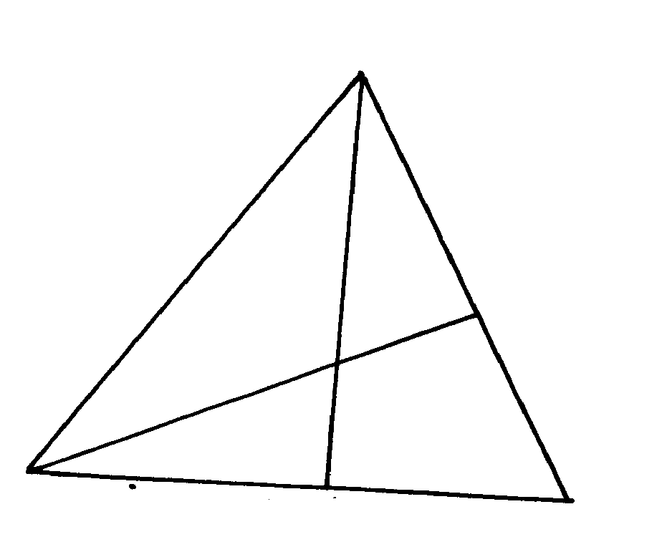

C

1. Given that AB = b and AC = c express AE and BD in terms of b and c. ( 3mks)

̃

̃

̃

̃

̃

̃

̃

1. Given further that BF = t BD and AF = s AE find the values of s and t (5mks)

̃

̃

̃

̃

1. By drawing a table of values of x and y
2. For the function y = 2x2 + 4x – 3 for values of x in the domain -4 $≤x≤$ 2; draw on the grid provided the graph of the function y = 2x2 + 4x – 3
3. Use the graph to find the solutions of the equation x2+ 2x- 1.5 = 0 to one decimal place.
4. Use the graph drawn to obtain the roots of the equation x2 + x – 5 = 0 to one decimal palce.