**Name :…………………………………………………….…… Adm.no ………....................................**

**School :…………………………………………………..……… Class…………………………….………**

**Candidate’s sign……………………………..… Date :…………………………………**

**121/1**

**MATHEMATICS**

**PAPER 1**

**TIME: 2 ½ HOURS**

**SET 6**

**FORM 3**

***Kenya Certificate of Secondary Education (K.C.S.E)***

**INSTRUCTIONS TO CANDIDATES:**

* Write **your name** and **Index number** in the spaces provided above
* This paper contains **two sections;** Section **I** and section **II.**
* Answer **all** the questions in section **I** and only **five** questions from section **II.**
* All workings and answers **must** be written on the question paper in the spaces provided below each question.
* Marks may be given for correct working even if the answer is wrong.
* Non-programmable silent electronic calculators and KNEC mathematical tables may be used except where stated otherwise
* Show all the steps in your calculations, giving your answers at each stage in the spaces below each question

**For Examiner’s Use Only;**

**Section I**

|  |  |  |  |  |  |  |  |  |  |  |  |  |  |  |  |  |
| --- | --- | --- | --- | --- | --- | --- | --- | --- | --- | --- | --- | --- | --- | --- | --- | --- |
| 1 | 2 | 3 | 4 | 5 | 6 | 7 | 8 | 9 | 10 | 11 | 12 | 13 | 14 | 15 | 16 | **TOTAL** |
|  |  |  |  |  |  |  |  |  |  |  |  |  |  |  |  |  |

**Section II**

**GRAND**

**TOTAL**

|  |  |  |  |  |  |  |  |  |  |
| --- | --- | --- | --- | --- | --- | --- | --- | --- | --- |
| **Question** | 17 | 18 | 19 | 20 | 21 | 22 | 23 | 24 | **TOTAL** |
| **Marks** |  |  |  |  |  |  |  |  |  |

*This paper consists of 15 printed pages. Candidates should check to ascertain that all pages are printed as indicated and that no questions are missing.*

**SECTION I (50 MARKS)**

Attempt ALL questions from this section

1. Show that 8260439 is exactly divisible by 11, using test of divisibility. (2mks)

2. Use logarithm tables to evaluate

-1

Giving your answer to 3 significant figures. (4mks)

3.

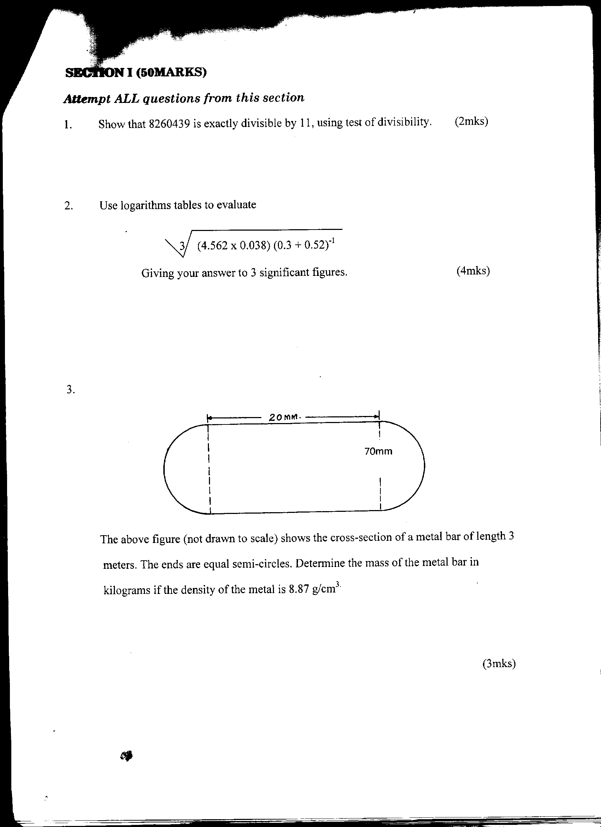

The above figure (not drawn to scale) shows the cross- section of a metal bar of length 3 meters. The ends are equal semi-circles. Determine the mass of the metal bar in kilograms if the density of the metal is8.87g/cm3. (3mks)

4. A surveyor recorded the information about a tea farm in his field book as in the table below.

**Q**

600 90 to **C** To **A** 180 420

300 90 to **D**

To **B** 50 50

**P**

(a) Given that PQ = 65m, make a sketch of the field. (2mks)

Hence find the area of the field in hectares. (2mks)

5. Tap A fills a water tank in 30min, **B** in 20mins and **C** in 10mins. All three taps are turned on from 8:55am to 8.59am and then **C** is turned off. At what time will the tank be filled after **C** has been closed? (3mks)

6. The mean of a set of n numbers is 28. If an extra number 18 is included in the set, the mean now becomes 26. **Find** the value of n. (2mks)

7. The graph below shows the motion of a bus for 10 minutes

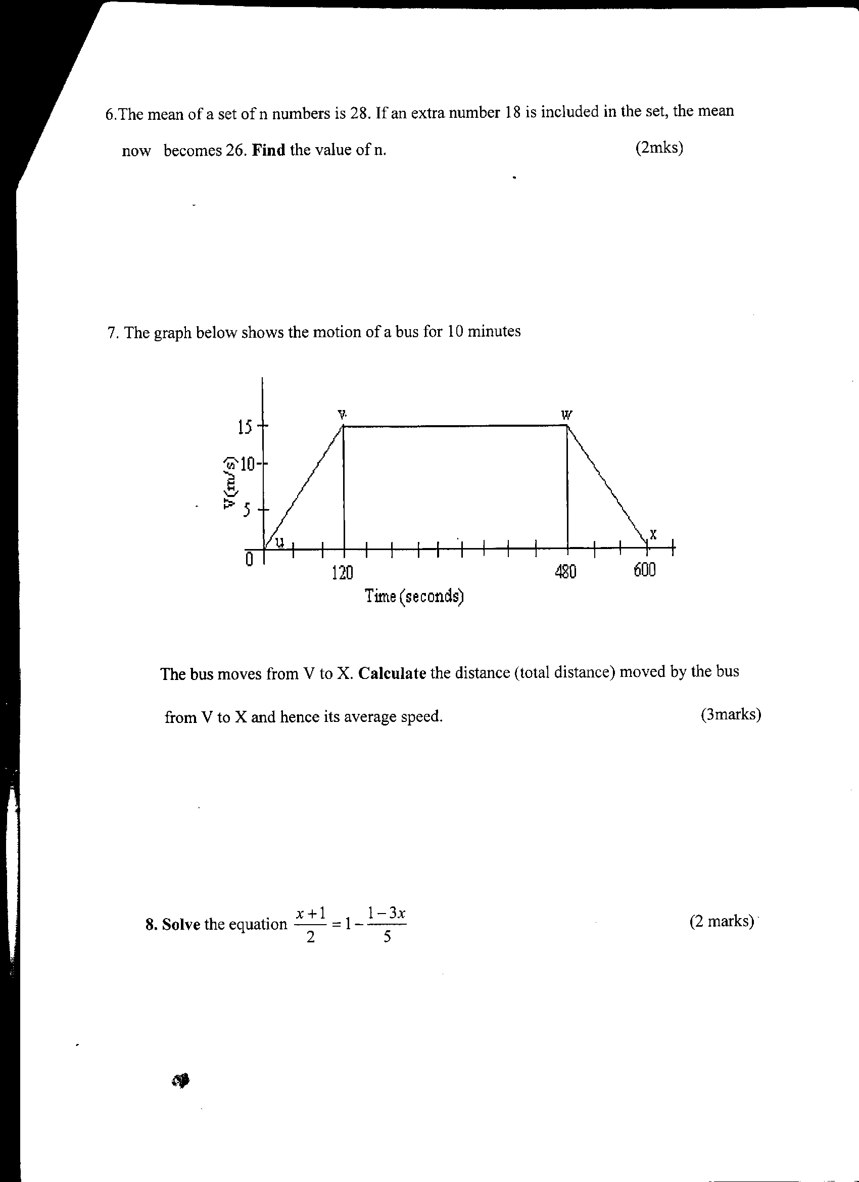

The bus moves from **V** to **X**. Calculate the distance (total distance) moved by the bus from **V** to **X** and hence its average speed. (3mks)

8. **Solve** the equation (2mks)

9. A tailor brought two pair of trousers at sh. 1600. He marked the price such that after allowing his discount of 15%, he would still make a profit of 30% on the cost price. Determine the price at which a pair of trouser was marked. (3mks)

10. A two digit number is made by combining any 2 of the digits 1, 3, 5, 7, 9, at random

(a) **Make** an array of possible combinations (2mks)

(b) **Find** the probability that the number is a prime number. (2mks)

11. Find the value of ***X*** in the following equation.

25 *x-1* + 5*2x*=130 (4mks)

12. Solve the simultaneous equations (3mks)

Log*4* (2*x* + *y*) = 2

Log*3* (5*x* + 3*y*) = 2

13. Given **A**(3,6) **B**(9,10) and that a point **R** divides **AB** in the ration 3 : -2, find the co-ordinates of **R**. (3mks)

14. The figure below shows a net of a circular cone with a lid. Given that **∠AOB** = 150o and **OA** = 14cm.

**O**

**B**

**r**

**150o**

**R = 14cm**

**A**

Determine

(a) The radius of the base of the cone. (2mks)

(b) The total, surface area of the cone (2mks)

15. 28% of Charles salary goes to taxes. The remainder is Charles’ disposable income. He uses ¼ of it for food and ¾ of the remainder for travelling and saves the rest. If the difference between what Charles saves and what goes for taxes is sh. 9860. How much does Charles earn before taxation.

(3mks)

16. Find the integral values of x for which *5 ≤ 3x + 2* and *3x – 14 < – 2* (3mks)

**SECTION II (50 MARKS)**

***Answer only five questions in this section in the spaces provided.***

17. Mr. Omwega is employed. His basic salary is Kshs. 21, 750 and is entitled to a house allowance of Kshs 15, 000 and travelling allowance of Kshs. 8, 000 per month. He also claims a family monthly relief of Kshs. 1, 056 per month. Other deductions are;

Union dues Kshs. 200 and

Co-operative shares Kshs 4, 500 per month.

The table below shows the tax rates for the year.

|  |  |
| --- | --- |
| Income (Kshs per annum) | Tax rates |
| 1 – 116, 600  116, 161 – 225, 600  225, 601 – 335, 040  335, 041 – 444, 480  Over 444, 480 | 10%  15%  20%  25%  30% |

Calculate;

(a) Mr. Omwanga’s annual taxable income. (2mks)

(b) The tax paid by Mr. Omwanga in the year. (6mks)

(c) Mr. Omwenga’s net income per month. (2mks)

18. Using a ruler and a pair of compasses only. Construct a parallelogram **ABCD** such that **AB** = 8cm diagonal **AC** = 12cm and angle **BAC** = 22.5o (4mks)

(a) Measure (i) The diagonal **BD** (1mk)

(ii) The angle **ABC** (1mk)

(b) Draw the circumcircle of triangle **ABC** (2mks)

(c) Calculate the area of the circle drawn. (2mks)

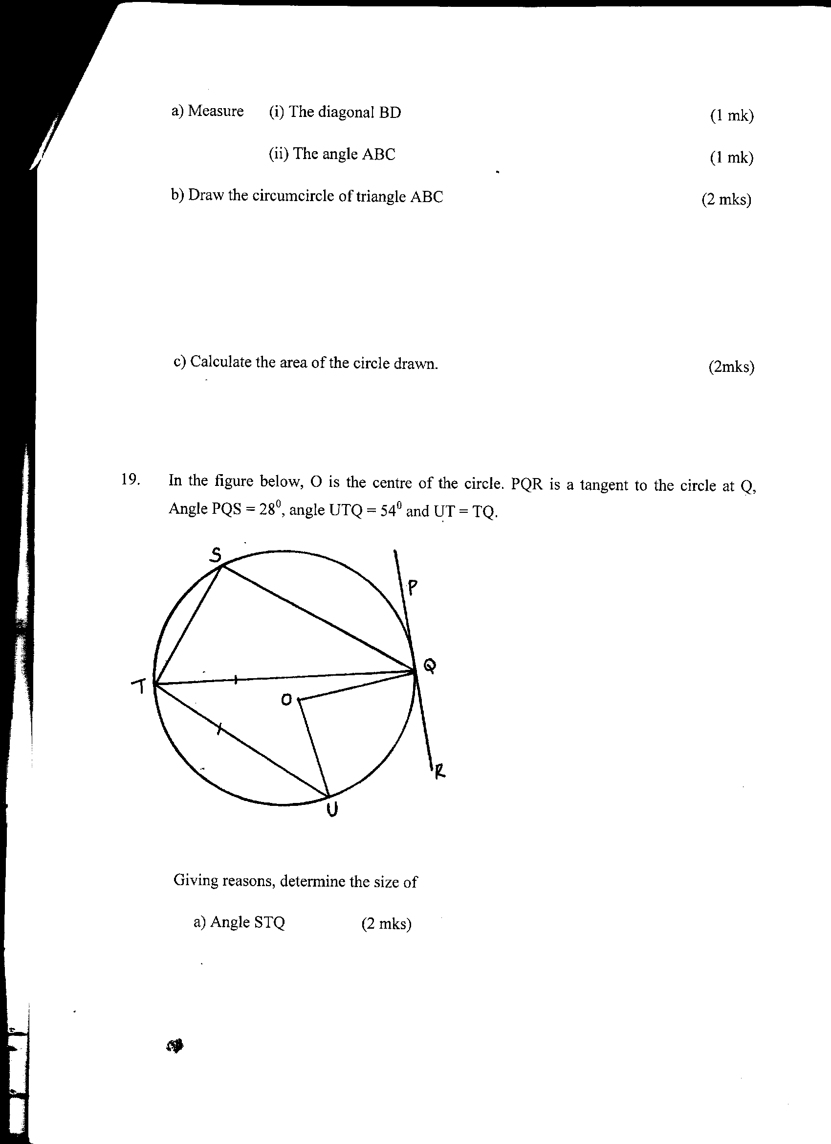19. In the figure below, **O** is the centre of the circle. **PQR** is the tangent to the circle at **Q**, Angle **PQS** = 28o, angle **UTQ** = 54 and **UT** = **TQ.**

Giving reasons, determine the size of

(a) Angle **STQ** (2mks)

(b) Angle TQU (2mks)

(c) Reflex angle **TQS** (2mks)

(d) Reflex angle **UOQ** (2mks)

(e) Angle **TQR** (2mks)

20. Two circles of radii 4cm and 6cm intersect as shown below. If angle **XBY** = 30o and angle **XAY** = 97.2o. Find the area of the shaded part. (10mks)

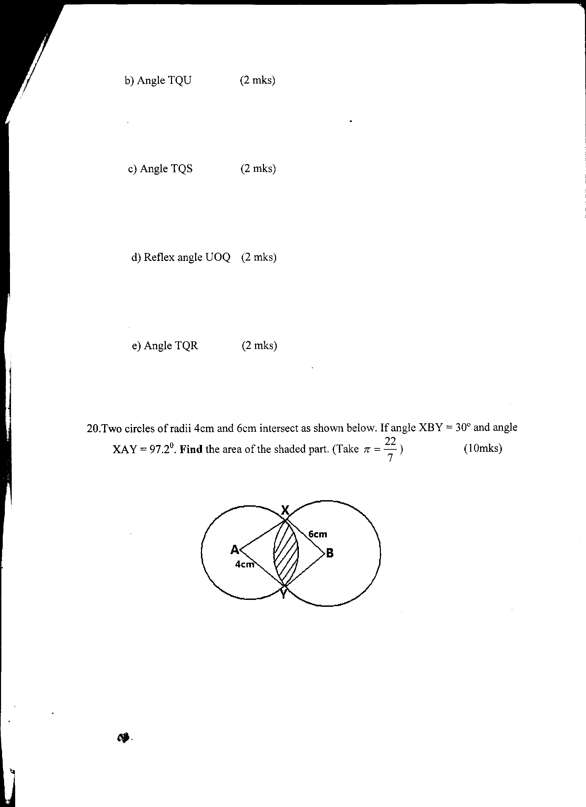

21. A bag contains 5 red, 4 white and 3 blues beads. Two beads are selected at random.

(a) Draw a tree diagram and list the probability space. (3mks)

(b) Find the probability that

(i) The last bead selected is red. (2mks)

(ii) The beads selected were of the same colour. (2mks)

(iii) At least one of the beads is blue. (3mks)

22. (a) Complete the table below for the function $y=x^{2 }+ \frac{12}{x}- 15$ for 0.5 ≤ *x* ≤ 4 (2mks)

|  |  |  |  |  |  |  |  |  |
| --- | --- | --- | --- | --- | --- | --- | --- | --- |
| **X** | 0.5 | 1 | 1.5 | 2 | 2.5 | 3 | 3.5 | 4 |
| **Y** | 9.25 |  |  | -5 | -4 |  |  |  |

(b) Draw the graph of $y=x^{2 }+ \frac{12}{x}- 15$ for 0.5 ≤ *x* ≤ 4, using a scale of 2cm = 1 unit on the x – axis and 2cm for 5 units on the y –axis (3mks)

(c) (i) From your graph, state the range of values of x for which $y=x^{2 }+ \frac{12}{x}≤18$ (2mks)

(ii) By adding a suitable straight line to your graph, solve the equation

23. The diagram below shows a histogram representing the marks obtained in a certain test.

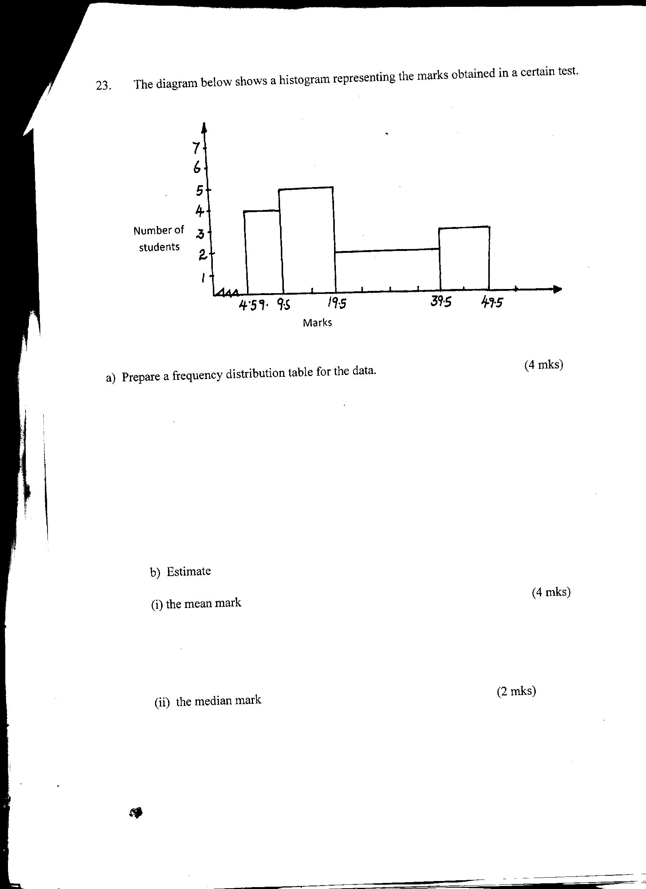

(a) Prepare a frequency distribution table for the data. (4mks)

(b) Estimate

(i) the mean mark (4mks)

(ii) the median mark (2mks)

**~**

**~**

**~**

**~**

24. triangle **OAB** is such that **OA** = **a** and **OB** = **b**. point **A** divides **OP** in the ration 5 : -2 and point **Q** is on **AB** such that **AQ** = $\frac{1}{5} AB.$**OQ** and **BP** intersect at **T**.

**~**

**~**

(a) Draw a diagram to represent the given situation. (1mk)

(b) Express in terms of **a** and **b**

(i) **OQ** (1mk)

**~**

**~**

**~**

**~**

(ii) **BP** (1mk)

**~**

(c) Given that **OT** = **kOQ** and BT = **hBP** where k and h are constants.

**~**

(i) Express **OT** in two different ways.

**~**

(ii) Determine the values of **k** and **h**. (3mks

(iii) Determine the ratio in which **T** divides **OQ** (1mk)