**NAME …………………………..……………….. DATE …………………………**

**INDEX NO. ……….……….…………………...…..… SIGNATURE ……………..…………..**

**233/2**

**CHEMISTRY**

**PAPER 2**

**(THEORY)**

**TIME: 2 HOURS.**

**SET 8**

FORM 3

**INSTRUCTIONS TO CANDIDATES.**

* Write your name and index number in the spaces provided above.
* Sign and write the date of exam in the spaces provided above.
* Answer **ALL** the questions in the spaces provided.
* Mathematical tables and silent electronic calculators may be used.
* All working **MUST** be clearly shown where necessary.
* This paper consists of 10 printed pages.

Candidates should check to ensure that all pages are printed as indicated and no questions are missing

**FOR EXAMINER’S USE ONLY.**

|  |  |  |
| --- | --- | --- |
| **Questions** | **Maximum score** | **Candidates score** |
| 1 | 13 |  |
| 2 | 12 |  |
| 3 | 10 |  |
| 4 | 10 |  |
| 5 | 11 |  |
| 6 | 10 |  |
| 7 | 13 |  |
| **Total score** | **80** |  |

1. A student wanted to prepare sodium carbonate in the laboratory. She set up the apparatus as shown.

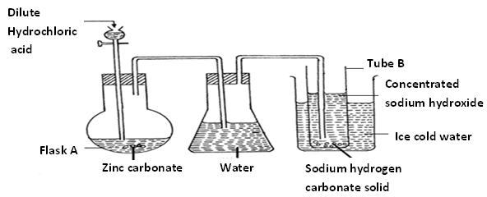

1. 1. Write an equation for the reaction taking place in flask A. (1mark)

………………………………………………………………………………………………………………………………………………………………………………………………………………………………

* 1. Give one reason why the product (s) are passed through water. (1mark)

………………………………………………………………………………………………………………………………………………………………………………………………………………………………

* 1. Give one disadvantage of passing products through water. (1mark)

………………………………………………………………………………………………………………………………………………………………………………………………………………………………

* 1. Write two possible equations that led to the formation of sodium hydrogen carbonate. (2marks)

………………………………………………………………………………………………………………………………………………………………………………………………………………………………

* 1. Suggest what the student should do to finally obtain sodium carbonate from sodium hydrogen carbonate. (1mark)

………………………………………………………………………………………………………………………………………………………………………………………………………………………………

* 1. Write an equation for the reaction in step (v) above. (1mark)

………………………………………………………………………………………………………………………………………………………………………………………………………………………………

1. A certain carbonate reacts with dilute hydrochloric acid according to the following equation.

XCO3(s) + 2HCl (aq) XCl2(g)  + CO2(g) + H2O(l)

1g of this carbonate was dissolved in 50cm3 of IM hydrochloric acid. After the reaction the solution the solution needed 30cm3 of IM sodium hydroxide for neutralization.

1. Calculate the number of moles of sodium hydroxide that reacted. (1mark)

………………………………………………………………………………………………………………………………………………………………………………………………………………………………

1. Determine the number of moles of hydrochloric acid used in the reaction with XCO3 (2marks)

………………………………………………………………………………………………………………………………………………………………………………………………………………………………………………………………………………………………………………………………………………

1. Calculate the molar mass of XCO3 (2marks)

………………………………………………………………………………………………………………………………………………………………………………………………………………………………………………………………………………………………………………………………………………………………………………………………………………………………………………………………

1. Then calculate the relative atomic mass of X. (1mark)

………………………………………………………………………………………………………………………………………………………………………………………………………………………………………………………………………………………………………………………………………………………………………………………………………………………………………………………………

2. Use the grid below to answer the questions that follow. The letters do not represent the actual symbols of elements.

|  |  |  |  |  |  |  |  |  |
| --- | --- | --- | --- | --- | --- | --- | --- | --- |
|  |  | | | | | | |  |
|  |  |  |  |  | G |  | J |  |
| A | D |  | E | F |  | H | K | L |
| B |  |  |  |  |  |  |  |  |
| C |  |  |  |  |  |  |  |  |

1. Give the family name of the group in which elements B and C are members. (1mark)

………………………………………………………………………………………………………………………………………………………………………………………………………………………………

1. State and explain the different in reactivity between
   1. B and D (1mark)

……………………………………………………………………………………………………………………………………………………………………………………………………………………………………………………………………………………………………………………………………………..

* 1. J and K (1mark)

………………………………………………………………………………………………………………………………………………………………………………………………………………………………………………………………………………………………………………………………………………

1. How does the atomic radius of E compare with that of F? Explain. (2marks)

………………………………………………………………………………………………………………………………………………………………………………………………………………………………………………………………………………………………………………………………………………

1. Element R forms an oxide of the formula RO2 and belongs to period two. Indicate in the grid the position of R. (1mark)

………………………………………………………………………………………………………………………………………………………………………………………………………………………………………………………………………………………………………………………………………………

1. Explain the trend in the melting points in the group of elements to which A and D belong. (1mark)

………………………………………………………………………………………………………………………………………………………………………………………………………………………………………………………………………………………………………………………………………………

1. Give the formula of the compound formed between E and K. (1mark)

………………………………………………………………………………………………………………………………………………………………………………………………………………………………

1. Name the type of bond formed when A reacts with I. Explain. (2marks)

………………………………………………………………………………………………………………………………………………………………………………………………………………………………

1. Give one use of element L. (1mark)

………………………………………………………………………………………………………………………………………………………………………………………………………………………………

1. Give the electron arrangement of an ion of

C ………………………………………………………………………………………….. (½ mark)

G ………………………………………………………………………………………… (½ mark)

3. Study the flow chart below to answer the questions that follow.

Polymer C

Propene

A

Bromine gas in carbon tetrachloride

Cracking (breaking an alkaline into smaller alkane and an alkene)

II

Hrdrocarbon B

Methane

I

1. 1. Name the process I and II (2marks)

I

………………………………………………………………………………………………………………

II

………………………………………………………………………………………………………………

* 1. Identify the products A and B (2marks)

A

…………………………………………………………………………………..….………………………

B

………………………………………………………………………………………………………………

* 1. Name one catalyst used in process II (1mark)

………………………………………………………………………………………………………………………………………………………………………………………………………………………………

* 1. Draw the structural formula of the repeating unit in the polymer C. (1mark)

………………………………………………………………………………………………………………………………………………………………………………………………………………………………

1. Name two uses of methane. (2marks)

………………………………………………………………………………………………………………………………………………………………………………………………………………………………………………………………………………………………………………………………………………

1. Write the equation of the reaction taking place in:
   1. Process II. (1mark)

………………………………………………………………………………………………………………………………………………………………………………………………………………………………

* 1. Formation of product A. (1mark)

………………………………………………………………………………………………………………………………………………………………………………………………………………………………

4.

1. Name the solution and catalyst used in the preparation of oxygen in the laboratory. (2marks)

………………………………………………………………………………………………………………………………………………………………………………………………………………………………

1. Write a chemical equation for the reaction in a) above. (1mark)

………………………………………………………………………………………………………………………………………………………………………………………………………………………………

1. In an experiment to determine the proportion of oxygen in air, copper turnings were packed in excess in a long combustion tube connected to two syringes of 110cm3 each in volume. Syringe R contained 110cm3 of air while syringe S was closed and empty as shown.

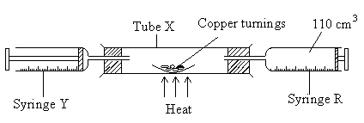

Air was passed over heated copper turnings slowly and repeatedly until there was no further change in volume. 87.5cm3 of air remained in syringe R.

1. Why was copper packed in excess. (1mark)

………………………………………………………………………………………………………………………………………………………………………………………………………………………………

1. Why was air passed over heated copper slowly? (1mark)

………………………………………………………………………………………………………………………………………………………………………………………………………………………………

1. State one observation made in the combustion tube during the experiment. (1mark)

………………………………………………………………………………………………………………………………………………………………………………………………………………………………

1. Write an equation for the reaction that took place in the combustion tube. (1mark)

………………………………………………………………………………………………………………………………………………………………………………………………………………………………

1. Determine the percentage of oxygen used up during the experiment. (2marks)

………………………………………………………………………………………………………………………………………………………………………………………………………………………………

1. Give one commercial use of oxygen. (1mark)

………………………………………………………………………………………………………………………………………………………………………………………………………………………………

5. The diagram below shows the preparation of nitric (v) acid.

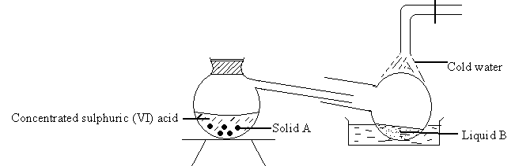

1. Name solid A. (1mark)

………………………………………………………………………………………………………………………………………………………………………………………………………………………………

1. Under what conditions does sulphuric (VI) acid react with solid A? (1mark)

………………………………………………………………………………………………………………………………………………………………………………………………………………………………

1. What is the color of liquid B? Give a reason for your answer. (2marks)

………………………………………………………………………………………………………………………………………………………………………………………………………………………………

1. What is the purpose of the cold water? (1mark)

………………………………………………………………………………………………………………………………………………………………………………………………………………………………

1. I cm3 of liquid B was diluted with distilled water and a few pieces of copper turning dropped into it. A colorless gas which turned to a brown gas in air were produced.
   1. Name the colorless gas. (1mark)

………………………………………………………………………………………………………………………………………………………………………………………………………………………………

* 1. Name the brown gas. (1mark)

………………………………………………………………………………………………………………………………………………………………………………………………………………………………

* 1. How is the brown gas formed? (1mark)

………………………………………………………………………………………………………………………………………………………………………………………………………………………………

* 1. Write an equation for the formation of the colourless gas. (1mark)

………………………………………………………………………………………………………………………………………………………………………………………………………………………………

* 1. Give two uses of nitric (V) acid. (2marks)

………………………………………………………………………………………………………………………………………………………………………………………………………..……………………

6.

1. The diagram below shows spots of pure substances A, B and C on a chromatography paper. Spot d is that of a mixture.

A B C D

After development A, B and C were found to have moved 8cm, 3cm and 6cm respectively. D had separated into two spots which had moved 6cm and 8cm.

1. On the diagram
   1. Label the baseline. (1mark)
   2. Show the positions of all the spots after development. (3marks)
2. Identify the substances present in the mixture D. (1mark)

………………………………………………………………………………………………………………………………………………………………………………………………………………………………

1. Describe how solid calcium chloride can be separated from a solid mixture of lead (II) chloride and anhydrous calcium chloride. (2marks)

………………………………………………………………………………………………………………………………………………………………………………………………………………………………………………………………………………………………………………………………………………

1. The table below shows liquids that are miscible and those that are immiscible.

|  |  |  |
| --- | --- | --- |
| Liquid | K | L |
| M | Miscible | Miscible |
| N | Miscible | Immiscible |

Use the following give to answer the questions that follow.

1. Name the method that can be used to separate M and K from a mixture of the two. (1mark)

………………………………………………………………………………………………………………………………………………………………………………………………………………………………

1. Describe how a mixture of N and L can be separated. (2marks)

………………………………………………………………………………………………………………………………………………………………………………………………………………………………

7.

1. 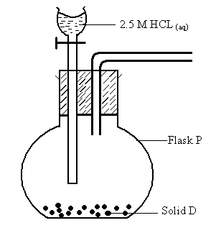The diagram below represents a set – up that was used to prepare a sample of dry sulphur (IV) oxide in the laboratory.
2. Name solid D. (1mark)

………………………………………………………………………………………………………………………………………………………………………………………………………………………………

1. Complete the diagram to show how the sample of the gas was collected. (2marks)

………………………………………………………………………………………………………………………………………………………………………………………………………………………………

1. Write the equation for the reaction that took place in flask P. (1mark)

………………………………………………………………………………………………………………………………………………………………………………………………………………………………

1. Exactly 140cm3 of the acid was reacted with excess solid D. Calculate the maximum volume of the sulphur (IV) oxide that could have been collected. (Molar gas volume at room temperature and pressure = 24000cm3) (2marks)

………………………………………………………………………………………………………………

………………………………………………………………………………………………………………………………………………………………………………………………………………………………

………………………………………………………………………………………………………………

………………………………………………………………………………………………………………………………………………………………………………………………………………………………

1. The diagram below shows a series of reactions starting with sulphur and air.

Sulphur

Air

SO2(g)

Step 1

SO3(g)

Oleum

Concentrated Sulphuric

acid

Pale Green solution

Green Precipitate

Metal Z

Blue Solution

Step IV

Step II FeCl3(aq)

Step III NaOH(aq)

Step V Liquid L

Step VI Liquid R

Step

VII

* 1. Write the equation for the reaction that occurred in step 1. (1mark)

………………………………………………………………………..…………………………………….

* 1. State the property of SO2(g) shown in step II. (½ mark)

……………………………………………………………………...……………………………………….

* 1. Write an ionic equation for the reaction that occurred in step III. (1mark)

………………………………………………………………………………………………………………

* 1. Name the industrial process represented by step IV. (1mark)

………………………………………………………………………………………………………………

* 1. Identify two substances (1mark)

………………………………………………………………………………………………………………

vi) Identify liquids L, R and metal Z (1½ marks)

………………………………………………………………………………………………………………

………………………………………………………………………………………………………………………………………………………………………………………………………………………………

* 1. Explain why at industrial scale it is not advisable to interchange liquids L and R in steps V and VI (1mark)

………………………………………………………………………………………………………………

………………………………………………………………………………………………………………………………………………………………………………………………………………………………