NAME: ………………………………………………..…………..…… AND.NO: ………………………
SCHOOL ………………………………………………..…..………… DATE: …………..…………….…
CANDIDATE’S SIGNATURE………………………………………..

233/2
CHEMISTRY
PAPER 2
THEORY
TIME: 2 HOURS

SET 1

Kenya Certificate of Secondary Education (K.C.S.E)

INSTRUCTIONS TO CANDIDATES:
- Write your name and index number in the spaces provided above
- Sign and write the date of examination in the spaces provided.
- Answer all the questions in the spaces provided.
- All working must be clearly shown where necessary.
- Mathematical tables and electronic calculators can be used.

For Examiners Use Only

Question | Maximum score | Candidate’s score
1 | 13
2 | 11
3 | 12
4 | 10
5 | 11
6 | 11
7 | 12
Total | 80

This paper consists of 11 printed pages. Candidates should check to ascertain that all pages are printed as indicated and that no questions are missing.
1. The table below shows the elements in the third period, the oxides of the third period and their properties.The letters are not the actual symbols of the elements. Study the information and answer
the questions that follow:

Element | Atomic number | Atomic radius(nm) | Oxide | State at RT | oxide melting point ºC
M | 11 | 0.191 | M₂O | Solid | 1132
N | ……… | 0.160 | NO | Solid | 2852
P | 13 | 0.130 | ……… | Solid | 2072
Q | 14 | 0.118 | QO₂ | ………. | 1610
R | ……… | 0.110 | ……… | Solid | 580
S | 16 | 0.102 | SO₂ | ……… | -75
T | 17 | 0.099 | TO₂ | Gas | -60
V | 18 | 0.095 | X | X | X

(a) (i) Complete the table above (3mks)
(ii) Explain the trend in the atomic radius across the period (2mks)
………………………………………………………………………………………………………
………………………………………………………………………………………………………

(iii) Explain why the oxide of element V does not exist (1mk)

………………………………………………………………………………………………………
………………………………………………………………………………………………………
(b) Name the type of structure and bond in the following oxide (2mks)
Oxide | Structure | Bond type
NO
TO₂

ii) Using dots and crosses to represent electrons. Show the bonding in the oxide, QO₂ (2mks)
(c) (i) Explain why elements P conducts electricity but T does not (1mk)
………………………………………………………………………………………………………
………………………………………………………………………………………………………
(ii) The oxide of P reacts both acids and alkalis. Give the name of this kind of oxide (1mk)
………………………………………………………………………………………………………

2. The set up below was to be used to prepare carbon (II) oxide in the laboratory. Use it to answer the questions that follow.
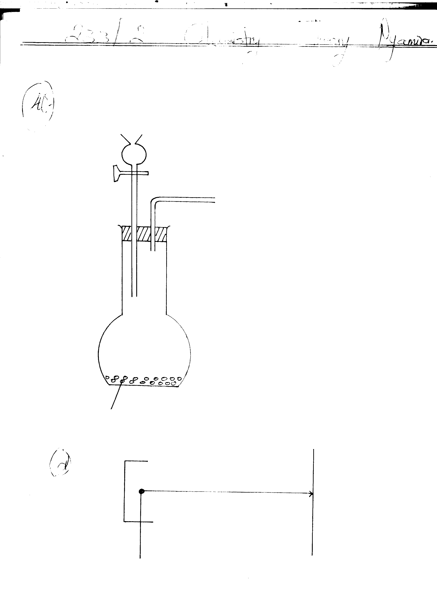
Sodium Methanoate
Liquid X

(a) Complete it in order to collect the gas. (3mks)
………………………………………………………………………………………………………
………………………………………………………………………………………………………
(b) Which is the appropriate identity of the liquid X? (1mk)
………………………………………………………………………………………………………
………………………………………………………………………………………………………
(c) Explain how you can chemically distinguish unlabelled gases of carbon (II) oxide and carbon (IV)
Oxide respectively. (2mks)
………………………………………………………………………………………………………
………………………………………………………………………………………………………
(d) Using dot (●) and crosses (x) draw the structure of Carbon (IV) oxide. (2mks)

(e) Calculate the volume of oxygen that will be required for complete combustion of 100cm³ of carbon (II)
oxide.

3. Air was passed through several reagents as shown in the flow chart below.
Gas P

Electrostatic
Precipitation
Concentrated Sodium Hydroxide
Air
Excess heated Copper turnings
Excess heated Magnesium Powder

Compressor

Fractionating column

Nitrogen (-196⁰C)
Argon (-186⁰C)

C (-183⁰C)

- Name the major components of air. (2mks)
……………………………………………………………………………………………………………………………………………………………………………………………….......................
- Write an equation for the reaction which takes place in the chamber with:
- Concentrated sodium hydroxide. (1mk)
…………………………………………………………………………………………………
…………………………………………………………………………………………………
- Excess heated copper turnings. (1mk)
…………………………………………………………………………………………………
…………………………………………………………………………………………………
- Excess heated magnesium powder. (1mk)
…………………………………………………………………………………………………
…………………………………………………………………………………………………
- Name one gas which escapes from the chamber containing magnesium powder. Give a reason for your answer. (2mks)
………………………………………………………………………………………………………
………………………………………………………………………………………………………
- Name the substance that was eliminated by electrostatic precipitation. (1mk)
…………………………………………………………………………………………….............
- Name a reagent that can be used in place of concentrated sodium hydroxide. (1mk)
………………………………………………………………………………………………........
- Name substance C. (1mk)
……………………………………………………………………………………………….......
- State two uses of gas C. (1mk)
………………………………………………………………………………………….......................
4. The diagram below shows the set up that can be used to obtain nitrogen gas in an experiment carried out by form 3 of Inaya Sec school.
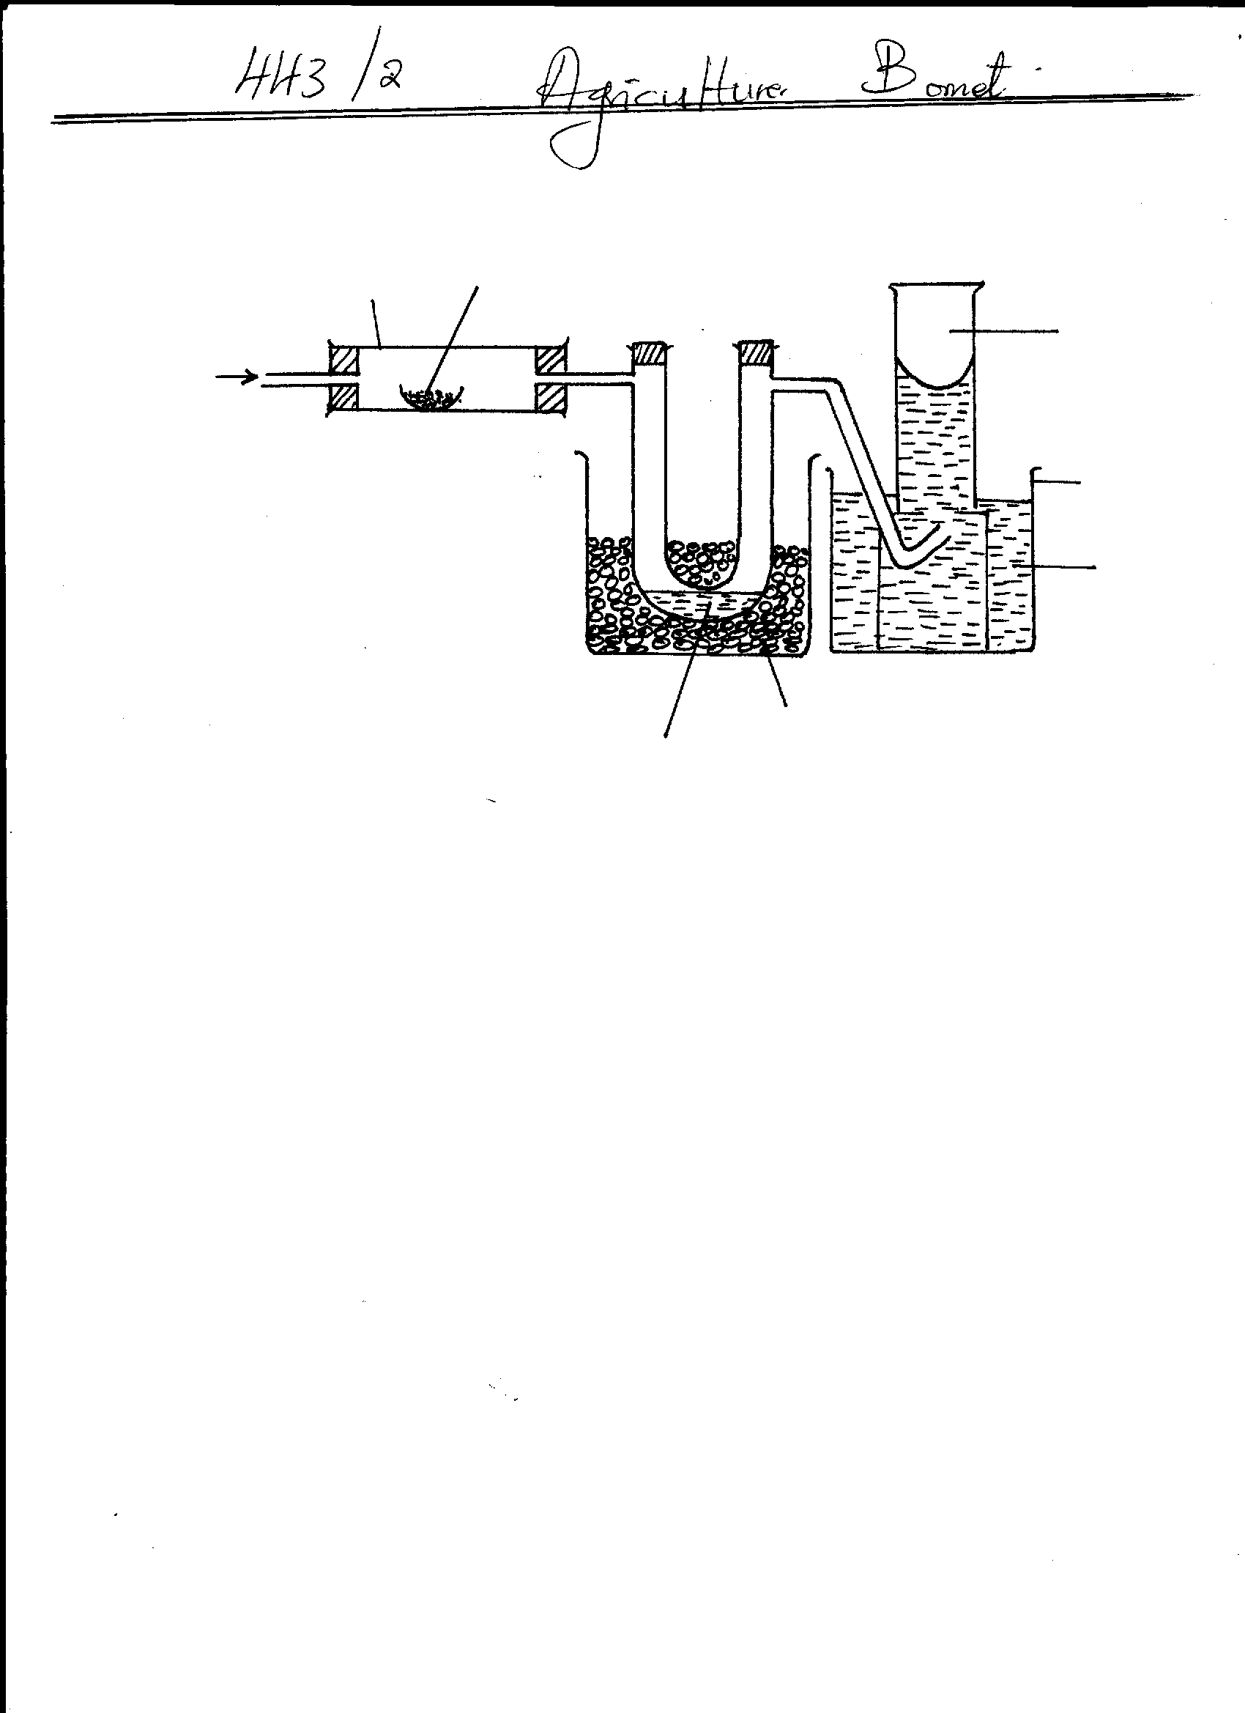
Nitrogen gas
Copper (ii) oxide
Water
Beaker
Ice
Liquid L
Dry ammonia gas
Tube K
Heat

(i) How is the ammonia gas from this process dried? (1mk) …………………………………………………………………………………………………………
(ii) Name liquid L? (1mk) ………………………………………………………………………………………………………… …………………………………………………………………………………………………………
(iii) What observation would be made at tube K at the end of the experiment? (1mk) ………………………………………………………………………………………………………… …………………………………………………………………………………………………………

(iv) Write an equation for the reaction that took place in the tube K. (1mk) ……………………………………………………………………………………………………… …………………………………………………………………………………………………………
(v) At the end of the experiment the pH of water in the beaker was found to be 10.0. Explain. (1mk)
………………………………………………………………………………………………………
………………………………………………………………………………………………………
(b) A student set up the following apparatus for preparing jars of dry ammonia but found that no gas collected in the gas jars, although a reaction occured in the flask.

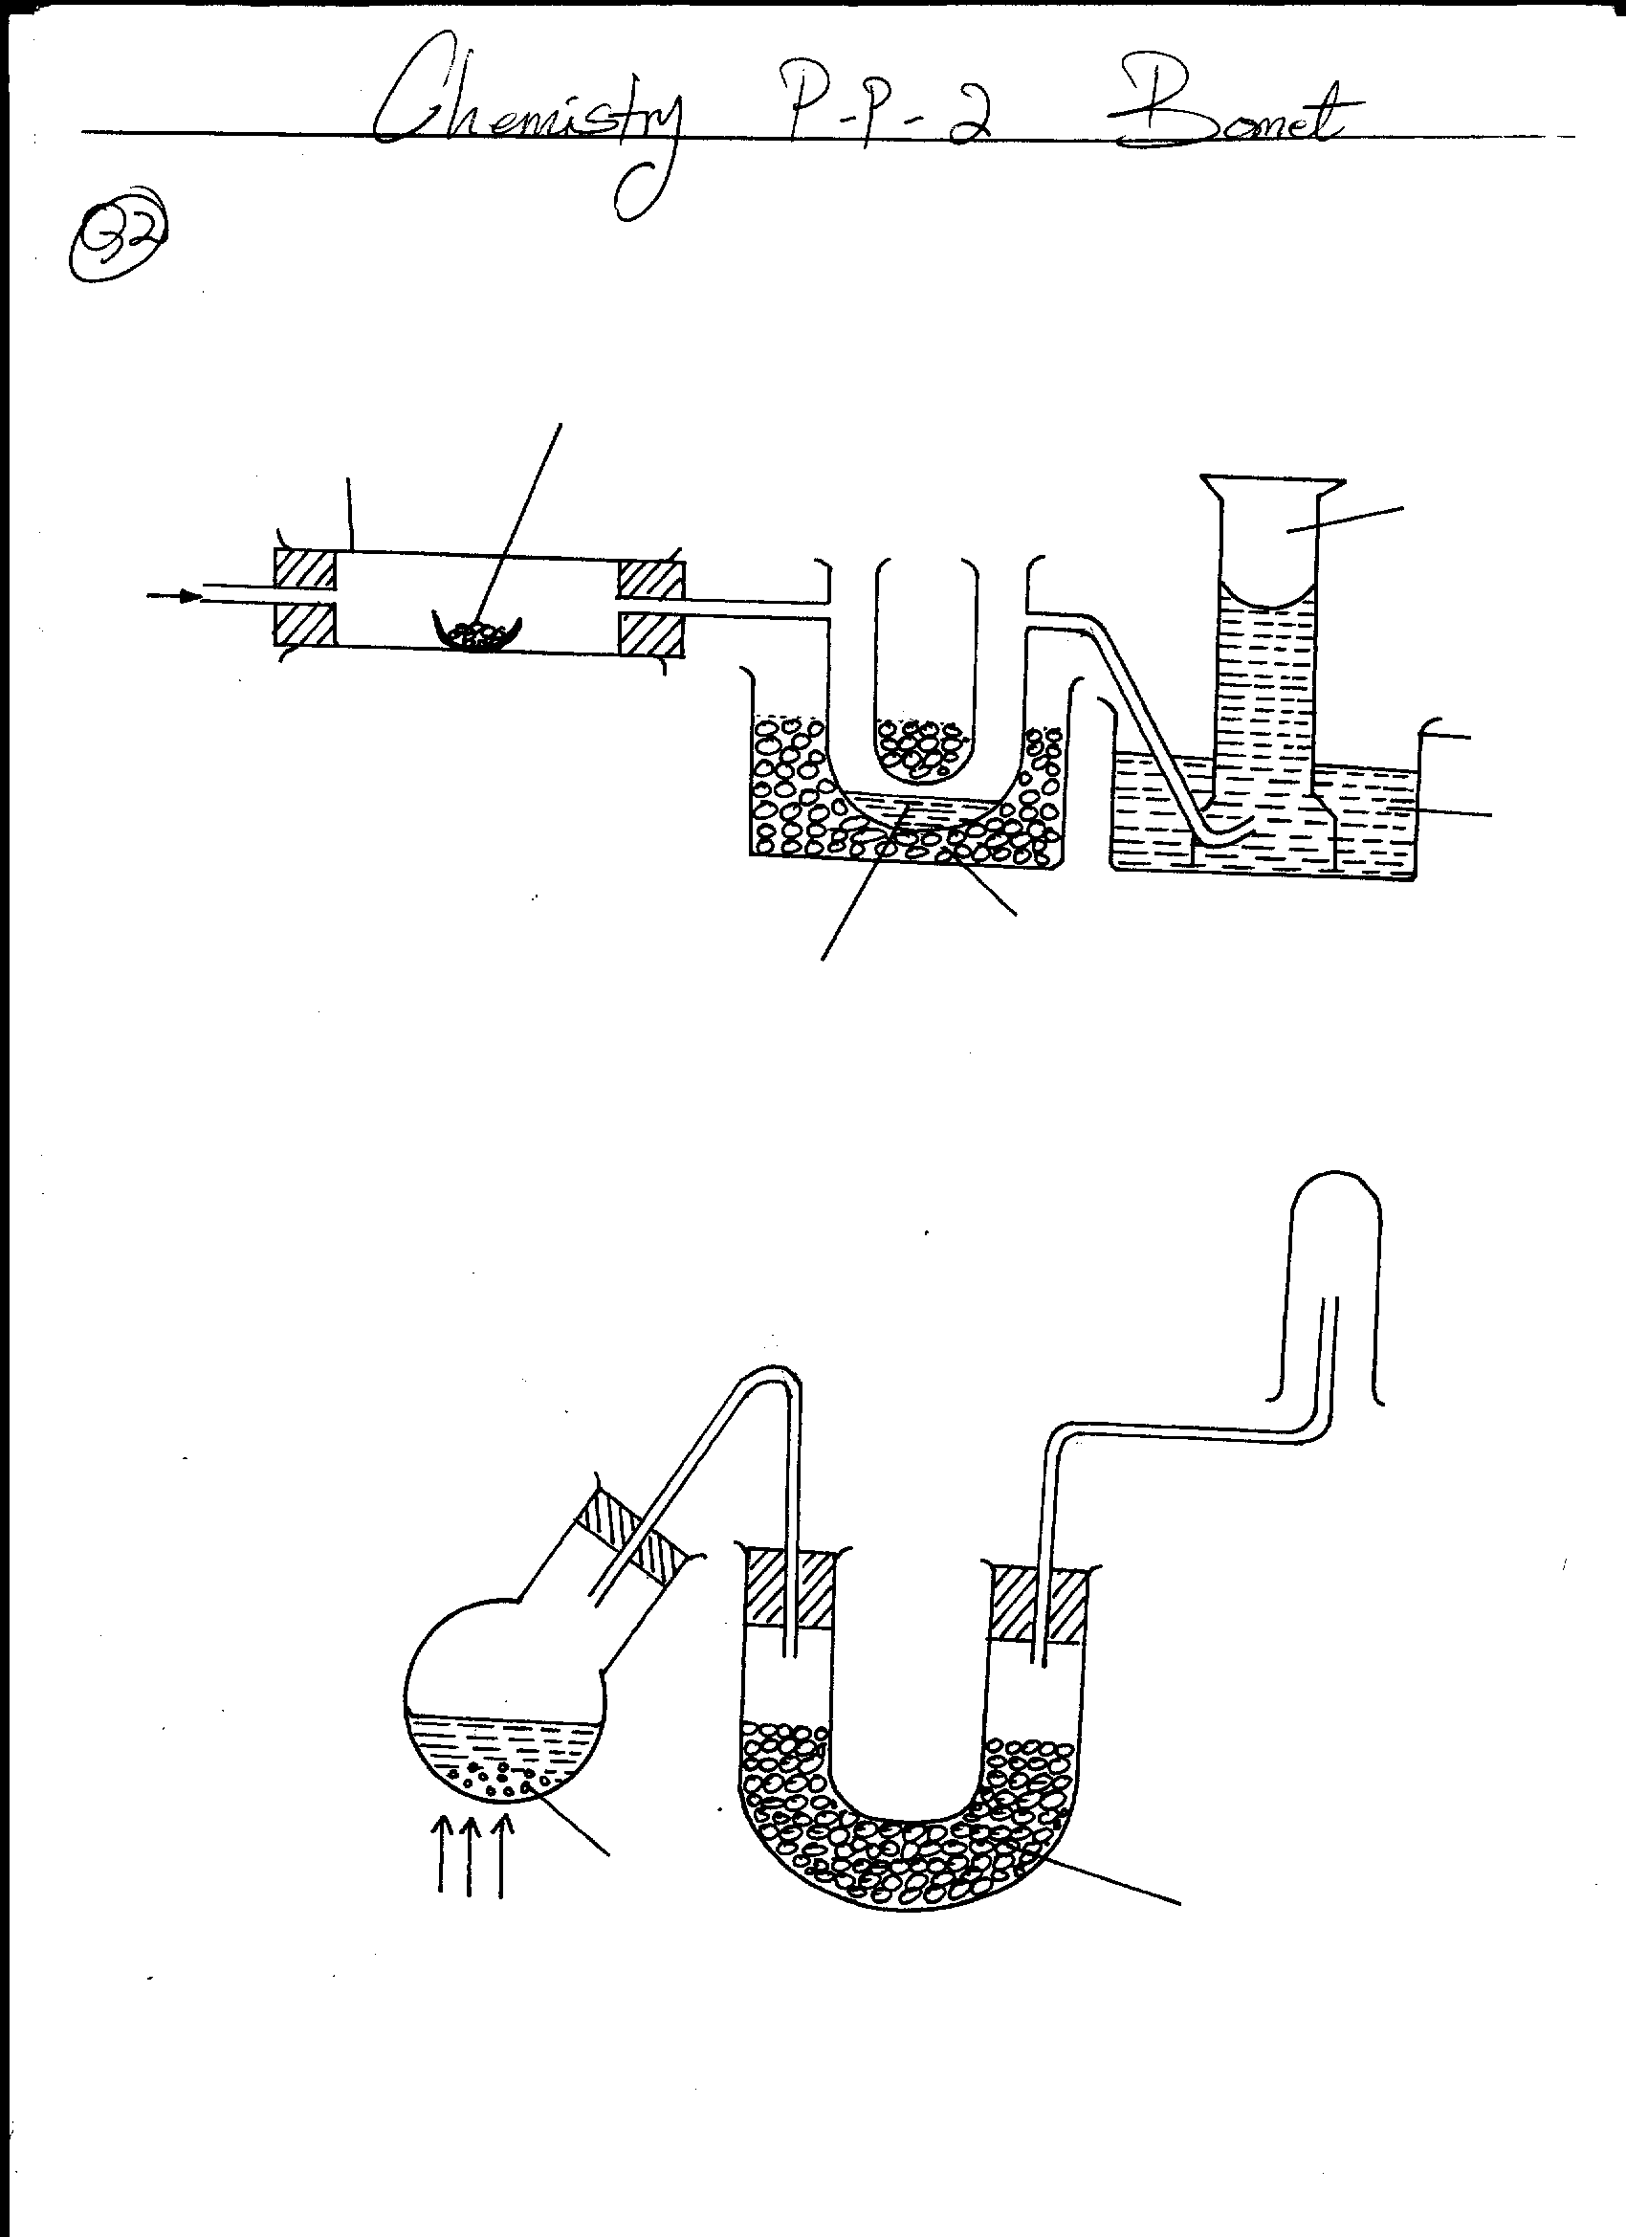
Heat
Dry agent
Ammonium chloride

(i) Explain why their was no gas collected? (1mk) ………………………………………………………………………………………………………… …………………………………………………………………………………………………………
(ii) The following alteration were made
- Using a mixture of ammonium chloride and an alkali, Ca(OH)₂ instead of NH₄CL
- The flask was made to slope with neck downward.
State the reason for each alteration above (2mks) ………………………………………………………………………………………………………… ………………………………………………………………………………………………………… ………………………………………………………………………………………………………… …………………………………………………………………………………………………………

(iii)When ammonia gas is passed into a jar of hydrogen chloride gas, white fumes are formed. Explain with an aid of equation of reaction. (2mks) ……………………………………………………………………………………………………………….. ………………………………………………………………………………………………...
(iv) Ammonia decompose if sparked electrically, what would you expect to be the products of the decomposition? (1mk) …………………………………………………………………………………………………
5. Study the flow diagram below and answer the questions that follow.

Ethyne
R
T
S
V
U
W + H₂SO₄
C₂H₅Cl + HCl
Acidified KMnO₄

Step III

Hydrogen chloride gas

Step II

Conc. Sulphuric (VI) acid
Step V

Step VII

Step V I

Reagent
X

Water warm

1 mole of hydrogen

Step I

1 mole of hydrogen
Step IV

(a) Name substances. (3 marks)

R …………………………………………………………………………………………….

S …………………………………………………………………………………………….

T ……………………………………………………………………………………………

U ……………………………………………………………………………………………

V …………………………………………………………………………………………..

W ………………………………………………………………………………………….

(b) Name reagent X and the condition required for the reaction in Step VII to occur. (2 marks)

………………………………………………………………………………………………………
………………………………………………………………………………………………………
(c) Name the type of reaction that occurred in

(i) Step I ………………………………………………………………………….(1mrk)

(ii) Step VII ………………………………………………………………………(1mark)
(d) Name the reaction that occurred in

(i) Step II ……………………………………………………………………... (1 mark)

(ii) Step IV ……………………………………………………………………. (1 mark)

(e) Draw and name two structural isomers of C₄ H₁₀. (2 marks)

6. The set-up below was used to prepare and collect gas X. During the experiment cleaned magnesium ribbon was strongly heated before heating the wet glass wool.
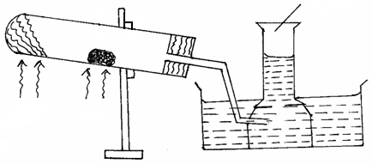
Heat
Heat
Reaction tube
Magnesium ribbon
Gas X

(a) Name gas X (1mrk)

………………………………………………………………………………………

(b) Why is magnesium ribbon cleaned before it is used? (1 mark)

…………………………………………………………………………………………….

(c) State one observation that would be noted in the reaction tube. (1 mark)

………………………………………………………………………………………………..

……………………………………………………………………………………………….

(d) Write the equation for the reaction in the reaction tube. (1 mark)

(e) State one industrial use of the solid product formed in the reaction tube. (1 mark)

………………………………………………………………………………………………

……………………………………………………………………………………………….

(f) What precaution should be taken at the end of experiment? Explain. (2 marks)

…………………………………………………………………………………………………
…………………………………………………………………………………………………
(g) At the end of the experiment 96.0cm³ of gas X were collected at 10°C and 1 atmosphere pressure. (Mg = 24, M.G.V = 22.4, T = O°C at stp, P = 1 atmosphere at stp).
(i) Determine the volume gas X would occupy at s.t.p? (2 marks)

(ii) Calculate the mass of magnesium ribbon used Mg = 24. (2 marks)

…………………………………………………………………………………………….

……………………………………………………………………………………………

7. (a) Dry ammonia gas is passed over heated lead (II) oxide in a combustion tube as shown in the diagram.

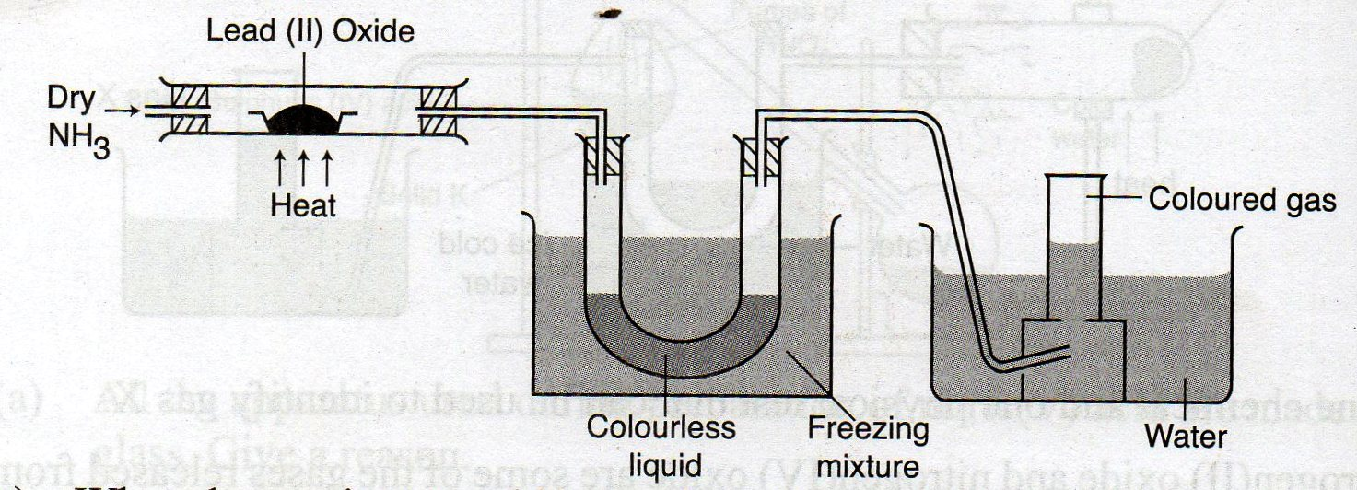

(i) What observation would be made in the combustion tube? Explain. ( 2mks)

……………………………………………………………………………………………………………………………………………………………………………………………..............................................

(ii) Write the reaction taking place in the combustion tube. (2mks)
………………………………………………………………………………………………………………………………………………………………………………………………………………………….

(iii) Outline a chemical test you would use to identify the colourless liquid collected in the u-tube. (2mks)
……………………………………………………………………………………………………………….

(iv) Name the colourless gas. (1mk)
………………………………………………………………………………………………………………..
(v) Name one industrial use of colourless gas. (1mrk)
…………………………………………………………………………………………………………………
(vi) State one industrial use of ammonia. ( 1mk)
………………………………………………………………………………………………………………..

(b) When compound x is heated,a red-brown gas is evolved and a yellow residue is left on cooling.Name
(i) The red-brown gas (1mrk) …………………………………………………
(ii) Name the chemical test for gas (i) above (1mrk)
………………………………………………………………………………………………

(iii) The ions present in the residue. ( 1mrk)
……………………………………………………………………………………………..
(iv) Compound X. ( 1mk)

