Name: .................................................................................................Class no........................

Date…………………………………

233/2
CHEMISTRY.
Theory
Paper 2
Time: 2 Hours

SET 4
Kenya certificate of secondary education (K.C.S.E)

Instructions to candidates
(a)Write your name and class number in the spaces provided above.
(b) write the date of examination in the spaces provided above
(c) Answer ALL the questions in the spaces provided in the question paper
- KNEC Mathematical tables and electronic calculators may be used for calculations
- All working MUST be clearly shown where necessary
- This paper consists of 11 printed pages
- Candidates should check the question paper to ascertain that all the pages are printed as indicated and that no questions are missing
- Candidates should answer the questions in English

For examiners’ use only.

Questions | Max-score | Candidates score
1 | 11
2 | 11
3 | 11
4 | 10
5 | 11
6 | 14
7 | 12
Total score = 80
Turn over
1. The diagram below represents the Haber’s process for the manufacture of ammonia. Study it and answer the
questions that follow.
Purifier
Hydrogen
Nitrogen
Compressor 500 atmosphere
Condenser
Heat Exchanger
Catalytic chamber
unreacted gases

Liquid ammonia

10%
ammonia

a) Name any two impurities removed by the purifier. (2 marks)
.................................................................................................................................................................
…………………………………………………………………………………………………………
b) The catalyst used in the process is finely divided iron. Why iron is finely divided? (1 mark)
...............................................................................................................................................................
c) In the Haber’s process the conversion of nitrogen and hydrogen into ammonia is only 10%. The remaining unreacted gases are recycled. What is the advantage of recycling? (1 mark)
...............................................................................................................................................................
d) A part from iron catalyst and pressure of 500 atmospheres, name any other condition required for this
process. (1 mark)
...............................................................................................................................................................
e) Give any two uses of ammonia (2 marks)
.................................................................................................................................................................
…………………………………………………………………………………………………………
f) In the manufacture of nitric (V) Acid from ammonia and air of nitric (v) acid from ammonia and air,
ammonia is catalytically oxidized to nitrogen (II) oxide
- Name the catalyst used in the reaction. (1 mark)
..................................................................................................................................................................
(ii) Write a balanced chemical equation for the reaction between ammonia and air. (1 mark)
……………………………………………………………………………………………………………….
(iii) State one environmental problem likely to be faced in an area where nitric (v) acid
Manufacturing plant is located. (1 mark)
...................................................................................................................................................................
(g) state one source of nitrogen in the Haber process (1 mark)
…………………………………………………………………………………………………………………….
2. The grid below represents part of the periodic table. (The letters do not represent the actual symbols of the elements).
 |  |  |  |  | P |  | V
Q |  |  |  |  | V | R | W
T | U |  |  |  |  | S | X

- i) Select an element that can form an ion with a charge of -2 (1 mark)
......................................................................................................................................................................
ii) What type of structure will the chloride of Q have? (1 mark)
.......................................................................................................................................................................
iii) Explain how the reactivities of V and W compare. (1 mark)
................................................................................................................................................................
(iv) Compare the atomic radius of U and that of T. Explain. (1 mark)
.................................................................................................................................................................
…………………………………………………………………………………………………………
b) 2.5g of Q react completely with 1.2dm³ of gas R at S.T.P
- Write a balanced equation for the reaction between Q and R. (1 mark)
........................................................................................................................................................................
ii) Determine the R.A.M of Q (Molar volume of gas at (S.T.P = 22.4dm³) (2 marks)
.......................................................................................................................................................................
.....................................................................................................................................................................
...................................................................................................................................................................
(c).Study the information given below and answer the questions that follow.
Formula of compound N | NaCl | MgCl₂ | Al₂Cl₆ | SiCl₄ | PCl₃ | SCl₂
Boiling point °C | 1470 | 1420 | Sublimes | 60 | 75 | 60
Melting point °C | 800 | 710 | at 800°C | -70 | 90 | -80

i) Why is the formula of aluminium chloride given as Al₂Cl₆ and not AlCl₃ ? (1 mark)
.................................................................................................................................................................
…………………………………………………………………………………………………………
ii) Give two chlorides that are liquid at room temperature. Give a reason for the answer. (2 marks)
.................................................................................................................................................................
…………………………………………………………………………………………………………
iii) Give a reason why Al₂Cl₆ has a lower melting point than MgCl₂ although both are chlorides of metals.
(1 mark)
...............................................................................................................................................................
3. The equation below represents the reaction between marble chips and dilute hydrochloric acid.
CaCO_{3(s)} + HCl_{(aq)} → CaCl_{2(aq)} + CO_{2(g)} + H₂O_{(l)}
- What observations would be made when dilute hydrochloric acid is added to marble chips? (1 mark)
.....................................................................................................................................................................
b) 2.0g of calcium carbonate are added to excess dilute hydrochloric acid. What is the mass of carbon (IV) oxide produced? (2 marks)
.................................................................................................................................................................
…………………………………………………………………………………………………………
(c) The rate of reaction between marble chips and hydrochloric can be altered by changing the reaction conditions. Name two factors which would affect the rate of the above reaction. (2 marks)
.................................................................................................................................................................
…………………………………………………………………………………………………………
d) State and explain the observations made when burning magnesium is lowered in a gas jar full of carbon (IV) oxide. (2 marks)
.................................................................................................................................................................
…………………………………………………………………………………………………………
e) Give a reason why calcium hydroxide is used to detect carbon (IV) oxide while potassium hydroxide solution is not. (2 marks)
.................................................................................................................................................................
…………………………………………………………………………………………………………
f) The percentage of carbon (IV) oxide in the air stays approximately constant. Give two ways in which carbon (IV) oxide is added the air to support the above statement. (2 marks)
.................................................................................................................................................................
…………………………………………………………………………………………………………
4. The diagram below represents the set-up that was used to prepare and collect hydrogen chloride gas in the laboratory.

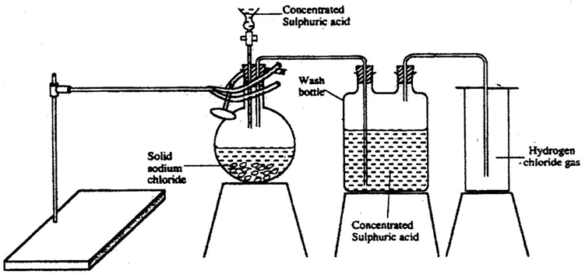

a) State the purpose of concentrated sulphuric(vi) acid in the wash bottle. (1 mark)
………………………………………………………………………………………………………………
b) Write an equation for the reaction between dry hydrogen chloride gas and heated iron (1 mark)
…………………………………………………………………………………………………………………
(c).Hydrogen chloride gas is dissolved in water to make hydrochloric acid. State one precaution to be observed
when dissolving hydrogenchloride gas in water. (1 mark)
.................................................................................................................................................................
…………………………………………………………………………………………………………
(d).In an experiment, a test-tube full of chlorine water was inverted in chlorine water as shown in the diagram below and the set up left in sunlight for one day.
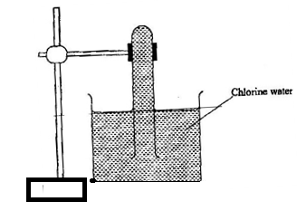
After one day, a gas was found to have collected in the test-tube
- Identify the gas. (1 mark)
…………………………………………………………………………………………………………………….
- What will happen to the P^{H} of the solution in the beaker after one day? Give an explanation.(1 mark)
.................................................................................................................................................................
……………………………………………………………………………………………………………
(e).In an experiment, dry chlorine gas was reacted with aluminium as shown in figure below.
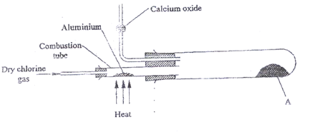
(i). Name substance A. (1 mark)
…………………………………………………………………………………………………………………….
ii) Write an equation for the reaction that took place in the combustion tube. (1 mark)
…………………………………………………………………………………………………………………….
(iii) 0.84 g of aluminum reacted completely with chlorine gas. Calculate the volume of chlorine gas used
(Molar gas volume is 24dm³, Al = 27). (3 marks)
……………………………………………………………………………………………………………………………………………………………………………………………………………………………………………………………………………………………………………………………………………………………………..
5.(a) Define the term hydrocarbon (1 mark)
……………………………………………………………………………………………………..........................
(b) A hydrocarbon with a M.F C₇H₁₆ after a reaction gave two hydrocarbons as shown
C₇H₁₆ C₅H₁₂ + W
- State the name of W (1 mark)
………………………………………………………………………………………………………………
- Name the process that produces C₅H₁₂ and W (1 mark)
…………………………………………………………………………………………………………….
- State the observation that would be made if 3 drops of bromine water are added to W (1 mark)
……………………………………………………………………………………………………………….
- Write the equation for the combustion of W
………………………………………………………………………………………………….....................
(c) The scheme below shows some reactions of substances. Study it and answer the questions that follows.
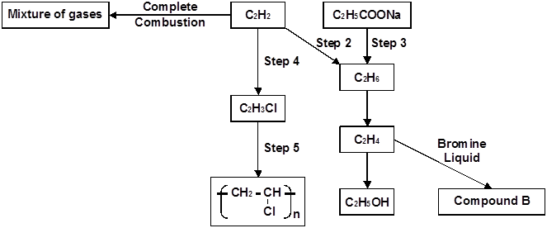

i) Name the reagents used in
Step 2................................................................................................................... (1 mark)
Step 3..................................................................................................................... (1 mark)
Step 4..................................................................................................................... (1 mark)
ii) Write down the name and structural formula of compound B. (2 marks)

(iii) Name the type of process involved in the following
Step 5………………………………………………………………………………… (1mark)
Step 4 ………………………………………………………………………………… (1mark)
6. Rusting is a destructive process in which iron is converted to hydrated iron (III) oxide.
a) State
i) two conditions necessary for rusting to occur. (2 marks)
.................................................................................................................................................................
…………………………………………………………………………………………………………
ii) two methods used to protect iron from rusting other than galvanizing. (2 marks)
......................................................................................................................................................................
.......................................................................................................................................................................
b) Explain why it is not advisable to wash vehicles using sea water. (1 mark)
...................................................................................................................................................................
.....................................................................................................................................................................
c) Explain why galvanized iron objects are better protected even when scratched. (1 mark)
...................................................................................................................................................................
......................................................................................................................................................................
d) The set-up below was used to prepare oxygen gas. Complete the diagram to show how a sample of the gas can be collected. (2 marks)

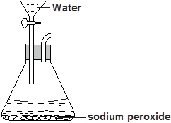
i) Write an equation for the reaction producing oxygen gas. (1 mark)
.....................................................................................................................................................
ii) How can the rate of production of gas be increased using the set-up above? (1 mark)
.....................................................................................................................................................
(e) Describe the chemical test for oxygen ( 2 marks)
…………………………………………………………………………………………………………………………
………………………………………………………………………………………………………………………….
(f) Give any two large scale uses of oxygen gas (2 marks)

………………………………………………………………………………………………………………
………………………………………………………………………………………………………………
7. The flow diagram below is a summary of the industrial manufacture of sulphuric (VI) acid.
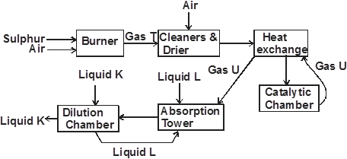

i) Write an equation for the reaction in the burner. (1 mark)
.....................................................................................................................................................
ii) Why is it important to pass gas T and air through cleaners? (1 mark)
....................................................................................................................................................
iii) Identify
a) Gas U (1 mark)
.....................................................................................................................................................
b) Liquid K (1mark)
....................................................................................................................................................
c) Liquid L (1 mark)
....................................................................................................................................................
iv) Write equation for the reaction taking place in the catalytic chamber (1 mark)
..................................................................................................................................................................
v) Other than platinum name another catalyst that can be used in the catalytic chamber. (1 mark)
....................................................................................................................................................................
vi) Give the name of the product formed in the absorption tower. (1 mark)
.....................................................................................................................................................................
vii) Write equation for the reaction taking place in the dilution chamber. (1 mark)
..................................................................................................................................................................
viii) Name the main pollutant in this process and state how it is taken care of. (2 marks)
.....................................................................................................................................................................
...................................................................................................................................................................
ix) Give one use of sulphuric (VI) acid. (1 mark)
...................................................................................................................................................................
...................................................................................................................................................................

SET 4
MARKING SCHEME CHEMISTRY PAPER 233/2
1.(a) Carbon (IV) oxide, ✓1 sulphur (IV) oxide, dust particles✓1

b) Finely divided to increase surface are for reaction✓1
c) Recycling reduces wastage/ Reduces cost✓1
d)Temperature of 450°C - 500°C✓1
e) - Manufacture of fertilizer e.g. (NH₄)₂ SO₄, NH₄ NO₃✓1
- Manufacture nitric (V) acid✓1
-Softening of hard water
-Stain remover
-Manufacture of hydrazine used in rocket fuel
f. (i) Platinum/platinum — rhodium✓1
(ii) 4 NH_{3(g)} +5O_{3(g)} 4 NO_{(g)} + 6H₂O_{(g)} ✓1
(iii) Unreacted gases e.g. NH₃, NO ,May leak into the environment and cause air pollution✓1
g).Fractional distillation of liquefied air✓1
2. (.i) R or S ✓1

ii) Giant ionic structure. ✓1

iii) V is more reactive compared to W. ✓1

iv)T has larger atomic radius compared to U. Across the period atomic radius decreases

due to increases in effective nuclear charge
(b)
(i)

(ii)
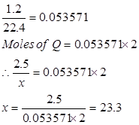

(c)(i) It exist as a dimer ✓1

(ii) SiCl₄ ✓½ SCl₂✓½
They have a very low melting point ✓1

(iii).Al₂Cl₆ is covalently bonded ✓½ it has a simple molecular structure which requires less energy to break.While MgCl₂ has ionic bond ✓½ with giant ionic structure which requires a lot of heat energy to break .

3. a) Bubbles/effervescence;✓1mk
b) R.F.M CaCO₃ = 100
Number of moles = ²/₁₀₀ = 0.02 moles
Moles of CO₂ = 0.02 (mol ratio 1:1)
Mass = 0.02 x 44 = 0.88g
c) -Size of the particles/surface area of marble chips ✓1
- Concentration of hydrochloric acid
d) White; and black solids; formed: this is because the burning magnesium dissociates carbon (IV) oxide into carbon (black) and oxygen. The oxygen oxidizes the magnesium to, magnesium oxide which is white;
e) It forms a white precipitate with calcium hydroxide;
- While with potassium hydroxide it does not due to formation of soluble potassium carbonate;
f) Burning/combustion of fossil fuels/organic compounds;
-Industrial process that involved use of carbon as reducing agent;
- Fermentation;
Acc respiration

4. .(a) to dry the HCl gas  1

(b) 2HCl(g) +Fe(s) FeCl₂(s)+ H₂(g)  1

(c)Use inverted filter funnel since HCl gas is highly soluble in water

(d) I.oxygen  1

II.it will decrease,HCl formed is acidic 1

(e)(i).Aluminium(III)chloride 1
(ii) 2Al(s)+3Cl₂(g) 2AlCl₃(s)  1
(iii) moles of Al =0.84/27
=0.03111moles ½
Moles of Cl₂= 0.03111x1.5
=0.046665moles ½
1mole =24dm³
0.046665moles =?
X= 1.12dm³ 1
5.(a) acompound containing carbon and hydrogen only ✓1
(b)(i) ethane ✓1
(ii) cracking ✓1
(iii)it will be decolourised from yellow ✓1
(iv) C₂H₄ (g) + 2O₂(g) CO₂(g) +2H₂O(l) ✓1
(c)(i) step 2 –hydrogen ✓1
Step 3-sodalime ✓1
Step 4- hydrogenchloride gas ✓1
(ii)step 5-polymerisation ✓1
Step 4 -addition ✓1
6. a)i)Presence of water ✓1 and air ✓1

ii) -Painting ✓
-Electroplating ✓
-Greasing.

b) Rusting is accelerated ✓½ by salt in the sea water. ✓ ½

c) Zinc being more reactive than iron corrodes preferentially, protecting iron.

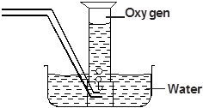
d)

i)

ii) By reducing the size of sodium peroxide particles

(e) introduce a glowing splint ✓,if it relights ✓ then the gas is oxygen
(f)-mixed with acetylene to form oxyacetylene used in welding ✓ and cutting of metals
-used in hospitals to aid patients with breathing problems ✓

7. a)
i)

ii) To remove impurities which otherwise would poison the catalyst ✓1

iii) a) Gas U - sulphur (VI) oxide ✓

b) Liquid K - water ✓

c) Liquid L - concentrated sulphuric (VI) acid ✓

iv)

v) Vanadium (V) oxide ✓1

vi) Oleum / fumming sulphuric (VI) acid ✓1

vii)

viii) Pollutant: Sulphur (IV) acid ✓½
Control : scrubbing the gas i.e. passing the exhaust gases ✓1 through chimneys lined with calcium hydroxide.

ix)- Manufacture of fertilizers ✓1
-Processing of metal ores.
-Manufacture of detergents.
-Used in lead-acid accumulators.
any 1 - 1 mark

