SET 1
CHEMISTRY 233/2
MARKING SCHEME
1a)i)
Atomic number | Oxide formula | State at RT
N-12 | P₂O₃ | Q - solid
R- 15 | R₂O₅ | S- Gas

ii) The atomic radius decreases across the period from M to V. Due to increasing
nuclear charge// increasing number of protons which pulls the outermost electrons closer to the nucleus

iii) Element V is chemically stable// stable electronic configuration does not gain or
loss// share electrons with oxygen to form an oxide

b) i)
Oxide | Structure | Bond type
No | Giant ionic | Ionic/ electro valent
TO2 | Simple covalent/ molecular | Covalent
( ½ mark each – total 2 marks)
c)i) P is a metal with valency electrons free to move but T is a non- metal// molecular has no free valency electrons// molecules are electrically neutral

ii) Amphoteric oxide
quiz

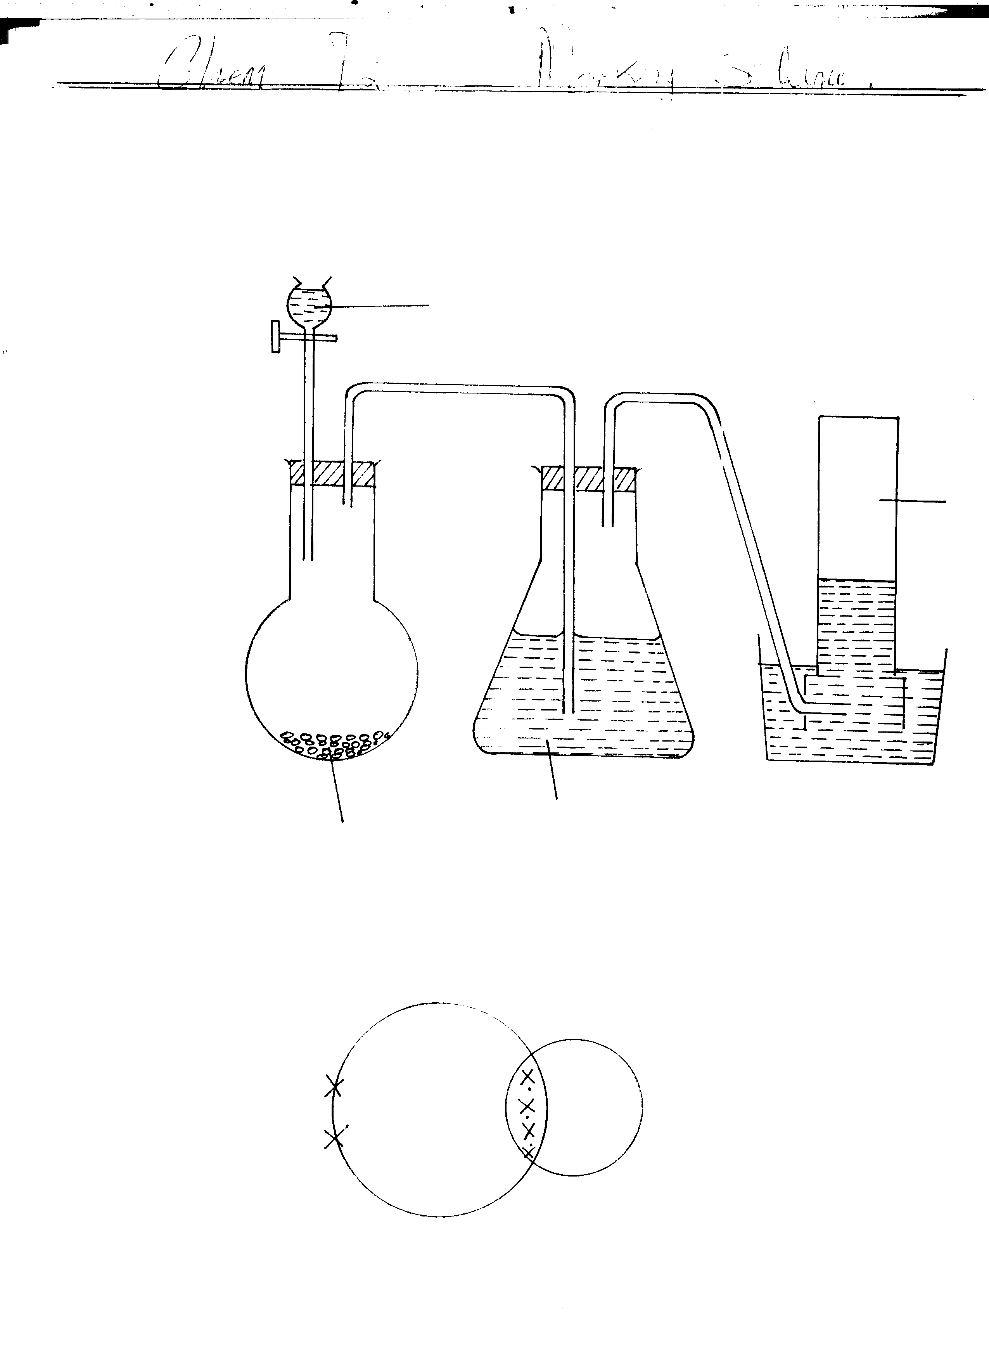
2.
Potassium Hydroxide
Sodium
Methanote
Sulphuric (VI) acid
CO

- Liquid x = concerntrated sulphuric (VI) acid

(c) Use calcium hydroxide √ 1

CO will not form a white precipitate √ ½ with calcium hydroxide solution where CO₂ will react and form a white precipitate √ ½ with calcium hydroxide solutions.

(d)
Electric distribution √1
Atomic distribution √1

(e) 2Co_{(g)} + O₂ _{(g)} → 2C O₂ _{(g)} √ 1mk

2 Vol 1 Vol 2 Vol

If 100 cm³ of Co reacts, 50 cm³ of O₂ is acquired.

∴ Vol of O₂ = 50 cm³ √ 1mk
3.(a) Oxygen√¹ and Nitrogen. √¹

(b) (i) CO_{2(g)} + NaOH_{(aq)} NaHCO₃^{(aq)} √ √ (1mk)
(ii) 2CU_{(s)} + O_{2(g)} 2CuO(s) √√ (1mk)
(iii) 3Mg_{(s)} + N_{2(g)} Mg₃N_{2(g)} √√ (1mk)

- - Neon / Argon / Helium√ (1mk)
- They are stable and thus unreactive. √ (1mk)
- Dust √ (1mk)
- Concentrated potassium hydroxide. √ (1mk)
- Oxygen
Uses
  - Used in deep sea diving.
  - Used in hospitals by patients with breathing difficulties.
  - Used in high altitude flying.
  - Used in mountain climbing.
  - Used for purification of crude oil.
  - Used in welding flames.
  - Used in burning fuel to propel rockets.
  - Used in preparation of explosive mixture e.g. petrol, charcoal and oxygen)/
NB Any three
4. (a) (i) By passing A through a U – tube filled with CaO√1mk
(ii) dinitrogen tetraoxide √1mk
- Brown solid seen √1mk
- 2NH_{3(g)} + 3CUO_{(s)} 3CU_{(s)} + 3H₂O_{(l)} + N_{2(g)} √1mk
- Excess NH3 react with water to form ammonium hydroxide solution which is basic. √1mk
(b)(i)Ammonium chloride sublimed and collected in the cooler parts of the round-bottomed flask and
the delivery tube √1mk
(ii) Ammonia salts liberates ammonia gas when heated with an alkali, not from its salt √1mk
So that the water, as it condenses does not run back into the hot flask and cracks it. √1mk
(iii) Ammonia combines with hydrogen chloride Or Ammonia being basic reacts with acidic gas to form a salt NH_{3(g)} + HCl_{(g)} NH₄ Cl _{(s)} √1mk
Nitrogen and Hydrogen V ½mk
2. (a) R – Ethene P½
T – Ethan-12-diol P½
V – Ethylhydrogensulphate P½
S – I – Chloroethane/chloroethane P½
W – Ethanol P½
U – Ethane P½
- Chlorine gas – Condition P1 presence of sunlight/UV. light P1
- (i) Addition P1
  - Substitution P1

(d) (i) Hydrochlorination/hydrohalogenation P1
(ii) Hydrogenation P1

(ii) (a) H H H H
⎟ ⎟ ⎟ ⎟
H - C - C - C - C - H P½ Butane P½
⎟ ⎟ ⎟ ⎟
H H H H

H H H
⎟ ⎟ ⎟
H - C - C - C - H P½ 2 - Methylpropane P½
⎟ ⎟ ⎟
H - C – H
⎟
H

H H

- Add bromine water P to each of them C₄H₈ would decolourise P½
bromine water while C₄H₁₀ would not. P½
or
Add acidified KMnO4 solution to each of them.
C₄H₈ would decolourise KMnO₄ while C₄H₁₀ would not.
5. (a) R – Ethene P½
T – Ethan-12-diol P½
V – Ethylhydrogensulphate P½
S – I – Chloroethane/chloroethane P½
W – Ethanol P½
U – Ethane P½

- Chlorine gas – Condition P1 presence of sunlight/UV. light P1
- (i) Addition P1
  - Substitution P1

(d) (i) Hydrochlorination/hydrohalogenation P1
(ii) Hydrogenation P1

(ii) (a) H H H H
⎟ ⎟ ⎟ ⎟
H - C - C - C - C - H P½ Butane P½
⎟ ⎟ ⎟ ⎟
H H H H

H H H
⎟ ⎟ ⎟
H - C - C - C - H P½ 2 - Methylpropane P½
⎟ ⎟ ⎟
H - C – H
⎟
H

H H

- Add bromine water P to each of them C₄H₈ would decolourise P½
bromine water while C₄H₁₀ would not. P½
or
Add acidified KMnO4 solution to each of them.
C₄H₈ would decolourise KMnO₄ while C₄H₁₀ would not.
6. (a) Hydrogen gas ¹.
(b) Remove magnesium oxide layer ¹ on the surfaces (1mk)
(c) Bright white light ¹ or
White powder ¹
- Mg_{(S)} + H₂O_{(S)} → MgO_{(S)} + H_{2(S)} ¹
(e) (i) Brick liners in furnaces. ¹
(ii) Radio frequency shielding.
(f) Withdraw delivery tube from water before you stop ½ heating to prevent sucking back. ½

(g) (i) Volume of Gas X at s.t.p.
V₁ = 96 V₂ = 2
P₁ = 1 P₂ = 1
T₁ = 283 ½ T₂ = 273
$V = \frac{PVT}{PT} = \frac{1 × \text{96} × \text{283}}{1 × \text{273}}$¹ = 99.52cm³ ½

  - Mass of magnesium ribbon used:
Moles of hydrogen gas
1 mole - 22400
? 99.52
$\frac{\text{99}\text{.}\text{52} × 1}{\text{22400}}$ ½ = 0.00444 ½
Moles of hydrogen moles of magnesium = 0.00444
∴Mass = 0.00444 × 24 ½ = 0.0166g ½

- a) Sulphur√1mk
Metal sulphide e.g. ZnS, CuS, √1mk
H₂S√1mk

b) i) sand ,clay√½mk
and limestone√½mk
ii) To prevent the impurities from damaging the catalyst. √1mk

c) 2SO_{2 (g)} + O_{2 (g)} V₂O₅ SO_{3 (g}) (1mk)
d) i) Vanadium (V) oxide
Platinized asbestos (1mk)
ii) Vanadium (v) oxide. it is not easily destroyed/poisoned by impurities
e) Because the reaction between SO₃ and water is exothermic and hence splashing of the sulphuric (VI) acid formed would occur due to its boiling (1mk)
f) SO_{3 (g) +} H₂SO_{4 (l)} H₂S₂O_{7 (l) (}1mk)
g) Sulphur (IV) oxide (1mk)
h) - Further oxidation SO₂ to form SO₃which is used in the process.
-Scrubbing method i.e. passing exhaust gases containing SO₂ through a tall chimney packed with cartridges containing oxides or carbonates of metals such as calcium.
CaO(_{s)} +SO₂ CaSO_{3(s)}

CaCO_{3(s)} +SO_{2 (g)} CaSO_{3(s) +} CO_{2 (g)}

