**SET 7**

**CHEMISTRY 233/2**

**MARKING SCHEME.**

1.(a) Carbon √ ½ and hydrogen √ ½ 1

(b)(i) Candle goes off √ 1 Carbon (iv) oxide produced does not √ 1 escape 2

(ii)Increases in mass √ 1 CaO absorbes √ 1 water vapour produced by the burning candles √ 1

(iii) absorbs excess water vapour √ 1

(iv) Conc H2SO4√ 1

Spirit lamp √ 1

©(i) Manganese (iv) oxide, Pottasssium Mangante VII, Potassium chromate VI √ ½ +√ ½ =1 1ny 2

(ii) Colour of pottasium bromiide changes from colourless to yellow/brown

Bromide ions are displaced to bromine gas and potassium chloride √ 1 2

(iii ) Add a few drops of dilute lead nitrate √ 1 or silver nitrate to the solution, white precipitate forms of Lead (II) chloride or of silver chloride 2

2.(a)(i) A√ ½ and E√ ½ @ ½ for both

(ii) B,C and D √ ½ any 2

(b)(i) D√ 1-boils at below 25oC√ 1 2

(ii) D√ - inert√ 1

(c) (i) B2(SO4)3 √ 1

(ii) 4A(s) +C2(g) 2A2C(s) √ 1 states and balanced not bal.=0, no symbola= ½

(d) Ionic √ 1- Non-metal and metal √ 1- forms nond by transfer of valence electrons 2

(e) T- √ 1 has the greatest tendency √ 1 to lose valence electron 2

3. (a) Solid state- has strong intermolecular forces of attraction

Liquid state- has weak intermolecular forces of attraction

(b) (i) gas to liquid

(ii) I- gas looses heat as it changes to liquid state

II liquid looses heat as it changes to solid state

(c)(i) Sublimation

(ii) Carbon (IV( Oxide, Iodine

(d) If it hs sharp or exaact melting point

4. (a)(i) Homologous series √ 1

(ii) alkenes √ 1

(iii) C2H4, C3H6, C4H8 and 1 any 1

Boils at temp below 278K√ 1

(iv)C8H16√ 1

(v) Boiling points increase with √ ½ increase in no. Of carbon atoms √ ½ due to increasing no. Of covalent √ ½ bonds that require √ ½ alot of heat energy to break 2

(b) Acidified Potassium manganate (vii) changes colour from purple to colourless√ 1// it is decolourised unsaturation

(c) (i) Mass of oxide = 13.3-10.98=2.32g

Mass of residue= 12.66-10.98=1.68g

Mass of oxide =2.32g

Mass of residue = 1.68g =iron √ ½

Mass of oxygen = 0.64g

Fe O

1.68 0.64

56 16

0.03 0.04 √ ½

0.03 0.03 FeO √ ½

1 1.3

(ii) FeO(s) + CO(g) Fe + CO2√ ½ not bal. =0 , No states= ½

5.(a)(i) thistle funneel √ 1

(ii) hydrogen peroxide √ 1

(iii) Manganese (IV) Oxide √ 1

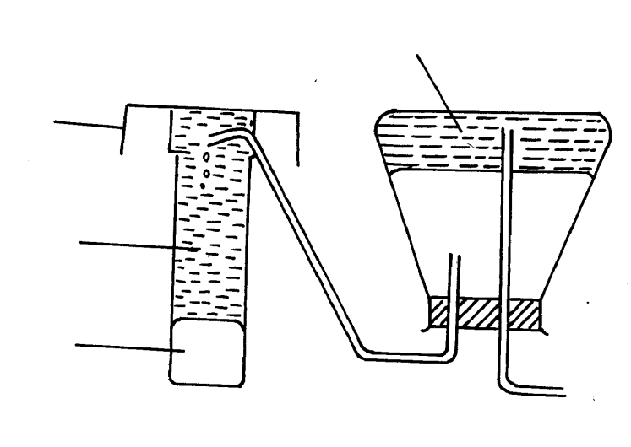(b) Speeds up the rate of rxn-production √ 1 of Oxygen gas

©

oxygen

√ drying agent

Water

Beaker

Conc H2SO4

(d) 2H2O2 (l)  O2(g)+2H2O(l)

€ Colourless √ ½ -Bp-186oC any 2 x ½

Oduorless √ ½ ½ x 1=1

6. (a) (i) –Iron Pyrite, Zinc blende, galena, Copper pyrite, Cinnabar, gypsum, Barutes, Kieserite any 1

(ii) to melt Sulphur

(iii) to change molten Sulphur into a low density froth and to force sulphur out to the surface √ 1

(b) making pesticides

Raw materials in the preparation of sulpur √

(c) Moles of S = 3.6 = 0.1125

32

Moles of SO2= 1/3 x 0.1125 = 0.0375moles √ ½

1 mole =64g (SO2= 64g/mol)

0.0375 = 64x 0.0275√ ½

=2.4g

64g= 24000cm3

2.4g = 24000x 2.4 √ = 900cm3

64

Alt : 1 mole = 24000cm3

0.0375 = 24000x 0.0375 = 900cm3

1

(d)(i) Sulphur Ore√ 1

(ii) 2Na(aq)+ 3SO32- Na2SO3(s)

(iii) Blue tunrs red √ ½ and red remains red √ ½

SO2 dissolves in water to form Sulphurous acid √ ½

(iv) White ppt dissolves to form a colourless solution √ ½

SO32-  are soluble in dil. HCl √ ½

7. (a) Carbon (IV) Oxide √ 1, ammonium chloride √ 2

(b) ammonium chloride √ 1

(c) React each with Ca(OH)2 √ 1– CO2 forms white ppt √ 1while CO doesn’t form white ppt √ ½

(d) AlCl3 is acidic √ 1 hence reacts with Na2CO3 (basic) to produce Carbon (IV) Oxide gas 2

(e) 2H+ (aq) + CO32- (aq) H2CO3(aq)