**SET 5**

**233/2**

**CHEMISTRY**

**PAPER 2**

**THEORY**

**MARKING SCHEME**

**Question 1**

1. G - 2.8.5 √ 1mk

F – 2.1 √ 1mk

1. D(s) D3+ + 3e- √ 1mk
2. E, √ ½ mk, F, √ 1mk, H√ ½ mk
4. B, √ ½ mk, F, √ ½ mk, H √ ½ mk
5. F>B>I √ 1mk
6. The ion has one energy level less than the atom √ 1/2mk. This increases the forces of attraction between the nucleus and the remaining fewer electrons making the ion smaller. √ ½ mk
7. H is more reactive than F, H has bigger atom hence the valence electron is far away from the nucleus (loosely held and therefore easily lost.) √ 1mk

19 P

X

X

X X

X

X

X X

+

17 P

o

o

oo

o

xo

o o

-

Only outermost energy levels of ions indicated.

H+ 2.8.8

A- 2.8.8



**Question 2**

Air is made up of different gases that are not chemically combined. √ 1m

1. 1. All the oxygen in the bell jar had been used up √ 1mk
   2. It reacts better with CO2 than tap water. √ 1mk
   3. √ 2mks
   4. Nitrogen gas / N2 √ 1mk
2. 1. Na2O2, √ 1mk, NaNO3, KClO3, KMnO4, Pb(NO3)2

2NaNO3(s)  → 2Na2O(s) + O2(g) √ 1mk

2KClO3(s)  → 2KCl(s) + 3O2(g) √ 1mk

2KMnO4(s)  → KMnO2O(s) + O2(g) √ 1mk

*(Any one, Must be Balanced, Correct states)*

* 1. It is slightly soluble in water √ 1mk  *reject insoluble in water.*
  2. Supports combustion / burning. √ 1mk

Combines with other element to form oxides. √ 1mk

**Question 3**

1. 1. J – Nitrogen (II) Oxide (NO) √ ½ mk
   2. Step (VI) – Reduction √ 1mk
   3. 3CuO(s) + 2NH3(g)   ­ heat N2(g) + 3Cu(s) + 3H2O(l)

*Balanced with state symbols* √ 1mk

*Balanced without symbols* √ 1mk

*Unbalanced 0mk*

* 1. NH4NO3(s) heat N2O(g) + 2H2O(l) √ ½ mk
  2. Used as a fertilizer √ ½ mk
  3. NH4NO3 – R.M.M = 28+4+48 = 80

% nitrogen =

CO(NH2)2 = R.M.M 12+16+28+4 = 60

% nitrogen =

Urea (CO(NH2)2 - best fertilizer

Since it has the highest % of nitrogen

1. 1. G √ 1mk
   2. E2+(aq) + 2OH-(aq) → E(OH)2(s) √ 1mk

**Question 4**

1. 1. Heptane √ ½ mk
   2. Pent – 2 - yne √ ½ mk
2. 1. Fractional distillation √ ½ mk
   2. Easy vaporization √ ½ mk

Close different boiling points √ ½ mk

1. 1. I. C3H6 √ ½ mk

II. Propene √ ½ mk

* 1. Bubble each gas through a solution of either potassium managanate (VII) or bromine water.

C2H6 will not decolourise any of the above reagent √ ½ mk

C3H6 will decolourise them √ ½ mk

1. 1. Two moles √ 1mk
   2. P1 => 1 – bromothene √ ½ mk

H ─ C = C ─ Br √ ½ mk

| |

H H

P2 => 1, 1 – dibromoethane √ ½ mk

H H

| |

H ─ C ─ C ─ Br √ ½ mk

| |

H Br

1. 1. S is ethanol √ ½ mk
   2. It is insoluble / does not dissolve in water √ 1mk

**Question 5**

1. 1. C(s) + O2(g) → CO2(g)

2C(s) + O2(g) → 2CO(s)

CO(g) + CuO(s) → Cu(s) + CO2(g) *any 2*

* 1. White ppt formed; CO2 produced in the combustion tube reacts with lime water to form calcium carbonate.

1. 1. P – Ammonia √ ½ mk

X – Carbon (IV) oxide √ ½ mk

A – Carbon / Coke √ ½ mk

B – Calcium Oxide √ ½ mk

R – Sodium Carbonate √ ½ mk

D – Ammonium Chloride √ ½ mk

* 1. Pump sea water into shallow bsins, √ , water evaporates √  and sodium chloride crystallizes. √
  2. Making glass

Softening hard water

Manufacture of anti – acid drugs

Food additives

Manufacture of detergents.

*Any one*

* 1. NH4Cl(aq) + Ca(OH)2(aq) → CaCl2(aq) + 2H2O(l)  2NH3(g) √ 1 mk

**Question 6**



* A – Super heated water √
* B – Hot compressed air
* C – molten sulphur 3mks

1. 1. Vanadium (v) oxide √ 1mk
   2. Manufacture of sulphuric (vi) acid √ 1mk
2. I. Solution K

* No white ppt formed √ ½ mk
* The BaSO3 formed decomposes immediately due to presence of acid in the solution √1mk

II. Sample L

* White ppt formed √ ½ mk
* Atmospheric oxygen oxidizes the sulphite ions to sulphate ion which forms the white ppt which does not dissolve in presence of acid in the solution . √ 1mk
  1. The brown iron (III) sulphate turns to green √ 1 mk
  2. Sulphur(IV) oxide bleaches by reduction √ 1 mk while chlorine bleached by oxidation. √ 1 mk
  3. SO 32- + [ dye + O] → SO2-4 + [ dye – O] √ 1 mk

(aq) Coloured (aq) colourless

**Question 7**

1. HCl(aq)  + NaOH(aq) → NaCl(aq) + H2O(l)

25cm3  46cm3

? : 11M

1 : 1

Moles of NaOH = $\frac{m x v}{1000}$ = $\frac{11 x 46}{1000}=0.506 moles$

Mole ration = 1:1

Therefore

Moles of HCl = Moles of NaOH = 0.0506 moles

1. 25cm3 → has 0.506 moles

250cm3 → ?

Mass = moles x Rmm of HCl

= 5.06 x 36.5

= 184. 69g √ 1mk

b)

1. Diagram √ 1 mk

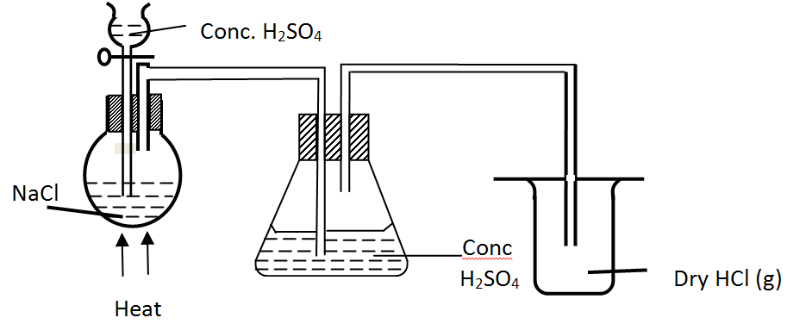

4 chemicals labeled √ 1 mk

1. NaCl(s)­ + H2So4(l) Heat NaHSO4(s) + HCl(g)
2. White ppt form √ 1 mk

Cl- ions react with Pb2+ ions forming PbCl2 which is insoluble at room temperature.

Pb2+(aq) + 2Cl-(aq) → PbCl2(s) (white ppt)

1. HCl dissolves the metal oxide coating making metal surface clean.

HNO3 is a strong oxidizing agent and therefore oxidizes the metal