**SET 2**

**FORM THREE EXAM**

**CHEMISTRY 233/2**

**MARKING SCHEME**

1. (a) Z √1

(b) Halogens √1

(c)(i) WQ√1

(ii) RQ3 or R2Q6 √1

(d) WQ √1

It has stronger ionic bonds holding the giant ionic structure√1

(e) X has less atomic radius than Y√1

X has less energy levels than Y√1

(f) It has fully filled octet, does not gain nor loose electrons√1

(g) PH=7 ½

It does not dissolve in water √ ½

(h) (i) L,Q √1

(ii) U √1

2. (a)(i) P: Prop-1-yne/propyne √1

(ii) Q: Butane√1

(iii) R: But-2-ene√1

(b)(i) I- Organic compounds with same fractional group having similar physical and chemical property when each member differ with CH2

II- Alkanes √1

(ii) C5H12 OR C6H14√1

(iii) Boiling points increases with increase in molecular masses√1

Increase in molecular mass leads to increase in the no. of van der waals forces holding the molecules √1

(iv) Pass the gases separately through;

Purple H+/KMnO4; decoluorised in C4H8 but not in C2H6

OR

Orange H+/K2Cr2O7; changes to green in C4H8 but not in C2H6

Yelow Bromine water; discolourised in C4H8 but not in C2H6

Burning them separately: C4H8 burns with a sooty flame while C2H6 burns with a not-sooty flame.

Chemical used √1

Correct observations for both √1

(v) Used as a fuel  *√1 any one correct*

Used as a solvent

H

|

H

|

H

|

H

|

H

|

|

|

|

H

H

H

H

-

(vi)

C - C - C - C - H √ ½ butane √ ½

|

H

|

H

|

|

|

|

H

H

H

C

-

H

H

|

H-

-H

C - C - C - H √ ½ 2-methylpropane √ ½

3.(a) (i) Concetrated Sulphuric (vi) acid *both √1*

-sodium chloride

(ii) To absorb unreacted/excess hydrogen √1 chloride gas

(iii) S: Fe(s) + 2HCl(g) FeCl2(s) +H2(g) √1

V: PbO(s) + H2(g)  Pb(s) +H2O(l) √1

(iv) The oxygen in Lead (ii) Oxide was reduced by hydrogen leaving √1 lead metal

(v) Black CuO forms and a brown metal √1

Colourless liquid formed √1

(b) Mg(s) + Cl2 MgCl2(s)

Moles of MgCl2 = 1.9 = 0.02moles √ ½

95

Moles of Cl2= 0.02moles √ ½

Volume of Cl2 = 22.4x 0.02moles√ ½

= 0.448dm3 √ ½

4. (a) (i) A: presurised air√1

B: Molten Sulphur√1

(ii) Boiled at a pressure above 1atmosphere √1

(iii) It is insoluble in water and has a lower melting point √ ½

(iv) Monoclinic Sulphur √1

Rhombic Sulphur √1

(b)(i) Na2SO3(s) +2HCl(aq) SO2+2NaCl(aq) + H2O(l)

(ii) Yellow solid √ ½ which is Sulphur √ ½ OR

Moisture/droplets of colourless liquid which is water√1 *any one correct*

(c)(i) It reacts with ammonia to form ammonium sulphate √1

(ii) I; oxidizing property √1

II: Dehydrating property√1

(iii) Slowly adding concentrated Sulphuric (vi) acid to a larger volume of water.

5.(i) Sodium hydroxide/Potassium hydroxide√1

(ii) The constituent components can be separated by physical means√ ½

They maintain their chemical and physical properties

(iii) Through fractional distillation√, nitrogen with lower boiling point boils √ ½ and distilled first leaving Oxygen√ ½

(b)(i) It is hygroscopic and absorbs √1 moisture

(ii) to condense the Nitric acid vapour to liquid√1

(iii) KNO3(s) + H2SO4(l)  KHSO4 (aq) +HNO3(g) √1

(iv) I: Concentrated Nitric (v) acid is a strong oxidizing agent, hence reacts √ ½ with rubber

II: The Nitrogen (ii) Oxide √ ½ produced is spontaneously oxidized by the atmospheric oxygen to NO2√ ½ which is brown

v. Brown fumes evolved √ ½ ⇒ NO2 √ ½ formed

Sulphur dissolves √ ½ ⇒ it is oxidized to SO2 gas.

(vi) Manufacture of dyes

Manufacture of explosives *any two correct √1 √1*

6(a)

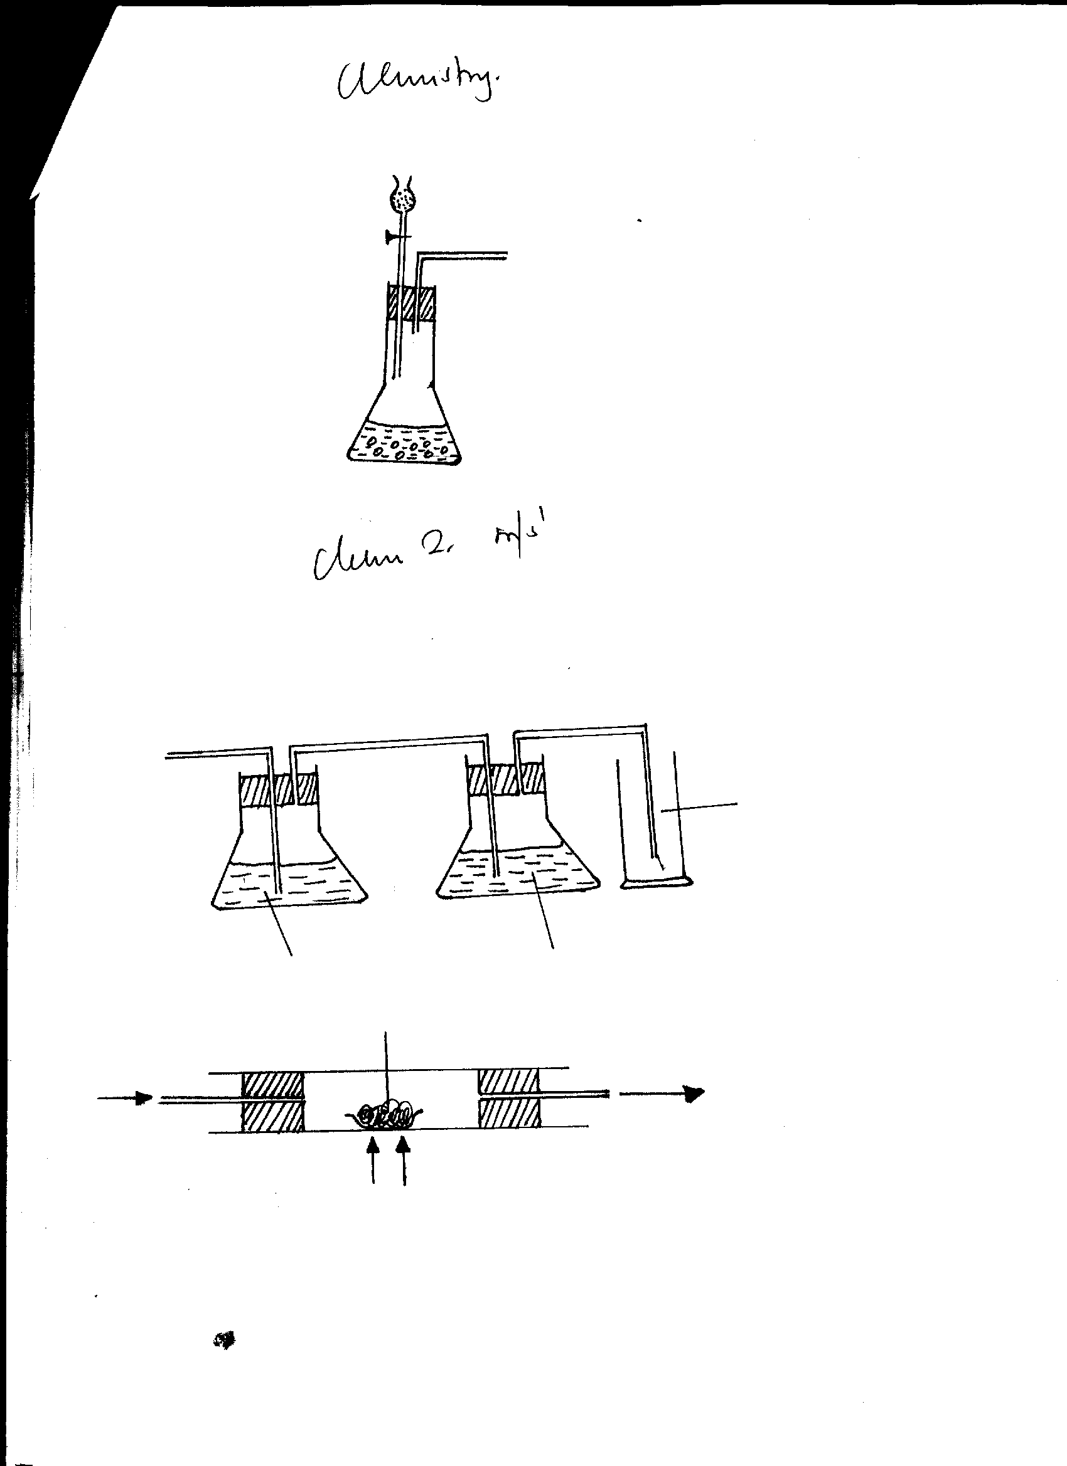

CO2

Conc sulphuric (vi) acid

Water

(b) CaCO3(s) + 2HCl(aq) CaCl2 +H2O(l) + CO2(g)

(c) B ecome moist √1 it is hygroscopic salt √1

(d)(i) Calcium Sulphate √1

(ii) Making plaster of Paris *any one correct*

(e) Black solid is formed √ ½ –Carbon √ ½

White residue √ ½

Magnesium oxide √ ½

7.

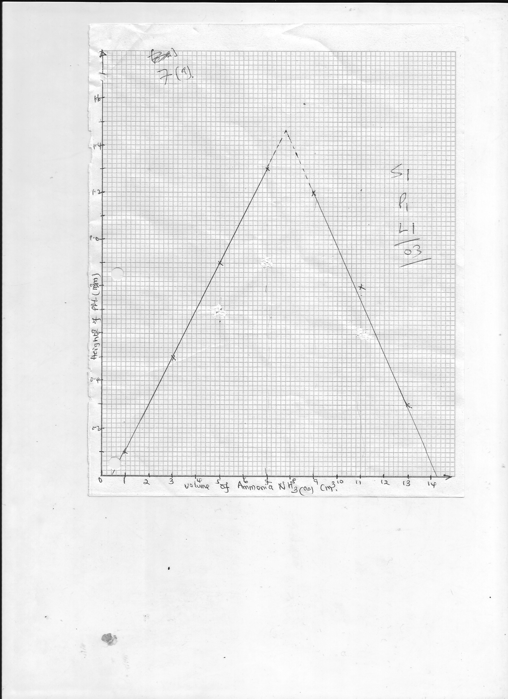

(a) Scale -1

Plotting 1

Lines extrapolated -1

(b)(i) 1.46cm ± 0.2 or value read after extrapolation

(ii) value read from the graph on the x-axis

(iii) value read from the graph where the droping line intercepts the x-axis

(c) (i) Moles = M x V = 0.643 x Ans in b(ii)

1000 1000

=Ans

(ii) 1 moles of CuSO4 = 1 mole of Cu2+ ions

∴ moles of CuSO4 = M x V = 1 x 3

1000 1000√ ½

=0.003moles

(d) Cu(aq)2+ : NH3 (aq)

=0.003 : Ans in c (i) √ ½

Converted to whole nos. √ ½

(e) Copper (ii) hydroxide √1