**NAME …………………………..……………….. DATE …………………………**

**INDEX NO. ……….……….…………………...…..… SIGNATURE ……………..…………..**

**233/1**

**CHEMISTRY**

**(THEORY)**

**PAPER 1**

**TIME: 2 HOURS.**

**SET 6**

**FORM 3**

*Kenya Certificate of Secondary Education.*

**INSTRUCTIONS TO CANDIDATES.**

1. Write your **NAME** and **INDEX NUMBER** in the space provided above
2. Sign and write the date of examination in the spaces provided above
3. Answer **ALL** the questions in the spaces provided
4. **ALL** working must be clearly shown where necessary.
5. Mathematical tables and silent electronic calculators may be used.
6. This paper consists of 11 printed pages.

Candidates should check to ensure that all pages are printed as indicated and no questions are missing

**FOR EXAMINER’S USE ONLY.**

|  |  |  |
| --- | --- | --- |
| **Question** | **Maximum score** | **Candidate’s score** |
| **1 − 31** | **80** |  |
| **Total score** | **80** |  |

1. The diagram below represents a paper chromatograph of pure A, B, C and D. A mixture of K contains A and D only.

Solvent front

A

C

B

D

A B C D K

1. Indicate on the diagram the chromatograph of K (1 mark)

…………………………………………………………………………………………………………………................................................................................................................................................................................

1. Label part Z (1 mark)

…………………………………………………………………………………………………………………................................................................................................................................................................................

2. Element Y has atomic number 8 while X has 16.

(i) Write electronic configuration of X and Y. (2 marks)

X

………………………………………………………………………………………………………………...

Y

...........................................................................................................................................................................

(ii)Name the type of bond and structure formed when X and Y reacts. (1 mark)

…………………………………………………………………………………………………………………................................................................................................................................................................................

3. (a) State the Graham’s Law of Diffusion (1mark)

…………………………………………………………………………………………………………………................................................................................................................................................................................

(b) 60cm3 of oxygen gas diffused through a porous partition in 50 seconds. How long would it take 60cm3 of N Nitrogen (IV) oxide gas to diffuse through the same partition under same condition.

(O = 16.0, N = 14.0)

…………………………………………………………………………………………………………………................................................................................................................................................................................

4. The diagram below shows some properties of Ammonia gas. Use it to answer the questions that follow.

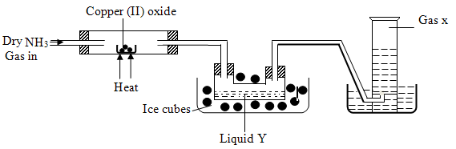

1. State the observation made in the combustion tube. (1mark)  
   …………………………………………………………………………………………………………………....................................................................................................................................................................
2. (i) Give the test that can be used to identify liquid Y (1mark)

…………………………………………………………………………………………………………………....................................................................................................................................................................

(ii) Name gas X (1mark)

…………………………………………………………………………………………………………………....................................................................................................................................................................

5. The table below shows the PH values of some solutions.

|  |  |  |  |  |  |
| --- | --- | --- | --- | --- | --- |
| Solution | J | K | L | M | N |
| pH | 6 | 13 | 2 | 10 | 7 |

1. Which solution is likely to be

(i) Potassium hydroxide (½ mark)

…………………………………………………………………………………………………………………..

…………………………………………………………………………………………………………………..

(ii) Lemon juice. (½ mark)

……………………………………………………………………………………………………………………………………………………………………………………………………………………………………

(b) Explain why a solution of hydrogen chloride gas in methylbenzene was identified as N. (2marks)

…………………………………………………………………………………………………………………................................................................................................................................................................................

(c) Compare the electrical conductivity of solutions J and L. (1mark)

…………………………………………………………………………………………………………………................................................................................................................................................................................

6. Complete the table below by filling in the missing test and observations.

|  |  |  |
| --- | --- | --- |
| Gas | Test | Observation |
| (i) Chlorine gas | Put a moist red litmus paper into the gas | 1mark |
| (ii) Sulphur (IV) Oxide | 1mark | Paper turns green |
| (iii) Propene gas | Add a drop of bromine water | 1mark |

7. (a) State the observation made at the end of the experiment when a mixture of Iron powder and sulphur is

heated in a test tube. (1mark)

…………………………………………………………………………………………………………………................................................................................................................................................................................

1. Write an equation for the reaction between the product in (a) above and dilute hydrochloric acid.

(1 mark)

………………………………………………………………………………………………………………….....................................................................................................................................................................

8. The diagram below was used to prepare oxygen gas in the laboratory.

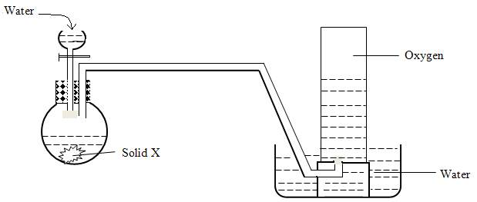

1. (i) Name solid X (1 mark)

………………………………………………………………………………………………………………….....................................................................................................................................................................

(ii) Write down the equation for the reaction that takes place between solid X and water. (1mark)

………………………………………………………………………………………………………………….....................................................................................................................................................................

(iii) What property of oxygen makes it possible to be collected by the method shown in the above

diagram. (1 mark)

………………………………………………………………………………………………………………….....................................................................................................................................................................

9. (i) What are isotopes? (1mark)

…………………………………………………………………………………………………………………................................................................................................................................................................................

(ii) Naturally occurring neon is composed of

20

Ne -------- 90.92%

10

21

Ne---------- 0.26%

10

22

Ne--------- 8.82%

10

Work out the relative atomic mass of neon using this information. (2 marks)

…………………………………………………………………………………………………………………................................................................................................................................................................................

…………………………………………………………………………………………………………………................................................................................................................................................................................

10. Using dot (•) and cross (x) diagram, show the bonding in the compound phosphonium ion PH4+ 0

(P = 15, H = 1 ) (2marks)

…………………………………………………………………………………………………………………................................................................................................................................................................................

…………………………………………………………………………………………………………………................................................................................................................................................................................

11. Name the process that takes place when:-

(i) Crystals of Zinc Nitrate change into solution when exposed to air. (1 mark)

…………………………………………………………………………………………………………………................................................................................................................................................................................

(ii) Solid Carbon (IV) Oxide (dry ice) changes directly into gas. (1 mark)

…………………………………………………………………………………………………………………................................................................................................................................................................................

(iii) Ethene gas molecules are converted into a giant molecule. (1mark)

…………………………………………………………………………………………………………………................................................................................................................................................................................

12. Gas B was passed into water as shown below.

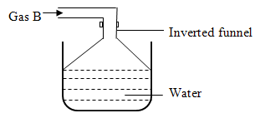

1. When a blue litmus paper was dropped into the resulting solution, it turned red. Give a reason to this observation. ( 1mark)

………………………………………………………………………………………………………………….....................................................................................................................................................................

1. What is gas B ( 1mark)

………………………………………………………………………………………………………………….....................................................................................................................................................................

1. State the function of the funnel. ( 1mark)

………………………………………………………………………………………………………………….....................................................................................................................................................................

13. When 8.0g of hydrated Copper (II) Sulphate was heated until no further change a solid of 5.1g of

anhydrous salt remained.

Calculate the empirical formula of the hydrated salt. (CU = 63.5, S = 32.0, O = 16.0, H = 1.0)

(3 marks)

…………………………………………………………………………………………………………………................................................................................................................................................................................

…………………………………………………………………………………………………………………...............................................................................................................................................................................

14. Steam was passed over heated magnesium in combustion tube as shown below.

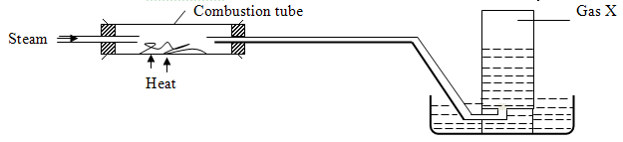

(i) Name gas X (1mark)

…………………………………………………………………………………………………………………................................................................................................................................................................................

(ii) Write down an equation for the reaction in the combustion tube. (1 mark)

…………………………………………………………………………………………………………………................................................................................................................................................................................

(iii) State one use of the residue formed in the combustion tube

…………………………………………………………………………………………………………………………………………………………………………………………………………………………………….

15. (a) Give the structural formula of 3, 3-dimethylpent-1-yne. (1 mark)

…………………………………………………………………………………………………………………................................................................................................................................................................................

1. Name the following compounds using the IUPAC system.

(i) CH3CHCHC = CH2 (1 mark)

| |

Br CH3

…………………………………………………………………………………………………………………................................................................................................................................................................................

(ii) CH3CH2CCCH3 (1 mark)

|

CH3

…………………………………………………………………………………………………………………................................................................................................................................................................................

16. The equation below represents a major reaction in one of the industrial processes.

N2(g) + 3H2(g) 2NH3(g)

1. Name the industrial process. (½marks)

………………………………………………………………………………………………………………….....................................................................................................................................................................

1. Name the catalyst used in the process. ( ½ marks)

………………………………………………………………………………………………………………….....................................................................................................................................................................

1. When ammonia gas is mixed with oxygen is sparked over platinum wire, brown fumes are evolved. Explain. ( 2 marks)

………………………………………………………………………………………………………………….....................................................................................................................................................................

17. Starting with copper metal, describe how a sample of crystals of Copper (II) Chloride may be prepared in

the laboratory. (3 marks)

…………………………………………………………………………………………………………………................................................................................................................................................................................

…………………………………………………………………………………………………………………................................................................................................................................................................................

18. Calculate the volume of 2.2M hydrochloric acid which is required to neutralize completely 9.4g of

potassium oxide. (K = 39.0, O = 16.0) (3 marks)

…………………………………………………………………………………………………………………................................................................................................................................................................................

19. When hydrogen sulphide gas was bubbled into an aqueous solution of Iron (III) Chloride a yellow

precipitate was deposited.

1. State another observation that was made ( 1mark)

………………………………………………………………………………………………………………….....................................................................................................................................................................

1. Write an equation for the reaction that took place. ( 1mark)

………………………………………………………………………………………………………………….....................................................................................................................................................................

1. What type of reaction was undergone by hydrogen sulphide in this reaction? (1 mark)

………………………………………………………………………………………………………………….....................................................................................................................................................................

23. The table below shows physical properties of some substances. Use the information in the table to answer

the questions that follow.

|  |  |  |  |  |
| --- | --- | --- | --- | --- |
|  |  |  | Electrical conductivity | |
| Substance | M.P (0C) | B.P (0C) | Solid | Liquid |
| M | 1083 | 2595 | Good | Good |
| N | 801 | 1413 | Poor | Good |
| O | 5.5 | 80.1 | Poor | Poor |
| P | -114.8 | -84.9 | Poor | Poor |
| Q | 3350 | 4827 | Poor | Poor |

1. Which substance is likely to be (1 mark)

(i) A metal

………………………………………………………....................................................................................

(ii) A liquid at room temperature (1mark)

…………………………………………………………………………………………………………………....................................................................................................................................................................

(b) Which substance is likely to have the following structures?

(i) Simple molecular (1mark)

…………………………………………………………………………………………………………………................................................................................................................................................................................

(ii) Giant atomic (1mark)

…………………………………………………………………………………………………………………................................................................................................................................................................................

21. When a student was stung by a nettle plant, a teacher applied an aqueous solution of ammonia to the

affected area of the skin and the student was relieved of pain. Explain. (2 marks)

…………………………………………………………………………………………………………………................................................................................................................................................................................

22. Hydrogen Suphide is a highly toxic and flammable gas. It is normally prepared in a fume chamber.

(a) Name two reagents that can be used to prepare hydrogen sulphide in the laboratory. (1 mark)

…………………………………………………………………………………………………………………................................................................................................................................................................................

1. One of the uses of hydrogen sulphide is to produce sulphur as shown in the following equation.

2H2S (g) + SO2(g) 3S(s) + 2H2O(l)

Identify the reducing agent in this reaction and give a reason for your answer. (2 marks)

…………………………………………………………………………………………………………………................................................................................................................................................................................

…………………………………………………………………………………………………………………..

1. Other than production of Sulphuric (IV) acid, state one commercial use of sulphur. (1mark)

…………………………………………………………………………………………………………………....................................................................................................................................................................

23. Study the scheme below and answer the questions that follow.

Step Step

C2H6

CH≡CH

C2H5COONa

(V) Step 1 (IV)

Step

(II)

[ CH2 – CHCl ] n

CH2 = CHCl

(i) Name the reagents in

Step I (1 mark)

…………………………………………………………………………………………………………………....................................................................................................................................................................

Step II (½ mark)

…………………………………………………………………………………………………………………....................................................................................................................................................................

Step IV (½ mark)

…………………………………………………………………………………………………………………....................................................................................................................................................................

(ii) Write an equation to complete combustion of CH≡ CH (½ mark)

…………………………………………………………………………………………………………………...................................................................................................................................................................

24. A student carried out an experiment on the action of Sulphuric (VI) acid on three carbonates and recorded

his results as shown in the table below. Study the table and answer the questions that follow. The carbonates used were of the same mass and same concentration.

|  |  |  |
| --- | --- | --- |
| Carbonate | Acid | Vol. of CO2 obtained |
| CaCO3 | H2SO4 | 8cm3 |
| MgCO3 | H2SO4 | 100cm3 |
| ZnCO3 | H2SO4 | 100cm3 |

Explain the results in terms of volume of CO2 gas obtained. (2 marks)

…………………………………………………………………………………………………………………................................................................................................................................................................................

25. State how the following substances conduct electricity.

(a) Molten Calcium Chloride (1mark)

…………………………………………………………………………………………………………………....................................................................................................................................................................

1. Graphite ( 1mark)

…………………………………………………………………………………………………………………....................................................................................................................................................................

26. Under certain conditions, chlorine gas reacts with Sodium Hydroxide to form Sodium Hypochlorite.

(a) Name the conditions under which Sodium Hydroxide reacts with chlorine gas to form Sodium

Hypochlorite. (1 mark)

…………………………………………………………………………………………………………………....................................................................................................................................................................

1. State two uses of Sodium Hypochlorite. ( 2 marks)

……………………………………………………………………………………………………………………………………………………………………………………………………………………………….

27. Exhaust fumes of some cars contain Carbon (II) Oxide and other gases.

(a) Explain how Carbon (II) Oxide is formed in the engines. (1mark)

…………………………………………………………………………………………………………………....................................................................................................................................................................

(b) Name the other gases other than Carbon (II) Oxide that are contained in exhaust fumes and are pollutants.

(2 marks)

…………………………………………………………………………………………………………………....................................................................................................................................................................

28. The diagram below represent the set up used to prepare gas X in the laboratory. Study it and answer the

questions that follow.

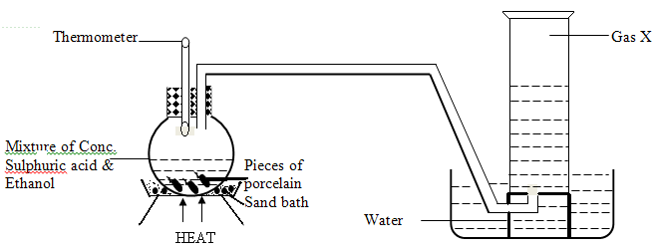

1. Name gas X ( 1mark)

…………………………………………………………………………………………………………………....................................................................................................................................................................

(ii) What is the purpose of the thermometer in the set up above? (1mark)

…………………………………………………………………………………………………………………....................................................................................................................................................................

(iii) Write down the equation that takes place in the flask to produce gas X (1mark)

…………………………………………………………………………………………………………………....................................................................................................................................................................