**NAME …………………………..……………….. DATE …………………………**

**INDEX NO. ……….……….…………………...…..… SIGNATURE ……………..…………..**

**233/1**

**CHEMISTRY PAPER 1**

**(THEORY)**

**TIME: 2 HOURS.**

**SET 5**

*Kenya Certificate of Secondary Education.*

**INSTRUCTIONS TO CANDIDATES.**

1. Write your **NAME** and **INDEX NUMBER** in the space provided above
2. Sign and write the date of examination in the spaces provided above
3. Answer **ALL** the questions in the spaces provided
4. **ALL** working must be clearly shown where necessary.
5. Mathematical tables and silent electronic calculators may be used.
6. This paper consists of 11 printed pages.

Candidates should check to ensure that all pages are printed as indicated and no questions are missing

**FOR EXAMINER’S USE ONLY.**

|  |  |  |
| --- | --- | --- |
| **Question** | **Maximum score** | **Candidate’s score** |
| **1 − 31** | **80** |  |
| **Total score** | **80** |  |

1. The element, Y has an electronic arrangement 2:8:2
2. Give the valency of the element. (1mark)

………………………………………………………………………………………………………………………………………………………………………………………………………………………………

1. What is the likely nature of its chloride? (1mark)

………………………………………………………………………………………………………………………………………………………………………………………………………………………………

1. 1. Briefly explain the preparation of flower extract. (2marks)

………………………………………………………………………………………………………………………………………………………………………………………………………………………………………………………………………………………………………………………………………………………………………………………………………………………………………………………………

* 1. Give the observation when phenolphthalein indicator is added to a solution of sodium hydroxide. (1mark)

………………………………………………………………………………………………………………………………………………………………………………………………………………………………

1. Study the information in the table below and answer the questions that follow. ( the letters do not represent the actual symbols of the elements)

|  |  |  |  |
| --- | --- | --- | --- |
| Element | Electrical conductivity | Ductility | Action of water. |
| A  B  C | Good  Good  Good | Good  Poor  Good | No reaction  No reaction  Reacts |

Select an element which:-

1. Is likely to be in group (II) of the periodic table (1mark)

………………………………………………………………………………………………………………

1. Could be used to make electric cable (1mark)

………………………………………………………………………………………………………………………………………………………………………………………………………………………………

1. Is likely to be graphite. (1mark)

………………………………………………………………………………………………………………………………………………………………………………………………………………………………

1. A balloon can hold 1000cm3 of air before bursting. The balloon contains 975cm3 of air at 50C. Will the balloon burst when it is taken into a house at 250C? Assume that the pressure of the gas in the room remains constant. (2marks)

………………………………………………………………………………………………………………………………………………………………………………………………………………………………………………………………………………………………………………………………………………………………………………………………………………………………………………………………

1. A student set up the following experiment to study the effect of heat on lead (II) nitrate.

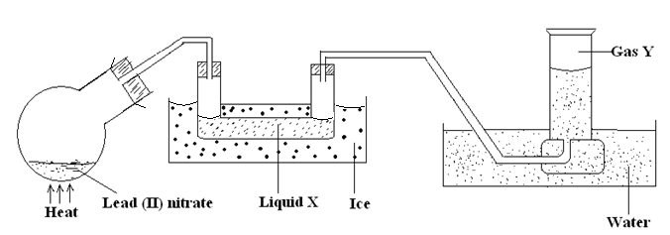

1. Identify liquid X (1mark)

…………………………………………………………………………………………..

1. Describe the chemical test for gas Y. (1mark)

………………………………………………………………………………………….

1. Write the equation for the reaction (1mark)

………………………………………………………………………………………….

1. 1. Write an equation to represent the polymerization of propene.

H H

C = C

H CH3

* 1. Name the polymer formed from it. (1mark)

………………………………………………………………………………………………

1. A student set up an experiment as shown in the diagram below.

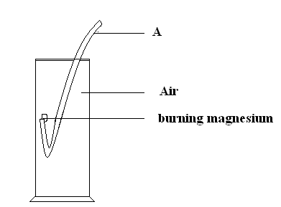

1. Label the apparatus A (1mark)

…………………………………………………………………………………

1. Name the two compounds formed from the above experiment. (1mark)

………………………………………………………………………………..……………………………………………………………………………………..

1. Write the two equations showing the formation of the compounds in (ii) above. (2marks)

…………………………………………………………………………………..…………………………………………………………………………………..

1. Sulphuric (VI) acid, H2SO4 forms two salts of potassium which are potassium hydrogen sulphate and potassium sulphate. With reference to the two salts, what is
2. An acid salt (1mark)

……….…………………………………………………………………………………

1. A normal salt (1mark)

……….…………………………………………………………………………………

1. A hydrocarbon X has molecular mass of 56. On combustion, 0.28g of the hydrocarbon gave 0.88g of carbon (IV) oxide and 0.36g of water. Determine the molecular formular of the hydrocarbon. (3marks)

………………………………………………………………………………………………………………………………………………………………………………………………………………………………………………………………………………………………………………………………………………………………………………………………………………………………………………………………………………………………………………………………………………………………………………………………………………………………………………………………………………………………

1. 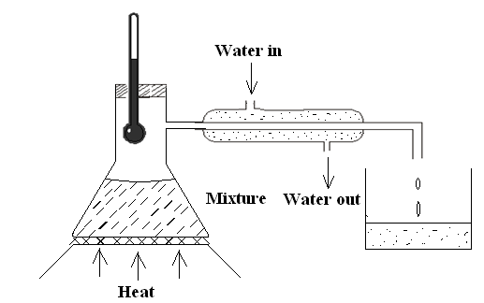 The set up below can be used to separate ethanol from a mixture of ethanol and water.

1. Identify an error in the set up. (1mark)

………………………………………………………………………………………………………………………………………………………………………………………………………………………………

1. Name this method of separation (1mark)

………………………………………………………………………………………………………………………………………………………………………………………………………………………………

1. What properties make it possible to separate ethanol from water by this method? (1mark) ……………………………………………………………………………………………………..………. ………………………………………………………………………………………………..…………….
2. The diagram below shows dry hydrogen being passed over heated copper (II) oxide. Study it and answer the questions that follow.

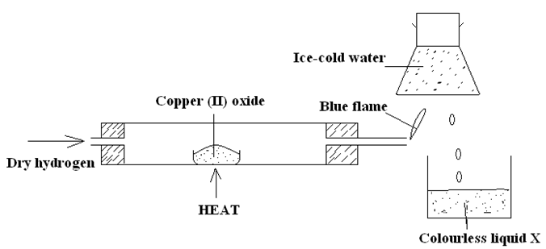

1. State and explain the observation made in the combustion tube in the course of the experiment. (2marks)

………………………………………………………………………………………………………………………………………………………………………………………………………………………………

1. Name the colourless liquid X. (1mark)

………………………………………………………………………………………………………………………………………………………………………………………………………………………………

1. Write the equation taking place in the combustion tube. (1mark)

………………………………………………………………………………………………………………………………………………………………………………………………………………………………

1. Using dot (**.**) and cross (x) diagram illustrate the bonding in the following compounds.
2. Carbon (iv) oxide (C = 6 , O = 8) (1mark)

………………………………………………………………………………………………………………………………………………………………………………………………………………………………

1. Magnesium chloride (Mg = 12, Cl = 17) (1mark)

………………………………………………………………………………………………………………………………………………………………………………………………………………………………

1. Give two reasons why helium is used in weather balloons. (2marks)

……………………………………………………………………………………………………………………………………………………………………………………………..………………………………..

1. A compound J reacted with concentrated sulphuric acid to give a colourless gas K. A solution of gas K in water reacts with zinc metal to give a gas L

Name:- (3mark)

J: ……………………………………………………………………………………..

K: …………………………………………………………………………………….

L: …………………………………………………………………………………….

1. A set up to investigate electrical conductivity of substances was assembled as shown below

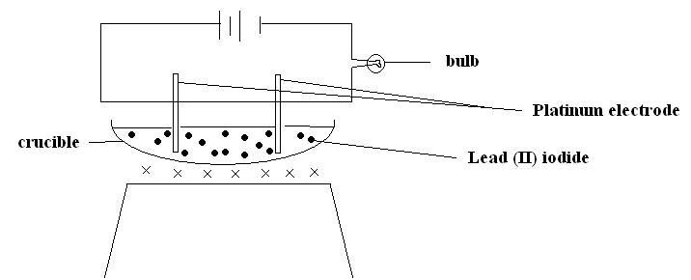

The bulb did not light.

1. What was missing in the set up? (1mark)

…………………………………………………………………………………………………………………………………………………………………………

1. The bulb lit when the omission was corrected. Explain (2marks)

………………………………………………………………………………………………………………………………………………………………………………………………………………………………

1. Use the scheme below to answer the questions that follow.

Solid H

CO2

Solid J

Ca (OH)2

H2O

1. Identify the solid
   * 1. H…………………………………………………… (1mark)
2. J……………………………………………………. (1mark)
3. State one laboratory use of Ca(OH)2 (1mark)

………………………………………………………………………………………..…………………………………………………………………………………………………………………………………..

1. Study the flow chart below and answer the questions that follow :-

Solid

C

Green Solution in Excess

Green PPT

Gas B

A

Heat

HCl(aq)

Sulphur

Excess

NaOH (aq)

Identify (3marks)

1. Solid C

………………………………………………………………………..

1. Gas B

………………………………………………………………………..

1. Substance A

………………………………………….…………………………….

1. An anhydrous salt Q (relative formula mass=125) combines with water to form hydrated salt Q. XH2O. It is found that 50g of Q combine with 36g of water. Find the value of X. (2marks)

………………………………………………………………………………………………………………………………………………………………………………………………………………………………………………………………………………..……………………………………………………………………………………..……………………………………………………………………………………………………………………………………………………………………..……………………………

1. Compound R is a solid with giant ionic structure. In what forms would the compound conduct an electric current? (1mark)

………………………………………………………………………………………………………………………………………………………………………………………………………………………………

1. Study the flow chart below and answer the question that follow:-

Solid P

Black Powder

Q

+

A gas that turns lime water to white precipitate

CuSO4

Dilute sulphuric

Acid

Heat

Give the chemical formula of:-

1. Solid P …………………………………………………….. (1mark)
2. Powder Q ………………………………………………………. (1mark)
3. 30cm3 of 0.5M hydrochloric acid was used to neutralize 25cm3 of sodium hydroxide solution. Determine the concentration of sodium hydroxide in grams per litre.

(H=1, O = 16, Na = 23) (2marks)

…………………………………………………………………………………………………………………………………………………………………………………..……..……………………………………………………………………………………………………………………………………………………

…………………………………………………………………………………………………………………………………………………………………………………..……..……………………………………………………………………………………………………………………………………………………

1. The metal X, Y and Z forms oxides XO, YO, and ZO. Hot powdered Y will remove oxygen from XO but not from ZO. Arrange the metals in order of reactivity starting with the most reactive. (1mark)

………………………………………………………………………………………………………………………………………………………………………………………………………………………………………………………………………………………………………………………………………………

1. The table below shows atomic numbers of four elements W, X, Y and Z.

|  |  |  |  |  |
| --- | --- | --- | --- | --- |
| Element | W | X | Y | Z |
| Atomic number | 20 | 17 | 19 | 9 |

1. Write the electron arrangement of the ion of Z. (1mark)

………………………………………………………………………………………………………………………………………………………………………………………………………………………………

* 1. What is the formula of the compound formed between W and X. (1mark)

………………………………………………………………………………………………………………………………………………………………………………………………………………………………

* 1. Name the bond and structure of the compound in b(i) above. (1mark)

………………………………………………………………………………………………………………………………………………………………………………………………………………….…………

1. Hydrogen sulphide gas is bubbled through bromine water.
   1. Give two observations made. (1mark)

………………………………………………………………………………………………………………………………………………………………………………………………………………………………

* 1. Write the equation for the reaction taking place. (1mark)

………………………………………………………………………………………………………………………………………………………………………………………………………………………………

* 1. State the chemical test for hydrogen suphide. (1mark)

………………………………………………………………………………………………………………………………………………………………………………………………………………………………

1. An oxide of copper in a porcelain boat was reduced by a stream of hydrogen. The results obtained were as follows.

Mass of porcelain boat = 4.5g

Mass of boat + oxide = 6.4g

Mass of boat + copper = 6.02g

1. Determine the empirical formula of the oxide (Cu = 64, O = 16) (2marks)

………………………………………………………………………………………………………………………………………………………………………………………………………………………………

………………………………………………………………………………………………………………………………………………………………………………………………………………………………

1. If the relative formula mass of the oxide is 80, determine its molecular formula. (1mark)

…………………………………………………………………………………………………………………………………………………………………………………………………………...………………….

1. The set up below shows the preparation of ammonia in the laboratory.

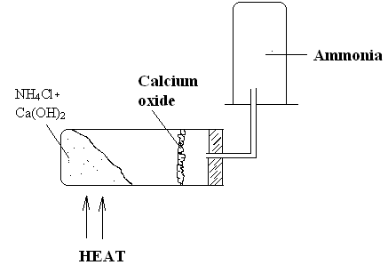

* 1. Write the equation for the reaction that takes place in the boiling tube. (1mark)

………………………………………………………………………………………………………………………………………………………………………………………………………………………………

* 1. What is the purpose of the calcium oxide? (1mark)

………………………………………………………………………………………………………………………………………………………………………………………………………………………………

* 1. Explain the method used to collect the gas. (1mark)

………………………………………………………………………………………………………………………………………………………………………………………………………………………………

1. The diagram below shows a set up for the laboratory preparation of dry chlorine.

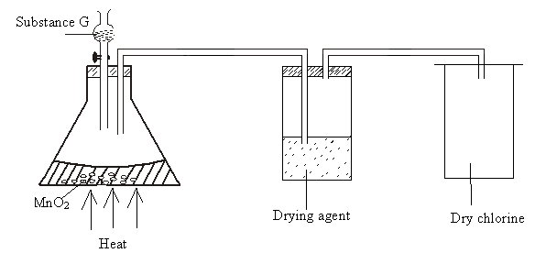

1. Name
   1. Substance G ……….……………………………………………. (1mark)
   2. Suitable drying agent……………………………………………. (1mark)
2. What property of chlorine makes it be collected as shown in the diagram. (1mark)

……………………………………………………………………………………………………………………………………………………………………………………………………………………………………………………………………………………………………………………………………………………………………………………………………………………………………………………………………………………………………………………………………………………………………………………………………………………………………………………………………………………..………