**Name:…………………………………………………….…… Adm.no ……….............................**

**School:…………………………………………………..……… Class………………………………..**

**Candidate’s sign……………….… Date :…………………………………**

**233/1**

**CHEMISTRY**

**PAPER 1**

**(THEORY)**

**TIME: 2 HOURS**

**SET 2**

***Kenya Certificate of Secondary Education(K.C.S.E.)***

**INSTRUCTIONS TO CANDIDATES:**

* Write your **name** and **index number** in the spaces provided above.
* Sign and write the date of the examination in the spaces provided above.
* Answer **all** the questions in the spaces provided in the question paper.
* Mathematical tables and electronic calculators may be used for calculations.
* All workings **must** be clearly shown where necessary

**For Examiner’s Use only.**

|  |  |  |
| --- | --- | --- |
| **QUESTION** | **MAXIMUM SCORE** | **CANDIDATE’S SCORE** |
| 1 – 28 | **80** |  |

*This paper consists of 11 printed pages. Candidates should check to ascertain that all pages are printed as indicated and that no questions are missing.*

1. An element **W** has atomic number 13 while element **V** has atomic number 8

(i) Write the electron arrangement for **W** ( ½ mk)

**W**………………………………………………………………………………………………………

**V**……………………………………………………………………………………………………….

(ii) Write the formula of the compound formed when **W** and **V** react ( 1mk)

………………………………………………………………………………………………………

(iii) What type of bond would be present in the compound formed in (ii) above (1mk)

………………………………………………………………………………………………………

2. In the industrial preparation of oxygen state:

(a) how dust particles are removed from air (1mk)

………………………………………………………………………………………………………

(b) How carbon (IV) oxide is removed before the mixture is cooled to -25oC (1mk)

………………………………………………………………………………………………………

(c) Why is the mixture cooled to -25oC? (1mk)

……………………………………………………………………………………………………

3. The set up below was used to prepare and collect ethyne gas

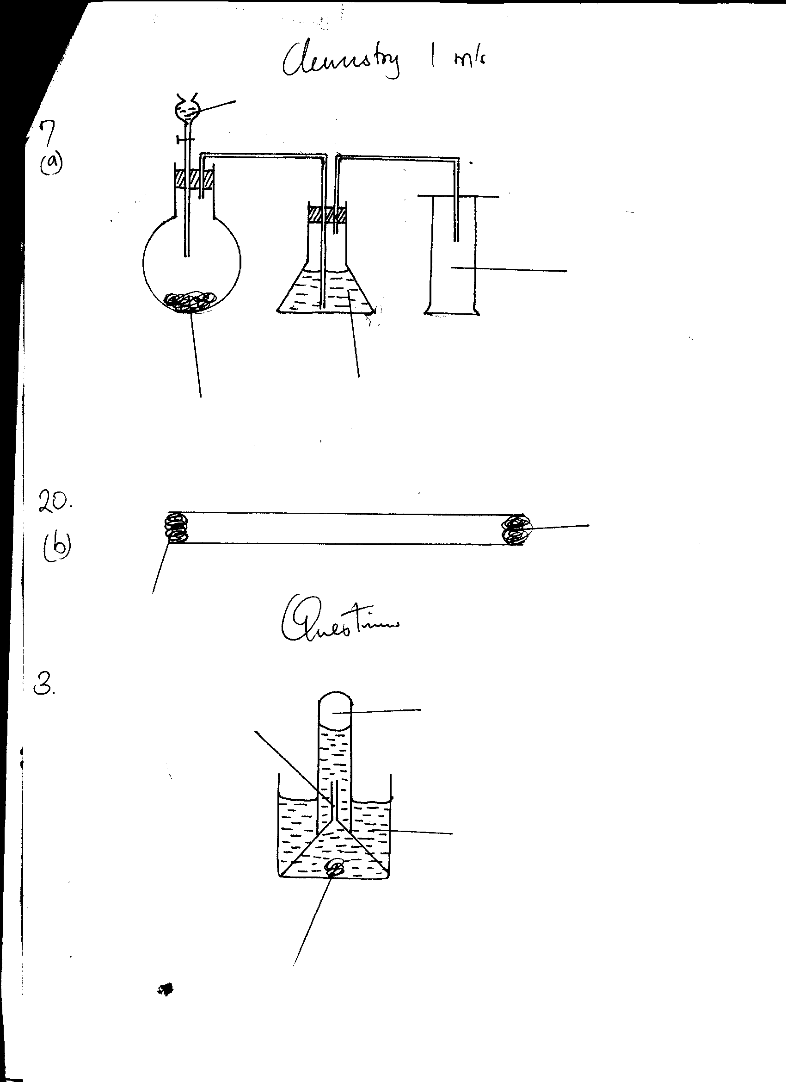

**Ethyne**

**Inverted funnel**

**Water**

**Calcium carbide**

(i) Write a well balanced equation for the reaction that produced ethyne (1mk)

………………………………………………………………………………………………………

(ii) At the end of the experiment the gas was collected in a test tube and burnt in air. Describe the flame observed. (1mk)

…………………………………………………………………………………………………………

(iii) Give one Industrial use of ethyne (1mk)

……………………………………………………………………………………………………

4. A gas occupies 400cm3 at 500k and 1 atmospheric pressure. What will be the temperature when the volume and pressure of the gas were 100cm3 and 0.5 atm respectively. (2mks)

5. Solutions **R S** and **T** have PH values shown below

**Solution PH value**

**R** 2.0

**S** 6.5

**T** 8.5

(a) What is the nature of solution **R** ? (1mk)

…………………………………………………………………………………………………………

(b) Which solution would react most vigorously with sodium hydrogen carbonate? (1mk)

………………………………………………………………………………………………………….

(c) Which solution is likely to be ammonia solution? (1mk)

………………………………………………………………………………………………………….

6. Hydrated Copper (II) Sulphate exists as blue crystals and anhydrous Copper (II) Sulphate is a white powder. Describe a laboratory experiment that can be used to show that the action of heat on hydrated Copper (II) Sulphate is a reversible reaction (3mks)

………………………………………………………………………………………………………….

………………………………………………………………………………………………………….

………………………………………………………………………………………………………….

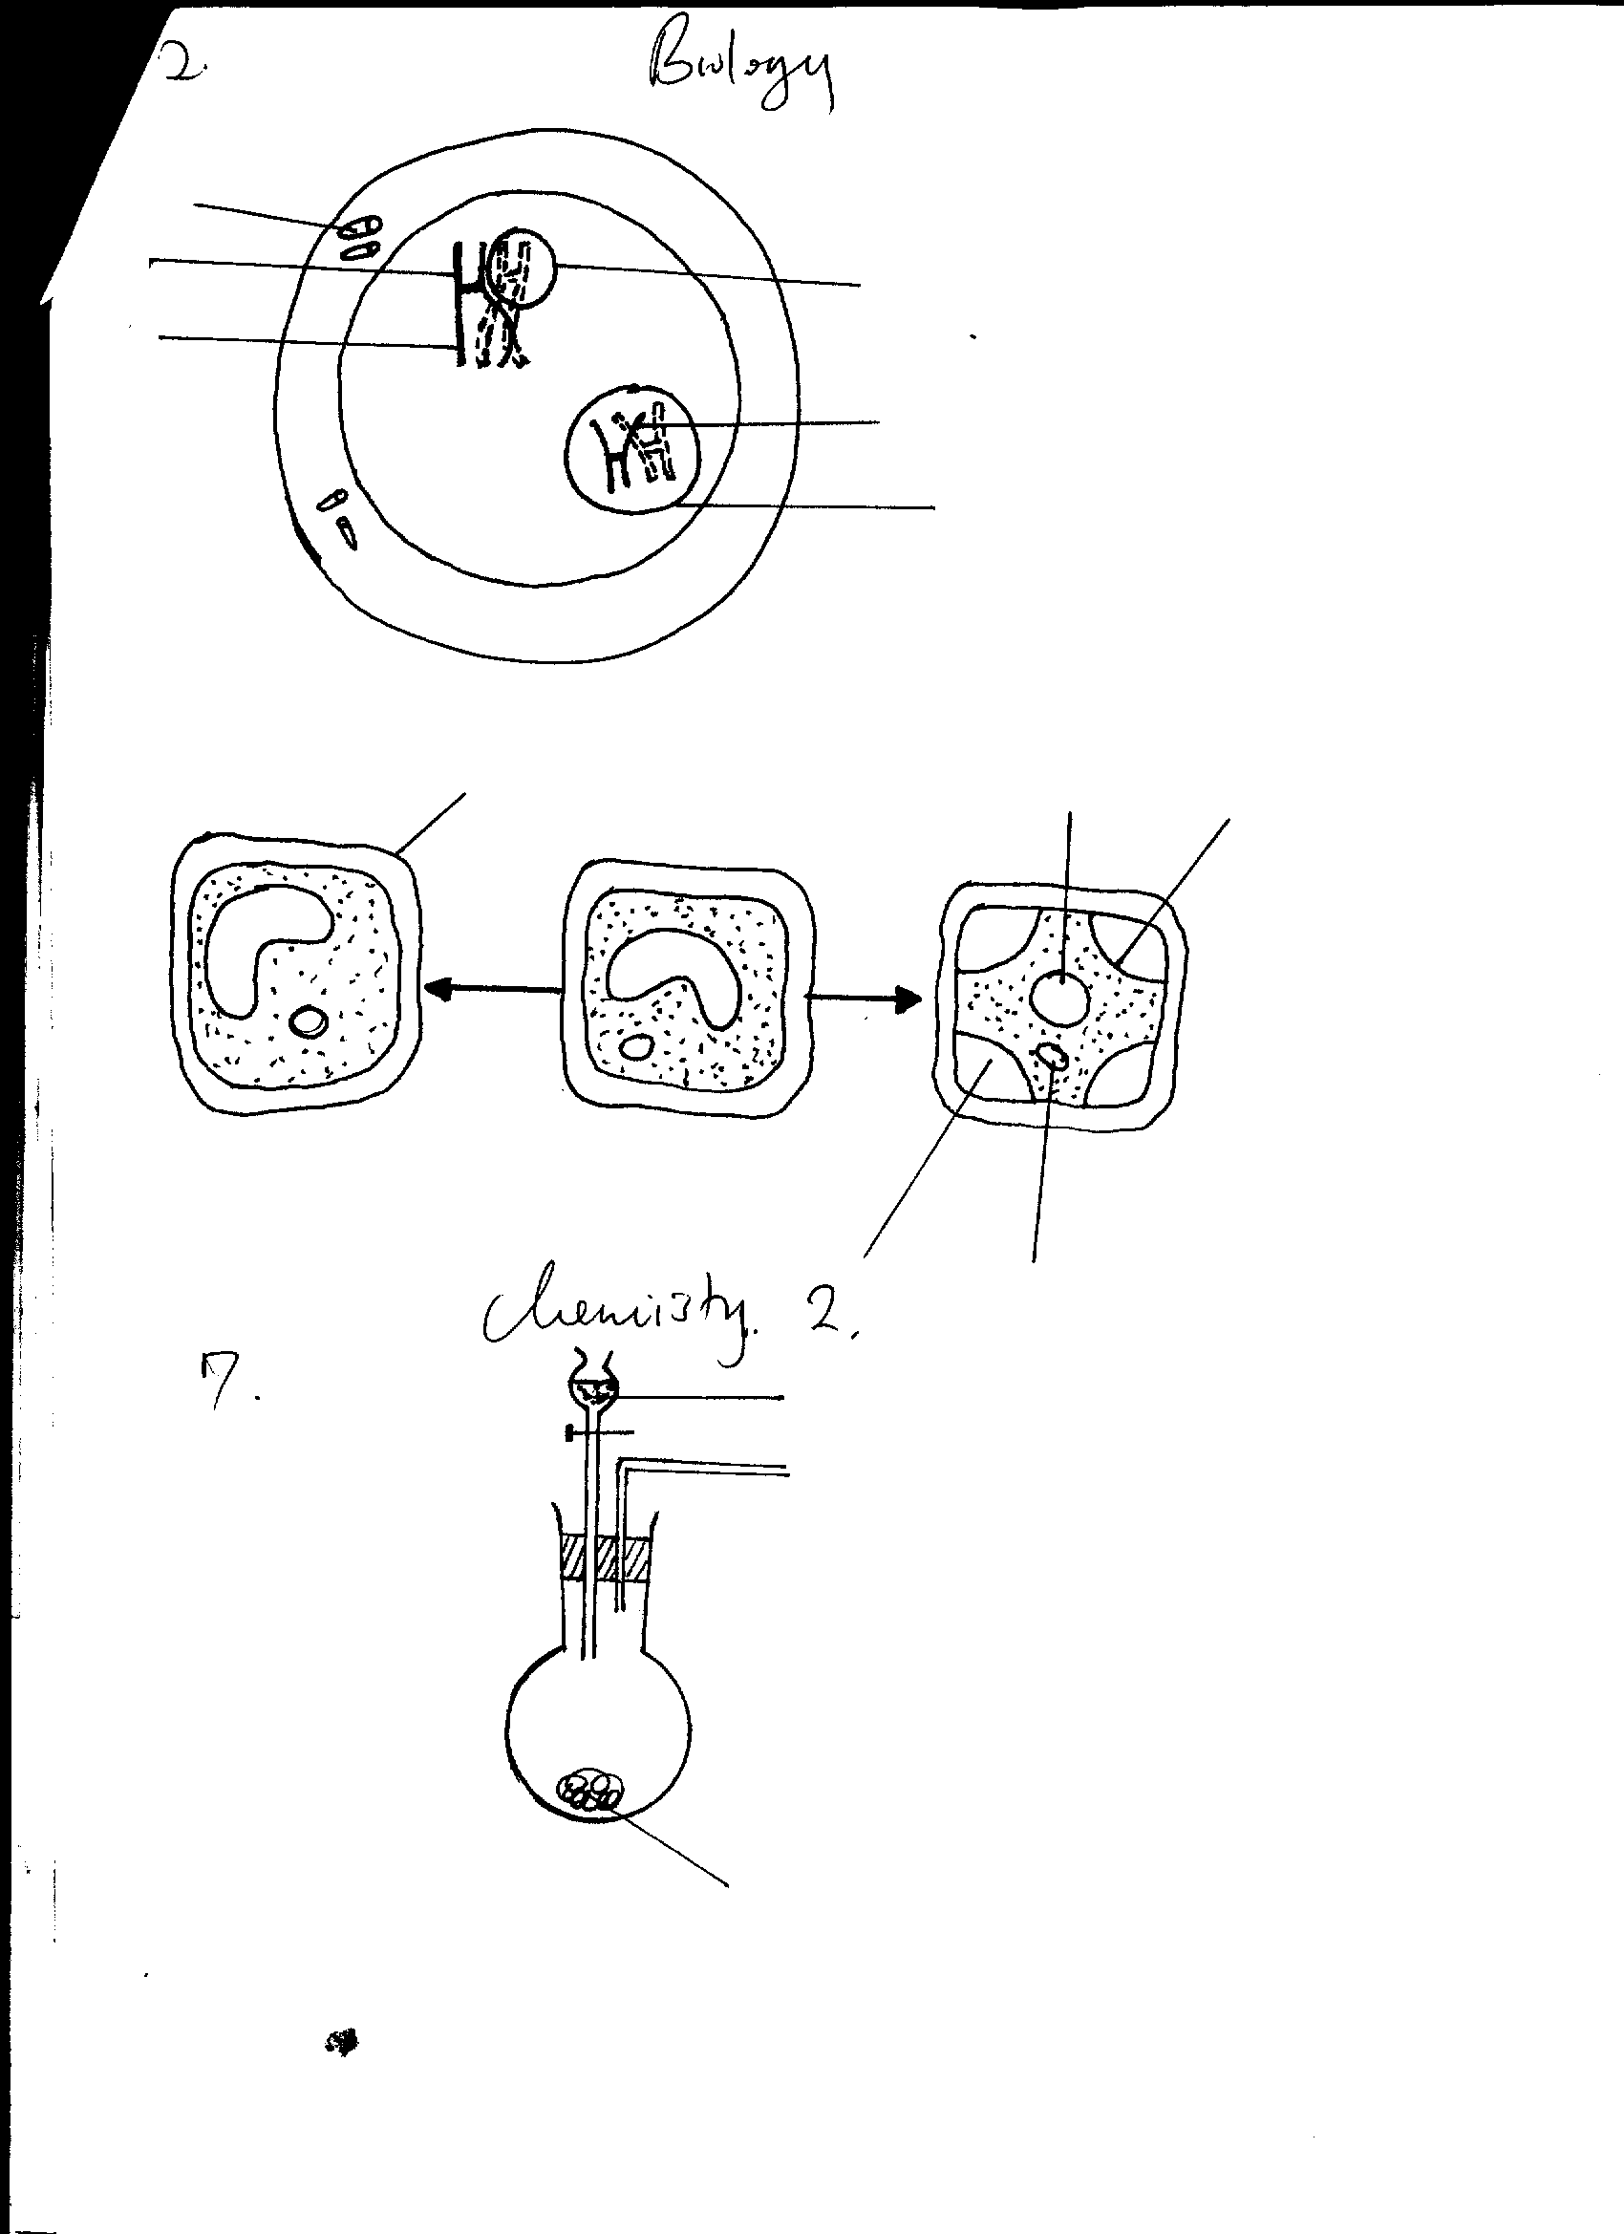7. The diagram below was used to prepare Sulphur (iv) Oxide gas in the laboratory.

**Dilute HCl**

**Reagent R**

(a)Complete the diagram to show how dry Sulpur (iv) oxide gas may be collected. (2mks)

………………………………………………………………………………………………………….

………………………………………………………………………………………………………….

(b)Name reagent **R** (1mk)

………………………………………………………………………………………………………….

8. (a) What is Isomerism? (1mk)

………………………………………………………………………………………………………….

(b) Draw and name **two** isomers of C5H12 (2mks)

9. Study the information given below and answer the questions that follow. The letters are not actual symbols for the elements

Element electronic configuration ionization Energy kJ/mol

**P** 2,1 519

**Q** 2,8,1 494

**R** 2,8,8,1 418

(i) What is the general name given to the group in which elements **P,Q** and **R** belong? (1mk)

………………………………………………………………………………………………………….

(ii) What is ionization energy? (1mk)

………………………………………………………………………………………………………….

(iii) Explain why element **R** has the lowest ionization energy. (1mk)

………………………………………………………………………………………………………….

10. When a compound **Y** is heated, a dark brown gas is evolved and a residue which is yellow when hot and white on cooling is left

Identify

(a) the brown gas

………………………………………………………………………………………………………….

(b) the ions present in the residue (1mk)

………………………………………………………………………………………………………….

(c) the compound **Y** (1mk) ………………………………………………………………………………………………………….

11. An organic compound contains 24.4%, carbon 4.04% Hydrogen and the rest Chlorine. (C=12, H=1 Cl=35.5)

(a)Determine the empirical formula of the organic compound. (2mks)

………………………………………………………………………………………………………….

………………………………………………………………………………………………………….

………………………………………………………………………………………………………….

(b) If the relative molecular formula of the compound is 99. Find its molecular formula. (1mk)

………………………………………………………………………………………………………….

………………………………………………………………………………………………………….

12. The diagram below represents bonds in hydroxonium ion

+

H

H

O

E

F

H

(i)Name the type of bond represented **E** and **F** (2mks)

**E**……………………………………………………………

**F**……………………………………………………………

(ii) Explain how bond type represented by **F** is formed. (1mk)

………………………………………………………………………………………………………….

13. 0.24g of divalent metal **M** dissolves in 50cm3 of 0.25M Sulphuric (vi) acid the resulting solution required 10.0cm3 of 0.5M Sodium hydroxide to neutralise excess acid. Determine the relative atomic mass of M (3mks)

14. The table below gives some physical properties of some elements of the periodicd table

|  |  |  |  |  |  |
| --- | --- | --- | --- | --- | --- |
| Element | Si | P | S | Cl | Ar |
| Melting point (oc) | 1410 | 44.2  590 | 113  119 | -101 | -189 |
| Melting point (oc) | 2360 | 280 | 444 | -347 | -186 |

Explain the following

(a)The boiling and melting point of Silicon (Si) is very high (2mks)

…………………………………………………………………………………………………………

(b) Sulpur (**S**) and Phosphorous (**P**) have two values for the melting points (1mk)

………………………………………………………………………………………………………….

15. The diagram below shows a set up that can be used to prepare ethene gas

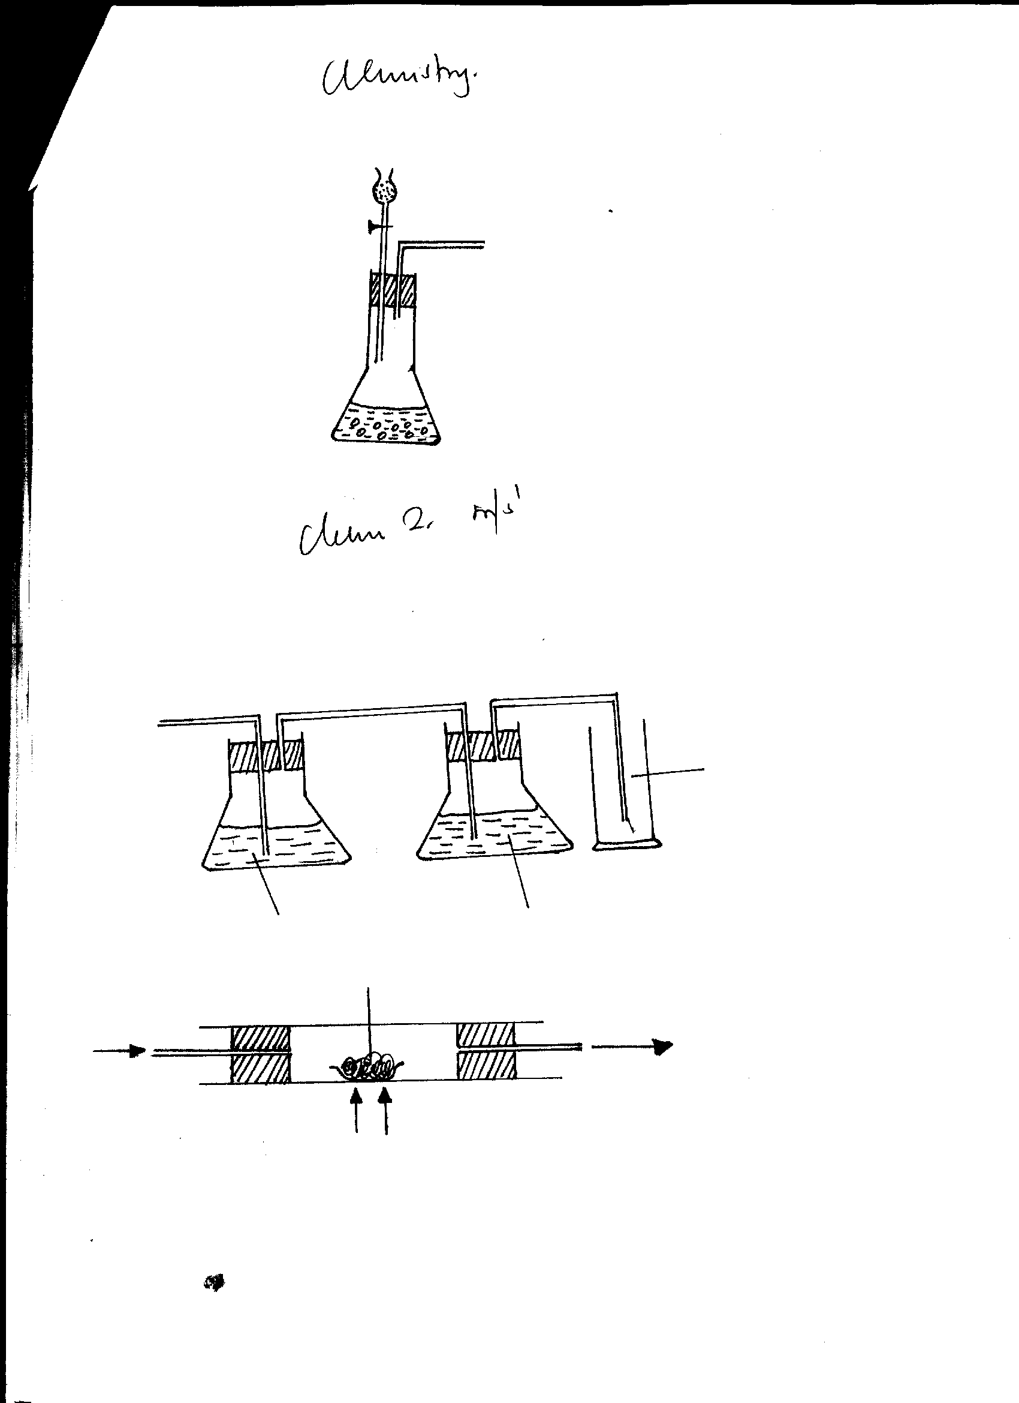

**Solid K**

**Heat**

**ethene**

**Ethanol**

**Vapour**

(i)Suggest the identity of solid **K** (1mk)

………………………………………………………………………………………………………….

(ii) Describe a chemical test that can be used to distinguish between ethene and ethane (2mks)

………………………………………………………………………………………………………….

………………………………………………………………………………………………………….

16. Describe how a pure sample of solid Copper (II) Sulphate would be prepared starting with Copper metal. (3mks)

………………………………………………………………………………………………………….

………………………………………………………………………………………………………….

………………………………………………………………………………………………………….

………………………………………………………………………………………………………….

17. (a) State Graham’s law (1mk)

………………………………………………………………………………………………………….

………………………………………………………………………………………………………….

(b) Calculate the time taken for a given volume of methane (CH4) gas to diffuse through a small hol. If the same volume of Sulphur (iv) oxide SO2 under the same conditions take 100 seconds (C=12, O=16, S=32, H=1) (2mks)

18. But-2-ene undergoes hydrogenation as shown by the equation below

CH3CH=CHCH3(g) + H2(g)  CH3CH2CH2CH3(g)

(a)Name the product formed when But-2-ene reacts with hydrogen gas (1mk)

………………………………………………………………………………………………………….

(b) State the conditions necessary for the above reaction. (1mk)

………………………………………………………………………………………………………….

(c) Give **one** industrial use of hydrogenation (1mk)

………………………………………………………………………………………………………….

19. Explain why burning Magnesium continues to burn when lowered into a gas jar full of Carbon (iv) oxide whereas a burning splint would be extinguished (2mks)

………………………………………………………………………………………………………….

………………………………………………………………………………………………………….

20. Study the set up below and answer the questions that follow

**Cotton wool soaked in**

**Conc HCl**

**Cotton wool soaked**

**in Conc ammonia**

**Glass tube**



**Cork**

(a)What observation would be made in the tube (1mk)

………………………………………………………………………………………………………….

(b) Indicate with a cross **(x)** on the diagram the likely position where the observation stated in (a) above would be made (1mk)

(c) Give an explanation for your answer in (b) above (1mk)

………………………………………………………………………………………………………….

21. The equation below represents the reaction in which ethane burns in Oxygen

C2H4(g) + 3O2(g)  2CO2(g) + 2H2O(g)

Calculate the volume at stp of carbon (iv) oxide formed if 1.4 g of ethane are completely burnt in oxygen (C=12, O=16 M.G.V=22.4dm3 at stp) (3mks)

22. The table below gives information about the electrical conductivity and the likely bonding in substances **N P** and Q. Complete the table by inserting the missing information in the spaces. (3mks)

|  |  |  |  |
| --- | --- | --- | --- |
| **Substance** | **Likely type of bonding present** | **Electrical**  **Solid** | **Conductivity**  **Liquid** |
| **N** | Metallic | (i)……………………….. | Conducts |
| **P** | (ii) …………………… | Does not conduct | Conducts |
| **Q** | (iii)……………………. | Does not conduct | Does not conduct |

23. When concentrated Sulphuric (vi) acid reacts with sodium chloride, a gas K is produced. This gas is dissolved in water as shown below.

**Funnel**

**Distilled water**

**Gas K**

(a) Name gas **K** (1mk)

………………………………………………………………………………………………

(b) Give **two** reasons why the funnel is used in the set up (1mk)

(i)……………………………………………………………………………

(ii)……………………………………………………………………………

24. A mixture contains ammonium chloride, copper (ii) oxide and sodium chloride. Describe how each of the substances can be obtained from the mixture (3mks)

………………………………………………………………………………………………………….

………………………………………………………………………………………………………….

………………………………………………………………………………………………………….

25. Study the table below and answer the questions that follow. The letters are not actual symbols for the elements

|  |  |  |  |
| --- | --- | --- | --- |
| **Element** | **Protons** | **Electrons** | **Neutrons** |
| **V** | 18 | 18 | 22 |
| **W** | 17 | 18 | 18 |
| **X** | 19 | 19 | 20 |
| **Y** | 9 | 8 | 10 |
| **Z** | 19 | 19 | 22 |

**Identify**:- (3mks)

1. a cation

………………………………………………………………………………………………………….

1. an anion

………………………………………………………………………………………………………….

1. a pair of isotopes

………………………………………………………………………………………………………….

26. The diagram below represents the industrial extraction of Sulphur

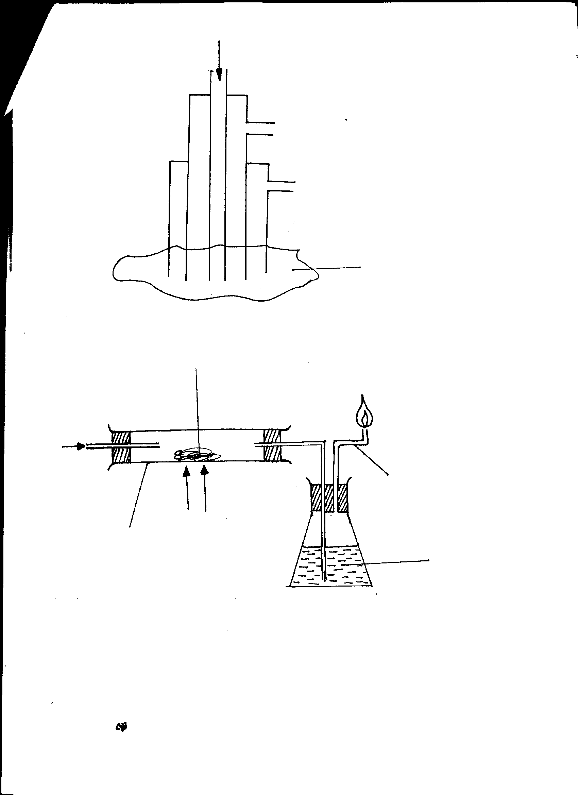

**Hot compressed air**

**Tube I**

**Tube II**

**Sulphur bed**

(a) Give the name of the process represented above (1mk)

…………………………………………………………………………………………………

(b) Name the substances that pass through tube (½ mk)

**I** ………………………………………………………………………………………………

**II** ……………………………………………………………………………………….… (½ mk)

(c) What is the purpose of hot compressed air in this process? (1mk)

………………………………………………………………………………………………………….

27. In an experiment, ammonia gas was prepared by heating a mixture of an ammonium salt and an alkali.

(a) Name **one** alkali and one ammonium salt that can be mixed to produce ammonia gas

Ammonium Salt………………………………………………………………………… ( ½ mk)

Alkali ……………………………………………………………………………… ( ½ mks)

(b) Name the drying agent that can be used to dry the ammonia gas (1mk)

………………………………………………………………………………………………………….

………………………………………………………………………………………………………….

………………………………………………………………………………………………………….

(c) State **two** uses of ammonia gas (1mk)

………………………………………………………………………………………………………….

………………………………………………………………………………………………………….

………………………………………………………………………………………………………….

28. The apparatus shown below was used to investigate the effect of Carbon (II) Oxide on heated Copper (II) Oxide.

**Lime water**

**Tube K**

**Flame**

**Copper (II) Oxide**

**Combustion tube**

**HEAT**

**CO(g)**



(a) State the observation that was made in the combustion tube (1mk)

………………………………………………………………………………………………………….

………………………………………………………………………………………………………….

(b) Write an equation for the reaction that took place in the combustion tube (1mk)

………………………………………………………………………………………………………….

………………………………………………………………………………………………………….

(c) Why it is necessary to burn the gas coming out of tube **K**? (1mk)

………………………………………………………………………………………………………….

………………………………………………………………………………………………………….