NAME: ………………………………………………… ADM. NO: …………………..………………
SCHOOL ……………………………………………… DATE: ………………………………….…….
CANDIDATE’S SIGNATURE……………………..…

233/1
CHEMISTRY
PAPER 1
THEORY
TIME: 2 HOURS

SET 1

Kenya Certificate of Secondary Education (K.C.S.E)

INSTRUCTIONS TO CANDIDATES:

- Write your name school and index number in the spaces provided above.
- Sign and write the date of examination in the spaces provided above.
- Answer all the questions in the spaces provided below each question.
- Mathematical tables and electronic calculators may be used
- All working MUST be clearly shown where necessary.

For Examiner’s Use Only
Question | Maximum score | Candidate’s score
1-28 | 80

This paper consists of 11 printed pages. Candidates should check to ascertain that all pages are printed as indicated and that no questions are missing.

1. Identify and state the use of the apparatus represented below. (2 marks)
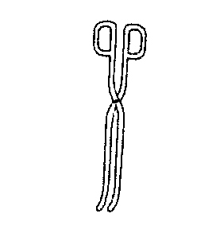
Name……………………………………………………………………
Use………………………………………………………………………
2. Give the systematic name of each of the compounds represented by the formulae below.
(3 marks)
(a) CH₃C≡CCH₃
……………………………………………………………………………………………..
(b) CH₃CH=CHCH₂CH₃
……………………………………………………………………………………………..

3. A fixed mass of a gas occupies 105cm³ at -14 ºC and 650mmHg. At what temperature will it have a volume of 15cm³ if pressure is adjusted to 690mmHg? (3marks)

4. a) Using dots (.) and crosses (x) to represent electrons, show the bonding in the compounds formed between magnesium and fluorine. (Atomic numbers; Mg= 12, F=9) (1 mark)

b) State one likely physical property of the compound formed between magnesium and
fluorine in (a) above. (1 mark)

5. A set-up to investigate electrical conductivity of substances was assembled as shown below.
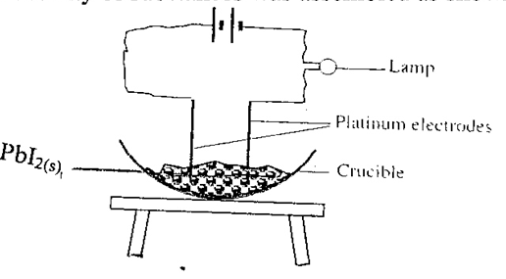
The bulb did not light.
(a) What was missing in the set-up? (1 mark)
……………………………………………………………………………………………………
(b) The bulb lit when the omission was corrected. Explain. (2 marks)
……………………………………………………………………………………………………
……………………………………………………………………………………………………
6. An oxide of copper in a porcelain boat was reduced by a stream of hydrogen. The results obtained were as follows;
Mass of porcelain boat = 4.5g
Mass of boat + Oxide = 6.40g
Mass of boat + Copper = 6.02 g
- Determine the empirical formula of the oxide. (3 marks)

ii) If the relative formula mass of the oxide is 80, determine its chemical formula.
(Cu = 64, O = 16) (1 mark)

7. Starting with copper metal, describe how to prepare solid copper (II) carbonate. (3 marks)
…………………………………………………………………………………………………
…………………………………………………………………………………………………
8. The diagram below shows a ‘jiko’ when in use. Study it and answer the questions that follow
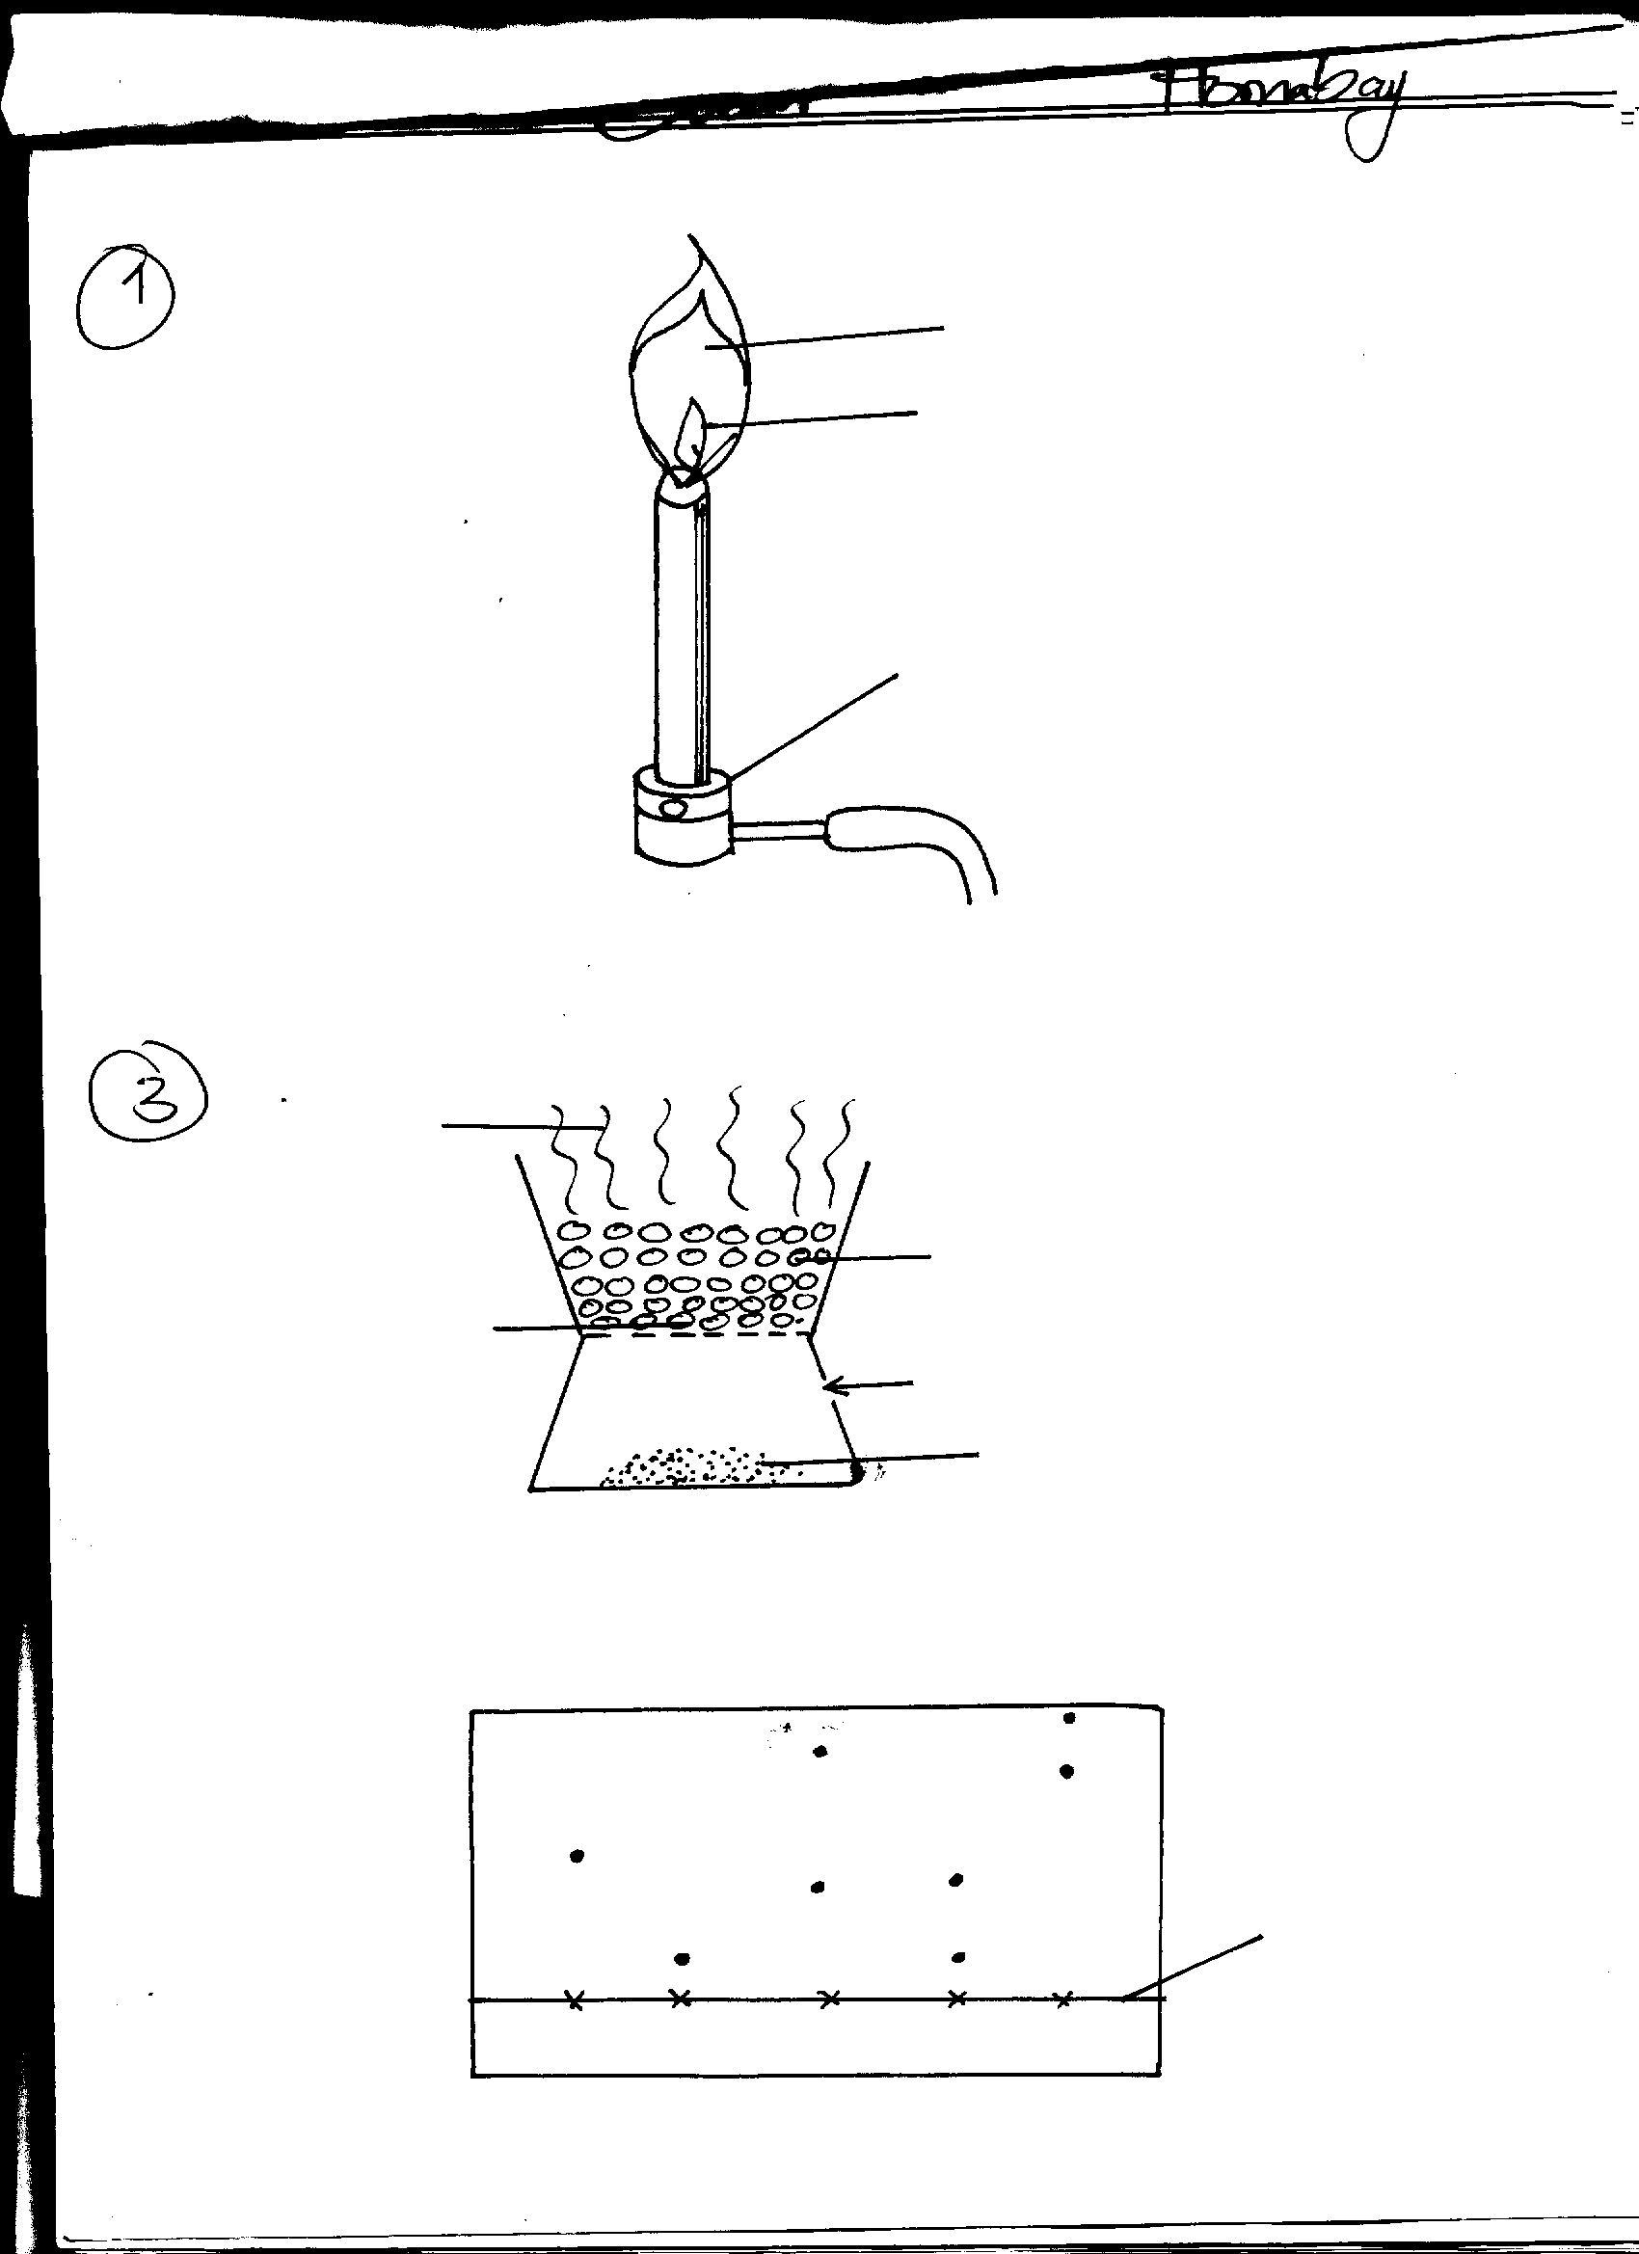
Region B
Region A
Burning charcoal
Air
Ash

(a) Identify the gas formed at region B (1mk)
……………………………………………………………………………………………
……………………………………………………………………………………………
(b) State and explain the observation made at region B (2mks)
…………………………………………………………………………………

9. A student set up the following experiment to study the effect of heat on lead (II) nitrate.
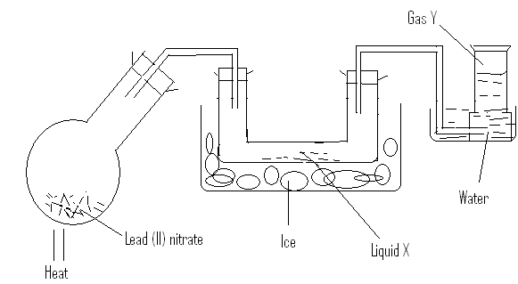
i)Identify liquid X (1 mark)
………………………………………………………………………………………………………
ii)Describe the test for gas Y. (1 mark)
………………………………………………………………………………………………………
………………………………………………………………………………………………………
iii)Write a balanced chemical equation for the reaction. (1 mark)
………………………………………………………………………………………………………
10. The set-up represented below can be used to separate ethanol from its mixture with water.

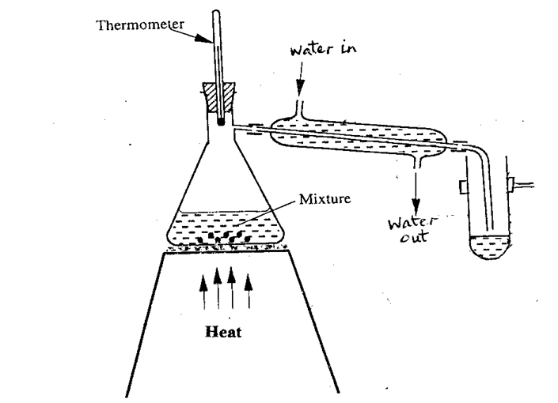

(a) Identify an error in the set-up. (1 mark)
……………………………………………………………………………………………………
(b) Name this method of separation. (1 mark)
……………………………………………………………………………………………………
(c) What properties make it possible to separate ethanol from water by this method? (1 mark)
……………………………………………………………………………………………………
……………………………………………………………………………………………………

11. Describe how to distinguish between substances I and II .
(3 marks)
I.CH₃CH₃ II. HCCCH₃
……………………………………………………………………………………………………
……………………………………………………………………………………………………
……………………………………………………………………………………………………
……………………………………………………………………………………………………
12. Element K has two isotopes ²⁰K and ²²K with relative abundance of 90% and 10% respectively.
a) What are isotopes? (1 mark) ……………………………………………………………………………………………………………………………………………………………………………………………………
b) Determine the relative atomic mass of element K. (2 marks)

13. Give one application of calcium oxide. (1 mark)
……………………………………………………………………………………………………
……………………………………………………………………………………
14. Consider the diagram below.
a
b

c

Name the regions labeled a, b, c. (3 marks)

a ……………………………………………………………………….
b ……………………………………………………………………….
c ……………………………………………………………………….

15. State one use of:
a) Calcium nitrate (1 mark)
……………………………………………………………………………………………….
b) Magnesium hydroxide (1 mark)
……………………………………………………………………………………

16.. Some moist iron wool was placed in a test tube and the tube was inverted and set up as shown below.

x cm
y cm

The apparatus was left for one week. The water level rose and iron wool turned red-brown.

(i) Write the chemical equation to show the rusting of iron. (1 mark)
……………………………………………………………………………………………………………………………….
(ii) Write the expression for an approximate percentage. (1 mark)
……………………………………………………………………………………………………………………………….

(iii) State two similarities between rusting and combustion.
(a) …………………………………………………………………………………………..(1 mark)
(b) …………………………………………………………………………………………..(1 mk)

17. Sulphur burns in air to form a gaseous product.
i) What is the colour of the flame of burning sulphur? (1 mark)
………………………………………………………………………………………………………
ii) Give an equation for the reaction that takes place when the gaseous product is bubbled through water. (1 mark)
………………………………………………………………………………………………………
iii)State one importance of the product formed in 17(ii) above. (1 mark) ………………………………………………………………………………………………………

18. The _{P}H values of some solutions labeled E to I are given in the table below. Use the information to answer the questions that follow.

_{P}H | 14.0 | 1.0 | 8.0 | 6.5 | 7.0
Solution | E | F | G | H | I

- Identify the solution with the highest concentration of hydroxide ions. Give a reason for your answer. (2 marks)

_______________________________________________________________________

_______________________________________________________________________

_______________________________________________________________________
- Which solution can be used as a remedy for acid indigestion in the stomach?(1 mark)

_________________________________________________________________

19. Four metals are labeled P, Q, R and S (not actual symbols). Metal P displaces metal S from its oxide but cannot displace R from its oxide. Q when mixed with the oxide of R and heated, a reaction occurs.
Arrange the metals in order of reactivity, starting with the most reactive. (2 marks)
………………………………………………………………………………………………………
20. A certain element Y has atomic number 15 and mass number of 31.
(a) Calculate the number of neutrons in the element. (1mk)

_______________________________________________________________________

(b) Write the electron arrangement of the ion formed by element Y. (1mk)

_________________________________________________________________

- How would the atomic size of the above element compare with another atom X whose atomic number is 11 and mass number 23? Explain. (1mk)

_______________________________________________________________________

_______________________________________________________________________

21. The table below shows the first ionisation energies of elements P and Q.
Element | 1st Ionisation energy kJ/mole
P  Q | 494  418
a)What do these values suggest about the reactivity of P compared to that of Q? Explain. (2 marks)
………………………………………………………………………………………………………………………………………………………………………………………………………………………………………………………………………………………………
- State two factors that influence ionization energy. (1 mark)
………………………………………………………………………………………………………………………………………………………………………………………………

22. Steam is passed over heated iron filings in a combustion tube.
(a) Name the products of this reaction. (2 mark)
………………………………………………………………………………………………………
………………………………………………………………………………………………………
(b) Write an equation for the reaction that occurs. (1 mark)
- ……………………………………………………………………………………………………… Diamond and graphite are allotropes of carbon.
- What are allotropes? (1mk)
……………………………………………………………………………………………
……………………………………………………………………………………………In terms of structure and bonding explain why diamond is used in drilling through hard rocks while graphite is a lubricant (2mks)
………………………………………………………………………………….…………
……………………………………………………………………………………………

24. 30cm³ of 0.5M hydrochloric acid was used to neutralize 25cm³ of sodium hydroxide solution. Determine the concentration of sodium hydroxide in grams per litre. (3 marks)
(H=1, O=16, Na= 23)

- The table below gives some information about the physical properties of four substances which are represented by letters. L M N and K.

Substance | Melting point | Heat of vaporization | Electrical Conductivity  Solid molten
L  M  N  K | High  High  High  Low | High  High  High  Low | Poor  Good  Poor  Poor | Poor  Good  Good  Poor

Select with reasons an element which is likely to be:
- Copper metal (1mk)
……………………………………………………………………………………………
……………………………………………………………………………………………Silicon (iv) oxide (1mk)
……………………………………………………………………………………………
……………………………………………………………………………………………Potassium iodide (1mk)
…………………………………………………………………………………………….
26. a) Write balanced chemical equations for reactions between chlorine and; (2 marks)
i) Concentrated sodium hydroxide
……………………………………………………………………………………………………
ii) Dilute sodium hydroxide.
……………………………………………………………………………………………………
b) State one observation made when a gas jar of moist hydrogen sulphide is inverted over a gas jar of dry chlorine gas. (1 mark)
……………………………………………………………………………………………………
27.a) Hydrogen sulphide gas is bubbled through bromine water.
i) Give two observations made. (1 mark)
……………………………………………………………………………………………………
……………………………………………………………………………………………………
ii) Write an equation for the reaction that takes place. (1 mark)
……………………………………………………………………………………………………
b) State the test for hydrogen sulphide gas. (1 mark)
……………………………………………………………………………………………………
……………………………………………………………………………………………………
28.(a) State Gay-Lussac’s law. (1 mark)
……………………………………………………………………………………………………
……………………………………………………………………………………………………
b) When 100cm³ of a gaseous hydrocarbon (C_{x}H_{y)} burns in 300cm³ of oxygen, 200cm³ of carbon(IV)oxide and 200 cm³ of steam are formed.
Deduce the formula of the hydrocarbon. (2 marks)

