Name: ............................................................................................Class no........................

Candidate’s signature………………… Date……………

233/1
CHEMISTRY
Theory
Paper 1
Time: 2 Hours

SET 4
Kenya certificate of secondary education (K.C.S.E)

INSTRUCTIONS
- Answer ALL questions in the spaces provided.
- Mathematical tables and electronic calculators may be used.
- All working MUST be clearly shown where necessary.
For examiners’ use only.
Questions | Maximum score | Candidate’s score
1-28

This paper consists of 12 printed pages. Students should check the question paper to ensure that all pages are printed as indicated and that no questions are missing.
Turn over.
1. The diagram below shows a Bunsen burner when in use.

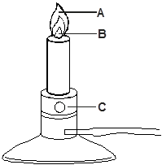

a) Name the regions labelled A and B. (2 marks)

A ........................................................................................................................................................................

B ........................................................................................................................................................................

b) State the function of the part labelled C (1 mark)

............................................................................................................................................................................. .............................................................................................................................................................................

2. Study the scheme below and answer the questions that follow.

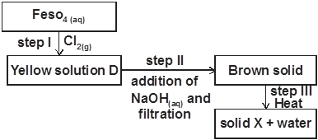

a) Write the formular of the cation present in solution D. (1 mark)

..............................................................................................................................................................................
b) What property of chlorine is shown in step 1. (1 mark)

..........................................................................................................................................................................

c) Write an equation for the reaction which occurred in step III. (1 mark)

........................................................................................................................................................................

3. A piece of chromatography paper was spotted with coloured inks obtained from pens labelled 1 to 6. The diagram below shows the spots after the chromatogram was developed.

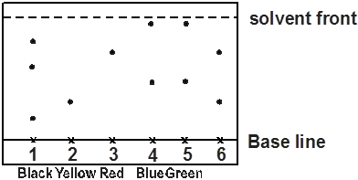

(a) Which two pens contained the same pigment? (1 mark)

.............................................................................................................................................................................

b) Which pens contained only one pigment? (1 mark)

..........................................................................................................................................................................

c) According to the chromatogram, which pigments are present in the ink of pen number 6. (1 mark)

.........................................................................................................................................................................

4. Starting with lead metal and any other reagent, describe how crystals of lead (II) chloride can be prepared. (3 marks)

............................................................................................................................................................................. .............................................................................................................................................................................
............................................................................................................................................................................. .............................................................................................................................................................................
5. Study the diagram below and answer the questions that follow.

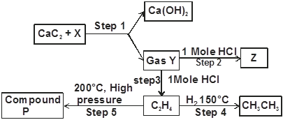

a) Identify reagent X (1 mark)

...........................................................................................................................................................................

(b). Draw the structural formula of gas Y. (1 mark)

c) What name is given to the process that takes place in step 5. (1 mark)

.............................................................................................................................................................................
6. Ammonia gas was collected in a round-bottomed flask and then the apparatus set up as shown below.

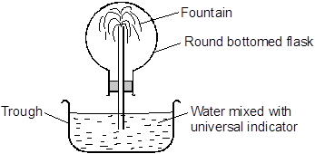

It was observed that the water in the trough rose up the flask forming a fountain

a) Why did the water rise up forming a fountain? (1 mark)

.........................................................................................................................................................................................................................................................................................................................................................

b) State and explain the colour of water mixed with the universal indicator after it gets into the round-bottomed flask. (2 marks)

............................................................................................................................................................................. .............................................................................................................................................................................

7. An ion X³⁺ has the electronic arrangement 2.8.
a) What is the atomic number of element X. (1 mark)

.............................................................................................................................................................................
b) To which group and period of the periodic table does element X belong? (1 mark)

............................................................................................................................................................................. ....
c) What type of bonds exists in the chloride of element X? (1 mark)

............................................................................................................................................................................
8. 400cm³ of gas D diffuses from a porous plug in 50 seconds while 600cm³ of oxygen diffuses from the same porous plug in 30 seconds. Calculate the relative molecular mass of gas D (O = 16) (3 marks)
............................................................................................................................................................................. .............................................................................................................................................................................
............................................................................................................................................................................. .............................................................................................................................................................................
9. A certain mass of sulphur (IV) oxide occupied 400cm³ at 30°C and 750mmHg pressure. Calculate the volume occupied by the same mass of gas if pressure is lowered to 300mmHg and temperature raised to 60°C. (2 marks)

............................................................................................................................................................................. .............................................................................................................................................................................
10. The diagram below represents a set up for large scale manufacture of hydrochloric acid. Study it and answer the questions that follow.

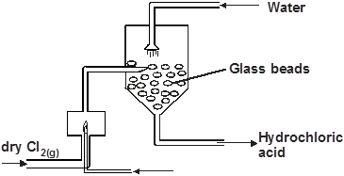

a) Name substance X. (1 mark)

.........................................................................................................................................................................

b) What is the purpose of the glass beads. (1 mark)

.......................................................................................................................................................................

c) Give two uses of hydrochloric acid. (1 mark)

............................................................................................................................................................................. .............................................................................................................................................................................

11. In an experiment air was passed through several re-agents as shown in the flow chart below.

a) Write an equation for the reaction which takes place in the chamber with magnesium powder (1 mark).

.........................................................................................................................................................................

b) State the Role of concentrated potassium hydroxide solution. (1 mark)

.................................................................................................................................................................................
c) What observation is made in the chamber containing copper turnings. (1 mark)

...............................................................................................................................................................................
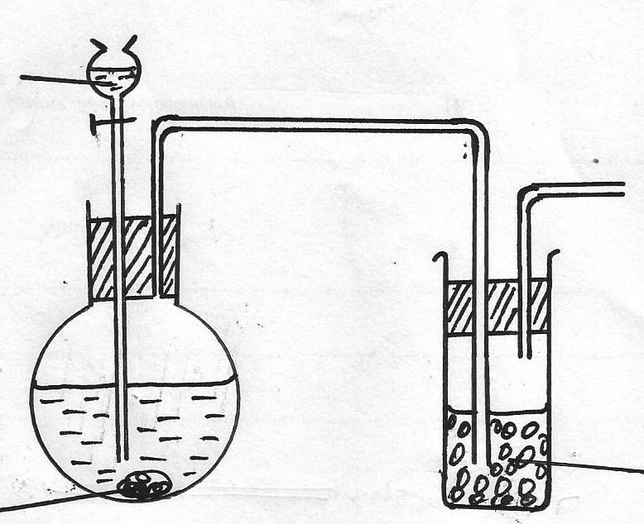
12. The set-up below was used to prepare dry sample of hydrogen Sulphide gas
Solid J
Solid H
Dil. Hydrochloric acid

(a) Complete the diagram to show how the gas was collected (2 marks)
(b) Identify the Solid H (¹/₂mark)
…………………………………………………………………………………………………………………….
(c) Write an equation for the reaction in which hydrogen sulphide is produced (½ mark)
………………………………………………………………………………………………………………………

13. Study the set-up below and answer the questions that follow.
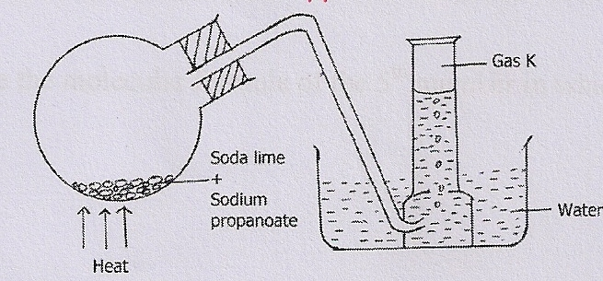
- Name gas K. (1 mark)

……………………………………………………………………………………………………………….
- To which homologous series does K belong? (1 mark)

…………………………………………………………………………………………………………………

- Write the chemical equation of the reaction in the round bottom flask. (1 mark)

.............................................................................................................................................................................
14.The scheme below shows some reaction sequence starting with solid M.
Solid M
Solid N
White ppt
Colourless Solution Q
+ Gas which burns with a ‘pop’ sound
Few drops of NH_{3(aq)}
Excess NH_{3(aq)}
H₂SO_{4(aq)}

- Name solid M (1 mark)
…………………………………………………………………………………………………………………

- Write the chemical formular of a complex ion present in solution Q (1 mark)

............................................................................................................................................................................. .............................................................................................................................................................................
- Write an ionic equation of the reaction between barium nitrate and solution N. (1 mark)

............................................................................................................................................................................. .............................................................................................................................................................................
15. An element x has an isotopic compositions as shown below;
15
7
X
80.99%
7
5.6%
and
17
7
13.5%
X
X
,
16

i. What are isotopes? (1 mark)

............................................................................................................................................................................. .............................................................................................................................................................................
ii. Calculate the relative atomic mass of element X (2 marks)

............................................................................................................................................................................. .............................................................................................................................................................................
16. The equations show some reactions. Use the equations to answer the following questions.
CH₃CH₂OH Step I CH₂=CH₂ Step II CH₃CH₃
(a).Name the type of reaction in step I and II. (2 marks)
Step I
………………………………………………………………………………………………………………………
Step II
……………………………………………………………………………………………………………………..
(b).Explain why ethene bums with a more smoky flame than ethane. (1 mark)
………………………………………………………………………………………………………………………………………………………………………………………………………………………………………………
17.(a) Explain why melting point of chlorine gas is greater than that of Argon. (1 mark)
...............................................................................................................................................................................................................................................................................................................................................
(b) Using dot(●) and cross (x) to represent electrons draw a diagram to show bonding in carbon (iv) oxide. (1 mark)

(c) In terms of structure explain why Graphite is used as a lubricant. (1 mark)
........................................................................................................................................................................................................................................................................................................................................................................

18.One mole of hydrogenchloride gas reacts with an organic compound R to give a simple product with structural formula shown below
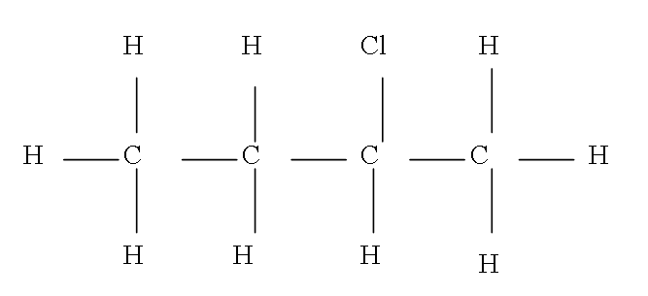
(a) Give the name of the product (1 mark)
………………………………………………………………………………………………………………
(b) Draw the structural formula of compound R. (1 mark)

19. When 15cm³ of a gaseous hydrocarbon P was burnt in 100cm³ of oxygen, the resulting gaseous mixture
occupied 70cm³ at room temperature and pressure. When the gaseous mixture passed through potassium
hydroxide solution, it’s volume decreased to 25cm³.
(a)What volume of oxygen was used during the reaction? (1 mark)

…………………………………………………………………………………………………………………….

…………………………………………………………………………………………………………………….
(b) Determine the molecular formula of the hydrocarbon. (2 marks)

............................................................................................................................................................................. .............................................................................................................................................................................
20. The set up below was used to prepare nitric (V) acid in the laboratory.
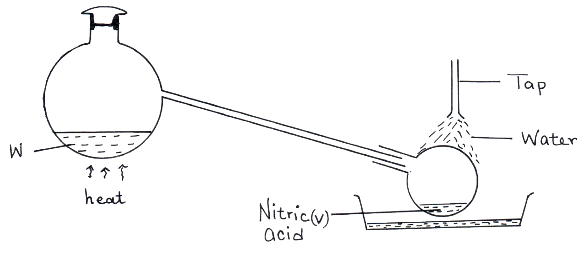

(a).Name the mixture W. (1 mark)

…………………………………………………………………………………………………………………….
(b).Write an equation for the reaction that takes place in flask A. (1 mark)

………………………………………………………………………………………………………………………
(c) Explain why nitric (V) acid produced appears yellow. (1 mark)

…………………………………………………………………………………………………………..................................
…………………………………………………………………………………………………………………………………21.The table below gives elements represented by letters which are not the actual symbols.
Element | U | V | W | X | Y | Z
Atomic No. | 8 | 12 | 13 | 15 | 17 | 20
(i).Select an element that can form divalent anion. (1 mark)

………………………………………………………………………………………………………………………

(ii).What is the structure of the oxide of W? (1 mark)

………………………………………………………………………………………………………………………

(iii) Compare the atomic radius of W and X. (1 mark)

………………………………………………………………………………………………………………………………………………………………………………

22. What is the role of the following parts during fractional distillation of a mixture of water and ethanol
(i) Fractionating column (1 mark)
………………………………………………………………………………………………………………………………………………………………………………………………………………………………………………(ii) Glass beads in the fractionating column (1 mark)
………………………………………………………………………………………………………………………(b) State any one application of fractional distillation process (1 mark)
……………………………………………………………………………………………………………………..
23.On complete combustion of 0.5g of a hydro carbon; 1.257g of carbon (IV) oxide and 0.514g of water were produced. If the relative molecular mass of the hydrocarbon is 84, determine the molecular formula (C=12,H=1,O=16) (3 marks)
……………………………………………………………………………………………………………………………….
………………………………………………………………………………………………………………………………
……………………………………………………………………………………………………………………………….
……………………………………………………………………………………………………………………………….
24. The diagram below shows an iron bar which supports a bridge the iron bar is connected to a piece of
magnesium metal.

Iron bar

Soil Magnesium metal

Connecting wire

Explain why it is necessary to connect the piece of magnesium to the iron bar. (2 marks)

………………………………………………………………………………………………………………………………………………………………………………………………………………………………………………………………………………………………………………………………………………………………………
25. When fuels burn in the internal combustion engine at high temperature, one of the products formed is
nitrogen (II) oxide.
(a) Write the equation for the formation of nitrogen (II) oxide. (1 mark)

………………………………………………………………………………………………………………………
(b) Give a reason why nitrogen (II) oxide is not formed at room temperature. (1 mark)

……………………………………………………………………………………………………………………………………………………………………………………………………………………………………………...
(c ) Describe how formation of nitrogen (II) oxide in the internal combustion engine leads
to gaseous pollution? (1 mark)

………………………………………………………………………………………………………………………………………………………………………………………………………………………………………………
26. When solid magnesium carbonate was added to a solution of hydrogen chloride in methyl benzene there was no effervescence. On addition of water to the resulting mixture there was vigorous effervescence. Explain these observations. (2 marks)
………………………………………………………………………………………………………………………………………………………………………………………………………………………………………………
………………………………………………………………………………………………………………………

27. Below is a flow diagram that summarizes the manufacture of sulphuric (VI) acid.
Air Air Liquid L

Substance E Roasting Gas P Catalytic Y Z
Chamber chamber

Oleum
(a) Identify
(i) Substance E ……………………………………………………………… ( ½ mark)
(ii) Liquid L………………………………………………………………………….. ( ½ mark)

(b) Write a chemical equation to show the reaction at Z. (1 mark)

………………………………………………………………………………………………………….
(c ) Name the commonly used catalyst in the catalytic chamber. (1 mark)

…………………………………………………………………………………………………………..
28. A student set-up the apparatus below in order to determine the percentage by volume of oxygen in air.
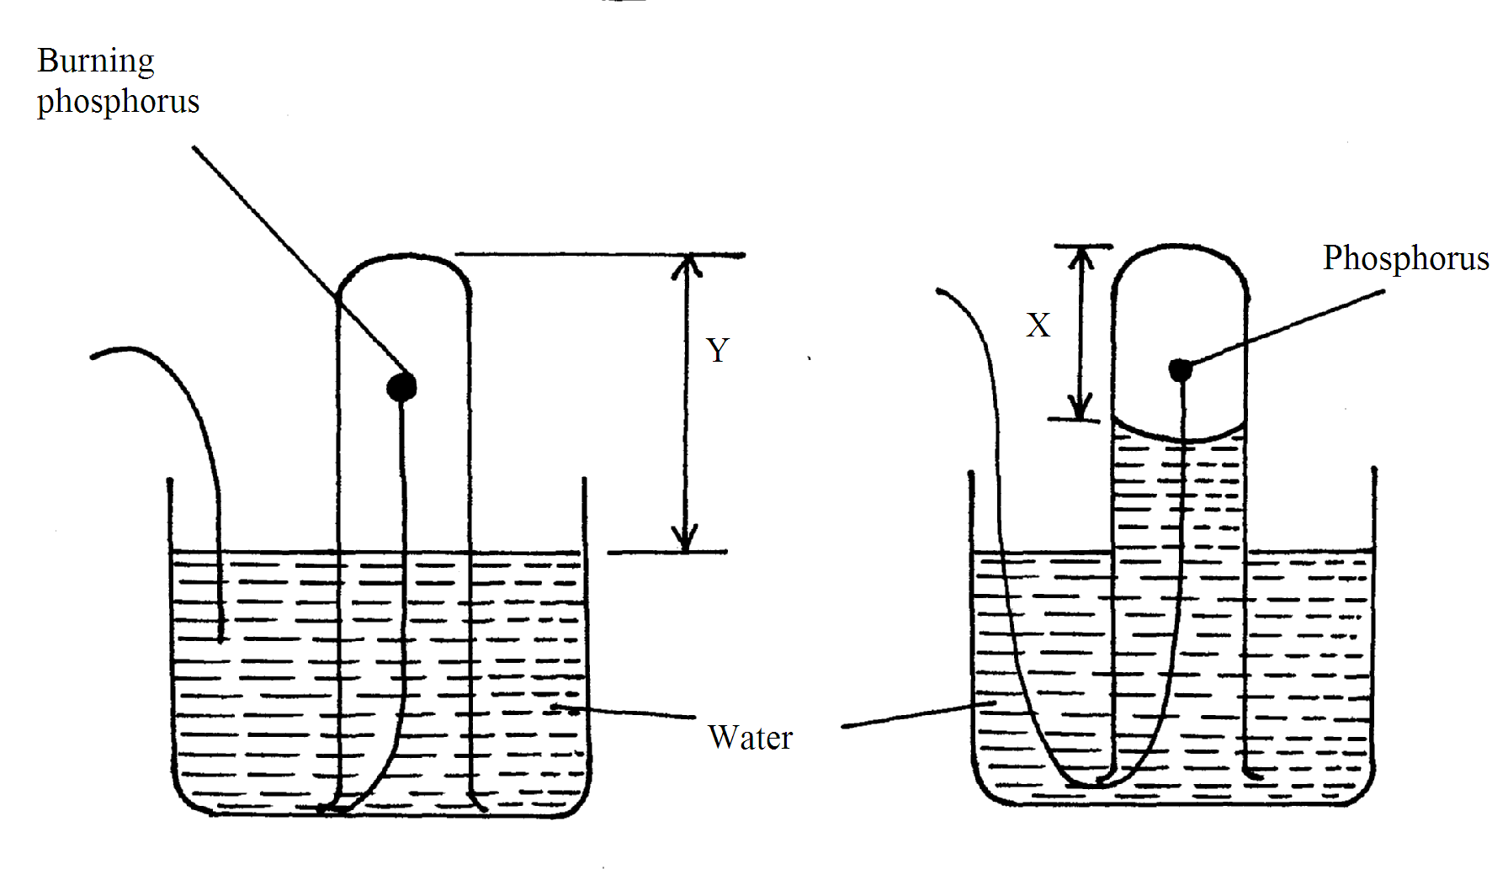
AT BEGINING
AT END

a) Why did water rise when the reaction had stopped? (1 mark)
......................................................................................................................................................................
b) The student wrote the expression for the percentage by volume of oxygen in air as
$\frac{y−x}{y}x\text{100}\text{\%}$
Why was the volume of oxygen calculated using the above expression incorrect? (1 mark)
.....................................................................................................................................................................................................................................................................................................................
c) What should have been done after the reaction had stopped in order to get a correct volume. (1 mark)
............................................................................................................................................................................................................................................................................................................................................
SET 4
MARKING SCHEME CHEMISTRY PAPER 233/1
1.a) A - Pale blue region ✓1
B - Almost colourless region ✓1

b) Controls the amount of air entering the chimney / opens and closes the air inlet. ✓1

2.(a)Fe³⁺ ✓
b) oxidising agent ✓

(c)

3. a) 4 and 5 ✓1
The two must be present for one to score the mark

b) 2 ✓½ and 3 ✓½

(c) yellow ✓½ and red ✓½

4.Add lead metal to warm dilute nitric (V) acid ✓½ while stirring in a beaker until in excess.
Filter ✓½ to obtain lead (II) nitrate as filtrate. Add sodium chloride crystals in a beaker of
water and stir to make a solution ✓½ Add the filtrate to sodium chloride solution ✓½
Filter ✓½ to obtain PbCl₂ as residue
Rinse the residue with water then dry ✓½ the residue between filter papers.

5. a)Water ✓1

b)H - C ≡ C - H ✓1

c)Polymerisation

6. ) To occupy ✓½ the space initially occupied by the dissolved ✓½ ammonia gas.

b) Universal indicator turns blue. ✓1. Because the ammonia gas dissolved in water forming an alkaline solution ✓1

7. a)13 ✓1

b) Group - 3 , ✓½ Period - 3 ✓½

c) - Covalent bond ✓½
- Co-ordinate bond ✓½

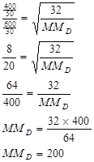
8.

9. 400 x 750 = 300 x V₂
303 333
333 x 400 x 750 ✓½ = V₂
303 x 300
V₂ = 1099.0cm³ ✓½ 2mks

10. a) Hydrogen ½

b) Increase the S.A. for dissolving HCl_{(g)} ✓½

c) -Used in etching of metals. ✓½
-In manufacture of polymers such as P.V.C. ✓½

11.

b) To absorb CO₂ from the air✓1.

c) Red brown ✓½ copper changes to black ✓½ due to the oxidation copper to form copper (II) oxide.

12.(a)downward delivery since it is denser than air✓1

(b) ironsulphide✓1
(c) FeS(s) +2HCl(aq) H₂S(g) +FeCl₂(aq) ✓1
13.(i)ethane✓1
(ii)alkane✓1
(iii) CH₃CH₂COONa(s) + NaOH(s) CH₃CH₃(g) + Na₂CO₃(s) ✓1

14.(a) Zinc metal✓1
(b) [Zn(NH₃)₄]²⁺✓1
(c) Ba²⁺aq + SO₄²⁻aq BaSO₄(s) ✓1
15.(i)atoms with same atomic number but different mass number
(ii)( 80.99 x15 ) +(5.6x16) + (13.5x17) ✓1
100
=15.3395✓1

16.(a) Step I — Dehydration ✓1
Step II— Hydrogenation ✓1
(b) Ethene burns with more smoky flame than ethane since ethane has a higher percentage content of Carbon as compared to ethane and hence the carbon escapes unoxidized causing
the smoky flame

17.a).It has stronger Van der waals forces than organ which is mono-atomic

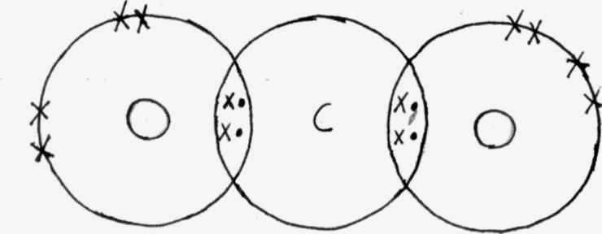
b)

 (1mrk)

c).It has layers in its structures joined by weak van der waals forces which slide over each other.

18. (a) 2 – chlorobutene ✓
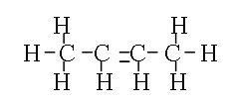
(b)

//
19. (a) 100 – 25 ½ = 75cm³ ½

(b).C_{X}H_{y} + O₂ → CO₂ + H₂O
15cm³: 75cm³: 45cm³
Volume ratio 1: 5 : 3
Value of χ = 3, y = 8, hence formula C₃H₈ (2mks)

20. (a) Conc. sulphuric (VI) acid + potassium nitrate (1mk)
(b) H₂SO_{4(l)} + KNO_{3(S)} → KHSO_{4(aq)} + HNO_{3(aq)} (1mk)
(c) Nitric (V) acid decomposes on exposure to light to form nitrogen (IV) oxide. (1mk)

21. (i) U
(ii)simple molecular

(iii)X is smaller than W

22. i) Allows water vapour to condense into liquid and flow back into the flask before reaching boiling point is reached.√
ii) Increase surface area for condensation process√

b) Oil refinery / manufacture of oxygen and nitrogen /wine industries.√

23. (a) Mass of Carbon = $\frac{\text{12}x1\text{.}\text{257}}{\text{44}}$ = 0.343g√ ½
Mass of Hydrogen =$\frac{2x0\text{.}\text{514}}{\text{18}}$ = 0.057g√ ½
C H
$\frac{0\text{.}\text{343}}{\text{12}}$ $\frac{0\text{.}\text{057}}{1}$
$\frac{0\text{.}\text{0286}}{0\text{.}\text{0286}}$= I $\frac{0\text{.}\text{057}}{0\text{.}\text{0286}}$ = 1.99
(3mks)

EF = CH₂
(CH₂)_{n} = 84
14n = 84
n =$\frac{\text{84}}{\text{14}}$ = 6√ ½
MF = (CH₂)₆ = C₆H₁₂√ ½

24.Magnesiun is above √1 iron in the reactivity series. It supplies electrons √1 to the iron bar
hence prevents it from rusting

25.(a) N_{2 (g)} + O_{2 (g)} 2NO _{(g)} √1

(b) NOg is unstable and N quickly oxidize √ by atmospheric oxygen to NO_{2 (g)} √1

(c ) NO (g) dissolves in atmospheric waters to form NO₂ which is a gaseous pollutant √1

26. Hydrogen chloride has a covalent bond. It dissolves in methyl benzene. A solution of hydrogen chloride in methyl benzene does not ionize √1 / remains in molecular form hence no H⁺ ions, addition of water causes hydrogen chloride to ionize / dissociate into H⁺ and Cl – ions. The H⁺ ions react with the carbonate ion to form carbon (IV) oxide gas hence effervescence √1
27. (a) (i) Sulphur √ ½ , zinc blende Zns , galena (Pbs)
(ii) Concentrated sulphuric (VI) acid √ ½

(b) H₂SO₄ _{(l)} + SO_{3 (g)} H₂S₂O_{7 (l)} √1

(c ) Vanadium (V) oxide (V₂O₅ ) √1 Penalisze platinum

28. a) To occupy space previously occupied by oxygen that was used by burning phosphorous. ✓01
b)Because oxides of phosphorous formed still occupy space previously occupied by oxygen.
(P₂O₅, P₂O₃) ✓01
c)Let all the fumes dissolve in water before final reading is taken ✓01

