Name: ............................................................................................Class no........................

Candidate’s signature………………… Date……………

233/1
CHEMISTRY
Theory
Paper 1
Time: 2 Hours

SET 3
Kenya certificate of secondary education (K.C.S.E)

INSTRUCTIONS
- Answer ALL questions in the spaces provided.
- Mathematical tables and electronic calculators may be used.
- All working MUST be clearly shown where necessary.
For examiners’ use only.
Questions | Maximum score | Candidate’s score
1-28

This paper consists of 11 printed pages. Students should check the question paper to ensure that all pages are printed as indicated and that no questions are missing.
Turn over.
1. The diagram below represents a paper chromatogram of pure A, B, C and D. K is a mixture that contains A and D only.
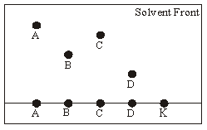
- Indicate on the diagram the chromatogram of K. (1 mark)

- Give a reason why A moves faster to the solvent front than B (1mark)
………………………………………………………………………………………………………………….
………………………………………………………………………………………………………………….
(iii) Indicate on the diagram the base line (1 mark)

2. Element W has atomic number 14 and consists of three isotopes as shown below:
isotope | X | Y | Z
Isotopic mass | 28 | 29 | 30
% abundance | 92.2 | 4.7 | 3.1

- What are Isotopes? (1 mark)
………………………………………………………………………………………………………………….
………………………………………………………………………………………………………………….
- Determine the relative atomic mass of W (2 marks)
…………………………………………………………………………………………………………………………………
………………………………………………………………………………………………………………………………….
3. When a hydrocarbon was completely burnt in oxygen, 4.2g of carbon (IV) oxide and 1.71g of water were formed. Determine the empirical formula of the hydrocarbon (H=1.0, C = 12.0, O = 16.0) (3 marks)
…………………………………………………………………………………………………………………..
…………………………………………………………………………………………………………………..
…………………………………………………………………………………………………………………...
4. Study the information in the table below and answer the questions that follow. The letters do not represent the actual symbols of elements.
 |  | Ionization Energy
Element | Electron arrangement | 1st I.E. | 2nd I.E
P | 2.2 | 900 | 1800
Q | 2.8.2 | 736 | 1450
R | 2.8.8.2 | 590 | 1150
- What chemical family does elements P, Q and R belong? (1 mark)
………………………………………………………………………………………………………………...
…………………………………………………………………………………………………………………..
(ii) What is meant by the term 1st ionization energy? (1 mark)
………………………………………………………………………………………………………………….
…………………………………………………………………………………………………………………..
(iii) The 2nd ionization energy is higher than the first ionization energy of each. Explain. (1mark)
…………………………………………………………………………………………………………………
…………………………………………………………………………………………………………………
(iv) When a piece of element R is placed in cold water, it sinks to the bottom and an effervescence of a colourless gas is observed. State one commercial use of the gas. (1 mark)
…………………………………………………………………………………………………………………
5. When hydrated copper (II) sulphate is subjected to a source of heat gently, it forms a white anhydrous copper (II) sulphate. On adding water to the white powder, blue copper (II) sulphate crystals are reformed.
- Write the equation for the above case (1 mark)
…………………………………………………………………………………………………………………
- Name the type of change that occurs in the above case and give a reason for your answer. (2 marks)
………………………………………………………………………………………………………………….
………………………………………………………………………………………………………………….
6. The diagram below shows how muddy water can be made clean. Study and answer the questions that follow.
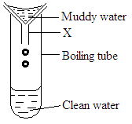
- Name the apparatus labelled X. (1mark)
………………………………………………………………………………………………………………
- Give a reason why the clean water took a long time to drop into the boiling tube. (1mark)
………………………………………………………………………………………………………………
………………………………………………………………………………………………………………
- Name the method of separation shown above. (1mark)
…………………………………………………………………………………………………………………..
7. (a) Explain why the metals Magnesium and Aluminium are good conductors of electricity. (1mark)
…………………………………………………………………………………………………………………...
…………………………………………………………………………………………………………………...
(b) Other than cost, give two other reasons why aluminium is used for making electric cables while magnesium is not. (1mark)
…………………………………………………………………………………………………………………...
8. A certain mass of gas occupies 146dm³ at 291K and 98.31kPa. What will be its temperature if its volume is reduced to 133dm³ at 101.325 kPa? (3 marks)
………………………………………………………………………………………………………………………………………………………………………………………………………………………………………………………………………………………………………………………………………………
9. A mixture contains ammonium chloride, copper (II) oxide and sodium chloride. Describe how each of the substances can be obtained from the mixture. (3 marks)
…………………………………………………………………………………………………………………
………………………………………………………………………………………………………………….
…………………………………………………………………………………………………………………

10. A test-tube containing damp iron wool is inverted in water.
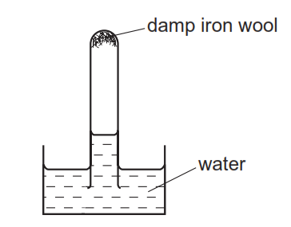
State and explain what is observed after three days . (2 marks)
………………………………………………………………………………………………………………………………………………………………………………………………………………………………
11. The curve shown below was obtained when solid naphthalene was heated to boiling.
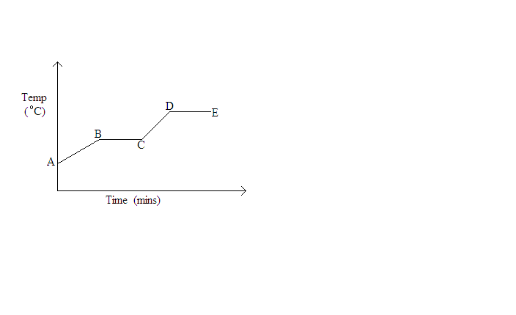
Explain in molecular terms the changes occurring in portions.
- AB (1 mark)
………………………………………………………………………………………………………………………………………………………………………………………………………………………………
- DE (1 mark)
………………………………………………………………………………………………………………………………………………………………………………………………………………………………
- What is the significance of portion BC? (1 mark)
……………………………………………………………………………………………………………………………………………………………………………………………………………………………
12. Describe how solid sample of lead II chloride can be prepared using the following reagents. dilute Nitric Acid, Dilute Hydrochloric Acid, and lead Carbonate (3marks)
………………………………………………………………………………………………………………………………………………………………………………………………………………………………………………………………………………………………………………………………………………………………………………………………………………………………………………………………
13. 120cm³ of nitrogen gas diffuses through a membrane in 40 seconds. How long will it take 240cm³ of carbon (IV) oxide to diffuse through the same membrane? (3 marks)
………………………………………………………………………………………………………………….
………………………………………………………………………………………………………………….
…………………………………………………………………………………………………………………..
14. Name the following compounds (1 mark)
(i) CH₃CH=CHCH₃
…………………………………………………………………………………………………………………..
(ii) CH₃-CH₂-CH-CH₂CH₂CH₃ (1 mark)
CH₂CH₃
…………………………………………………………………………………………………………………..
15. The table below gives some information about certain chemical substances. The letters used are not the actual chemical symbols or formulae.
Substance | Melting point (⁰C) | Boiling point (⁰C) | Electrical conductivity
Substance | Melting point (⁰C) | Boiling point (⁰C) | of solid | of liquid | in water
A  B  C  D  E  F | 1540  -114  712  -39  2045  1700 | 3000  -85  1418  357  3000  2776 | Good  Poor  Poor  Good  Poor  Poor | Good  Poor  Good  Good  Good  Poor | Insoluble  Good  Good  Insoluble  Insoluble  Insoluble
From the list, select.
(i) Two substances that cannot be elements (1 mark)
…………………………………………………………………………………………………………………...
(ii) A substance that is likely to have giant atomic structure. (1 mark)
…………………………………………………………………………………………………………………...
(iii) Two substances which cannot be broken down when an electric current is passed through them. (1 mark)
…………………………………………………………………………………………………………………
16. The diagram below represents aset up that can be used to react Lithium with water to produce gas X which is then reacted with copper II oxide.
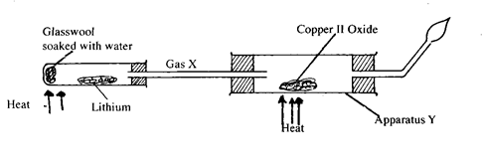
(i) Write an equation for the reaction between gas X and CuO (1mark)
…………………………………………………………………………………………………………………
(ii) Give the observation made in the apparatus (1 mark)
………………………………………………………………………………………………………………..
(iii) Why is it necessary to burn excess gas at the end of the jet (1 mark)
…………………………………………………………………………………………………………………..
17. The diagram below shows how two gases, P and Q were collected.
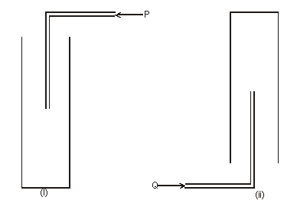

(a) Name the two methods used. (1 mark) ………………………………………………………………………………………………………………
(b) State properties of P and Q that enable them to be collected through the methods shown. (2 marks)
…………………………………………………………………………………………………………………………………………………………………...
18. Solution R,S and T have P^{H} values shown in the table below:
Solution | pH value
R | 1.0
S | 6.5
T | 8.0
- What do you deduce about the nature of solution R? (1 mark)
…………………………………………………………………………………………………………………..
- Which solution would react most vigorously with sodium hydrogen carbonate. (1 mark)
………………………………………………………………………………………………………………………………………………………………………………………………………………………………
c) Which solution is likely to be ammonia solution? (1 mark)
………………………………………………………………………………………………………………
……………………………………………………………………………………………………………….
19. When magnesium ribbon is burnt in air and the product dissolved in water, a colourless solution is formed and a colourless gas is evolved.
(i) What effect does the solution formed have on litmus paper? (1 mark)
………………………………………………………………………………………………………………….
………………………………………………………………………………………………………………….
(ii) Name the compound responsible for the production of the colourless gas. (1 mark)
………………………………………………………………………………………………………………….
(iii) Write down a balanced chemical equation for the reaction producing the colourless gas
(1mark)
………………………………………………………………………………………………………………………………………………………………………………………….
20. The curve shown below was obtained when solid naphthalene was heated to boiling.
(a) Explain in molecular terms the changes occurring in portions.
(i) AB (1 mark)
……………………………………………………………………………………………………………………………………………………………………………………………………………………………..

(ii) DE (1 mark)
………………………………………………………………………………………………………………
……………………………………………………………………………………………………………….
(b) What is the significance of portion BC? (1 mark)
………………………………………………………………………………………………………………
21. The diagram below shows an arrangement of electrons in Aluminium chloride dimer
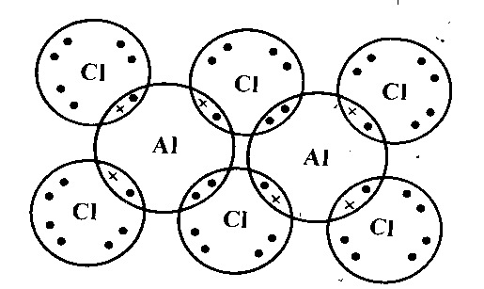
(i) Write down the structural formula of the above molecule (1 mark)
……………………………………………………………………………………………………………….
(ii) On the diagram indicate using an arrow the dative bond (1 mark)
22. Study the flow chart below.
Ethanol
Ethene
Compound T
Process I

Conc. H₂SO_{4(l)}
Hydrogen

Ni/catalystt

(a) Name
(i) compound T (1 mark)
………………………………………………………………………………………………………………..
(ii) process I (1 mark)
…………………………………………………………………………………………………………………
(b) Give one use of ethene (1 mark)
………………………………………………………………………………………………………………
23. Propene reacts with 1 moles of bromine to form another compound whose structural formula is.

H Br Br H
| | | |
H- C - C - C - C – H
| | | |
H H H H
i) What is the name of the compound shown above (1mark)
...............................................................................................................................................................................
...............................................................................................................................................................................
(ii) Name the homologous series to which propene belongs (1mark)
………………………………………………………………………………………………………………….
24. In the last stage of the solvay process, a mixture of sodium hydrogen carbonate and ammonium chloride is formed.
(i) State the method of separation used. (1mark)
…………………………………………………………………………………………………………………..
(ii) Write an equation showing how lime is slaked (1ma
………………………………………………………………………………………………………………….
(iii) Name the by-products recycled in the above process (1mark)
…………………………………………………………………………………………………………………
25. 62g of hydrated sodium carbonated Na₂CO₃. nH₂O, were dissolved in distilled water and made up to one litre of solution 20cm³ of 1.5 m hydrochloric acid completely reacted with 30.0cm³ sample of the sodium carbonate solution. Determine the value of n. ( Na = 23.0 , C =12.0, 0= 16.0). (3 marks)
…………………………………………………………………………………………………………………..
…………………………………………………………………………………………………………………...
…………………………………………………………………………………………………………………..
26. The diagram below represents a charcoal burner. Study it and answer the questions that follow
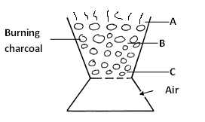
(i) Write equations for the reactions occurring at
Zone A……………………………………………………………………………………. (1mark)
Zone B………………………………………………………………………………….. (1mark)
Zone C……………………………………………………………………………………. (1mark)
(ii) What is the colour of the flame (1 mark)
…………………………………………………………………………………………………………………
27. The table below shows information about three solid substances A, B and C. Study it and answer the question that follow.
Solid | Cold water | Hot water
A | Soluble | Soluble
B | Insoluble | Insoluble
C | Insoluble | Soluble

Describe how you will separate the three solids from a mixture of the three. (3 marks)
………………………………………………………………………………………………………………….
…………………………………………………………………………………………………………………...
…………………………………………………………………………………………………………………...
28. The figure below can be used to investigate effect of an electric current on molten lead(II)iodide
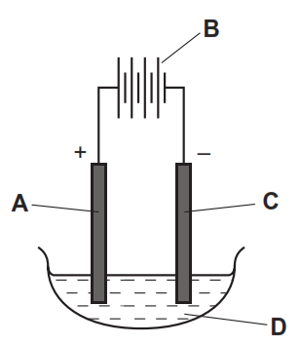
- Identify the electrodes labelled A and C (1mark)
…………………………………………………………………………………………………………………...
(ii) Which particles are responsible for conduction in molten lead(II)iodide (1 mark)
…………………………………………………………………………………………………………………...

SET 3
MARKING SCHEME CHEMISTRY PAPER 233/1
1.
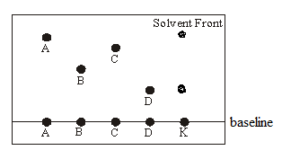
(i)See diagram
(ii) less sticky on the adsorbent material, less dense than B, more soluble in the moving solvent
(iii) see diagram

2.(a) Different atoms of the same element with same atomic number but different mass number✓1

(b) (92.2 x 28) +(4.7 x 29) + (3.1 x 30) ✓1
100
=28.109✓1
3. mass of carbon in CO₂ = 12/44 x 4.2 = 1.4445g✓½
Mass of H in H₂0 = 2/18 x 1.71 = 0.19g✓½
C H
1.1445 0.19
12 1
0.09545 0.19
0.09545 0.09545 ✓1
1 : 2
Formula = CH₂✓1
4.(i) Alkaline earth metals✓1
(ii) the energy required to remove the 1st electron from an atom in gaseous state✓1
(iii) after losing the first electron,the remaining electrons experience greater attraction from the nucleus hence difficult to remove✓1
(iv) Hydrogen✓1
5.(a) CuSO₄.5H₂O CuSO₄(s) + 5H₂0(l) ✓1
(b)Reversible chemical change,on addition of water heat is produced and the reaction is reversible✓1
6(a) Filter funnel
(b) Air trap inside prevent water going through filter paper.
- No space is provided for air escape.
(c) filtration
7.(a)-they have delocalized electrons✓1
(b) –aluminium has lower density than magnesium✓½
-aluminium is resistant to corrosion due to the protective oxide layer on its surface✓½
8. P₁V₁ = P₂V₂
T₁ T₂
98.31 x 146 =101.325 x 133
291 T₂
T₂= 3921581.475
14353.26
=273.22K
9.Heat the mixture to sublime✓½ ammoniumchloride,Add water✓½ to the remaining mixture to dissolve ✓½sodiumchloride,filter✓½ to remove copper(ii)oxide as residue, heat✓½ the filtrate to obtain sodium chloride solid✓½
10.-iron wool turns to brown
-level of water rises up the test tube
Brown is due to rust, level of water rises tontake up space initially occupied by oxygen
11.(i)molecules of naphthalene absorb energy,this raises the temperature
(ii) DE-boiling takes place at constant temperature
(iii) it shows melting.

12. Dissolve lead carbonate in dilute Nitric acid; react the mixture with dilute hydrochloric acid, filter to get lead (II) chloride.
13 . ✓1
=2.3936cm³/s✓1
Rate =
2.3936=
Time =100.26s✓1

14.(i) But-2-ene✓1

(ii)3 –ethylhexane✓1
15.(i) C and E✓1
(ii) F✓1
(iii) A and D✓1
16(i). H₂(g) + CuO(s) Cu(s) + H₂O(l)
(ii) Copper(ii)oxide Changes colour from black to brown copper
(iii) to prevent an explosion when it mixes with air. ✓1
17.(a)(i) downward delivery (ii) upward delivery✓1
(b) P-denser than air✓1 Q-lighter than air✓1
18.(a)it is strongly acidic✓1
(b)R✓1
(c)T✓1
19.(i)it turns red litmus paper to blue
(ii) Magnesium nitride✓1
(iii) Mg₃N₂(s) +H₂O(l) 3Mg(OH)₂(aq) + 2NH₃(g) ✓1
20.(a) i.solid absorbs heat energy, temperature rises✓1
(ii) boiling takes place at a constant temperature, heat absorbed is latent heatb of vaporization✓1
(b) it is melting point✓1
21. .(i) Al₂Cl₆✓1
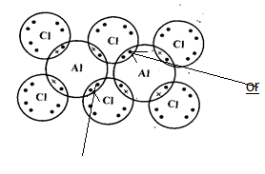
(ii)

✓1

22.(a)(i) Ethane✓1

(ii) Dehydration✓1

(b).ripening of fruits/manufacture of polyethene
23. (i) 1,2 dibromobutane

(ii) alkene

24.(i)Fractional crystallization/filtration ✓1
(ii).CaO _{(s)} + H₂O _{(l)} Ca(OH)_{2 (aq)} ✓1
(iii).Ammonia,carbon(iv)oxide,water ✓1

25.Na₂CO₃(s) + 2HCl 2NaCl + CO₂ + H₂
Moles in 20cm³ of HCl =
Moles of carbonate used =
Molarity of carbonate =
26(i) A- CO (s) + O₂(g) CO₂(g)
B- CO₂(g) + C(s) CO(g)
C- C(s) + O₂(g) CO₂(g)
(ii)blue

27. Place the mixture in a beaker with ½ hot water and stir. Filter the mixture while hot to obtain solid B ½ as a residue. Let the filtrate containing A and C ½ cool. Solid C will be deposited½ since it is insoluble in cold water. Filter to obtain solid C as a residue. Evaporate½ the filtrate to dryness to obtain solid A.
28.(i) A anode ½
C-cathode½

(ii)mobile ions1

