**SET 2**

**FORM THREE EXAM**

**CHEMISTRY 233/1**

**MARKING SCHEME**

1. (i) W-2,8,1√ ½

V- 2,6 √ ½

(ii) W2V3 √1

(iii) Ionic bond √1

2. (a) dust particles removed by electrostatic precipitation

(b) CO2 removed by passing air through concentrated Sodium hydroxide and concentrated potassium hydroxide.

(c) to remove water vapour in form of ice.

3. (i) CaC2(s) + 2H2O(l) C2H2(g) +Ca(OH)2(aq)

(ii) yellow sooty flame // yellow luminous flame √1

(iii) used in Oxy-acetylene torch for welding and cutting metals √1

4. P1V1 = P2V2 √ ½

T T2

T2= 100x 0.5 x 500√1

400x1

400x 1 = 100x 0.5

500 T2

= 62.5K√1

5. (a) Solution R – acidic // strong acid

(b) Solution R √1

(c) Solution T √1

(6) Heat √ ½ the hydrated salt, blue xrystals change to white powder √ ½ allow the white powder to cool// collect √1 vapour and cool. Add the condensed liquid to the white solid √ 1/2 , it changes to blue√1 **3**

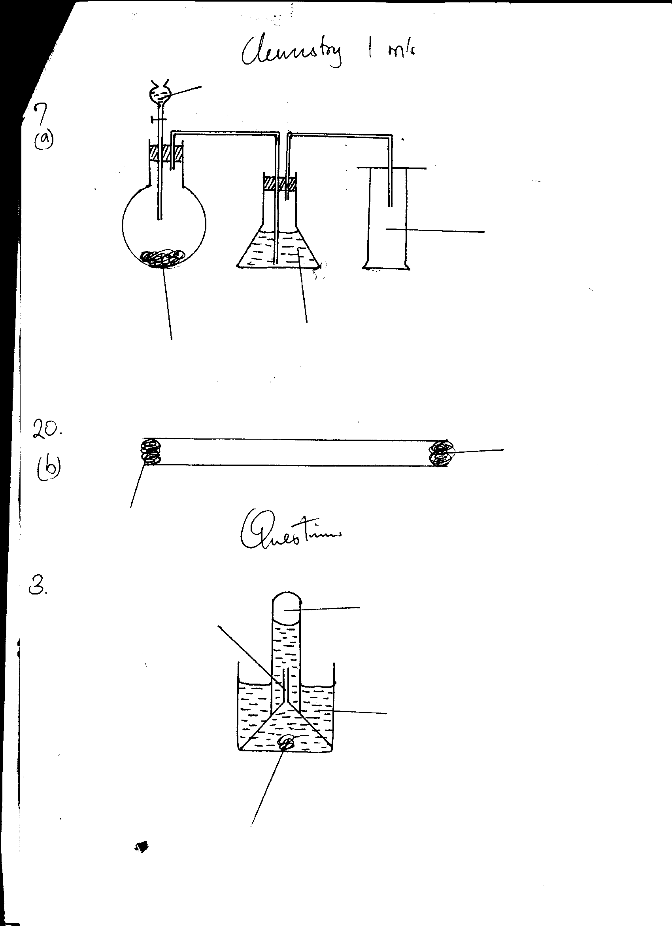7.(a) √1

**Dil HCl**

**Reagent R**

**Concentrated sulphuric**

**Acid** √1

**SO2(g)**

(b_ R- sodium sulphite √1

8. (a) Isomerism- existence of compounds with the same molecular formular but different structural formulae√1

H

|

|

|

|

|

|

|

|

|

|

H

H

H

H

H

H

H

H

H

H

H

(b)

|

H

|

|

|

|

H

|

C

|

H

|

H

|

H

-

H

-H

HH

H

H

- C - C - C - C - C - √ ½ C - C - C - C - H √ ½

H

Pentane √ ½ 2- methylbutane √ ½

|

H

|

C

H

H

|

|

H

-

H

-

H

|

H

|

C

|

H

-

-

H

H - C - C - C - H √ ½

2,2- dimethy/ propane √ ½

.9(i) Alkaline metals

(ii) Ionization energy-energy required to completely remove an electron from the outermost energy level of an atom in gaseous state √1

(iii) Element R has a large atomic radius hence the electron in the outermost energy level is √1 loosely attracted by the positive nucleus .

10.(a) Nitrogen (IV) Oxide √1

(b) Zn 2+ √ ½ and O2- √ ½ **3**

©\ Zinc Nitrate √1

11(a) C H Cl

No. of moles 24.24 4.04 71.72 √ ½

12 1 35.3

2.02 4.04 2.02 √ ½ **2**

Mole ration 2.02 4.04 2.02 √ ½

2.02 2.02 2.02

1 2 1

Formula CH2Cl √ ½

(b) (CH2Cl)n =99

(12+ (2x1) + 35.5) n = 99

49.5n = 99√ ½

n=2

Molecular formula C2H2Cl2 √ ½

12. (i) E – Covalent √1

F- Co-ordinate // covalent √1

(ii) Oxygen atom in water molecule has two ions pairs of electrons √ ½ available for bond formation. It donates one √1 ion pair sharing with the hydrogen ion√ ½

13. moles of H2SO4 = 50 x 0.025 = 0.0125 √ ½

1000

Moles of NaOH = 10 x 0.5 = 0.005 √ ½

1000

Mole ratio acid :alkali

2 : 1

∴ moles of excess acid = ½ x 0.005 = 0.0025√ ½

Moles of acid that reacted with metal

0.0125 – 0.0025 = 0.01√ ½

Mole ratio metal : acid

1 : 1

∴ moles of metal = 0.01

R.A.M of metal = 0.24 √ ½

0.01

= 24√ ½

14. (a) Silicon has a giant atomic √1 structure with strong covalent bonds which require a lot of heat energy to break.

(b) Sulphur and phosphorous exhibit allotropy√1. The two values are the m.p.t of each allotrope √1

15. (i) K- alluminium oxide

(ii) bubble the two gases through acidified Potassium Manganate (vii) in separate test tubes, ethane decolourizes potassium manganate (vii) while ethane√1 does not//.

OR

Pass the two gases through bromine water in separate test tubes, ethane decolorizes bromine water while ethane does not.

16. Heat Copper metal in air to dilute Sulphuric acid

Filter off the excess Copper √ ½ oxide.

Evaporate √ ½ the filtrate to saturation allow to cool for crystals to form.

Wash the crystals √ ½ with distilled water and dry between filter papers

17. (a) Graham’s law- Under the same conditions of temperature and pressure the rate of diffusion of a gas is inversely proportional to the square root of its density.

(b) T1 = √M1

T1 = ? T2= 100

M1 = 16 M2=64

T2 √M2 √ ½

T1 = 16

100 64 √ ½

T1 = 1 √ ½ **2**

100 2

T1 = 50secs√ ½

18. (a) Butane √1

(b) Conditions for hydrogenation 1

Nickel catalyst √ ½

Temperature 150- 250oC √ ½ 1

(c) Manufacture of Margarine √1 1

19. Burning Magnesium produces a lot of heat which dissociates CO2 into C and O2 the oxygen then supports combustion whereas the heat produced by a burning splint cannot dissociate CO2 hence extinguished.

20. (a) Dense white fumes of ammonium chloride



**Cotton soaked in Conc ammonia**

**Cotton wool soaked in conc HCl**

**x**

(c) Ammonia gas is les dense √ ½ hydrogen chloride gas hence diffuse √1 faster than HCL √ ½

21. C2H4 (g) + 3 O2(g)  2CO2(g) +2H2O(g)

RFM of C2H4 = (2x12)+ (1x4)=28√ ½

Moles of C2H4 = 1.4 = 0.05√ ½

28

Mole ratio C2H4:CO2

1 : 2

Moles of CO2= 2x 0.05√ ½

=0.1√ ½

1 mole = 22.4dm3

0.1 mole = ?

0.1 x 22.4= 2.24dm3 √ ½

22. (i) Conducts √1

(ii) ionic √1

(iii) covalent √1

23.(a) Gas K- Hydrogen chloride √1

(b) to prevent suck back √ ½ dur to chloride, then cool the vapour to solidify

Add water √ ½ tp obtain CuO as residue and evaporate √ ½ the filtrate to dryness to obtain NaCl

25.(a) Cation –element Y √1 has lost an electrons

Anion –element W has gained electrons

Isotopes- X and Z √1 for both **3**

26.(a) Frasch Process √1

(b) I- molten Sulphur and water √ ½

II- Supper heated water √ ½ **3**

(c) Hot compressed air to push out molten Sulphur and water through tube I

27(a) ammonium salt

Ammonium chloride // ammonium sulphate √ ½

Alkali-calcium hydroxide // sodium hydroxide or Potassium hydroxide

(b) drying agent for ammonia gas

Calcium oxide √1// quick lime.

(c) uses of Ammonia gas

In laundry to remove temporary hardness of water and neutralize acidic stains

Manufacture of nitric acid

Manufacture of fertilizers

In regrirating plants such as ships and warehouses any two @ ½ mk

28. (a) Black Copper (II) oxide changesto red brown metal √1

(b) CuO(s) +CO(g) Cu(s) + CO2(g)

(C)Carbon (II) Oxide is extremely poisonous √1